A. Multiple Choice 選擇題 二十分
1. ( ) Look at the apple! (① It’s ② I’m ③ You’re) red.
2. ( ) (① Who ② What ③ How) color is it?
3. ( ) A nurse is on (① a ② an ③ two) ox.
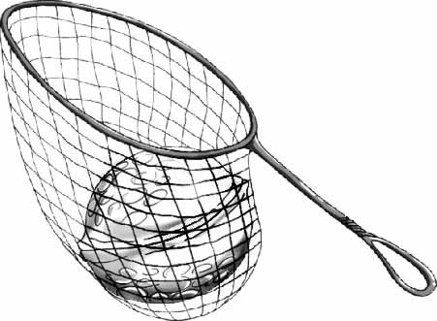
4. ( ) (① Am ② Are ③ Is) you ready?
5. ( ) A nut is (① on ② in ③ to) a net.
6. ( ) What (① red ② blue ③ color) is the ball?
7. ( ) The sky is (① color ② ox ③ blue).
8. ( ) Whose dog is it (① . ② ! ③ ?)
9. ( ) (① Let ② Let’s ③ Wow) start!
10. ( ) Mix blue and red.
Wow! It’s (① red ② color ③purple).
B. Look and Write（填入正確的單字）：
每個單字四分，共二十分
swim student singer drive teacher
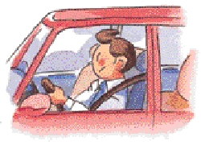


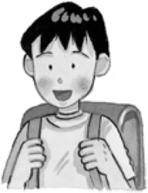
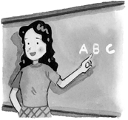

C. Look and Match（將圖片與正確的句子連起來）：
每題三分，共二十一分
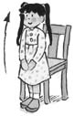
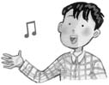
1. He’s a doctor. ˙ ˙
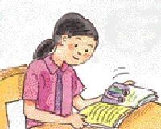
2. Open your book. ˙ ˙

3. She’s a nurse. ˙ ˙
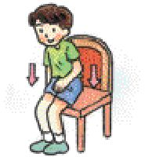
4. Close your book. ˙ ˙
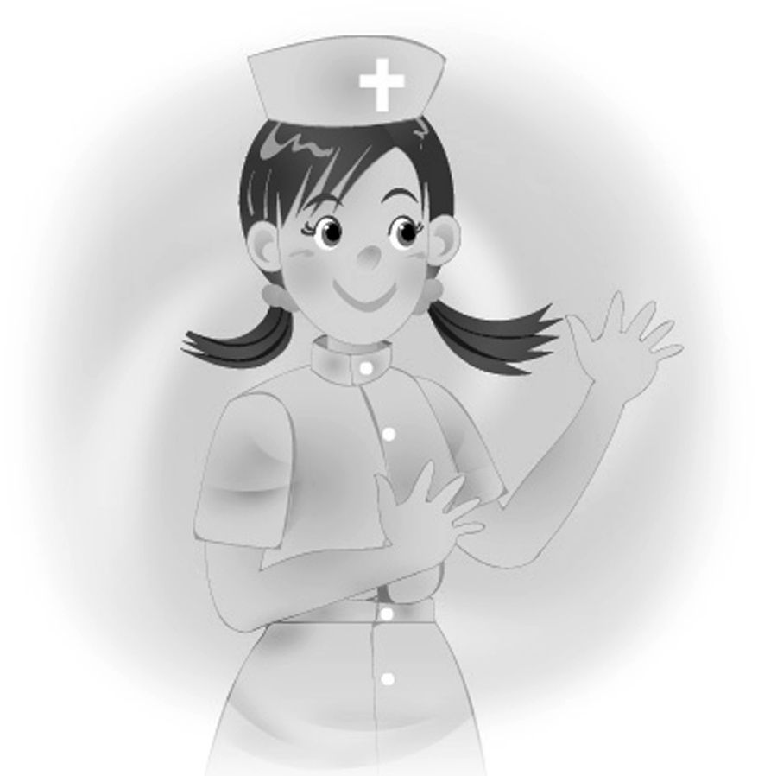
5. He can sing. ˙ ˙
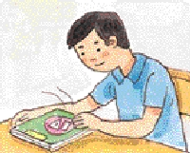
6. Stand up. ˙ ˙
7. Sit down. ˙ ˙
D.Fill in the Blanks 填充題 二十七分
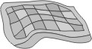
- Whose __uilt is it?
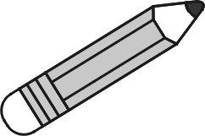
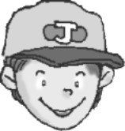
- It’s __ __ __ pencil.
→
- Take __ __ __ your pencil.
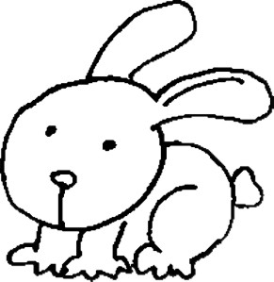
- It’s my __ __ __ __ __ __.
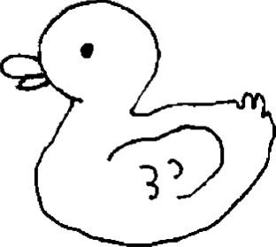
- It’s your __ __ __ __.
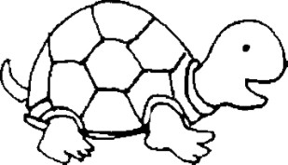
- It’s her __ __ __ __ __ __.
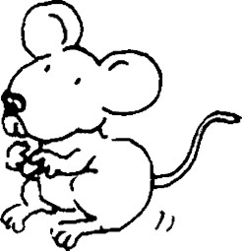
- It’s his __ __ __ __ __.

E.Listen and Circle（將聽到的發音字母圈起來）：
每題三分，共十二分
1. at （ c f ）
2. esk （ b d ）

3. ather （ c f ）
4. ook （ b d ）

