雲 林 縣 拯 民 國 小 九 十 六 學 年 度 第 二 學 期 四年級 英 語 第二次 知 能 考 查
四年 班 座號 姓名

- Listen and circle. 12%
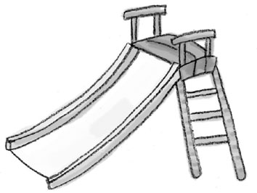
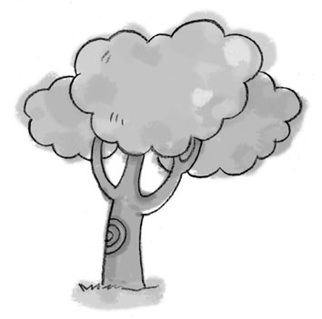
1. 2.
i-e
-ie
-ie
ee

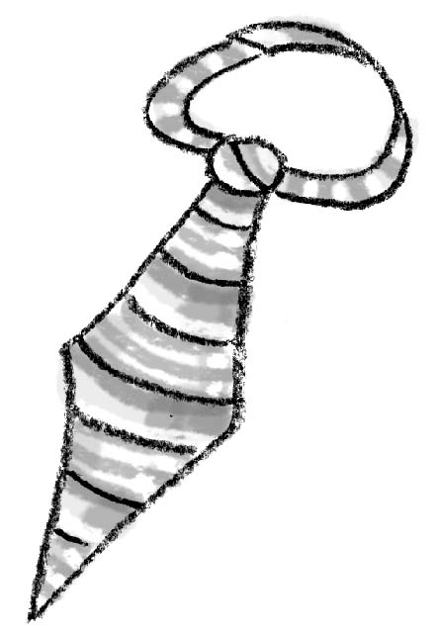
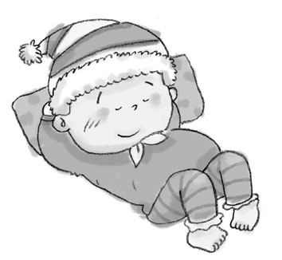
3. 4.
a-e
-ie

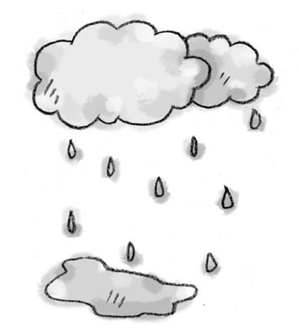
5. 6.
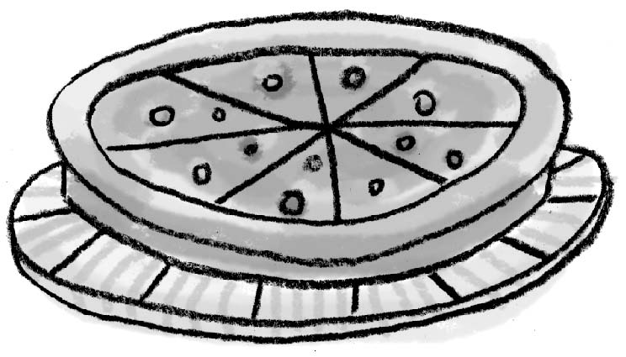

- Listen and write.12%
Ex: v a g
hat
h i t
1. s ai t 2. k ey
m ee d s ay

3. n ee b 4. p ae
p ai d f ie

5. d a n e 6. r ee g
m i p e j ai p

- Correct the sentence.10%
Ex: I am students. ➔ I am a student.
1. Yes, I don’t.
➔_______________________________________
2. Is you want some apples？
➔_______________________________________
3. No, I do.
➔_______________________________________
- Read and match.12%
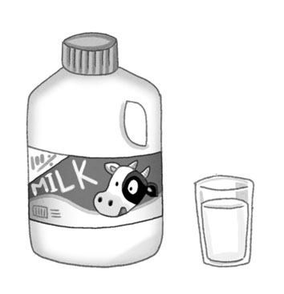
1.
  j __ ice   o-a

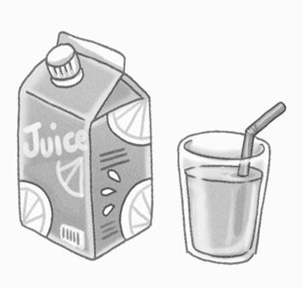
2.
  m__ lk   u

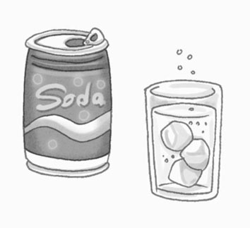
3.
  w__ t __r  i

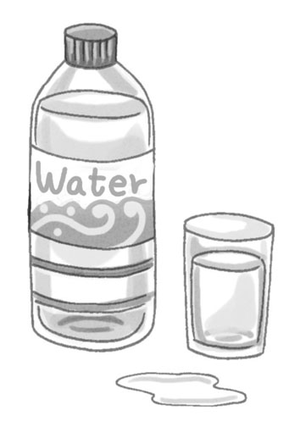
4.
  s __d __  a-e

V. Let’s match.6 %
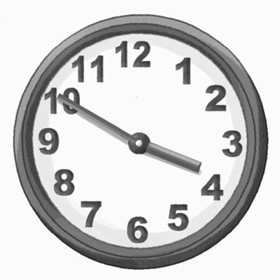
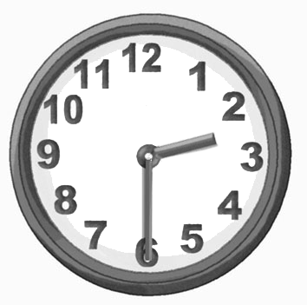
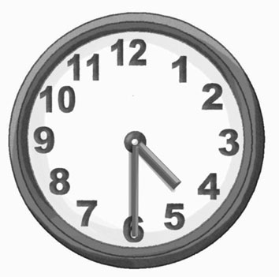
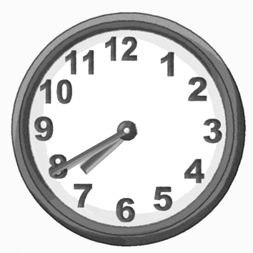
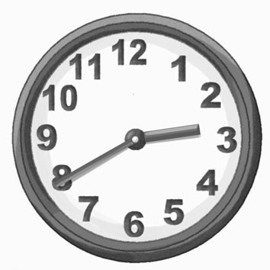
1. 2. 3.
A: What
time is it？
B: It’s two
thirty.
A: Is it seven Forty？
B: Yes, it is.
A: Is it three Twenty？
B: No, It’s
four thirty.

VI.Read and circle.12%
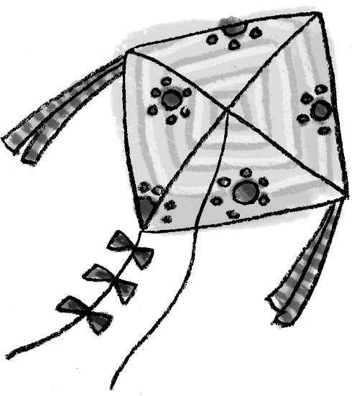  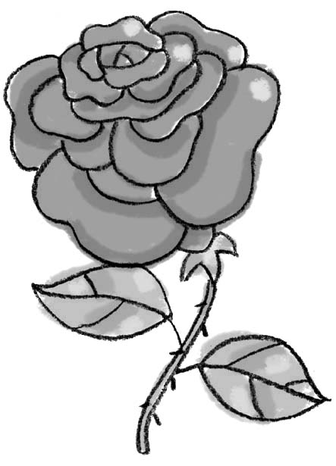  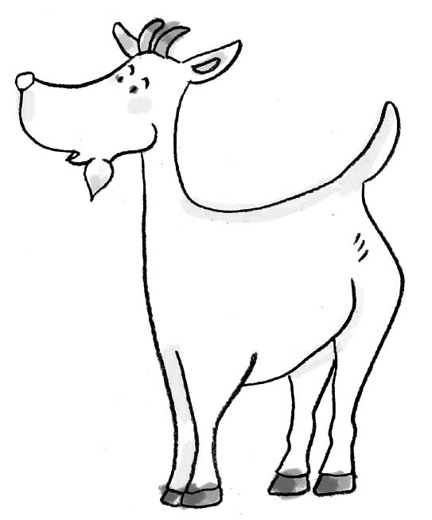  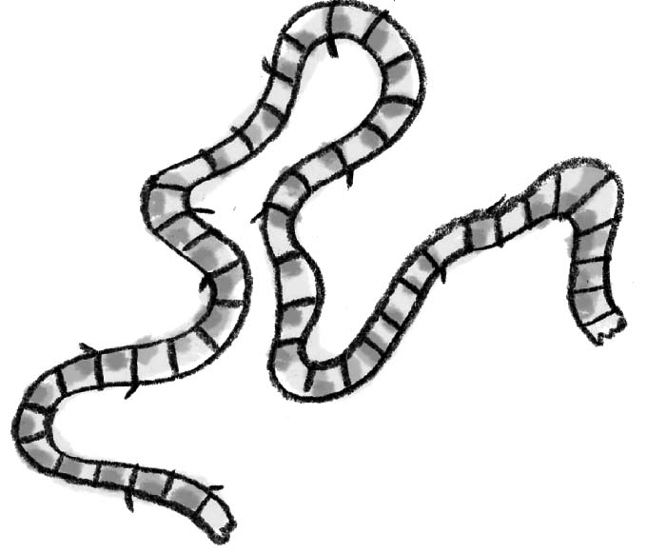  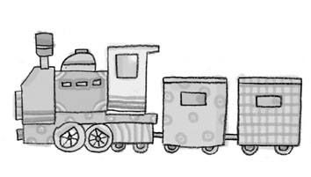  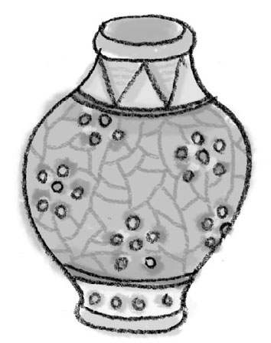 | goat |  | train
 | boat |  | nine
 | rose |  | kite
 | vase |  | rope
 | coat |  | face
 | kite |  | rose

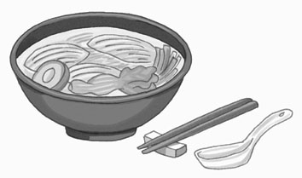
VII.Read and write.12%
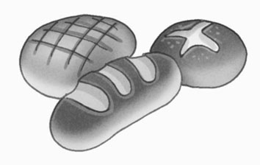
1. 2.

e b d r a o o l s n d e

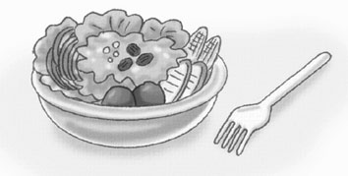
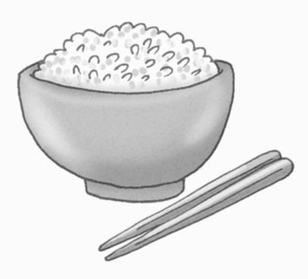
3. 4.

s a a l d i c r e

VIII.unscramble 16%
1. a/ lives / light / heart / long /.

2. strength / . / union / is

3. No / without / sweet / sweat/.

4. More / less /, / haste / speed /.

IX.Read and fill in.8%
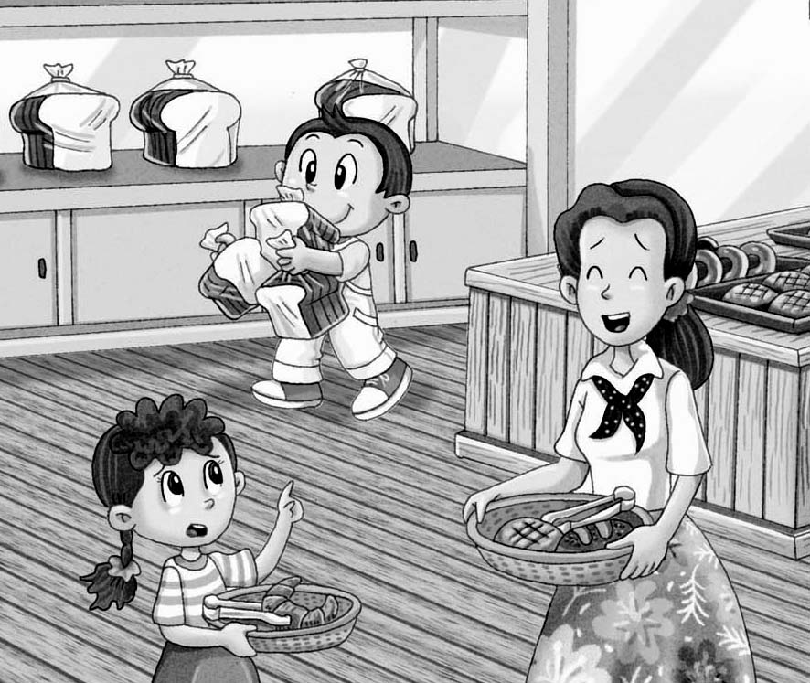
Betty: Does Leo
________ bread？
Ken’s mom: Yes, he
___________
bread ________ _________.

