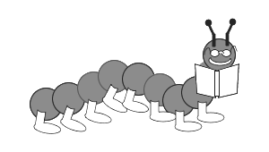
The Very Hungry Caterpillar
Name:

Example: The caterpillar ate one apple on Monday .
1.The caterpillar ate four strawberries on .
2.The caterpillar ate two pears on .
3.The caterpillar ate one nice green leaf on .
4.The caterpillar ate three plums on .
5.The caterpillar ate five oranges on .
6.The caterpillar ate one piece of chocolate cake, one ice-cream cone, on pickle, one slice of Swiss cheese, one slice salami, one lollipop, one piece of cherry pie, one sausage, one cupcake, and one slice of watermelon on .
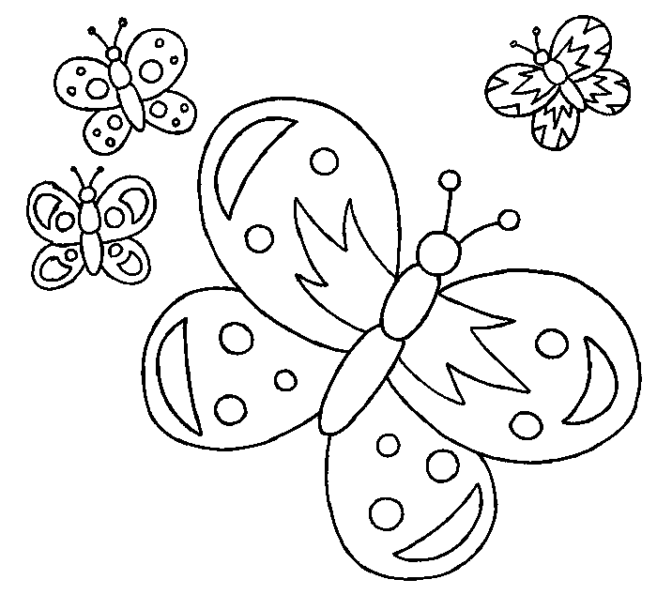
7. The little hungry caterpillar became a , caterpillar.
8. In the end, it was a !

