新東國小社區生活營學生獎懲次數分析
本學期(設置後)與上學期(設置前)之獎懲比較
姓 名 |  | 獎 勵 |  |  |  |  |  | 懲 戒 |  |  |  |  |  | 曠 課
 | 獎勵券(前) | 獎勵券(後) | 獎狀(前) | 獎狀(後) | 扣獎勵券(前) |  |  | 扣獎勵券(後) |  | 小過(前) | 小過(後) |  |  | 曠課(前) |  |  | 曠課(後)
黃○○ | 5 | 8 | 2 | 2 | 0 |  |  | 0 |  | 0 | 0 |  |  | 0 |  |  | 0
陳○○ | 3 | 5 | 1 | 2 | 1 |  |  | 0 |  | 0 | 0 |  |  | 0 |  |  | 0
黃○○ | 4 | 7 | 1 | 1 | 0 |  |  | 0 |  | 0 | 0 |  |  | 0 |  |  | 0
鄭○○ | 6 | 9 | 2 | 3 | 0 |  |  | 0 |  | 0 | 0 |  |  | 0 |  |  | 0
王○○ | 4 | 5 | 2 | 2 | 1 |  |  | 0 |  | 0 | 0 |  |  | 0 |  |  | 0
余○○ | 4 | 5 | 0 | 1 | 0 |  |  | 0 |  | 0 | 0 |  |  | 0 |  |  | 0
劉○○ | 3 | 6 | 2 | 2 | 1 |  |  | 0 |  | 0 | 0 |  |  | 0 |  |  | 0
王○○ | 2 | 4 | 0 | 1 | 0 |  |  | 0 |  | 0 | 0 |  |  | 0 |  |  | 0
徐○○ | 3 | 3 | 1 | 1 | 0 |  |  | 0 |  | 0 | 0 |  |  | 0 |  |  | 0
余○○ | 4 | 6 | 2 | 3 | 0 |  |  | 0 |  | 0 | 0 |  |  | 0 |  |  | 0
合計 | 38 | 58 | 13 | 18 | 3 |  |  | 0 |  | 0 | 0 |  |  | 0 |  |  | 0
分析:
實施社區生活營前後，獎懲方面成效比較
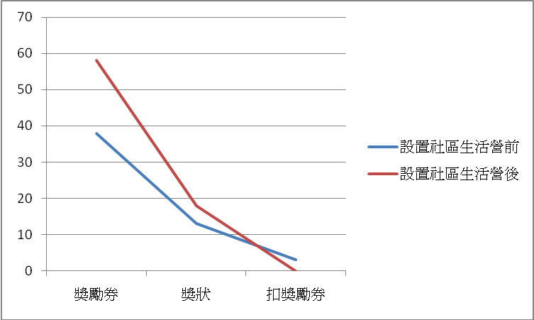 |  |  |  |  |  |  |  |  | 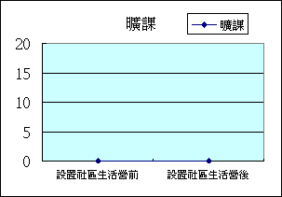
獎勵券 獎狀 扣獎勵券 曠課
設置社區生活營前 38 13 3 0
設置社區生活營後 58 18 0 0

※每個選項及數據分別複製到excel再插入函數

