
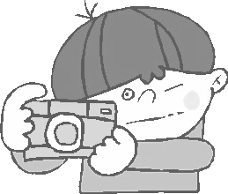
寒假作業－－用照片寫日記
◎請自行加上彩色圖框插畫。
辛亥國小四年___班 座號：____ 姓名：____________

用文字說明這張照片的活動內容
___________________________________________________________________________________________________________________________________________________________________________________________________________________________________________________________________________________________________________________________________________________________________________________________________________________________________

