III. Look at the picture and circle the correct word. 看圖圈對的字。 @2%*10
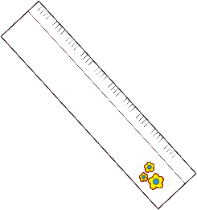 | It’s ( a , an ) ruler. |  | 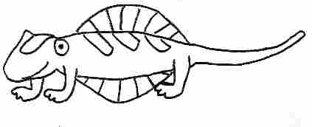 | It’s ( a , an ) iguana.
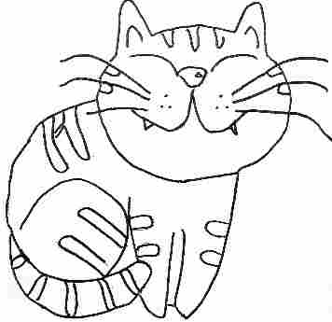 | What is it?  It’s ( a , an ) cat. |  | 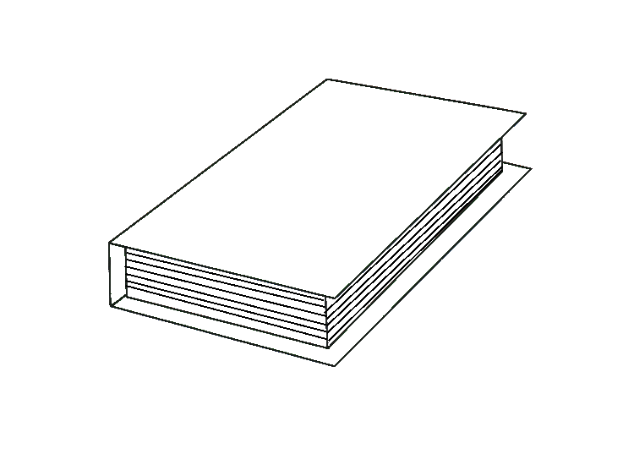 | Look! It’s an ( green , orange ) book.
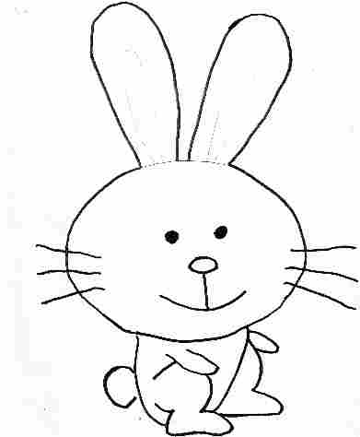 | one ( rabbit , rabbits ) |  | 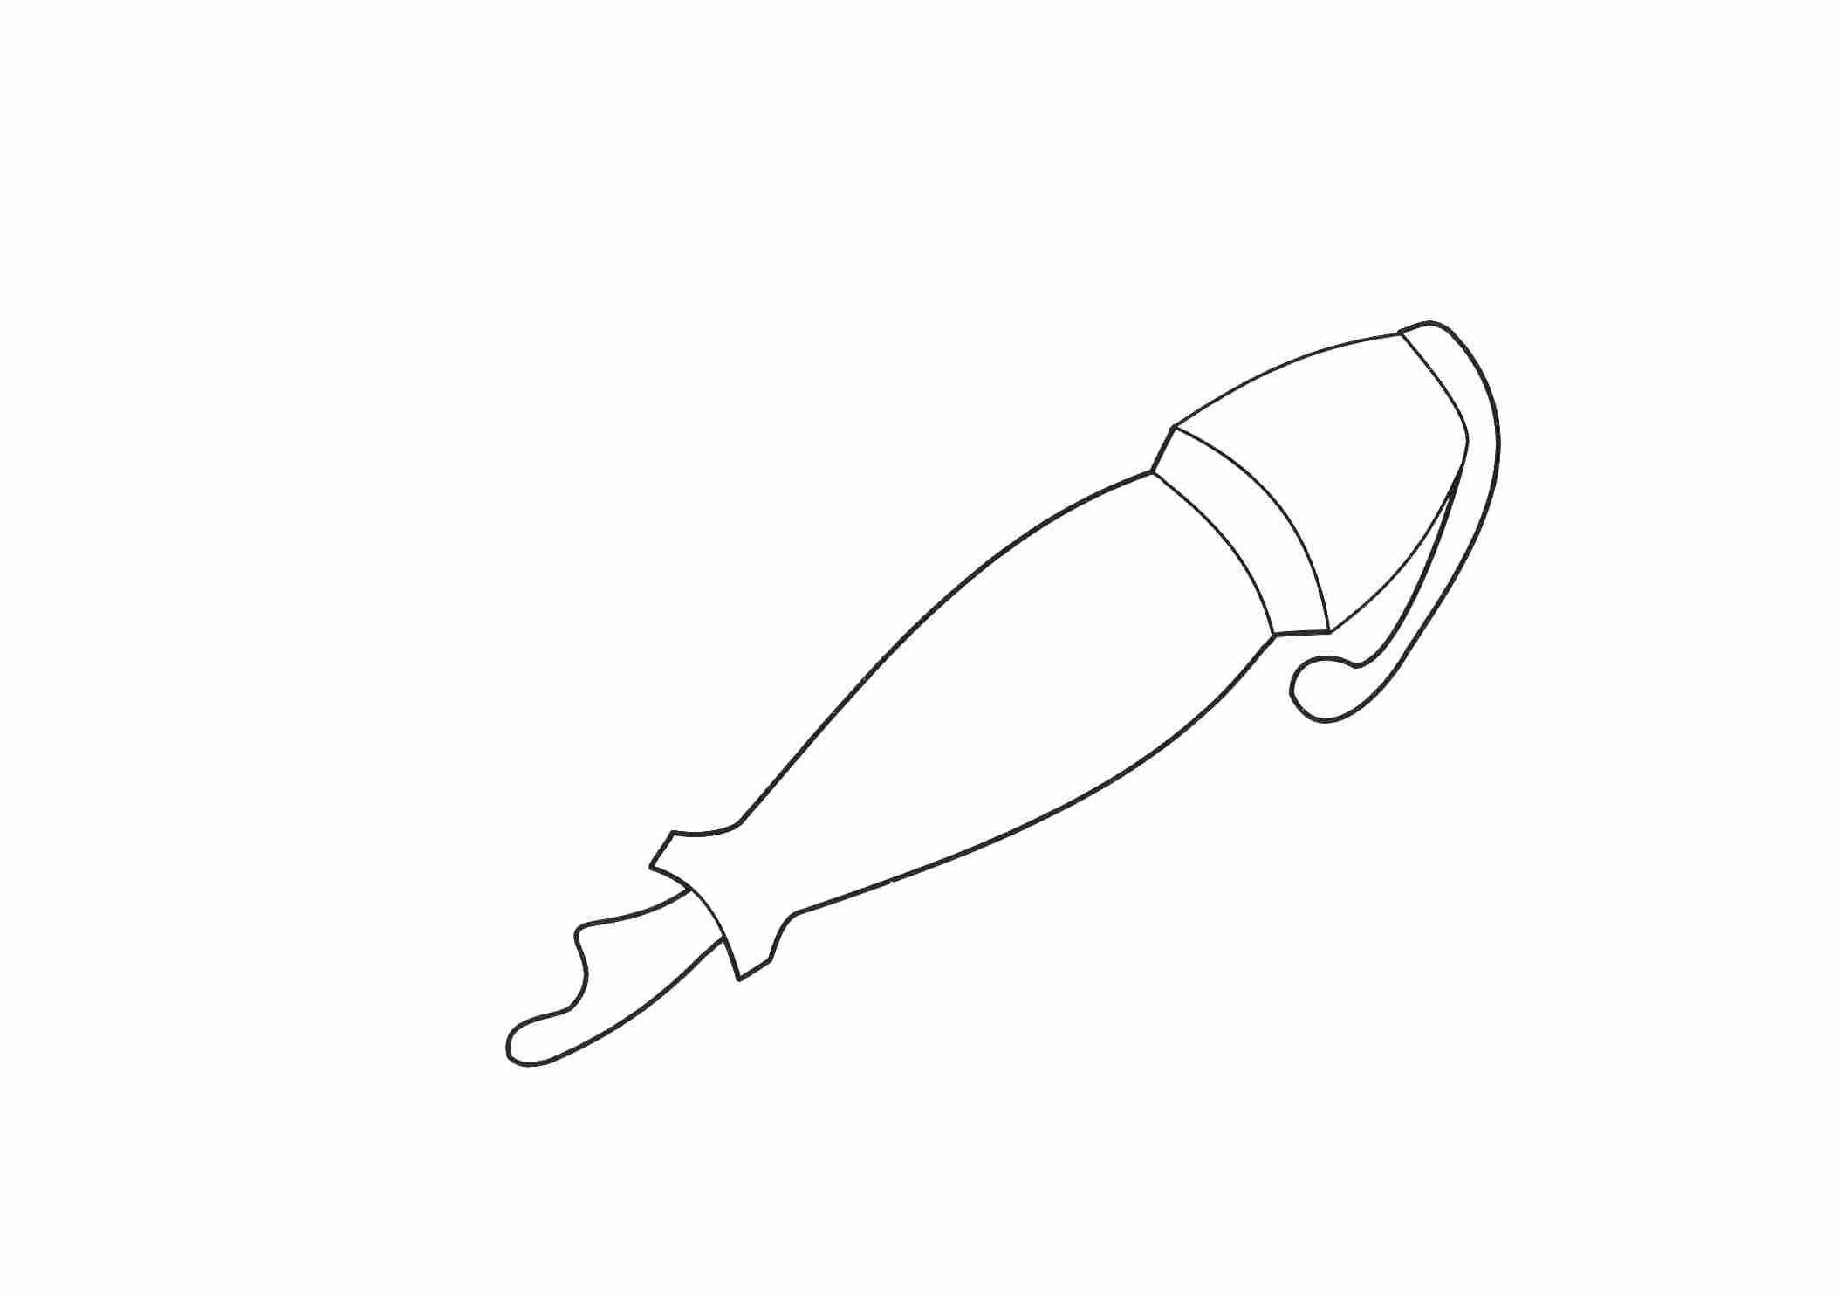 | ( one , two ) pen
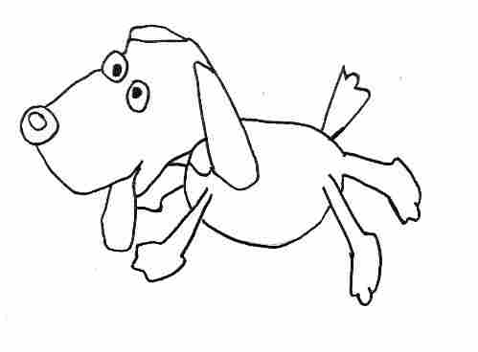 | eight ( dog , dogs ) |  | 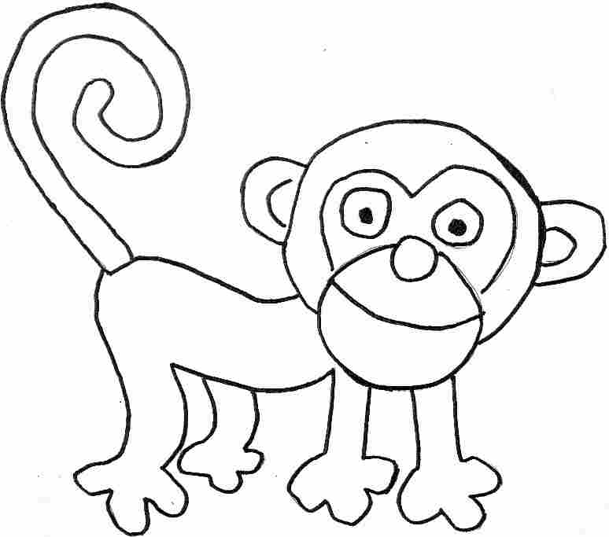 | ( four , five ) monkeys
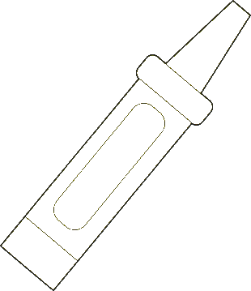 | six ( crayon , crayons ) |  | 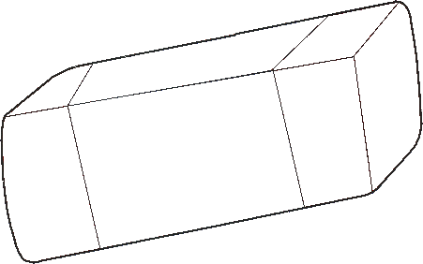 | ( two , three ) erasers
 | It’s ( an , a ) ruler. |  |  | It’s ( an , a ) iguana.
 | What is it?  It’s ( an , a ) cat. |  |  | Look! It’s a  ( green , orange ) book.
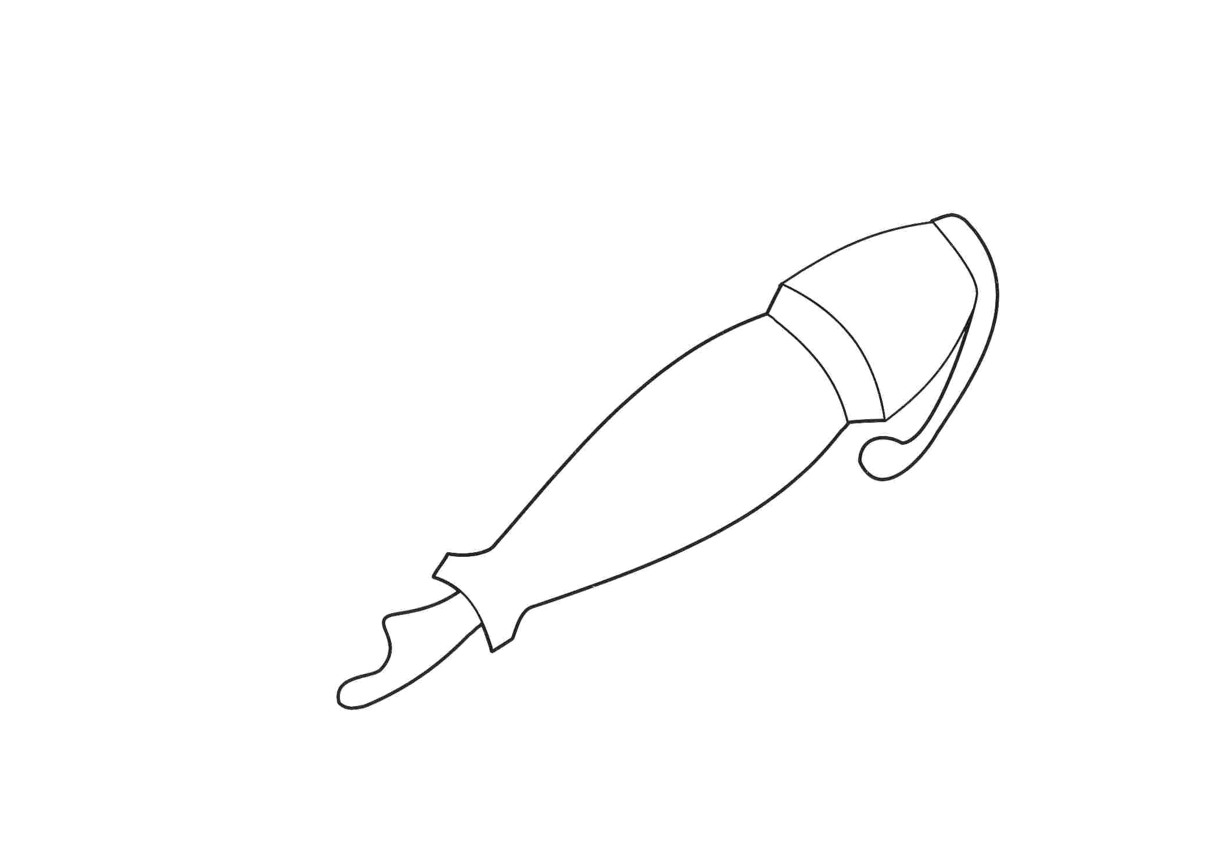 | ( one , two ) pens |  |  | one ( rabbits , rabbit )
 | ( four , five ) monkeys |  |  | eight ( dogs , dog )
 | ( two , three ) erasers |  |  | six ( crayons , crayon )
 | ( four , five ) monkeys |  |  | eight ( dogs , dog )
 | ( six , seven ) crayons |  |  | three ( erasers , eraser)

