澎湖海事106學年度第二學期學習中心二年三級英文

LESSON 1.
Small talk

Name：
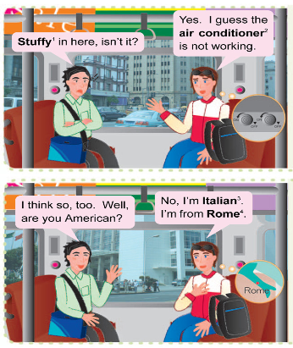
單字
1. stuffy adj. 不通風的，悶的
It’s stuffy in here.
Let’s go outside.

2. air conditioner 空調裝置，冷氣機
There are two air conditioners in this classroom.
conditioner n. 調節器

3. Italian adj. 義大利（人）的；
n. 義大利人（語）
I like Italian food more than French food.

4. Rome n. 羅馬
Rome wasn’t built in a day.

課文 | 翻譯
A: Stuffy¹ in here, isn’t it?  B: Yes. I guess the air conditioner² is not working.  A: I think so, too. Well, are you American?  B: No, I’m Italian³. I’m from Rome⁴. | A:  B:  A:  B:
賓果遊戲-對話模式：
(1) Are you American?
No, I’m from __________.
Japan | Thailand | Italy
Korea | Taiwan | France
New Zealand | India | England
(2) Is she American?
No, she’s from __________.
(3) Is Andy American?
No, he’s from __________.

一起記單字
- stuffy
(1)
(2)
(3)
(4)

- guess
(1)
(2)
(3)
(4)

3.air
(1)
(2)
(3)
(4)

4.air conditioner
(1)
(2)
(3)
(4)

5.work
(1)
(2)
(3)
(4)

6.think
(1)
(2)
(3)
(4)

7.so
(1)
(2)
(3)
(4)

8.well
(1)
(2)
(3)
(4)

9.American
(1)
(2)
(3)
(4)

10.small
(1)
(2)
(3)
(4)

11.talk
(1)
(2)
(3)
(4)

12.small talk
(1)
(2)
(3)
(4)

句型1
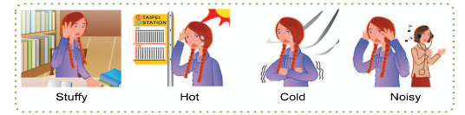
Stuffy in here, isn’t it? F Adj. + in + here / there, + isn’t it?

1.這裡很悶，不是嗎？
2.這裡很熱，不是嗎？
3.這裡很冷，不是嗎？
4.這裡很悶，不是嗎？

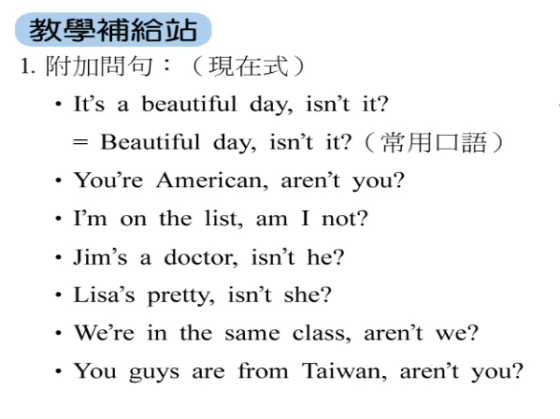
單字練習…
閒聊
不通風的
空氣
台灣
台北
澎湖
美國
猜測
工作/運作
嗯
認為/想
也
冷氣機
句型
1.這裡好悶啊，不是嗎？
2.我也這麼認為。
3.你是美國人嗎？

4.我從台灣來。
5.冷氣不運轉了。(A組)

牛刀小試
1.閒聊 |  | 2.不通風 | 3.空氣
4.美國 | 5.猜測 | 6.運轉 | 7.認為
8.台灣 | 9.澎湖 | 10.冷氣機(A)

A組單字
1.我從台灣來。

2.我也這麼認為

3.這裡好悶啊，不是嗎？

4.妳是美國人嗎？

5.冷氣不運轉了。

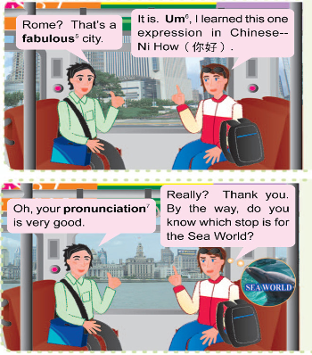
單字
5. fabulous adj. 很棒的（口語用法）
Spiderman is a fabulous movie.

6. um interj. 嗯（表示遲疑）

7. pronunciation n. 發音
You need to work harder on your English pronunciation.

課文 | 翻譯
A: Rome? It’s a great city with fabulous⁵ food.  B: It is.  Um⁶, I’ve just learned a Chinese expression−Ni How (你好). Am I saying it right?  A: Oh, your pronunciation⁷ is very good.  B: Really? Thank you. By the way, do you know which stop is for the Sea World? | A:  B:  A:  B:
一起記單字
- fabulous
(1)
(2)
(3)
(4)

- learn
(1)
(2)
(3)
(4)

- expression
(1)
(2)
(3)
(4)

- very
(1)
(2)
(3)
(4)

- good
(1)
(2)
(3)
(4)
- really
(1)
(2)
(3)
(4)

- thank you
(1)
(2)
(3)
(4)

- by the way
(1)
(2)
(3)
(4)

- know
(1)
(2)
(3)
(4)

- Chinese
(1)
(2)
(3)
(4)

- stop
(1)
(2)
(3)
(4)

- for
(1)
(2)
(3)
(4)

- sea
(1)
(2)
(3)
(4)

- world
(1)
(2)
(3)
(4)

- Which
(1)
(2)
(3)
(4)

- City
(1)
(2)
(3)
(4)

- Great
(1)
(2)
(3)
(4)

- Food
(1)
(2)
(3)
(4)

- With
(1)
(2)
(3)
(4)

- Say
(1)
(2)
(3)
(4)

- Right
(1)
(2)
(3)
(4)

- Just
(1)
(2)
(3)
(4)

- Pronunciation
(1)
(2)
(3)
(4)
句型2
How do you say “Thank you” in Chinese?
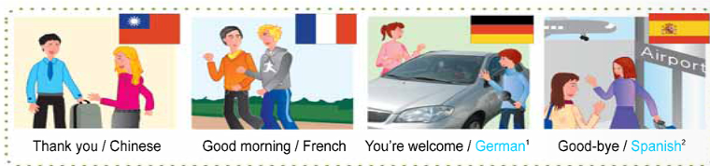
F How do you say + “N” + in + 語言?

1.” Thank you”中文怎麼說？

2.” Good morning”法文怎麼說？

- “You’re welcome”德文怎麼說？

4.” Good-bye”西班牙文怎麼說

