November Library Project 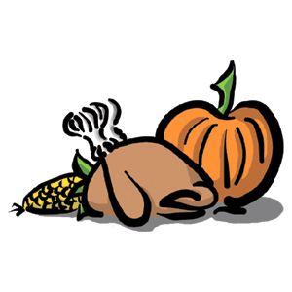 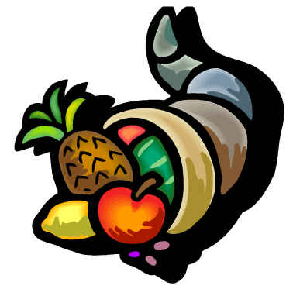 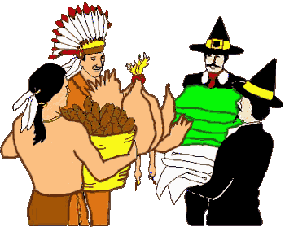
Presenters: Simon Oliver, Mark Daves, and Judy Kuan
November 4
Introduction to Thanksgiving and Change of the Seasons
Activity: Leaf Art
Materials: Parents/Students bring crayons, markers, leaves
November 11
Read: The Story Of Thanksgiving
Activity: Drawing Turkey
Materials: Parents/Students bring crayons, markers
November 18
Activity: Making Pine Cone Turkey
Materials: Parents/Students bring glue, scissors, clay, pencils, markers
November 25
Activity:
Materials: Parents bring carving knives

