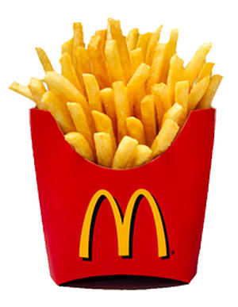
Fast Food Dialogue
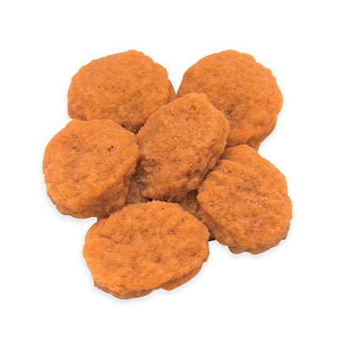

Waiter : Welcome to Liou Bao Restaurant. May I take your order?
Customer : Yes, I would like a hamburger and small french fries , please.
(劃線部分可替換表格一單字)
(or I would like a combo number 3, and combo number 4 for
2, please.) (劃線部分可替換表格三單字)
Waiter : Would you like something to drink?
combo

Customer : A medium coke-cola, please.
(劃線部分可替換表格二單字 )
Waiter : Would you like that for here or to go?
Customer : For here please. / To go please.
Waiter : Is that all?
For here please.
To go please.
Customer : Yes. Thank you.
Waiter : Your total is NT .
Customer : Here is NT .
Waiter : Your change is NT . Thank you and come again.
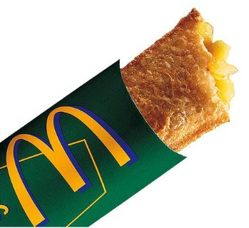
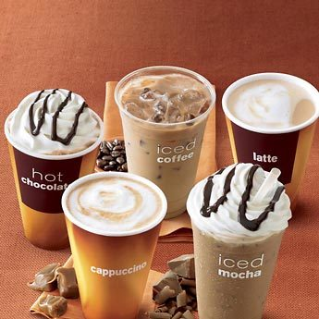

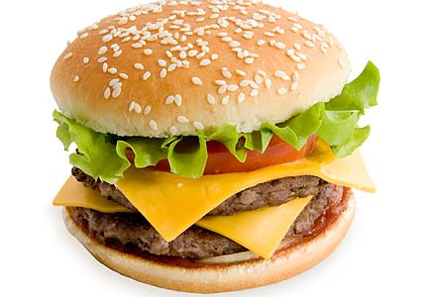

ketchup
napkin
straw
large
medium
small
corn soup
hot chocolate
orange juice
coke-cola
ice tea
coffee

hamburger
chicken sandwich
filet-o-fish
fried chicken
chicken nugget
french fries
apple pie
salad

combo 套餐
a combo number 1 1
a combo number 2 2
combo number 3 for 4 43
combo number 5 for 2 25

