Lesson Plan
（The Unit will divide into 4 sessions and this is session 1.）
Topic |  | Unit 1: My family |  |  |  | School | 集美國小
Grade |  | 4thgrade class 4 |  | Time | 40 mins | Designer | 張文乾(Peter Chang)
Material  Analysis |  | The topic is talking mainly about the family members and their vocations. |  |  |  | Student Background | Have learned “Wow English book 1-3” by康軒
Learning Objective |  | - be able to recognize and read family members( father, mother, brother and sister ).  - be able to introduce his/her own family members.  e.g. “ This is my_______ .”  3. be able to describe vocations ( doctor, teacher, baseball player, dancer and student ) introduced in the story.
Teaching Resources |  | self designed story(PowerPoint), flash cards, pictures, pictures of my family and students’ family, projector, screen, CD player
stage |  |  | Teaching Activities |  |  |  |  | Assessment Measures
暖身活動 | Warm up  activity |  | - Greetings  - Sing a song together with T.P.R. activity  (Hands, Hands up ) |  |  |  |  | Students  like to sing with  T.P.R.
發展活動  發  展  活  動 | Presentation  Practice  Presentation  Practice  Presentation  Practice  Presentation  Practice |  | - Introduce family members by showing the pictures of a popular Japanese cartoon “My family”.  - Review the vocabulary and play a matching game.  - The teacher acts as a member of the family and introduce his/her family to the others.  - Role play: Using flash cards to practice.  - Let students introduce their own family members if they have pictures  - Teach sentence pattern: Use flash cards to do substitution drill.  Who is he/she?  He/she is ________ .  - Guessing: Put flash cards in a box or bag. Then ask a student to draw a card from it and ask question to the others.  - Read the story “ Peter’s family”, so the students can learn more information about the family members.  - Charades: The teacher mimes first, then ask one student to go up to the stage to mime one’s family member from the story. The other students will have to try to guess. |  |  |  |  | ※Can listen  and speak.  ※Would like to play the role  ※Would like to  participate.  ※Can ask and answer  ※Can listen and repeat  ※Can ask  and say  the vocations.
綜合活動 | Wrap up  and  Assignment |  | - Briefly review family members with a family chart ( worksheet 1)  - Homework:  A. Color the pictures of Andy’s family members (worksheet 1 ).  B. Try to write in the blank with appropriate words. |  |  |  |  | Can finish  drawing and  writing the homework.
Extension |  | 1. Ask students: What do these words (father, mother, brother, sister, teacher, player, dancer) have in common? Work with them to sort based on the suffix -er, and -ther.  2. The picture book “ The Carrot Seed by Ruth Krauss” can be introduced for further reading.
Reflection & Feedback

【學習單1】

Class(班級)： Number (座號) ： Name(姓名) ：

My Family
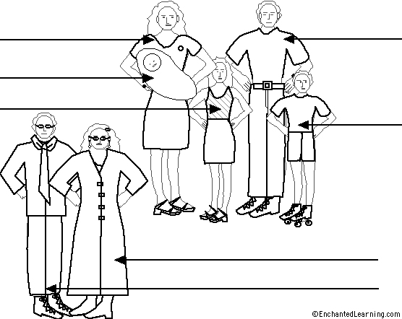

grandfather  ( grandpa )  father  brother  Andy( I ) | grandmother  ( grandma )  mother  sister  baby

Class(班級)： Number (座號) ： Name(姓名) ：
【學習單2】 My family小書
參考字彙: worker工人 businessman生意人 house keeper家管 policeman警察
nurse 護士 soldier 軍人 babysitter看顧孩子者 accountant會計人員

A brief content of the curriculum

Unit 1. My family

Focus on family members and their profession
Teach the way to introduce one’s family members. e.g. “ This is _______ .”
And the way to ask someone we would like to know about. e.g. “ Who is he/ she?”

Unit 2. How old is he?
Focus on numbers ( 1—50 )and the age of the family members:
Teach the way to ask someone’s age.
e.g. “How old are you?” I am ________ .
“ How old is he/ she?” He/She is ________.

Unit 3. He likes to swim.
Focus on the hobbies of the family members. The sentence pattern is as follows:
What does he/she like to do?
He/She likes to swim ( run, walk, read, sing, listen to the music. )

Review 1.
The teacher can integrate the previous lessons to give more information on one’s family member.
For example: This is my father.
He is a doctor.
He is 48 years old.
He likes to swim.

The Syllabus of Unit 1 ( The other Sessions )

Session 2
- Warm up: review the family members taught in session 1.
- Activities:
A. Divide students into groups. Ask student to show the picture an introduce
his/her family to the others
B. Students exchange picture and take turn to ask “ Who is he/ she?” by pairs
C. Assign students to write the vocabulary 3 times for each.
D. Play the game“ Hangman” to reinforce the spelling of those words.
- Let’s Sing : My Family( Tune: London Bridge Falling Down )
- Show “ Peter’s Family” and ask students about their professions.
5. Do the homework: See appendix 2.

Session 3
- Warm up: review the song and let them have a contest with groups.
- Activities:
A. Review the sentence patterns with Q&A. e.g. “ Who is he/ she?”
“He/ She is _______?”
B. Teach phonetic suffix –er and –ther.
C. Ask students: What do these words (father, mother, brother, sister, teacher, player, dancer) have in common? Work with them to sort.

Session 4
- Warm up: review the song and Phonics
- Activities:
A. Guide students to do workbook
B. The content of the workbook may include:
    - Listen and Circle ( Phonics )
    - Listen and Check ( words of profession )
    - Look and Copy (words of family members and profession)
    - Connect and Write (Q&A )
    - Listen and Number ( dialogue )
C. The teacher collects students’ workbooks to check and correct

