Teacher  教師 | 張 淑 慧 |  | Subject  科 目 |  | 英 文 科
Topic  主題 | Little Red Riding Hood (小紅帽)
Key words  主題單字 | ears、eyes、nose、mouth
Sentence Patterns  句 型 | His/Her ears are very long .  His/Her nose is very big .
Time  教學時間 | 40 分 | Teaching aids  教 具 |  | 電腦、單槍投影機、閃示卡、  句形條 、學習單
Teaching Focus  教學重點 | 本堂課教學重點為課文之重要句型介紹，課堂中透過小組句型仿造與發表，讓學童加深印象。複習活動另設計學習單，讓學童獨自仿作，增加練習機會。
Stage of lesson  教學流程 | The content of Activities  活 動 內 容 |  |  |  |  | Time  時 間
Warm up  引起動機 | - 介紹小紅帽人物角色。包括：  Little Red Riding Hood、grandmother、mother、big bad wolf、woodcutter  2. 老師帶學生唸課文。 |  |  |  |  | 5 分
Main Activities  主題活動 | - 老師提問，引導基本句型：  ※How does little red riding hood know the big bad wolf is not her grandma?  ※Does the big bad wolf’s ears/eyes look like grandma’s ears? Why?  ※ Does the big bad wolf’s mouth/nose look like grandma’s mouth? Why?  - 句型展示：  (1) 教師展示主題句型條，並配合單字練習。  His ears are very long .  His eyes are very big .  His mouth is very big .  His nose is very big .  (2)句型變化，造句練習。  Her eyes are very big .  - 分組練習：每排發下一張海報和角色圖卡，請小組利用句型造句，形容指定人物長相。  例：分配到野狼圖卡的小組，可仿造下列句子。  His ears are very long.  - 小組發表作品。 |  |  |  |  | 5 分  5分  10分  10分
Review  複習活動 | 發下學習單，並交待指定作業。 |  |  |  |  | 5 分
Grade： 4 Class： Name：

【Little Red Riding Hood】
- Label the Wolf
eye nose mouth
leg ear tail

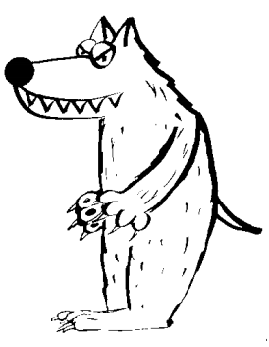
- Make Sentences
- The wolf’s ears are very long .
- The wolf’s are very .
- The wolf’s is very .
- The wolf’s is very .

Grade： 4 Class： Name：

【Little Red Riding Hood】
- Label the Wolf
eye nose mouth
leg ear tail

tail
eye
ear
nose
mouth
leg
- Make Sentences
- The wolf’s ears are very long .
- The wolf’s eyes are very big .
- The wolf’s mouth is very big .
- The wolf’s tail is very short .

Grade： 4 Class： Name：

【Little Red Riding Hood】
Label the Picture
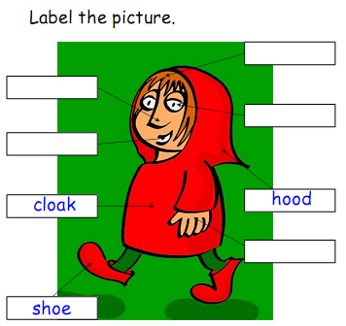
eye nose mouth
hair hand

