臺北市立龍山國民中學99學年度第1學期七年級英語科第3次定期評量試題卷
版本：佳音翰林iEnglish 範圍：Book 1 Unit 6~ Review (3)
注意： | 1.本試題卷共有4頁，請記得翻頁作答。
注意： | 2. 1-25為單一選擇題，請以2B鉛筆將各題正確答案的英文代碼劃在電腦卡上。
注意： | 3. 26-49為寫作題，請用藍、黑筆於答案卷上作答。

- 聽力測驗：下列各題，請依據錄音內容與問題選出一個正確或最佳的答案。每題唸兩次。
（每題2分，共20分）
I. 對話
1. A. He is studying at the park. B. He is talking to the girl. C. He is playing basketball.
2. A. She is playing games. B. She is dancing. C. She is singing with his uncle.
3. A. Her birthday is on Friday. B. She is helping the man. C. She is decorating the room.
4. A. 6:11. B. 5:49. C. 7:00.
5. A. It’s cloudy. B. It’s rainy. C. It’s snowy.
6. A. He is from London. B. He is cold. C. He is not warm.
7. A. Taipei Zoo. B. Taipei Park. C. Their house.
II. 短文：請依據此篇短文回答第八到十題。
8. A. Amy’s parents. B. Amy’s sister. C. Amy’s aunt.
9. A. It’s sunny and warm. B. It’s cool and sunny. C. It’s cold and rainy.
10. A. Meg is in the dining room. B. Amy is jumping rope.
C. Amy’s dad is playing with the hula hoop.

B、綜合測驗：下列各題，請依據題意選出一個正確或最佳的答案。（每題2分，共12分）
11. Boy: Girl: No, he is not flying a kite.
A. What is he doing? B. Are there a lot of people flying a kite?
C. Isn’t he flying a kite? D. What about flying a kite?
12. Girl: What time is it? Boy:
A. It’s at ten o’clock. B. It’s seven twenty.
C. Two weeks later. D. It’s Tuesday.
13. Girl: Boy: It is sunny and dry.
A. Is it cloudy and cold? B. Where is the umbrella from?
C. How many seasons are there in a year? D. How is the weather?
14. Mom: the turkey ? Dad: It’s for the welcome party.
A. What’s ; for B. How’s ; for C. What’s ; like D. Who’s ; for
15. Bobby is tired, and he is sleeping bed.
A. on B. at C. for D. in
16. There is a lot of in Keelung (基隆).
A. rain B. rains C. rainy D. raining

C、克漏字測驗：下列各題，請依據文意選出一個正確或最佳的答案。（每題2分，共10分）
I.
Joe is 17 a bike to school. He is 18 tired to get up early. It is eight twenty-nine, and he is late for school. What about his classmates? What are they doing? His classmates are 19 a nice speech now, and they are happy with that.

 speech演講

17. A. ride B. to ride C. rides D. riding
18. A. too B. to C. for D. about
19. A. listen to B. to listen C. listening to D. listening

II.
Jolin: What time is it?
Elva: It’s nine thirteen.
Jolin: Oh, no! I have to go now.
Elva: What’s wrong?
Jolin: SpongeBob SquarePants is palying 20 TV now. I watch it every night.
Elva: SpongeBob? The little yellow guy? It’s really funny.
Jolin: Yes, and it is my favorite.
Elva: All right. 21  have to 必須 wrong 不對的

20. A. in B. on C. in the D. on the
21. A. Nice to see you. B. You’re welcome. C. See you later. D. Thank you.

D、閱讀測驗：下列各題，請依據選文或所附圖表資料，選出一個正確或最佳的答案。
（每題2分，共8分）
I.
Dear John,

How are you? It is good to get your card. I love the words, and the picture on it is beautiful. Thank you so much.

It is warm here, and my cousin is swimming with my uncle now. The beach is really nice and quiet. My family and my uncle’s family come to the beach every weekend.

What about Taipei? Is it cold? Winter vacation is coming. Happy Chinese New Year to you! Remember, I am going to Taiwan in summer. See you then.
Your friend,
Anita in Hawaii 2011

 beach 海灘 vacation假期

22. What day is it?
A. Saturday. B. Monday. C. Tuesday. D. Thursday.
23. Which is true?
A. It is warm in Taipei. B. The letter (信) is sent (寄) from Hawaii.
C. Anita is in Taiwan. D. John is swimming with his cousin.

II.
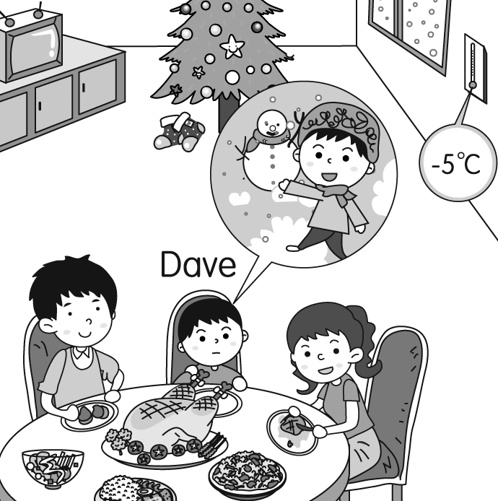

24. What is Dave thinking (想) about?
A. Having a party. B. Going shopping.
C. Playing with snow. D. Flying a kite.
25. Which is NOT true?
A. They are having a big meal (餐). B. The weather is very cold.
C. There are two boys and two girls at the table. D. It is snowing.

E、文意字彙：下列各題，請依據題意寫出適當的單字。（每題2分，共12分）
26. Kevin is his grandparents’ favorite g n.
27. There are sixty seconds (秒) in one m e.
28. We eat lunch at n n. 
29. Where are my g es? I need to read the book with them. 
30. Winter is a cold s n here.
31. It’s so windy today, and there are many l ves on the ground.

F、動詞形式：下列各題，請依據題意，填入適當的動詞形式。（每題1分，共8分）
32. Don’t (kick) a ball in the calssroom.
33. They are (read and write) at school.
34. Let’s (make) a snowman for Lisa.
35. Please (remember) this phone number.
36. What are you (wait) for?
37. Is Grandpa (write) a card to his friend?
38. Owen and Susan are (decorate) the living room.
39. Grandma is (do) tai chi on the balcony.

G、依提示作答（每題3分，共12分）
40. at / Helen’s / party / birthday / is / p.m. / three / forty-five (重組句子)
41. there. / is / Leo / Mary / his / walking / over / dog / with (重組句子)
42. How is the weather? (請用What …改寫)
43. Is it cool and dry? (請以又熱又濕回答)

H、翻譯（每題3分，共18分）
44. New York的秋天天氣如何？
45. 春天的時候，到處都有美麗的花朵。
46. 為了耶誕節準備的長襪在哪裡？
47. 看！William和Sophie在門口了。
48. 十一點半了。睡覺時間到了。
49. 星期三上午有一場烤肉會。
試題結束

試題結束
試題結束

