注意： | 1.本試題卷共有五頁，請記得換頁作答。
注意： | 2. 1~28題為單選選擇題，請以2B鉛筆將各題正確答案的英文代碼劃在答案卡上。
注意： | 3. 29~52題為書寫題，請在答案卷上作答。
- 聽力測驗
A. 選出聽到的單字。(每題1分，共3分)
- A. tree B. treat C. trick D. weak
- A. can B. pen C. ban D. ten
- A. brushes B. buses C. boxes D. watches

B. 選出聽到的句子。(每題1分，共2分)
- A. The sofa is near the door.
B. The koala is next to the door.
C. The koala is near the door.
D. The sofa is next to the door.
- A. Is your father in your bathroom?
B. Is your father in your bedroom?
C. Is your flower in your bathroom?
D. Is your flower in your bedroom?
C. 依據聽到的句子，選出與句意相符的圖片。(每題2分，共6分)

A  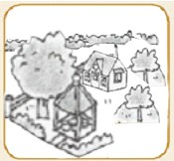 | B  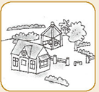
C  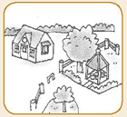 | D  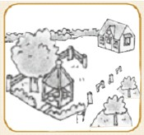

A  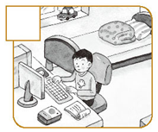 | B  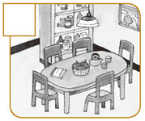
C  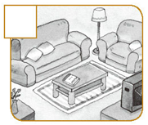 | D  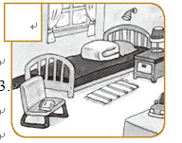

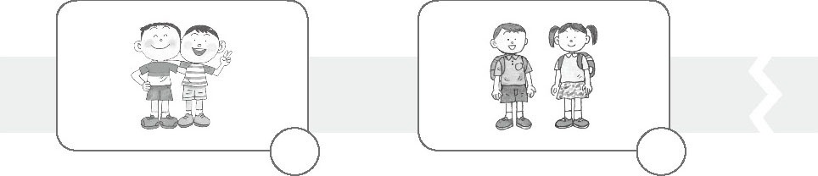  A.  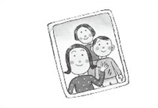 | B  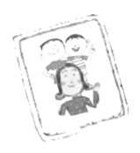
C  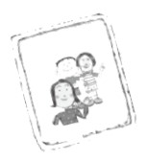 | D  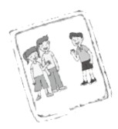

D. 依據聽到的內容，選出正確的回應句。(每題2分，共4分)
- A. My gift from Ted.
B. These are my classmates.
C. My notebooks.
D. No. They are my erasers.
- A. They are in the bear house.
B. Yes, there are some.
C. Yes, they are bears.
D. Let’s go to see the bears.

E. 依據聽到的內容，選出正確的答案。(每題1分，共2分)
- A. In the bedroom.
B. In the bathroom.
C. In the living room.
D. In the kitchen.
- A. There are three koalas.
B. They are three koalas.
C. There are two koalas.
D. They are two koalas

F. 依照聽到的短文內容，回答題組問題。(每題1分，共3分)
- A. A cat.
B. A dog.
C. A dog and a cat.
D. A desk.
- A. His sister is not at home.
B. She pretends(假裝成) a cat.
C. She is hiding (躲藏) behind the desk.
D. She is hiding under the table.
- A. No. The cat is too big.
B. No. There is no cat.
C. No. The cat is ugly.
D. Yes, he does.

- 文法選擇。(每題2分，共20分)
  - Allen: ________ it? Bill: An orange.
A. How’s B. Where’s C. Who’s D. What’s
  - They are _______.
A. Cathy’s birthday gifts B. Cathy birthday’s gifts
C. Cathy birthday gifts D. Cathy’s birthday gift
  - Come here, Frank and Susan! These are ____________.
A. our aunt’s gift B. gift from our aunts
C. our aunts’ gift D. gifts from our aunts
  - There are many birds _____ the tree.
A. in B. at C. on D. to
  - Emily, _______ the book.
A. opens B. to open C. not open D. don’t open
  - My parents are ____ the park.
A. to B. at C. on
  - Allen: Are there ______ pictures on the desk? Bill: Yes, there are ________.
A. some; any B. any; any C. any; some D. some; some
  - Allen: Are there two elephants behind the tree? Bill: No, _____.
A. it’s not B. there aren’t C. they aren’t D. it’s one
  - [on the telephone] [電話中] Allen: Where are you? Bill: I’m _____ Patty’s house.
A. not B. from C. to D. at
  - _____ MacDonald’s farm, he had some chicks. Cluck! Cluck! Cluck!
A. On B. In C. At D. To.
- Read the following passage and answer the questions. 閱讀下列短文並回答題組問題。
(每題2分，共6分)
I am Amy. Patty and I are now at Taipei Zoo. We are so happy today because there are so many cute animals here. Koalas, penguins, and kangaroos are my favorite animals. First, I want to see koalas. They are very cute because they always sleep. I want to see penguins, too. They have beautiful colors and walk in a very funny way. “Hey! Look over there, Patty!” I shout. There is a Formosan Black Bear house near the large trees. I pull Patty’s hand and say, “Let’s go there first.” She says, “All right! It’s one of my favorite animals.”
  - Why are Amy and Patty so happy?
A. They are at Taipei Zoo. B. They love to see many animals.
C. The animals have beautiful colors. D. The animals walk in funny ways.
  - What are NOT Amy’s favorite animals?
A. koalas B. Formosan Black Bears
C. penguins D. kangaroos
  - What are the animals Amy and Patty want to see first?
A. the koalas B. the penguins
C. the Formosan Black Bears D. the kangaroos
- 文意字彙。(每題2分，共20分)
  - ________ Please finish (完成) the homework of Unit 4 in your w________k today.
  - ________ There are three numbers, one, two, and three. And two is b_____n one and three.
  - ________ Allen: G_______s What? Bill: Uh ... a birthday gift from Uncle Fred.
  - ________ Please be q______t in the classroom, Cindy.
  - ________ Please don’t w_______ y, Meg. All your classmates are very nice.
  - ________ It’s dark. L_____s go home.
  - ________ That’s a z_____a, not a horse.
  - ________ Look! A l____e koala is behind its mother. It’s so cute.
  - ________ My dog loves to watch television. He is very i_____g.
  - ________ Wow! You can do this difficult(困難的) homework. You’re so s_____t.
- 將句子中的名詞皆改成複數，並改寫各句為複數句型。
(每題3分，共12分，錯一處扣1分)
例：There is an egg on the table. 改成 There are eggs on the tables.
  - There’s a wolf under the bus, not a dog.
  - This is a watch, and that is a pencil box.
  - A boy is under the tree.
  - This is a fly. That is a monkey. 改為複數句，而且合併成一句。
- 整句翻譯。(每題3分，共18分，錯一處扣1分)
  - 這是房間，而那是浴室。
  - Wendy每天早上喝綠茶。
  - 這台腳踏車是嬸嬸送的生日禮物。
  - 那些繪本不是Ted送的禮物嗎？不，不是。
  - 有一台粉紅色的機車在Patty家前面。
  - 動物園裡有幾隻河馬呢？
- 依圖提示填空。(每格1分，共4分)
There is a bird on the 49 50 .  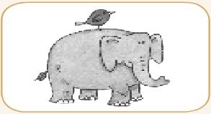 | There are five 51 52 the tree.  