台北市立龍山國中98學年度第二學期九年級英語科第2次定期評量試題卷 1
版本:康軒 考試範圍: 第六冊L4- Review
第一部分: 聽力測驗 (共10分)
注意： | 1.本試題卷共有六頁，請記得翻頁作答。
注意： | 2. 1-25題為單一選擇題，請以2B鉛筆將各題正確答案的代碼劃在答案卡上。
注意： | 3. 26-45題，請在答案卷上作答。
本測驗共有三大題，每一小題都會唸兩次，請同學們注意聽，仔細作答。
- 請仔細聽廣播中的句子，並將最能符合圖意的句子代碼劃在答案卡上。(每題2分，共6分)
Q1 Mrs. White Q2 Miss Lin Q3 North↑
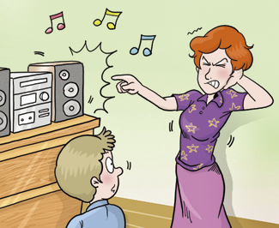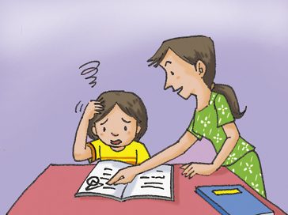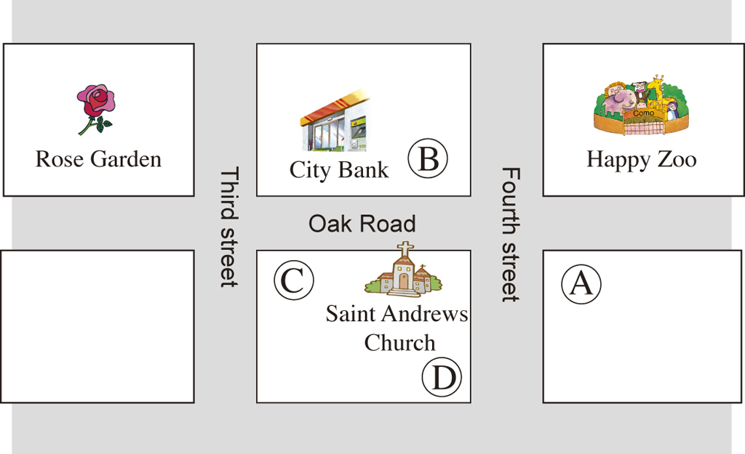

- 根據以下表格，聽廣播中的問題，選出最適當的答案。(每題2分，共2分)
Q4
Happy Holiday Tour
Two- Days Tour :
Taichung
Science Museum
Free science classes for children (Under 12 years old)
Price:
Adult | NT$700/ one person；  NT$1,000/ two people
Children (Under 12 years old) | NT$300/ one person
If you want to join this tour, please call 2356-4789. (Day)
0956789067. (Night)

- 聽廣播中的文章與問題，選出最適當的答案。(每題2分，共2分)
Q5

第二部份: 綜合測驗(共90分)
一、語法與字彙測驗 (每題2分，共14分)
6. Lisa: Sandy is always on time, but she is twenty minutes late today. Where’s she?
Bob: Look! __________
(A) Here is your watch. | (B) Here comes Sandy. | (C) Here you are. (D) Here he comes.
7. Sam used to live far from his office. It __________ him almost one hour to go to work then.
(A) costs | (B) cost | (C) takes | (D) took 【尚有試題】
8. John: It’s quite dark here. Why not __________? Amy: Sure. 2
(A) turn on the light | (B) turn off the light | (C) give it up | (D) put it on
9. No matter __________, we should respect their ideas and feelings.  respect 尊重
(A) how interesting people around us were (B) what people around us did
(C) how different people around us are (D) why people around us said so
10. Turandot , __________ is one of the famous operas, was played in Taichung on March 27 and 28.  Turandot 杜蘭朵公主 opera 歌劇
(A) which | (B) who | (C) whether | (D) whose
11. These boxes are too small. I think I need to get bigger __________ where I can put everything.
(A) one | (B) ones | (C) it | (D) them
12. There is a market ____________ to our house. My family can walk there for only three minutes, and it is convenient for us to buy vegetables and fruits there.
(A) near | (B) between | (C) close | (D) far

二、克漏字測驗 (每題2分，共12分)
【A】
Sara: Are you using Facebook with your cell phone?
Mark: Right. It’s truly a cool cell phone which can take pictures, surf the Internet, play music…, (13)
Sara: Where did you buy it?
Tony: I got it in a computer store where I took my broken notebook to be fixed.
Sara: A computer store?
Mark: At first, I didn’t plan to buy the cell phone. It was on sale, and it was almost 60% off, so I decided to buy it.
Sara: Do you mean (14) ?
Mark: Exactly. I did it without careful thinking. By the way, these days I checked the special
sale on the Internet and I found I-Pod is worth buying. I’m going to (15) .
Sara: Well, just a friendly reminder. Use money wisely and buy the things you really need.
Mark: You’re right. Thank you. I’ll think about it.

13. | (A) you can say that again. | (B) you did a great job.
 | (C) believe in yourself. | (D) you name it.
14. | (A) you sold it on the Internet. | (B) you thought about it for a long time.
 | (C) you bought it by chance. | (D) you got it in cash.
15. | (A) put it on my shopping list | (B) give it up and sell it
 | (C) save money on it | (D) know more about it

 fix 修理 exactly 的確是 worth 值得 reminder 提醒

【尚有試題】

【B】 3
People nowadays are so busy that almost each of them is under great pressure. It is important to learn how to relax. Here is a story about a person who successfully releases pressure and has a happy life. Take Ted for example, he (16) day and night to run his business ten years ago. Day by day, he started to be thinner and thinner. He thought becoming thinner was no big deal. Also, he believed he (17) a rich man some day. However, nothing got well with him. He had serious problems like a stomachache and a headache. He went to see a doctor and the doctor told him to do exercise, listen to music and talk to people. By following the tips, he succeeded in relaxing himself. Surprisingly, he (18) more energetic since then. In this way, he can do his job better. He realizes that there’s nothing important than a balanced life, and he is willing to share his successful experience with others.

16. | (A) spend | (B) pay | (C) cost | (D) take
17. | (A) bigger | (B) worse | (C) better | (D)
18. | (A) To follow | (B) Following | (C) Follow | (D) Followed
19. | (A) a picture | (B) a break | (C) a look at | (D) medicine
(5) Do eyes exercise every day.
The eyes are the soul of the windows. We should take good care of them.

 pressure 壓力 release 釋放 relax 放鬆 no big deal 沒關係 balanced 平衡的

16. | (A) work | (B) works | (C) worked | (D) is working
17. | (A) is | (B) was | (C) has been | (D) would be
18. | (A) was becoming | (B) has become | (C) will become | (D) became

- 閱讀測驗(每題2分，共14分)
【A】 House Rental
House A
＊ Thirty-minutes drive to downtown.
＊ Five bedrooms, two bathrooms, a living room, and a garden.
＊ NT$12,000/one month. (You have to pay your own utility fee.)

House B
Free shuttle bus to downtown.
A living room, two bedrooms and two bathrooms.
NT$8,000/ one month. (Utility fee is included. You have to pay
NT$500/ one month for the security fee.)

Apartment A
Ten-minutes walk to Taipei Main Station.
One bedroom and one bathroom.
For students only.
NT$6,000/ one month. (Utility fee is included.)

Apartment B
Near the City Library and the City Art Center.
One living room, two bedrooms and one bathroom.
No pets.
NT$11,000/one month. (You have to pay your own utility fee.)

 rental 出租 utility fee 水電費 shuttle bus 接駁車 include 包含 security fee 公共安全費 4
19. | Mr. and Mrs. Lin work in downtown. They want to live far from it, but they do not have a car.  How much do they have to pay for the place they will most likely choose?   most likely 最有可能
 | (A) NT$12,000. | (B) NT$8,000. | (C) NT$8,500. | (D) NT$6,000.
20. | Which is NOT true?
 | (A) Mary is a student who takes classes near Taipei Main Station. Apartment A is good for her.
 | (B) There are six people in Mr. Li’s family. He owns a car. House A is the one he may choose.
 | (C) Lily and Lisa think that living safely is the most important thing. House B is good for them.
 | (D) Sam likes reading and keeps one dog and one cat. Apartment B is the best one for him.

【B】
Global warming is a serious problem which is widely talked about all over the world. To deal with this problem, the world has been trying their best to tell people how to protect Mother Earth. Taiwan is no exception.
Plus or Minus 2 Degrees Celsius is a popular movie that points out the problems people in Taiwan are facing and how they can stop them from becoming worse. Sisy Chen, the producer, says that Taiwan would be one of the countries that are affected by the climate change. For example, several low-lying places would be under water. How terrible it is! Therefore, Sisy Chen hopes people can eat more vegetables and less meat. The reason is that keeping the livestock makes more carbon dioxide, which is harmful. Also, she says that green energy technologies can help families save up 70 percent in electricity costs.
The beautiful island, Taiwan, is the place where we live and grow. Taiwan is like our mother, who brings us up. Now Taiwan is having problems that hurt her health. Let’s do our part to protect it!
ant

 global warming 全球暖化 producer 製作人 affect 影響 climate 氣候 low-lying 低窪的 livestock 家畜 carbon dioxide 二氧化碳

21. What is the best title for the article?
(A) Watch the Movie, Plus or Minus 2 Degrees Celsius.
(B) Save the Earth. Save Taiwan.
(C) Buy More Vegetables, Less Meat.
(D) Green Technology Changes Our Lives.
22. According to the reading, which is NOT true?  according to 根據
(A) Some places that are low-lying places would be below water.
(B) Using green energy technologies saves much money.
(C) Each of us in Taiwan should do something good and helpful to this island.
(D) People can eat more vegetables because they are cheaper. 【尚有試題】

【C】 5

(In a talk show.)
Host: Ellen Guest 1(G1) Guest 2(G2) Guest 3(G3) Guest 4(G4)
…………………………………………………………………………………………………………
Host: Welcome to Ellen’s Talk Show. Do you have children? What do you think about having children? Some people think it’s a wonderful thing; however, some see it as a burden.
Let’s share our ideas.
G1: There are no words that can tell how great it is to raise children. By teaching them, I have to
learn how to help them and their smile cheers me up. This makes me grow and have a sense of
achievement.
Host: Would you like to give us an example?
G1: Sure. I still remember the first time my little son stood up and walked. What he did truly
touched me a lot. But before that, he fell down so many times and I tried my best to help him.
Host: It seems you really enjoy getting along with children. How about other guests?
G2: Raising children costs a lot of money. Also, I think it would be hard for me to have my own
free time.
Host: Right. One of my friends says that she is very busy at work, but she still has to send her children to school early in the morning. This makes her tired.
G3: Raising children is rewarding. It’s important to have people, especially your children with you
when you are old. You don’t want to be lonely at that time, do you?
Host: You can say that again. I know some people who are over sixty really enjoy their life with their children and grandchildren.
G4: Well, I’m afraid that the environment is not good enough for our children. For example, global warming might hurt their life.
Host: Thank you for all the great ideas. If you have different ideas, please go to our website www.ellen talkshow.com to write down your ideas.
 burden 負擔 a sense of achievement 成就感 rewarding 有回饋的
23. What does to raise mean in line 4?
(A) To look at. (B) To take care of. (C) To listen to. (D) To watch out.
24. What does This mean in line 14?
(A) Sending children to school. (B) Falling down for many times.
(C) Helping children to walk. (D) Getting along with children.
25. According to the talk show, which is true?
(A) The second guest feels that having children is good because they help parents to make money.
(B) The third guest says that having children is good because it does not cost any money at all.
(C) The first guest thinks parents learn a lot and get much happiness from growing children.
(D) The fourth guest finds that the environment is getting better and better, so it’s a good idea to have children.  environment 環境 【尚有試題】
四、文意字彙 (每題2分，共20分) 6
26. Betty does well at school because she has good studying h ts. She never forgets to preview before class and review after class.
27. John and May are getting married next month. Many of their friends will go to their w g.
28. Mary: Remember to put the milk you haven’t finished into the r r, or it may become sour.
Ken: Sure. Thanks.  sour 酸的
29. Jeff likes toys a lot. He has been dreaming about owing a toy f y since he was a little boy.
30. Leo: There is not enough s e on this form for me to write down my personal information. What can I do?
Teresa: You can write it on the back of the form.
31. People are e ged to keep early hours and do exercise to stay healthy.
32. Clerk: Is this an i l dress that meets your needs?  formal 正式的
Sally: Yes, this is the one that I’ve been looking for. I need a formal one to go to a party.
33. Our Home Econimics teacher teaches boys how to use n es to go with shirts and suits.
 Home Economics 家政
34. Lisa’s family go to c h to celebrate Christmas every year.
35. I’m so lucky to have such wonderful friends like you. I’ll cherish our friendship f r.
 cherish 珍惜
36. | People can do more things.  They use their time well. | (使用關係代名詞將兩句合併成一句。)
37. | Come to work on time. Don’t talk too long on the phone.  Bob’s boss wants him to do these things. | (以Bob’s boss wants…開頭，將兩句合併成一句。)
38. | I am not sure.  Did David finish his homework? | (以I am not sure…開頭，將兩句合併成一句。)
五、依提示作答 (每題2分，共10分)
39. Watching and thinking are important. (以It…改寫。)
40. Amanda was too happy to say anything. (用 so…that改寫。)

六、整句式翻譯 (每題4分，共20分，錯一處，扣1分)
41.他們將需要一些時間來想出如何解決這些困難的問題。
42.我想知道在往高速公路的路上是否有一座湖。
43.Peter相信努力是通往成功的人生的關鍵。
44.我姊姊上星期買的電腦可以儲存所有她所需要的資料。
45.我住在山上的祖父母不僅能呼吸新鮮的空氣而且欣賞美麗的風景。
【試題結束，請仔細檢查】

台北市立龍山國中98學年度第二學期九年級英語科第2次定期評量答案卷
______年______班______號 姓名：___________ 組別：______ 任課教師：___________
四、文意字彙：請根據提示的首尾字母寫出合乎句意的英語語詞(每題2分，共20分)
注意： | 1.本試題卷共有六頁，請記得翻頁作答。
注意： | 2. 1-25題為單一選擇題，請以2B鉛筆將各題正確答案的代碼劃在答案卡上。
注意： | 3. 26-45題，請在答案卷上作答。
26. |  | 27. |  | 28.
29. |  | 30. |  | 31.
32. |  | 33. |  | 34.
35.
五、依提示作答(每題2分，共10分)
36.
37.
38.
39.
40.
六、整句式翻譯(每題4分，共20分，錯一處，扣1分)
41.
42.
43.
44.
45.

臺北市立龍山國民中學九十八學年度第二學期九年級英語科第二次定期評量(聽力稿)
第一部分: 聽力測驗
本測驗共有兩大題，每一小題都會唸兩次，請同學們注意聽，仔細作答。
一、 請仔細聽廣播中的句子，並將最能符合圖意的句子代碼劃在答案卡上。
Q1
(A) | Mrs. White let her son dance with the music.
(B) | Mrs. White asked her son to turn on the radio.
(C) | Mrs. White wanted her son to turn off the radio.
Q2
(A) | No matter how hard the questions are, Miss Lin never helps her daughter.
(B) | No matter how difficult the questions are, Miss Lin always helps her daughter.
(C) | No matter how easy the questions are, Miss Lin always gives up helping her daughter.
Q3
(A) | Happy Zoo is to the east of City Bank.
(B) | Rose Garden is to the south of City Bank.
(C) | The church is to the north of City Bank.

二、根據以下表格，聽廣播中的問題，選出最適當的答案。
Q4 Which is true?
(A) John is eleven years old. He needs to pay for science classes in the Science Museum.
(B) It is nine o’clock in the morning. People can call 0956789067 for more information about the tour.
(C) Mr. and Mrs. Brown want to join the tour and they have to pay NT$1,000 for it.
Q5
George and Mary got married last month. They planned to live in Taipei after they got married because both of them worked there and they wanted to take care of Mary’s parents ,who lived in Taipei, too. Georg and Mary needed to find an apartment that was big enough for themselves, Mary’s parents and their pets to live in. However, after looking for some apartments for several days, they couldn’t find any apartment that met their needs. That was because the prices of the apartments in Taipei were all too high. Besides, the apartments they could buy were just too small. Therefore, George and Mary changed their mind. They planned to live in Tauyuan, where George’s parents lived and they could find cheaper and bigger apartments.
What problem did George and Mary have when they looked for apartments in Taipei?
(A) George and Mary are in a different city where Mary’s parents lived.
(B) The apartments they liked cost too much and were too small.
(C) George’s parents lived in Tauyuan.
龍山國中98學年度第二學期九年級英語科第2次定期評量答案
注意： | 1.本試題卷共有六頁，請記得翻頁作答。
注意： | 2. 1-25題為單一選擇題，請以2B鉛筆將各題正確答案的代碼劃在答案卡上。
注意： | 3. 26-45題，請在答案卷上作答。
1. | C | 2. | B | 3. | A | 4. | C | 5. | B | 6. | B | 7. | D | 8. | A | 9. | C | 10. | A
11. | B | 12. | C | 13. | D | 14. | C | 15. | A | 16. | C | 17. | D | 18. | B | 19. | C | 20. | D
21. | B | 22. | D | 23. | B | 24. | A | 25. | D
四、文意字彙：請根據提示的首尾字母寫出合乎句意的英語語詞(每題2分，共20分)
26. | habits | 27. | wedding | 28. | refrigerator
29. | factory | 30. | space | 31. | encouraged
32. | ideal | 33. | neckties | 34. | church
35. | forever
五、依提示作答 (每題2分，共10分)
36. | People who (that) use their time well can do more things.
37. | Bob’s boss wants him to come to work on time and not to talk too long on the phone.
38. | I am not sure whether (if) David finished his homework (or not).
39. | It is important to watch and (to) think.
40. | Amanda was so happy that she couldn’t say anything.
六、整句式翻譯 (每題4分，共20分，錯一處，扣1分)
41. | They will (are going to) need some time to figure out (think about) how to solve these difficult (hard) problems.
42. | I want to know (wonder) whether (if) there’s a lake on the way to the highway (freeway) (or not).
43. | Peter believes(that) working hard (hard work) is the key to successful life.
44. | The computer (which, that) my sister bought last week can (could) save (hold) all the information she needs(needed).
45. | My grandparents who live in the mountains (living in the mountains) can not only have (the) fresh air but also enjoy (the) beautiful scenery.

