臺北市立龍山國中98學年度第2學期九年級英語科第1次定期評量試題卷
1
版本:康軒 考試範圍: 第六冊L1-L3
第一部分: 聽力測驗 (共10分)
注意： | 1.本試題卷共有五頁，請記得翻頁作答。
注意： | 2. 1- 25題為單一選擇題，請以2B鉛筆將各題正確答案的代碼劃在答案卡上。
注意： | 3. 26- 45題，請在答案卷上作答。
本測驗共有兩大題，每一小題都會唸兩次，請同學們注意聽，仔細作答。
- 請仔細聽廣播中的句子，並將最能符合圖意的句子代碼劃在答案卡上。(每題2分，共6分)
Q1 Q2 Q3
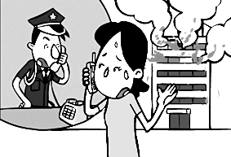
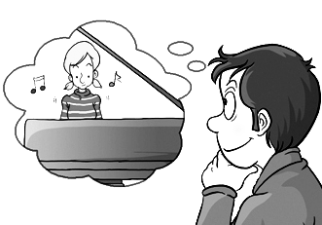
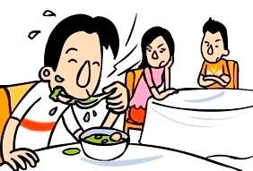

- 聽廣播中的文章與問題，選出最適當的答案。(每題2分，共4分)
Q4 (A) (B) (C)
 1987
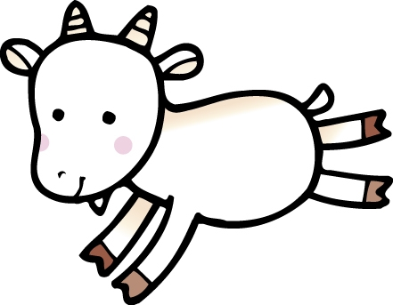2003
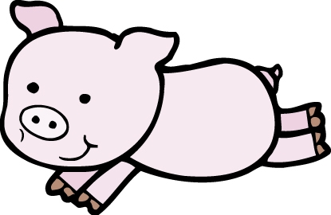1995

Q5

第二部份: 綜合測驗(共90分)
一、語法與字彙測驗 (每題2分，共12分)

6. Amy: Can I your eraser? I left mine at home.
Bob: No problem. Here you are.
(A) lend | (B) borrow | (C) pay (D) make
7. Allen: You look as thin as before. How did you make it?
Ben: Riding a bike every day makes me weight.
(A) lose | (B) loses | (C) lost | (D) to lose
8. Don’t go out your parents come back. Mr. White will come and see the house.
(A) since | (B) until | (C) if | (D) that
9. Mary’s mother wonders .
(A) if she have to do the dishes or not (B) what should she buy at the market
(C) when did she clean the room (D) how she will decorate the room
10. The Becks are not sure Tom has gone to New York last night.
(A) what | (B) where | (C) whether | (D) whose
11. John caught a bad cold last night. He was weak eat anything today.
(A) very; so | (B) enough; to | (C) too; to | (D) so; that

二、克漏字測驗 (每題2分，共14分)
2
【A】
Mark: You are late. What happened?
Tony: Sorry, my car didn’t work this morning. (12)
Mark: What would you do about it?
Tony: I went by MRT. By the way, (13)
Mark: You may ask Timmy Wang. He is good at fixing the car.
Tony: Thank you for your advice. I’ll call him. In fact, I think it’s better to take the MRT than to drive because it can save more energy.
Mark: (14) We should do our part to save our Mother Earth. Energy crisis and global warming are
two of the most serious problems that we have to solve right now.

12. | (A) I don’t know how to ride. | (B) Nobody told me when to leave.
 | (C) I have no idea who is the best man to ask for help. | (D) I haven’t planned where to go.
13. | (A) do you know who can fix the car for me? | (B) do you understand what I mean?
 | (C) are you sure whether I am late or not? | (D) can you guess who will come in next?
14. | (A) Two heads are better than one. | (B) Cheer up! It’s not the end of the world.
 | (C) You will do a better job next time. | (D) You can say that again.

& crisis 危機

※ instead代替 crisis 危機 waste 浪費

【B】
More and more students (15) most of their free time watching TV or playing computer games. That is why their eyesight becomes (16) , what is more, they wear glasses. (17) these tips, and you can have good eyesight.
- Keep a correct posture when you study.
- Take (18) every 30 or 40 minutes when you study.
(3) Make sure if there is enough light in your room.
(4) Eat a lot of fruit and vegetables every day.
(5) Do eye exercise at least for 5 minutes every day.
The eyes are the windows of the soul, so we should take good care of them.

16. | (A) spend | (B) pay | (C) cost | (D) take
17. | (A) bigger | (B) worse | (C) better | (D)
18. | (A) To follow | (B) Following | (C) Follow | (D) Followed
19. | (A) a picture | (B) a break | (C) a look at | (D) medicine
(5) Do eyes exercise every day.
The eyes are the soul of the windows. We should take good care of them.

15. | (A) take | (B) spend | (C) cost | (D) pay
16. | (A) bigger | (B) less | (C) better | (D) worse
17. | (A) To follow | (B) Following | (C) Follow | (D) Followed
18. | (A) a picture | (B) a break | (C) a walk | (D) medicine
、閱讀測驗(每題2分，共14分)
【A】

& posture姿勢 soul 靈魂

※ instead代替 crisis 危機 waste 浪費

三、閱讀測驗(每題2分，共14分)
3
【A】
Dr. Wu’s Clinic
Name: Dick Lee Date: 7 / 8 / 2009
Birthday: 6 / 5 / 1996
Problem: Stomachache
Directions:●6-15 years 1 spoon
●Adults 2 spoons
●Take with only warm water after meals.
● Put the medicine in a cold and dry place.
● Keep the medicine away from children.

& clinic診所 prescribe開藥方
19. | How many spoons of the medicine should Dick take a day?
 | (A) 1. | (B) 2. | (C) 3. | (D) 6.
20. | Which is NOT true?
 | (A) The medicine is prescribed by Dick.
 | (B) The medicine should be taken after dinner.
 | (C) The medicine shouldn’t reach by children easily.
 | (D) The medicine can’t be taken with iced water.
【B】

An ordinary old woman, Shu-Ju Cheng, becomes as famous as three owners of big companies
because she has donated over NT$ 10000,000 to those in need in the past twenty years. A library of
a school was even named after her.
When she was asked why she did all these, she said,“When I was a little girl, the school teacher
helped my family. From then on, I made up my mind to help others as long as I am able to give.”
The woman who has sold vegetables at the market for forty years still lives a simple life. She
hopes she will be able to donate more money to the poor. An old woman , like her, can do such a great
thing. How about you?
& ordinary普通的 company公司 donate捐贈 helpless無助的
21. What is the best title of the article?
(A) The story of a library.
(B) A story of the rich.
(C) A woman with a giving heart.
(D) A helpless woman.
22. Which is true about the woman?
(A) She has donated much money for forty years.
(B) She used to sell vegetables at the market.
(C) An owner of a big company helped her when she was young.
(D) She will keep donating money in the future.
【C】
4

(A) (B) (C) (D)
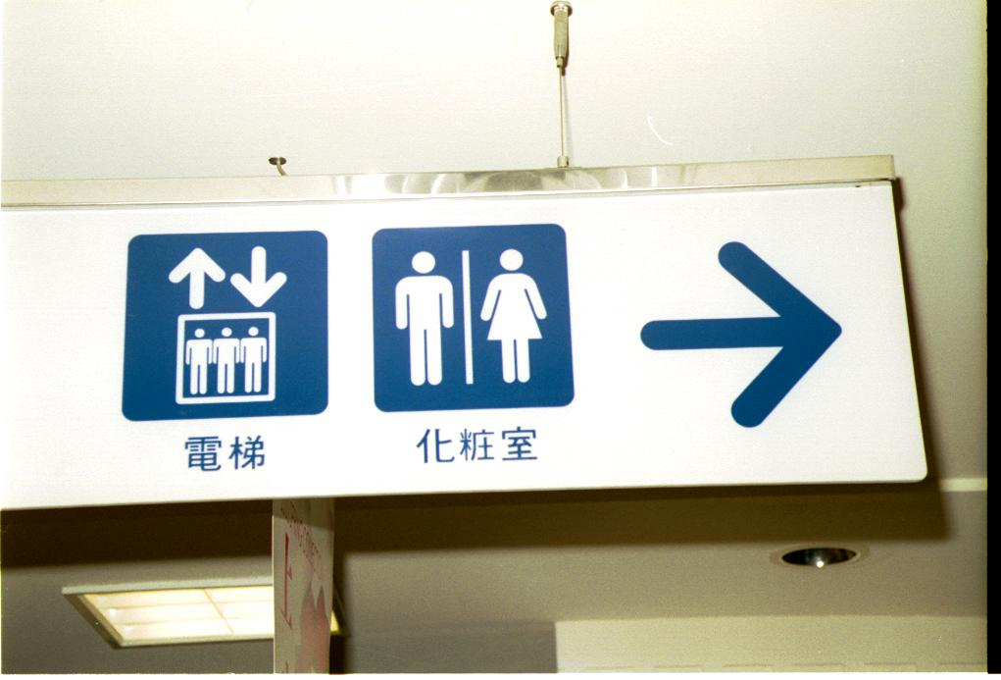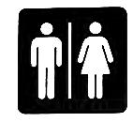
23. Mary went to Joy Department Store to shop her dad for a birthday present. When she came there,
she didn’t know which floor to buy a present. Which sign could she see to ask for information?



【D】

Haiti, a poor country, was struck heavily by a strong earthquake on January 12th. In fact, a serious one hit Taiwan eleven years ago. Unfortunately, it is not possible for scientists to forecast when and where an earthquake will hit. Therefore, it is important to follow safety tips.
When an earthquake hits, open the door or windows first. It is also a good idea to stay in the corner of a room because it is usually the safest place to hide. Use your hands to protect your head. Remember to stay away from windows because broken glasses may be dangerous. As soon as the quake stops, it is time to move to an open area. Be sure to watch out for shaking buildings or flying objects. Don’t use the elevator because the power may be cut off. Besides, you had better prepare a backpack which has a flashlight, some batteries, drinking water, a raincoat, and some money in it.
In a word, you will be safer if you are well-prepared for an earthquake. Be sure to follow safety tips
before hand.
should learn earthquake drills in daily life

& unfortunately不幸地 forecast 預測 area地區 elevator電梯 drill訓練 hide藏匿 breathe呼吸

24. What is the article mainly about?
(A) Earthquake drills should be part of daily life for everyone.
(B) There was a strong earthquake happened in Taiwan.
(C) We should help the people in Haiti rebuild their life.
(D) Scientists can’t forecast when the earthquake will hit in the near future.
25. Which is true?
(A) Staying in the center of the room is safer than staying in other places in the building.
(B) Run out of the building when the earthquake hits.
(C) Hide yourself beside the window to breathe fresh air.
(D) There should be a flashlight and batteries in the backpack for emergency.

& emergency 緊急

四、文意字彙 (每題2分，共20分)
5
26. Richard Caldera is a famous m n. He is good at playing the piano.
27. Tim: I feel t y now. Is there anything to drink?
Amy: There’s some juice in the kitchen. Here you are.
&district 區
28. Every student should be h t when they take a test.
29. The movie“Monga” not only caught many people’s eye but also let them have a great i t in Wangha
district.
30. Taipei International Flora Exposition will be held in November. It is a good way to let m ns of people around the world know where Taipei is.
31. Among the twelve animal signs, d n is the only one that hasn’t been seen it in the world.
32. Teacher: Look at the picture. What s e is it?
Susan: It’s a heart.
33. Every year, thousands of f ers from all over the world visit Sun Moon Lake to enjoy its beautiful
scenery.
34. Tammy: The telephone b l is ringing. Can you answer it for me?
Max: Sure. It’s Sara.
35. Heat the cookies at 180 d es for 5 minutes, and then make a cup of coffee for afternoon tea.

36. | Allen asked Tina a question.  Whose umbrella is this? | ( 用間接問句將兩句合併成一句 )
37. | I am not sure about it.  Did Carol go to the party the day before yesterday? | ( 將兩句合併成一句 )
五、依提示作答 (每題2分，共10分)
38. Mike didn’t know where he can park his car. ( 用不定詞片語改寫 )
39. It / surprising / Jack / sick / last week ( 依提示造句 )
40. The box was too heavy for me to move. ( 用 so…that改寫 )

六、整句式翻譯 (每題4分，共20分，錯一處，扣1分)
41.這個班長將邀請他所有的好朋友去他的生日派對。
42.屬雞的人誠實、有禮貌、但是懶惰是真的嗎?
43.你可以敎我們如何製作幸運籤餅嗎?
44.我想知道她以前是否養過貓。
45.布朗先生一家人還沒決定要去哪裡過寒假。

【試題結束。】

臺北市立龍山國民中學98學年度第2學期九年級英語科第1次定期考査(聽力稿)
第一部分: 聽力測驗
本測驗共有兩大題，每一小題都會唸兩次，請同學們注意聽，仔細作答。
一、 請仔細聽廣播中的句子，並將最能符合圖意的句子代碼劃在答案卡上。
Q1
(A) | The soup is too hot for the man to eat.
(B) | It’s not polite to make a lot of noise when you eat soup.
(C) | Be sure to wash your hands before you make soup.
Q2
(A) | I wonder whether the girl can play the piano or not.
(B) | The man wants to know if the girl can dance well.
(C) | The boy has no idea whether the girl will like the dress.
Q3
(A) | The police officer asks the woman to stop smoking.
(B) | The police officer asks the woman where the fire is.
(C) | The woman asks the police officer who took her car away.

二、聽廣播中的文章與問題，選出最適當的答案。
Q4 Tina is a Goat person. Which year was she born in?
(A) In 1975.
(B) In 1983.
(C) In 2003.

Q5
Mr. White moved to a small town in Tainan last year. He used to be a successful
businessman in Taipei. He worked hard to make a lot of money, but he didn’t take good care of his body until he got very sick. He went to see a doctor. The doctor told him he should change his bad living habits right away, or he would die soon. Mr. White decided to move to the country and started a new way of life. He kept early hours, ate healthy food, and took exercise every day. Now he is healthy again, and he realizes nothing else is more important than health.

Why did Mr. White move to Tainan?
(A) To make money.
(B) To see a doctor.
(C) To start a new way of life.

臺北市立龍山國中98學年度第2學期九年級英語科第1次定期評量答案卷
______年______班______號 姓名：___________ 組別：______ 任課教師：___________
四、文意字彙：請根據提示的首尾字母寫出合乎句意的英語語詞(每題2分，共20分)
注意： | 1.本試題卷共有五頁，請記得翻頁作答。
注意： | 2. 1-25題為單一選擇題，請以2B鉛筆將各題正確答案的代碼劃在答案卡上。
注意： | 3. 26-45題，請在答案卷上作答。
26. |  | 27. |  | 28.
29. |  | 30. |  | 31.
32. |  | 33. |  | 34.
35.

五、依提示作答(每題2分，共10分)
36.
37.
38.
39.
40.

六、整句式翻譯(每題4分，共20分，錯一處，扣1分)
41.
42.
43.
44.
45.

【做答完畢，再檢查一下喔!】

龍山國中98學年度第2學期九年級英語科第1次定期評量答案卷
______年______班______號 姓名：___________ 組別：______ 任課教師：___________
四、文意字彙：請根據提示的首尾字母寫出合乎句意的英語語詞(每題2分，共20分)
注意： | 1.本試題卷共有五頁，請記得翻頁作答。
注意： | 2. 1- 25題為單一選擇題，請以2B鉛筆將各題正確答案的代碼劃在答案卡上。
注意： | 3. 26 - 45題，請在答案卷上作答。
1. | B | 2. | A | 3. | B | 4. | C | 5. | C | 6. | B | 7. | A | 8. | B | 9. | D | 10. | C
11. | C | 12. | C | 13. | A | 14. | D | 15. | B | 16. | D | 17. | C | 18. | B | 19. | C | 20. | A
21. | C | 22. | D | 23. | D | 24. | A | 25. | D
26. | musician | 27. | thirsty | 28. | honest
29. | interest | 30. | millions | 31. | dragon
32. | shape | 33. | foreigners | 34. | bell
35. | degrees
五、依提示作答((每題2分，共10分)
36. | Allen asked Tina whose umbrella this is.
37. | I am not sure whether/if Carol went to the party the day before yesterday ( or not ).
38. | Mike didn’t know where to park his car.
39. | It is surprising that Jack got/was sick last week.
40. | The box was so heavy that I couldn’t move it.
六、整句式翻譯(每題4分，共20分，錯一處，扣1分)
41. | The class leader will invite all of his good friends to his birthday party.
42. | Is it true (that) Rooster People are honest, polite but lazy?
Is it true (that) people who are born in the Year of the Rooster are honest, polite
but lazy?
43. | Can you (please) teach us how to make fortune cookies?
44. | I want to know whether/if she used to keep a cat?
45. | The Browns haven’t decided where to spend the winter vacation.

