範圍：翰林國中英語第三冊Unit 7~ Review (3) 考試時間：50分鐘
臺北市立龍山國民中學98學年度第1學期八年級英語科第3次定期評量試題卷
注意： | 1.本試題卷共有六頁，請記得換頁作答。
注意： | 2.1-29題為單選選擇題，請以2B鉛筆將各題正確答案的英文代碼劃在答案卡上。
注意： | 3.30-51題為手寫題，請在答案卷上作答。
第一部份: 聽力測驗（每題2分，共16分）
本測驗共有三大題，每一小題都會播放兩次，請同學們注意聽廣播，仔細作答。
一、請根據聽到的對話，選出正確的敘述。
- (A) David will go to the supermarket five minutes later.
(B) There is a new theater across from the supermarket.
(C) The new theater is ten blocks away from their school.
- (A) Alice is going to try on the blue jeans.
(B) The blue jeans don’t look good on Alice.
(C) Alice spent a lot of money on the blue jeans.
二、根據聽到的內容與問題，選出正確的答案。
- (A) Daniel. (B) Susan. (C) Lisa.
- (A) She asks foreigners.
(B) She writes letters to her friends.
(C) She uses a dictionary.
- (A) He enjoys talking with foreigners.
(B) He enjoys singing English songs.
(C) He enjoys reading English newspapers.
三、根據菜單及聽到的問題，選出正確的答案。
(NT$)
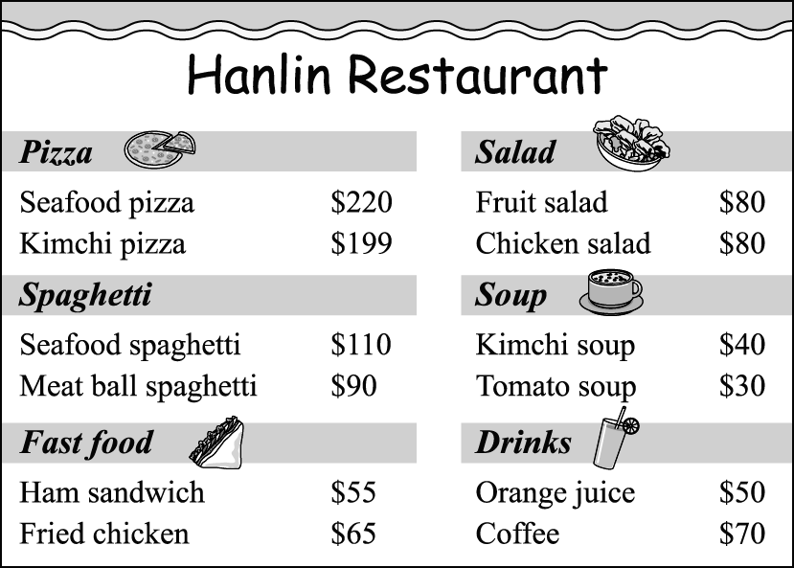 kimchi 泡菜

- (A) One. (B) Two. (C) Three.
- (A) Orange juice. (B) Coffee. (C) Fried chicken.
- (A) NT$100. (B) NT$110. (C) NT$120.
第二部份: 綜合測驗(共84分)
一、文法選擇(每題1分，共8分)
9. Lucy: Are you going to the bakery later?
Bob: . I have a piano class at 7 P.M.
(A) Yes, I won’t. |  | (B) Yes, I was.
(C) No, I don’t. |  | (D) No, I’m not.
10. My mother usually the whole weekend cleaning up the house.
(A) uses | (B) spends | (C) costs | (D) takes
11. Will Billy go windsurfing ?
(A) three hours ago | (B) every day
(C) this week | (D) last summer
12. Tim: Why don’t you go to Linda’s party?
John: I’d like to, but I can’t. There an important test next Tuesday.
(A) will have | (B) will be
(C) was | (D) has
13. Playing computer games a lot of fun for young children.
(A) have | (B) is
(C) has | (D) are
14. Mark: did it cost you to eat in the restaurant last night?
Sharon: About NT$600.
(A) How much | (B) How many
(C) How often | (D) How long
15. Lucas: The cake in the coffee shop is delicious.
Emma: .
(A) I agree. It looks good on you. (B) You can say that again. I enjoy it a lot, too.
(C) I think so. It’s my favorite color. (D) Let’s do it next time.
16. Jay: I’m hungry. Let’s get something to eat.
Mary: __________
Jay: Good idea.
(A) How about the gray shorts? (B) Yes, I’m full.
(C) I’d like a cup of coffee. (D) Why not order some pizza?

- 克漏字測驗 (每題2分，共10分)
【A】
Jack is going to see his friend, Linda, in the hospital this afternoon. One of his friends, Mark, is now at his place. They will go to the hospital together.
Mark: Are you ready to go now, Jack?
Jack: 17 I have to leave my parents a note.
Mark: Don’t they know that you’re visiting Linda in the hospital?
Jack: No, they don’t. I must also let them know that 18 to a basketball
game after we visit Linda. What time will the game finish?
Mark: 19
Jack: Then I’ll ask my father to pick us up from the gym at 10:15 P.M.
Mark: OK.  note便條
17. (A) Let’s go. (B) Time is up. (C) That’s right. (D) Wait a minute, please.
18. (A) we go (B) we went (C) we’ll go (D) we won’t go
19. (A) At about 10:00 P.M. (B) It took us two hours to watch the game.
(C) For three hours. (D) We’re late for the game.
【B】
Peggy is a happy girl.
She likes playing in the garden.
She is never 20 playing there.
She can play there for hours.
On rainy days, she takes an umbrella with her.

She likes the garden in the rain.
21 in the garden in the rain is great fun for her.
In the rain, she sees a different world.
Everything is clean and beautiful.
Peggy is happy.
She enjoys the garden, and she enjoys her childhood, too.
 childhood童年
20. (A) busy (B) tired of (C) good at (D) sure of
21. (A) Walks (B) Walk (C) Walking (D) Walked

三、閱讀測驗 (每題2分，共16分)
【A】
Sky Department Store

Winter Sale December 21~ January 20

NT＄1,200 →NT＄500 NT＄800→NT＄400 NT＄700→NT＄350 NT＄200→ NT＄100
- If you buy over NT＄1,200 in one day, you can get a pair of socks as a free gift.
- If you do not have time to come to the department store, please visit  over 超過
our website at www.skydepartmentstore.com to place your orders.
22. On Christmas Eve, Mark shopped at the department store and got a pair of socks as a free gift. What is he most likely to buy?  most likely 最有可能
(A) A sweater, a pair of jeans, and a hat. (B) Two pairs of jeans and a skirt.
(C) Two sweaters and a hat. (D) A sweater, two pairs of jeans, and a hat.
- Emily bought a sweater and two skirts at the department store on New Year’s Day. How much did
she save?
(A) NT＄550. (B) NT＄1,100. (C) NT＄1,400. (D) NT＄1,750.

【B】
Rose is talking to her classmate, Jack, in the classroom.
Rose: Hey, Jack. What did you put in the trash can?
Jack: Well, just some paper.
(Rose picks up the paper from the trash can.)
Rose: You should put it in the recycling bin over there.
Jack: OK. Let me put it in the bin.
Rose: You only used one side of the paper. Why don’t you use both sides of it? By doing this, you can save money and help our earth, too.
Jack: You’re right. The less paper we use, the fewer trees we cut down.
Rose: It rings the bell. My mother also says we have fewer and fewer natural resources on earth. Everyone has to do their part to protect Mother Earth. By the way, there’s a campaign, Saving Mother Earth, at Hope Park this weekend. Would you like to join it? If you go, you’ll get a
free shopping bag.
Jack: Yes, I’d like to.
Rose: How will you go there?
Jack: I’ll ask my father to drive me there.
Rose: How about riding a bike there together?
Jack: Great. It’s a good way to be friendly to the earth.

 bin 桶子 natural resource 天然資源 campaign 活動

25. Bob and Alice want to watch a movie after 9:00 p.m. Which theater can they go?



24. What does the word “it” mean in line 6 mean?
(A) The paper. (B) The trash can.
(C) The earth. (D) The recycling can.
25. What does the word “protect” in line 10 mean?
(A) To hurt. (B) To take care of.
(C) To celebrate. (D) To do something bad to.
26. According to the dialogue, which is true?  according to 根據
(A) “Saving Mother Earth” is a popular new song.
(B) People have to bring their own shopping bags to the activity.
(C) Rose told Jack to recycle paper.
(D) Jack and Rose will drive to Hope Park.

【C】
Do you eat breakfast every day? About 40% of the students in Taiwan do not have a proper breakfast. In fact, most of them do not eat breakfast at all, and that is their first mistake of the day. If you do not eat breakfast, you will get tired easily. That is why starting the day with a big breakfast is so important to you. Have breakfast before school, and you will be more energetic and do better at school.
Skipping breakfast is a common way for students to lose weight, but not a smart one. Many students think they will soon lose weight if they do not have any breakfast. However, this is not true. In fact, if you do not eat breakfast, you will eat more snacks between meals
or eat too much at lunch or dinner.
So, remember that eating a healthy breakfast is the best way to start off your day. Be nice to yourself by eating a good breakfast. Have breakfast every morning and start your day off right.
 proper 適當的 mistake 錯誤 skip 略過
energetic 有活力的 lose weight 減重

- What is the best title for the reading?  title 標題
(A) How to Eat Healthily?
(B) What Can Students Have for Breakfast?
(C) Why Do Students Need to Eat Breakfast?
(D) How to Lose Weight?
- What does “their first mistake of the day” mean?
(A) The students have a proper breakfast.
(B) The students skip their breakfast.
(C) The students eat some snacks between meals.
(D) The students try to lose some weight.
- Which is true?
(A) About 40% of the students do not eat breakfast at all.
(B) Skipping breakfast is a smart way to lose weight.
(C) Students feel tired easily if they eat breakfast in the morning.
(D) Having breakfast is a right way to start off the day.

四、文意字彙：請根據提示的首尾字母寫出合乎句意的英語單字(每題2分，共12分)
30. | My family likes Italian food, like s i and pizza.
31. | My pen doesn’t work well. I’ll buy a er one tomorrow.
32. | In Taiwan, junior high school students have to wear u ms to school.
33. | Who forgot to turn off the f t after using it? The water is still running.
34. | Mom usually makes green salad with a lot of l e in it.
35. | Taiwan is famous for its night markets. Shilin Night Market, for e e, is popular with foreigners.
五、填入正確的動詞形式 (每格2分，共10分)
36. | Next Sunday is Alex’s birthday. His friends are planning (hold) a party for him.
37. | Mark practices _________ (speak) English every day.
38. | You don’t need _________ (worry) about Jason. He can take care of himself.
39. | Paul is busy (study) in his room. Don’t make too much noise.
40. | Judy is poor at (count), so she never gets good grades in math.

六、依提示作答(每題2分，共10分)
41. Betty: _____________________ (根據答句的畫線部分造問句)
Tom: Susan is going to dance at the party tonight.
42. Karen: ________________ (根據答句的畫線部分造問句)

Jean: The bike cost him NT$ 3,000. 45.
43. Jane is afraid of it. (合併兩句)
Jane stays at home by herself. Emma
44. make/delicious hamburger/difficult/John (依提示造句)
45. What is Emma going to buy? (看右圖詳答)

七、整句式翻譯(每題3分，共18分，錯一處，扣1分)
46. | 這位廚師後天將要去哪裡釣魚?
47. | 跟美國人說英語並不困難。
48. | 對青少年而言，每天吃不同種類的蔬菜很重要。
49. | 下一次不要忘記帶自己的筷子來。
50. | 從台北搭飛機到紐約要花多久的時間?
51. | 騎腳踏車不會引起空氣污染。

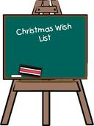
本試題到此結束，
作答完畢後，請確實
檢查。

