範圍: 翰林國中英語第一冊Unit6~Review 3 考試時間: 50分鐘
臺北市立龍山國中98學年度第一學期七年級英語科第三次定期評量試題卷
注意: | 1.本試題卷共有四頁，請記得翻面作答。  2.1-30題為單選選擇題，請以2B鉛筆將各題正確答案的英文代碼劃在答案卡上。  3.31-52題為寫作題，請在答案卷上作答。
第一部分: 聽力測驗 (共20分)
本測驗共有四大題，每一小題都會播放兩次，請同學們注意聽廣播，仔細作答。
一、請注意聽廣播中的句子，選出符合圖意的句子。(每題1分，共4分)
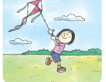 | 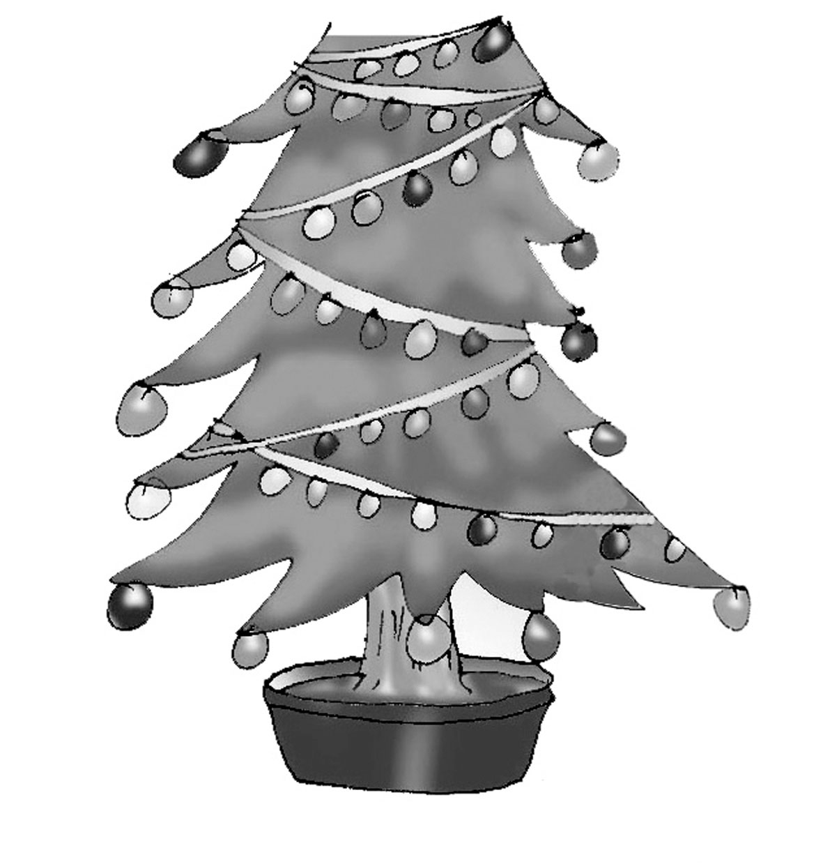 |  | 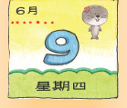
二、請注意聽廣播中的對話與問題，並將正確答案的英文代碼劃在答案卡上。(每題2分，共4分)
- (A) Yes, he’s singing under the tree.
(B) No, he’s reading in the classroom.
(C) No, he’s singing in the classroom.
- (A) It’s 8:20. (B) It’s 8:25. (C) It’s 8:30.
三、根據圖片與表格，聽廣播中的問題與選項，將正確答案的英文代碼劃在答案卡上。
(每題2分，共12分)
Time Day | Sun. | Mon.-Sat.
17:00-18:00 | Baseball | Cooking Time
18:00-19:00 | Happy News | Happy News
19:00-20:30 | Cats | Friends
20:30-22:00 | Mr. and Mrs. Smith | Let’s Talk in English
第二部分: 綜合測驗 (共80分)
一、文法選擇 (每題1分，共6分)
- Jack: What is John doing in the park? Sam: ________________.
(A) He’s not running in the park. (B) Yes, he’s riding a bike in the park.
(C) No, he’s running in the park. (D) He’s riding a bike in the park.
- There __________ some women dancing in the park.
(A) am (B) are (C) have (D) is
- It’s two forty p.m. It’s two forty __________.
(A) in the morning (B) in the afternoon (C) in the evening (D) at midnight.
- Amy: ________ is it? Patty: It’s fall.
(A) How old (B) What time (C) How many (D) What season
【 第一頁，共四頁，背面尚有試題，請繼續作答 】
- __________ usually cold in Taipei now.  usually 通常
(A) There is (B) This is (C) It is (D) They are
- My brother, Kevin, is so tired. He’s sleeping _____ bed in his room now.
(A) in (B) on (C) at (D) from
二、克漏字填空 (每題2分，共10分)
(19-23)
Dear Jessica,  How are you doing? I’m in New York now, and I’m starting my new school life here. The teachers and classmates here are very nice. Now, I 19 in the school library.  The weather in New York 20 the weather in Taiwan. The winter here is too cold 21 me. There’s even snow today. I like the weather in Taiwan. It’s not so cold during the winter.  Now, I have an English class 22 eight thirty every morning. It’s not easy but interesting.  23 and visit me next summer vacation!  Sincerely,  Meggy   library 圖書館 start 開始 life 生活 easy 容易的   visit 拜訪 next 下一個 vacation 假期 | Jessica Wang
 | 46, Na Ning Rd
 | Taipei, 108
 | Taiwan, ROC
- (A) sit (B) reading (C) read (D) am sitting
- (A) are like (B) isn’t like (C) like (D) not like
- (A) for (B) about (C) at (D) from
- (A) X (B) on (C) at (D) in
- (A) Going (B) Go (C) Coming (D) Come
三、閱讀測驗 (每題2分，共14分)
(24-25)
Weather Report on Jan 18, 2010
Taipei  18˚C-23˚C | London  10˚C-15˚C | New York  3˚C-8˚C | Sydney  23˚C-27˚C | Tokyo  -3˚C~2˚C
- Which city may be hot and dry on Jan. 18?  may 可能
(A) Taipei. (B) New York. (C) Sydney. (D) Tokyo.
- Amy is in London now. What should she bring with her?  should 應該 bring 攜帶
(A) A stocking. (B) A watch. (C) A hat. (D) An umbrella.

【 第二頁，共四頁，尚有試題，請繼續作答 】
(26-28)
- Who is barbecuing the food?
(A) Linda’s grandparents. (B) Linda’s parents.
(C) Linda’s uncle and aunt. (D) Linda’s mom and aunt.
My name is Linda. My family is having a barbecue with my uncle’s family at the park. Mom and Aunt Lily are barbecuing some food. My brother is kicking a ball with Uncle Sam. Grandma and Grandpa are walking our dog, Lucky. My cousin, Lucy, and I are flying a kite.
How about Dad? Oh, he is sitting under a tree and waiting for the food!
- Who is Lucy?
(A) Linda’s mom. (B) Linda’s dog. (C) Linda’s cousin. (D) Linda’s grandma.

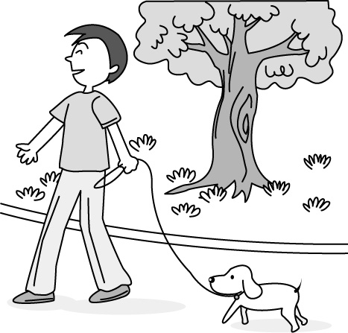
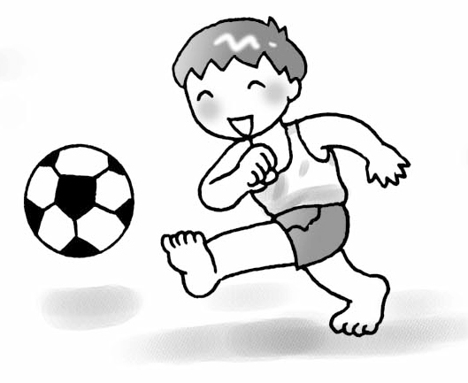

- What’s Linda’s brother doing?
(A) (B) (C) (D)
(29-30)
(It’s Sunday morning.)
 breakfast 早餐
 ready 準備好
 late 遲到
 What’s wrong? 怎麼了？
Mom: Brian, breakfast is ready.
Brian: What time is it, Mom?
Mom: It’s eight thirty.
Brain: Eight thirty! I’m late. Where are my glasses?
Mom: Aren’t they on your bed?
Brain: No, they aren’t.
Mom: Oh, they are on your desk.
Brian: Thanks, Mom. I’m going to school. Bye, Mom.
Mom: Wait! Going to school? What for?
Brain: Isn’t it Monday today?
Mom: No, it’s Sunday.
Brian: Oh, no. I’m late.
Mom: What’s wrong?
Brain: Peter is waiting for me at eight at school. We’re going to Taipei Zoo together.
- Where are Brian’s glasses?
(A) They are on his desk. (B) They are on his bed.
(C) They are at school. (D) We don’t know.
- Which is true?
(A) It’s Monday today. (B) It’s eight o’clock now.
(C) Peter is at the zoo. (D) Brian is at home.
【 第三頁，共四頁，背面尚有試題，請繼續作答 】
四、文意字彙：請根據提示的首尾字母寫出合乎句意的英語單字 (每題2分，共16分)
- Mr. Smith is a nice teacher. He is p r with the students.
- Students go to school from Monday to Friday. They have no classes on the w d.
- Let’s d e the Christmas tree with bells and cards.
- There are four p e in my family. They are my parents, my sitster and I.
- These beautiful f rs are for Amanda. It’s her birthday today.
- David and Rosa are in d t classes. They aren’t classmates.
- My parents h g some beautiful pictures in the living room.
- It’s rainy. The floor is w t, not dry.  floor 地板
五、依提示作答 (每題2分，共14分)
39.
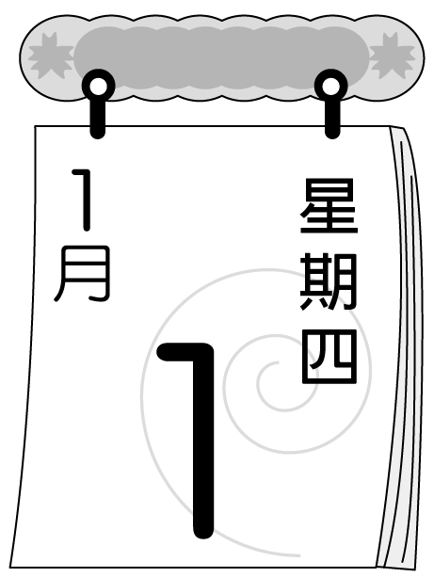
40.

- What day is the party? （看圖詳答問題）
- How’s the weather in fall? （看圖詳答問題）
- Aren’t you dancing? (以「跳繩」詳答)
- Bill: ? (請寫出完整問句)
Nancy: Mr. Green is from London.
- What time is your second(第二)class?
(請根據事實詳答，並將數字用英文回答)
- How many seasons are there in a year in Taiwan? (請根據事實詳答)
- Bill: What ? (請寫出完整問句)
Nancy: The weather is cool in fall in New York.
六、翻譯 (共20分)
（一）引導式翻譯(每格1分，共5分)
- 我的姊姊正在沙發旁玩呼拉圈。
My sister is __________ the hula hoop __________ the sofa.
- Kevin的父親正在陽台上打太極拳。
Kevin’s father is __________ tai chi __________ the __________.
（二）整句式翻譯(每題3分，共15分，錯一處，扣1分)
- 今晚在Amy家有場生日派對。
- 上課的時間到了。林老師就在門邊。
- 在台北，夏天有很多雨。
- Nicky正在和她的父親講電話？
- 台灣的冬天對Mike而言有一點溫暖。

【 第四頁，共四頁，本試題到此結束；作答完畢，請確實檢查 】

台北市立龍山國中98學年度第一學期七年級英語科第三次定期評量（聽力稿）
第一部分: 聽力測驗
本測驗共有四大題，每一小題都會播放兩次，請同學們注意聽廣播，仔細作答。
一、請注意聽廣播中的句子，選出符合圖意的句子。
- (A) Mandy is riding a bike.
(B) Mandy is reading comic books.
(C) Mandy is flying a kite.
- (A) There aren’t any gifts under the tree.
(B) There are a lot of gifts under the tree.
(C) There is only one gift under the tree.
- (A) It’s windy and cool.
(B) It’s rainy and cold.
(C) It’s sunny and hot.
- (A) It is Thursday.
(B) Today is Wednesday.
(C) It is Tuesday today.
二、請注意聽廣播中的對話與問題，並將正確答案的英文代碼劃在答案卡上。
- Boy: Where’s Jack?
Girl: Isn’t he singing under the tree?
Boy: No, he isn’t. Where is he?
Girl: Over there! He’s reading with his classmates in the classroom.
Question: Is Jack singing under the tree?
- Boy: Our first class is at 8:30. The teacher is coming, but Patty isn’t here.
Girl: Where is Patty?
Boy: I don’t know. Maybe she’s late. What time is it now?
Girl: It’s 8:25. Let’s call her.
Question: What time is it?
三、根據圖片與表格，聽廣播中的問題與選項，將正確答案的英文代碼劃在答案卡上。
- How many people are there in Gary’s family?
(A) There are four. (B) There are three. (C) There are two.
- Who is eating in the dining room?
(A) Gary. . (B) Gary’s mom. (C) Gary’s sister.
- Which is true?
(A) Gary is sleeping in his bedroom.
(B) Gary’s father is watching TV in the living room.
(C) Gary’s mom is taking a walk in the bathroom.
- It’s nine o’clock in the evening. Mr. and Mrs. Smith is on TV. What day is today?
(A) Monday. (B) Saturday. (C) Sunday.
- It’s 8:00 on Monday evening. What is on TV now?
(A) Let’s talk in English. (B) Friends. (C) Cats.
- It’s time for baseball game on TV. Let’s watch it together. What time is it now?
(A) It’s five p.m. (B) It’s six p.m. (C) It’s five a.m.
臺北市立龍山國中98學年度第一學期七年級英語科第三次定期評量試題卷
_____年_____班______號 姓名：______________ 任課教師：_____________老師
注意: | 1.本試題卷共有四頁，請記得翻面作答。  2.1-30題為單選選擇題，請以2B鉛筆將各題正確答案的英文代碼劃在答案卡上。  3.31-52題為寫作題，請在答案卷上作答。
四、文意字彙：請根據提示的首尾字母寫出合乎句意的英語單字(每題2分，共16分)
31 |  | 32 |  | 33 |  | 34
35 |  | 36 |  | 37 |  | 38
五、依提示作答 (每題2分，共14分)
39
40
41
42
43
44
45
六、翻譯 (共20分)
（一）引導式翻譯(每格1分，共5分)
46 | My sister is __________ the hula hoop __________ the sofa.
47 | Kevin’s father is __________ tai chi __________ the __________.
（二）整句式翻譯(每題3分，共15分，錯一處，扣1分)
48
49
50
51
52

臺北市立龍山國中98學年度第一學期七年級英語科第三次定期評量答案
1. | 2. | 3. | 4. | 5. | 6. | 7. | 8. | 9. | 10. | 11. | 12. | 13. | 14. | 15.
C | A | B | A | B | B | A | C | B | C | B | A | D | B | B
16. | 17. | 18. | 19. | 20. | 21. | 22. | 23. | 24. | 25. | 26. | 27. | 28. | 29. | 30.
D | C | A | D | B | A | C | D | C | D | D | C | C | A | D
四、文意字彙：請根據提示的首尾字母寫出合乎句意的英語單字(每題2分，共16分)
31 | popular | 32 | weekend | 33 | decorate | 34 | people
35 | flowers | 36 | different | 37 | hang | 38 | wet
五、依提示作答 (每題2分，共14分)
39 | It’s on Thursday./ The party is on Thursday.
40 | It’s windy and cloudy (in fall)./ The weather is windy and cloudy (in fall).
41 | No, I’m jumping rope.
42 | Where is Mr. Green from?
43 | It’s at nine twenty-five./ The second class is at nine twenty-five.
44 | There are four seasons in a year in Taiwan.
45 | What’s the weather like in fall in New York?
六、翻譯 (共20分)
（一）引導式翻譯(每格1分，共5分)
46 | My sister is using the hula hoop near the sofa.
47 | Kevin’s father is doing tai chi on the balcony .
（二）整句式翻譯(每題3分，共15分，錯一處，扣1分)
48 | There’s a birthday party at Amy’s house tonight.
49 | It’s time for class. Miss/ Mr./Mrs. Lin is at the door.
50 | There’s a lot of rain in summer in Taipei./ In Taipei, there’s a lot of rain in summer.  We have a lot of rain in summer in Taipei./ In Taipei, we have a lot of rain in summer.  It rains a lot in summer in Taipei./ In Taipei, it rains a lot in summer.  (a lot of= lots of)
51 | Is Nicky talking to/with her dad on the phone?  Is Nicky using the phone to talk to/with her dad?
52 | The winter in Taiwan is a little (bit) warm for Mike.  It/The weather is a little (bit) warm for Mike in (the) winter in Taiwan.  The weather in (the) winter in Taiwan is a little (bit) warm for Mike.

