臺北市龍山國民中學97學年度第2學七年級英語科第3次定期評量試題卷
七年 班 號 姓名： 組別： 任課老師：
1. 本試題卷共有四頁。請記得換頁作答。
注意: 2. 1-31題為單選選擇題。請以2B鉛筆將各題正確答案的英文代碼劃在答案卡上。
3. 32-53題為寫作題。請在答案卷上作答。
第一部分:聽力測驗（共20分）
本測驗共有三大題,每一小題都會播放兩次,請同學們注意聽廣播,仔細作答。
第一大題：請根據聽到的內容,選出句中聽到的英文單字,並將正確答案的英文代碼A、B或C劃在答案卡上。（每題1分，共四分）
1. | （A）study | （B）read | （C）his
2. | （A）bring | （B）likes | （C）land
3. | （A）hard | （B）hot | （C）works
4. | （A）are | （B）market | （C）tonight

第二大題：請注意聽廣播中的句子，選出符合圖意的句子, 並將正確答案的英文代碼A、B或C劃在答案卡上。（每題2分，共6分）
A. B. C.
 | Sam  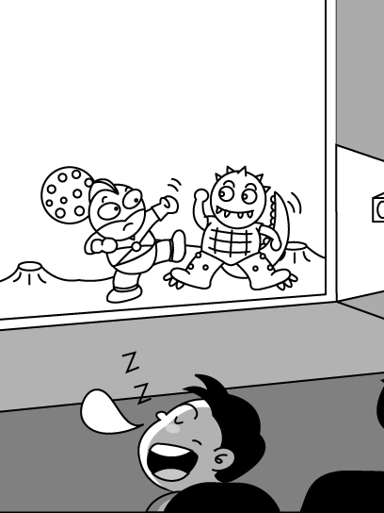 | 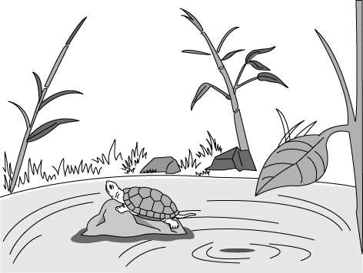

5. (A) He’s throwing a ball.
(B) He’s catching a ball.
(C) He’s hitting a ball.

6. (A) Sam enjoys watching the movie.
(B) Sam does not like the movie.
(C) Sam is very happy to see the movie.

7. (A) The turtle is in the pond.
(B) The turtle is under the water.
(C) The turtle is beside the pond.

第三大題 ：請注意聽下面的短文及問題,並將正確答案的英文代碼A、B或C劃在答
案卡上。（每題2分，共10分）
8. (A) They are 11 years old. (B) They are 12 years old. (C) They are 13 years old.
- (A) It’s on December 30. (B) It’s on December 31. (C) It’s on December 29.
10. (A) He is tall and fat. (B) He is short and fat. (C) He is tall and thin.
11. (A) Mike’s brother. (B) Mike. (C) Mike’s friend.
12. (A) They play baseball together. (B) They play soccer together.
(C) They run together.
第二部分:綜合測驗
一、文法選擇 （每題1分，共8分）
13. Sam’s birthday is coming soon. It is July.
(A) on (B) in (C) at (D) of
14. Sam：Is John talking to Mary? Peter：Yes, he is talking to .
(A) he (B) him (C) she (D) her
15. Peter：Does your cousin know Mr. and Mrs. Good?
Sam：Yes, she knows .
(A) you (B) them (C) us (D) we
- Ken practices playing the piano every day. He never
(A) give up (B) gives up (C) giving up (D) to give up
- Peter is a player the school tennis team.
(A) at (B) for (C) on (D) in
- Lisa is a cook, but she last year.
(A) weren't (B) wasn't (C) isn't (D) doesn't
- Coco: What date is Joan's birthday?
Ken:
(A) I have no idea. (B) It's at 2:00 pm. (C) It's on Monday. (D) It was last June.
- Frank：There were some problems with John’s homework this morning. And he didn’t
pass the math test. didn’t ：doesn’t的過去式
Tom:
(A) You can say that again. (B) Today really wasn’t his day .
(C) That's not a problem. (D) He was a lucky man.

二、克漏字選擇（每題2分，共10分）
Ding Ding is your best friend. He wants 21 with you. He also enjoys 22 stories to you. He hates watching TV. He can clean the house for you. He is never tired. You don’t need to feed him 23 give him water. He can work for you 24 twenty-four hours a day. Come and take one home. It’s only NT $1000. 25 two and get one free.

21. | (A) to dance | (B) dance | (C) dances | (D) dancing
22. | (A) to read | (B) read | (C) reads | (D) reading
23. | (A) and | (B) or | (C) but | (D) to
24. | (A) for | (B) at | (C) on | (D) in
25. | (A) To buy | (B) Buying | (C) Buys | (D) Buy

三、閱讀測驗（每題2分，共6分）
Alex is quiet. He is not a happy boy. He seldom talks. He reads a lot in the classroom during the break. He doesn’t like to play with classmates.
In fact, Alex was a happy and popular boy two years ago. He was on the basketball school team then. He played with his classmates after school. One day, he rode a bike home and had a car accident. He lost one leg. He didn’t smile anymore.
 in fact 事實上 had a car accident出車禍 lost失去
26. Which is true about Alex?
(A) He has two legs. (B) He is noisy. (C) He likes to talk. (D) He likes to read.
27. Why is Alex NOT happy anymore?
(A) He had a car accident. (B) He is on the basketball school team.
(C) He is popular. (D) He was quiet.
28. When was the car accident?
(A) Last week. (B) Two months ago. (C) Two years ago. (D) Three years ago.

四 看圖詳答問題（每題2分，共6分）
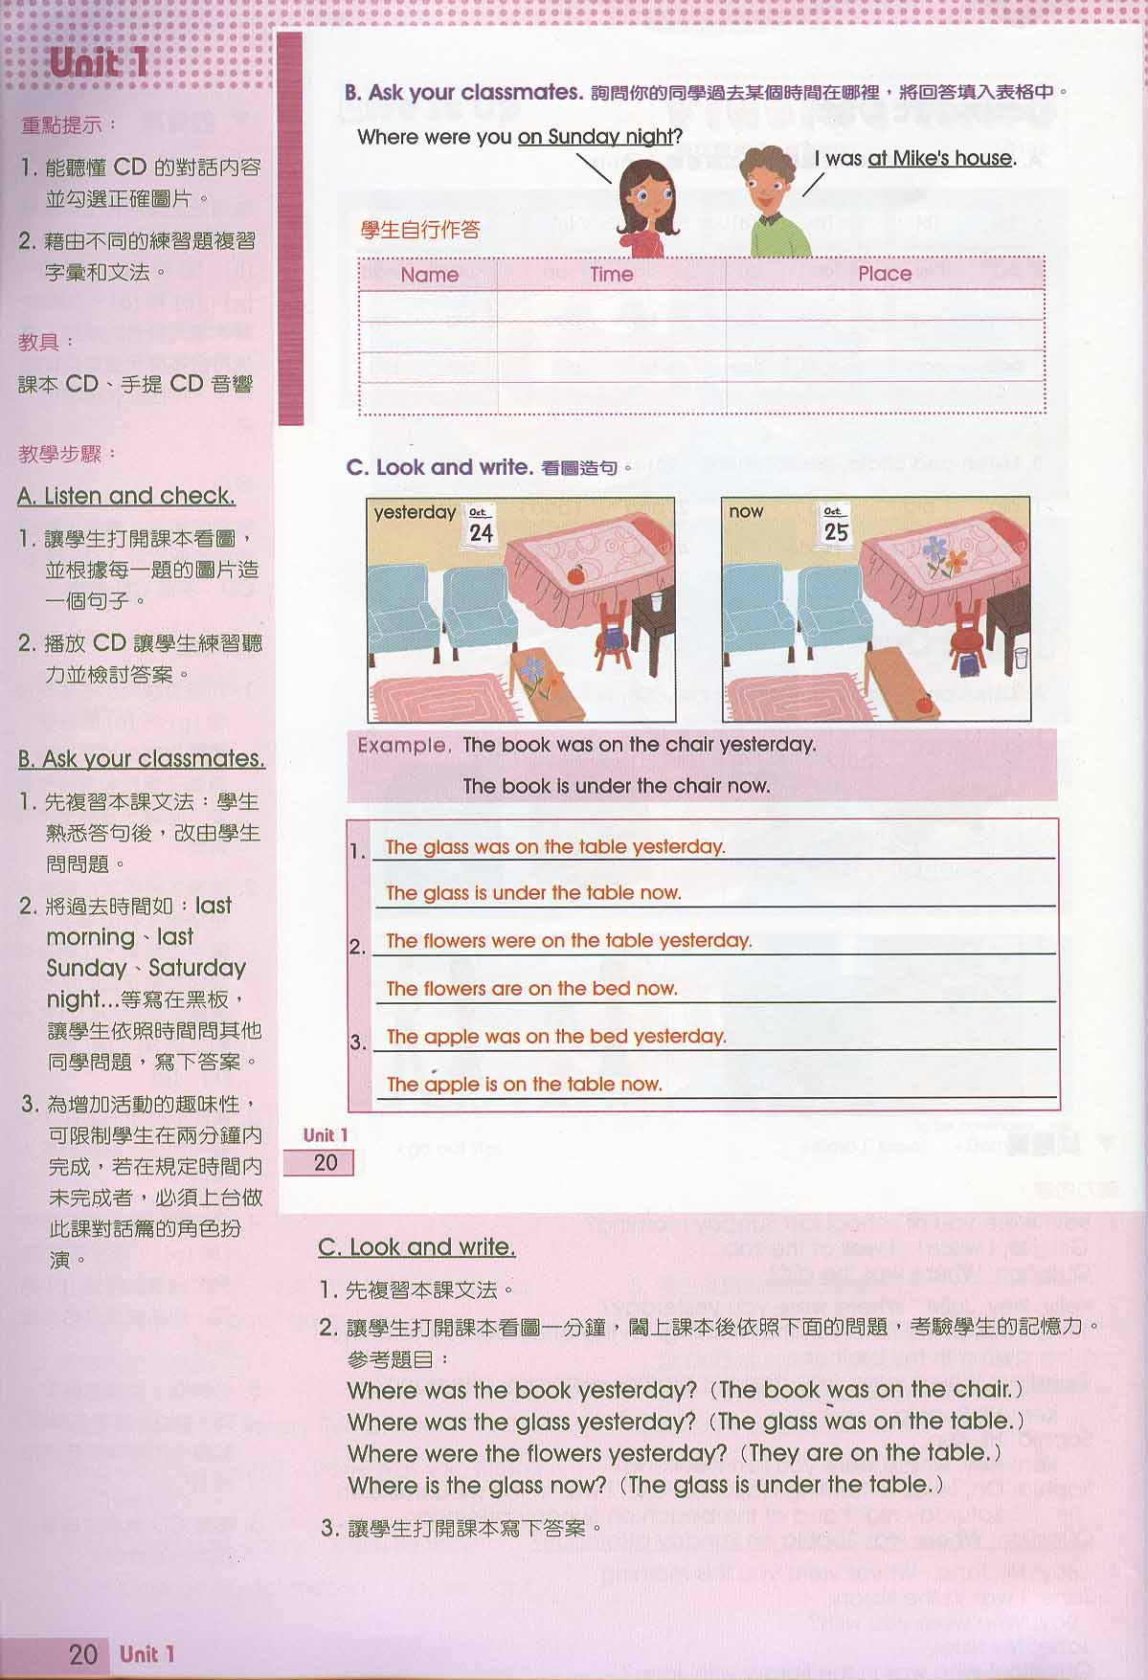

29. What date was the day before yesterday?
(A) Oct. 24. (B) Oct. 25. (C) Oct. 26. (D) Oct. 23.
30. Jay: Where was the glass yesterday?
John:
(A) Under the chair.
(B) On the chair.
(C) On the table.
(D) Under the table.
31. How many flowers are there on the bed now?
(A) One. (B) Three. (C) Two. (D) Four.

五、文意字彙（每題2分，共16分）
32. I love Jay Chou very much! I love all the songs on his new a m.
33. September is the n h month of the year.
34. My grandfather wants to be healthy, and he e es in the park every morning.
35. Sue likes to go to m ns in her free time. She likes to learn old things.
36. June 30 is the l t day of June.
37. Don't be n s. The math test is not hard at all.
38. Judy loves to l e in a big city. It is convenient to go shopping.
39. The h l is very big and beautiful. There are 500 rooms in it.

六、填空：（每題2分，共10分）
Dear Mark,
Summer vacation is coming soon. What is your plan 40 this summer vacation?
I plan 41 go to Ilan（宜蘭）with my family 42 August for two weeks. My grandfather lives 43 the mountains and he has a big farm there. My grandfather is 80 years old this year. His birthday is 44 August eighteenth. We will celebrate（慶祝）his
birthday with him. Hope you can come and join us.
Love,
John

七、依據提示回答問題：（每題2分，共6分）
45. What is the date today? （請根據事實，用英文詳答。）
46. A： .
B：My grandmother loves going shopping in the department store on weekends. （請寫出A所問的問句。）
47. March, April, and May are in spring. What are the three winter months of the year?

八、整句式翻譯（每題3分，共18分）
48.二月通常有二十八天。
49.每逢星期日，夜市到處都是人和車子。
50.每年夏天我們這裡下很多雨。
51. Nancy喜歡吹橫笛，但是她不喜歡作功課。
52.他十年前害怕老鼠，但是現在他不會了。
53.我爸爸不喜歡運動，但是週末他總是跟我們打羽球。

臺北市龍山國民中學97學年度第2學七年級英語科第3次定期評量試題卷
（聽力稿）
第一部分:聽力測驗
本測驗共有三大題,每一小題都會播放兩次,請同學們注意聽廣播,仔細作答。
（第一大題）：請根據聽到的內容,選出句中聽到的英文單字,並將正確答案的英文代碼A、B或C劃在答案卡上。（每小題1分，共4分）
1. Emily likes to read in her free time.
2. Look! The rabbit plans to carry the turtle on land.
3. Let's work hard to win the game.
4. I was at the night market last night.

（第二大題）：請注意聽廣播中的句子，選出符合圖意的句子,並將正確答案的英文代碼A、B或C劃在答案卡上。（每小題2分，共6分）
CD: Look at the picture A. What is the boy doing?
5. (A) He’s throwing a ball.
(B) He’s catching a ball.
(C) He’s hitting a ball.

CD：Look at the picture B. What do you see in the picture?
6. (A) Sam enjoys watching the movie.
(B) Sam does not like the movie.
(C) Sam is very happy to see the movie.

CD：Look at the picture C. Where is the turtle?
7. (A) The turtle is in the pond.
(B) The turtle is under the water.
(C) The turtle is beside the pond.

（第三大題）：請注意聽下面的短文及問題,並將正確答案的英文代碼A、B或C劃在答案卡上。（每小題2分，共10分）

Hi! I’m John. Mike and I are brothers. Thirteen years ago, I was born at 11:55 on the night of December 30. Six minutes later, Mike was born. At that time, I was big and fat, and he was small and thin. But now, I’m short and fat, and he’s tall and thin.
Both Mike and I love sports. I enjoy playing basketball, and he enjoys playing soccer. We plan to join the school teams this year. We also plan to run together after school.

8. How old are Mike and John?
9.When is Mike‘s birthday?
10.What does Mike look like now?
11.Who enjoys playing basketball?
12.What do Mike and John plan to do after school?

臺北市龍山國民中學97學年度第2學期七年級英語科第3次定期評量答案卷
年 班 號 姓名： 任課老師：

五、文意字彙（每題2分，共16分)
32. |  | 33. |  | 34. |  | 35.
36. |  | 37. |  | 38. |  | 39.

六、填空：（每題2分，共10分）
40. |  | 41. |  | 42. |  | 43. |  | 44.

七、依據提示回答問題：（每題2分，共6分）
45.
46.
47.

八、整句式翻譯（每題3分，共18分）
48.
49.
50.
51.
52.
53.

臺北市龍山國民中學97學年度第2學期七年級英語科第3次定期評量答案卷
一~四 選擇題答案：
1. | B | 2. | C | 3. | A | 4. | B | 5. | C
6. | B | 7. | A | 8. | C | 9. | B | 10. | C
11. | A | 12. | C | 13. | B | 14. | D | 15. | B
16. | B | 17. | C | 18. | B | 19. | A | 20. | B
21. | A | 22. | D | 23. | B | 24. | A | 25. | D
26. | D | 27. | A | 28. | C | 29. | D | 30. | B
31. | C

五、文意字彙（每題2分，共16分)
32. | album | 33. | ninth | 34. | exercises | 35. | museums
36. | last | 37. | nervous | 38. | live | 39. | hotel

六、填空：（每題2分，共10分）
40. | for | 41. | to | 42. | in | 43. | in | 44. | on

七、依據提示回答問題：（每題2分，共6分）
45. | Today is June 26/ 26th / twenty-sixth.
46 | What does your grandmother love to do on weekends?
47 | December, January, February.

八、整句式翻譯（每題3分，共18分）
48. | February usually has twenty-eight days. / There are usually twenty-eight days in February.
49. | There are many / a lot of/ lots of people and cars everywhere at the night market on Sundays.
50. | We have a lot of rain here every summer. / It rains a lot here every summer.
51. | Nancy likes playing/ to play the flute, but she doesn’t like doing/ to do her homework.
52. | He was afraid of a mouse/ mice ten years ago, but he isn’t now.
53. | My dad/ father doesn’t like doing exercise/ to do exercise, but he always plays badminton with us on weekends.

