龍山國中97學年度第二學期九年級英語科第1次定期評量試題卷
1
版本:康軒 考試範圍: 第六冊L1-L3
第一部分: 聽力測驗 (共 10 分)
注意： | 1.本試題卷共有六頁，請記得翻頁作答。
注意： | 2. 1- 36題為單一選擇題，請以2B鉛筆將各題正確答案的代碼劃在答案卡上。
注意： | 3. 37- 53題，請在答案卷上作答。
本測驗共有兩大題，每一小題都會唸兩次，請同學們注意聽，仔細作答。
- 請仔細聽廣播中的句子，並將最能符合句意的圖片代碼劃在答案卡上。(每題2分，共6分)
A | B | C | D | AB | AC
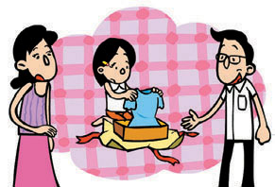 | 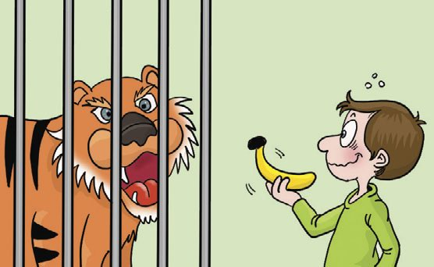 | 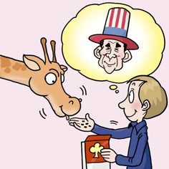 |  | 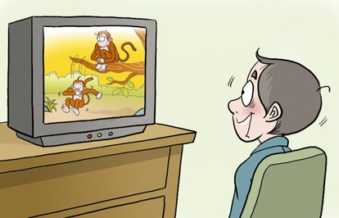 | 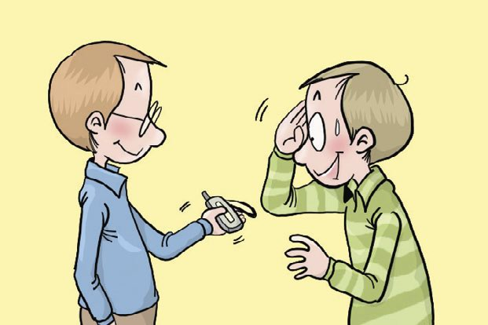
Q1-Q3
- 聽廣播中的文章與問題，若答案為｢是｣，則劃記A，若答案為｢否｣，則劃記B。(每題2分，共4分)
Q4-Q5
-----------------------------------------------------------------------------------------
第二部份: 綜合測驗(共90分)
一、語法與字彙測驗 (每題1分，共12分)
6. A: Can you some money to me? I left mine at home.
B: No problem, how much do you need?
(A) borrow | (B) pay | (C) lend | (D) make
7. A: You are late. What happened?
B: Sorry, my car can’t start at that time. I don’t know .
(A) how to do (B) what to do it
(C) how to drive a car (D) who to ask for help
8. A: You look as thin as before. How did you make it?
B: Doing exercise every day lets me good shape.
(A) keep | (B) keeps | (C) kept | (D) to keep
9. Don’t go out your parents come back. Maybe someone will come and fix the TV.
(A) since | (B) because | (C) until | (D) that
10. Although Tim and Mark are twins, they are different in many ways. For example, Tim is
hard-working, but Mark is .
(A) lazy | (B) successful | (C) polite | (D) careful
11. Before you send a letter, remember to the letter and put it into the envelope.
(A) beat | (B) fold | (C) cut | (D) repeat
12. The baseball game was exciting we almost forgot to eat lunch.
(A) very; so | (B) quite; but | (C) too; to | (D) so; that
13. Hey! Kids. Have a seat and help to the fruit in the basket.
(A) yourself | (B) yourselves | (C) themselves | (D) myself

2
14. A: My teacher has no idea who .It is a waste of energy.
※ waste 浪費
B: Perhaps you can ask Tina. She is the last student that left there.
(A) didn’t turn off the computer |  | (B) comes tomorrow
(C) to answer the hard question |  | (D) left the garbage in the classroom
15.They are not sure Tom came here last night.
(A) what | (B) where | (C) whether | (D) whose
16. Mr. White vegetable soup for lunch, but he eats fruit salad today.
(A) used to have | (B) used to having | (C) used to drink | ( D) used to drinking
17. Mary’s mother wonders .
(A) if she have to cook dinner or not |  | (B) what should she buy in the supermarket
(C) when to go to her school |  | (D) why did she clean the car

- 克漏字測驗 (每題2分，共16分)
【A】

Ray: Hey! Dad. ( 18 ) ?
Dad: Not at all. A “man’s” talk?
Ray: I think I fall in love. There is a new classmate in my class. She both speaks English and plays tennis well. However, I’m too shy to talk to her. Can you teach me how to make friends with her? By the way, (19) ?
Dad: Well, 1990 is the year in which I met her.
Ray: Tell me more. Why do you love her so much?
Dad: She is the kindest girl that I have ever seen. I saw her help a blind woman cross the street and then get into my taxi. It’s embarrassing that (20) . I didn’t mind at all. We talked happily on her way home and began our first date after two days.
Ray: Sounds romantic. But, I still have no idea what to talk to her.
Dad: For example, many girls don’t like math (21) . Maybe you can start your talk by teaching her the confusing subject.
Ray: Thanks a lot. I’ll give it a try.
Dad: Good luck to you.

※ confusing 困惑的

18. | (A) Do you have the time | (B) Are you busy now
 | (C)Can you give me some money | (D) Can I go out with Jack
19. | (A) when did you know Mom | (B) what did you do
 | (C) how to talk to her | (D) how do you make new friends
20. | (A) she didn’t know where to go | (B) she forgot to bring the money
 | (C) she forgot my name | (D) she left her bag in the car
21. | (A) that you are afraid of | (B) that you are tired of
 | (C) that Mr.Wu teaches | (D) that you are good at

3
【B】
Are you ready for the coming basic competence contest? This is the first difficulty that most junior high school students have to overcome. (22) studying more hard than before, having correct eating habits is also important. Here are some advices:
1. Never skip breakfast: A wonderful day begins with a rich breakfast. People without eating breakfast not only easily forget things (23) often feel tired.
2. Chew slowly and calmly. You had better (24) some water when you eat.
3. (25) deep-fried food and sweeten drinks which only make you fat.
4. Eat more fruit and vegetables which are high in fiber and vitamins. Some food can make you stay in a good mood, like milk, bananas, or onions. Have them as more as possible.
Follow these tips, and you’ll be surprised to find that you can concentrate better. In a word, having
a healthy body and mind is the successful key to face basic competence contest.

In a word, having a healthy body and mind is the successful key to solve all problems
in our life.

※ overcome克服 advice建議 skip 省略 chew嚼 fiber纖維 vitamin維他命 mood心情

22. (A) Except | (B) Expert | (C) Beside | (D) Besides
23. (A) but | (B) and | (C) so | (D) or
24. (A) drinking | (B) to drink | (C) drink | (D ) drank
25. (A) Look up | (B) Give up | (C) Pick up | (D) Wake up

三、閱讀測驗 (每題2分，共22分)
J.K.Rowing had a very hard time before her novels has become one of the most popular ones in the world. Babe Ruth, an excellent baseball player, struck out more than one thousand times, but he also hit 714 home runs. Before Ang Lee is known as a famous director, he also had to write many scripts for others to increase his experiences.
【A】
※ struck out 三振 director 導演 script 劇本 increase增加 appreciate珍惜

26. What can we learn from the three examples?
(A) People who never give up their dreams will win at the end of the game.
(B) Appreciate what you have, even something small.
(C) Two heads are better than one.
(D) Well begun is half done.
【B】
27. What does the sign mean when you see it on the bus? | 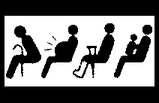
(A) The four kinds of people can take the bus for free.
(B) The bus is only taken by the four kinds of people.
(C) It’s kind of you to give the seat to the four kinds of people.
(D) The four kinds of people can pay less money for their tickets.

4
【C】
Many people often eat toast for breakfast in the morning. So do I. But I’ve been tired of common toast with jams. Would you like to use the toast to make something different? Let’s try the dessert “ Pudding with toast cranberry.”
This is what you need:
＊80cc | milk | ＊ some sugar powder | ＊ 1 | egg
＊20g | sugar | ＊ a piece of toast | ＊10g | unsalted butter
 |  |  | ＊20g | dried cranberry
1. Cut the toast into small pieces and put them in a baked bowl.
2. Beat the egg and sugar well, and then mix with milk and melted butter until well-stirring.
3. Put all of them into the baked bowl.
4. Put some dried cranberry on the top of the toast.
5. Heat the toast at 160 degrees for 15 minutes or until it becomes brown.
6. Sprinkle some sugar powder on it and prepare for a cup of hot coffee.
Let’s take a rest and enjoy your own tea time.

※ pine坪

※ cranberry苺果 bake烘烤 powder 粉 stir 攪拌 mix 混合 melt溶化 sprinkle 灑

28. What is NOT needed when you make the pudding?
(A) Toast. | (B) Flour. | (C) Sugar. | (D) Butter.
29. Which one is NOT true about the pudding?
(A) This is a kind of dessert.
(B) It is made of toast.
(C) Dried cranberry is mixed with milk and melted butter.
(D) It goes well with coffee.
【D】
Light Up Their Hopes (2008/3-2008/9)
With a little money, everyone can help these poor kids and their families. Just＄100, you can get a set of stationery, including pens, a ruler, and a notebook. We’ll donate 40% of the money to “Taiwan Fund for Children and Families” and 20% to ” Hope Factory.” We hope every child can be taken care of and be kept away from danger.
Donation: Post Office Account 231-1314520
The first 50 donators will get a free teddy bear extra.
For more information 0800-100-520 ( http://www.lovekid.org.tw )

※ donate捐獻 account帳戶

30. Max and his sister want to join the program, how much will their money be donated to “TFCF?”
(A)＄200. | (B)＄100. | (C)＄80. | (D)＄40.
31. Which is true?
※ stationery文具 donate 捐獻 account 帳戶
(A) The program lasted for six months.
(B) It is an ad about celebration.
(C) To get more information, you can call 231- 1314520.
(D) Not everyone can get a free teddy bear by donation.
5
【E】Read the travel Ad.
A Trip to Pick up Strawberry in Miaoli
6:30 Meet at Taipei Train Station No3 Gate
7:00 Leave for
You’ll enjoy the beautiful West Taiwan on the bus.
9:00 Dahshi Flower Farm
You can lie on the grass, enjoy the fresh air and beautiful scenery.
You can take a break and take pictures.
12:00 Hsinchu Temple
Eat the local food for lunch in front of the temple.
You may also pray a luck in the temple. ( at your own cost )
14:00 Miaoli
Pick up the strawberry and have a strawberry pie with a cup of coffee for free.
17:00 Go back to Taipei
＄ | Weekday | Weekend  &Holiday
Adult | 600 | 750
Child ( 3-12 years old) | 400 | 550 | Child less than 3years old＄200
Get more information: (02) 2543-1234
※ pray 祈福 temple寺廟
32. What is true about the trip?
(A) People will take the trip by train.
(B) The trip goes every day.
(C) People can surf the Net to get more information.
(D) People who take the trip will pick up the strawberry in the morning.
33. Mrs. White will join the trip with her 13-year-old son and 2-year- old daughter this Saturday. How much will they pay?
(A)＄1700. (B)＄1600. (C)＄1400 (D)＄1300.

【F】
The Chinese New Year which lasted for nine days has already gone. Have you spent more time with your family? In fact, Chinese people say all of the celebrations should be ended on Lantern Festival, January 15th of the lunar calendar. After the day, all people start a new life of the year.
However, do you know the origin of the festival? One of the legends is that the Great God was angry with a town for killing his favorite goose. He decided to burn the town. The news was heard by a kind fairy. She taught the people of the town to hold a lot of lanterns on the street as if the town burned itself. The Great God didn’t know he was cheated and gave up burning the town. All people were saved. From then on, people celebrate the day by holding lanterns of different shapes. Many people even made ones themselves when they were little children. Other activities, like eating sticky rice ball and guessing the Lantern Riddles are common in Taiwan. Have you guessed a riddle? Let’s try one below: Guess an animal.
6

It has a long nose that helps drink water.
It also has two big ears that can be fans to keep away heat.
This year, the “International Sky Lantern Festival” is celebrated in Pingshi on February 9th. Did you go there? At any time, you can come to the little town and buy a favorite sky lantern. Write down your wish on it and fly it in the sky. Perhaps your dream will come true in the near future.
34. What animal is it?
(A) An elephant. | (B) A rooster. | (C) A rabbit. |  | (D) An ox.
35. Which is true about Lantern Festival?
(A) People held the lanterns high to celebrate the birth of the Great God.
(B) Lantern Festival fell on January 15th this year.
(C) The Great God burned up the town.
(D) The sky lantern can be bought in Pingshi at any time of the year.
36. Which one is NOT the main activity of Lantern Festival?
(A) Eat sticky rice ball. |  |  | (B) Watch Dragon boat race.
(C) Hang up lanterns. |  |  | (D) Guess the Lantern Riddles.
※ lunar calendar農曆 origin起源 legend傳說 fairy仙人 riddle謎語

四、文意字彙 (每題2分，共12分)
37. H t the soup, and you can have some to keep warm.
38. Many people have a great i t in the two pandas which come from China.
39. After walking for three hours, I feel quite t y and need a glass of iced water.
40. “ Don’t c t on the test.” This is the most important rule that all students must follow.
41. The famous tale story “Here comes the wolf.” teaches us that people should be always h t to others.
42. The 21st Summer Deaflympics will be held in Taipei in September. That’s the best way to
let m ns of people around the world know where the city is.

43. | { | Alex asked me a question. | ( 用間接問句將兩句合併成一句 )
43. | { | He said,” Where does your brother live? ” | ( 用間接問句將兩句合併成一句 )
44. | { | Will Jack drive to work?  I am not sure about it. | ( 將兩句合併成一句 )
五、依提示作答 (每題2分，共10分)
45. He really doesn’t know how he should write the sentence. ( 加入不定詞片語改寫 )
46. Swimming is interesting to him. ( 這句改成It 開頭 )
47. The tea is too hot for me to drink.(用 so…that改寫)

六、整句式翻譯 (每題3分，共18分，錯一處，扣1分)
48.深夜開快車很危險。
49.她以前在麵包店工作，現在她失業了。
50.真令人驚訝!Mike在成為著名的畫家前曾經生活很苦。
51.我正在想你是否能盡快地完成這項工作。
52.我的老師想知道我們每天花多少時間寫功課。
【試題結束。】

53.李氏夫婦不確定這個音樂家是否已經去了中國。

臺北市立龍山國民中學九十七學年度第二學期九年級英語科第一次定期考査(聽力稿)
第一部分: 聽力測驗
本測驗共有兩大題，每一小題都會唸兩次，請同學們注意聽，仔細作答。
一、 請仔細聽廣播中的句子，並將最能符合句意的圖片代碼劃在答案卡上。

1. | I don’t know why the man looks so angry.
2. | It is crazy to play with the tiger in the zoo.
3. | My parents have no idea whether my sister will like the present.

二、聽廣播中的文章與問題，若答案為｢是｣，則劃記｢A｣，若答案為｢否｣，則劃記｢B｣。

Amy: What’s your animal sign, John?
John: I’m a Dog person. How about you, Amy?
Amy: So am I. They say Dog people will be very lucky this year.

4. | It’s possible that John and Amy will be lucky this year.

Mr.Green used to be a famous doctor who worked in Taipei. After moving to
the country, he begins to grow flowers and makes money by selling them. Though
he makes less money than before, he enjoys the new way of life a lot.

5. | Mr.Green is a doctor working in the country now.

龍山國中97學年度第二學期九年級英語科第1次定期評量答案卷
______年______班______號 姓名：___________ 組別：______ 任課教師：___________
四、文意字彙：請根據提示的首尾字母寫出合乎句意的英語語詞(每題2分，共12分)
注意： | 1.本試題卷共有六頁，請記得翻頁作答。
注意： | 2. 1- 36題為單一選擇題，請以2B鉛筆將各題正確答案的代碼劃在答案卡上。
注意： | 3. 37 - 53題，請在答案卷上作答。
37. |  | 38. |  | 39.
40. |  | 41. |  | 42.

五、依提示作答(每題2分，共10分)
43.
44.
45.
46.
47.

六、整句式翻譯(每題3分，共18分，錯一處，扣1分)
48.
49.
50.
51.
52.
53.

【做答完畢，再檢查一下喔!】

龍山國中97學年度第二學期九年級英語科第1次定期評量答案卷
______年______班______號 姓名：___________ 組別：______ 任課教師：___________
四、文意字彙：請根據提示的首尾字母寫出合乎句意的英語語詞(每題2分，共12分)
注意： | 1.本試題卷共有六頁，請記得翻頁作答。
注意： | 2. 1- 36題為單一選擇題，請以2B鉛筆將各題正確答案的代碼劃在答案卡上。
注意： | 3. 37 - 53題，請在答案卷上作答。
1. | D | 2. | B | 3. | A | 4. | A | 5. | B | 6. | C | 7. | D | 8. | A | 9. | C | 10. | A
11. | B | 12. | D | 13. | B | 14. | A | 15. | C | 16. | A | 17. | C | 18. | B | 19. | A | 20. | B
21. | D | 22. | D | 23. | A | 24. | C | 25. | B | 26. | A | 27. | C | 28. | B | 29. | C | 30. | C
31. | D | 32. | B | 33. | A | 34. | A | 35. | D | 36. | B |  |  |  |  | .
37. | Heat | 38. | interest | 39. | thirsty
40. | cheat | 41. | honest | 42. | millions
五、依提示作答((每題2分，共10分)
43. | Alex asked me where my brother lives.
44. | I am not sure whether Jack will drive to work ( or not ).
 | I am not sure if Jack will drive to work.
45. | He really doesn’t how to write the sentence.
46. | It is interesting for him to swim.
47. | The tea is so hot that I can’t drink it.
六、整句式翻譯(每題3分，共18分，錯一處，扣1分)
48. | It is very dangerous to drive fast at night.
 | Driving fast at night is very dangerous.
 | To drive fast at night is very dangerous.
49. | She used to work in the bakery, but she is out of work.
 | She worked in the bakery, but she is out of work.
50. | It is surprising that Mike had a hard time before he became a famous painter.
 | It is surprising that Mike had a hard time before becoming a famous painter.
51. | I am wondering whether you can finish the work as fast as possible ( or not ).
 | I am wondering if you can finish the work as fast as possible.
52. | My teacher wants to know how much time we spend on the homework.
 | My teacher wants to know how much time we spend doing the homework.
53. | Mr. and Mrs. Lee are not sure whether the musician has gone to China or not.
 | Mr. and Mrs. Lee are not sure if the musician has gone to China.

【做答完畢，再檢查一下喔!】

