臺北市立龍山國中97學年度第1學期九年級英語科第3次定期評量試題卷
範圍: 康軒國中英語第五冊L7~Review 3 考試時間: 50分鐘
注意: | 1.本試題卷共有四頁，請記得換頁作答。  2.1-39題為單選選擇題，請以2B鉛筆將各題正確答案的英文代碼劃在答案卡上。  3.40-56題為寫作題，請在答案卷上作答。
第一部分: 聽力測驗 (共10分)
本測驗共有兩大題，每一小題都會播放兩次，請同學們注意聽廣播，仔細作答。
一、請注意聽廣播中的敘述，符合圖意，填A；不符合圖意，填B。 (每題1分，共4分)
1. | 2. | 3. | 4.
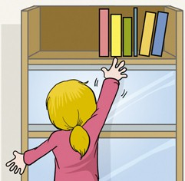 | 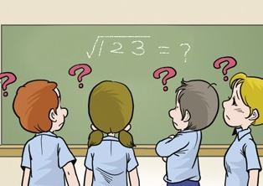 | 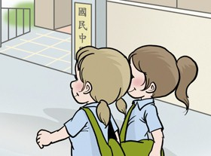 | 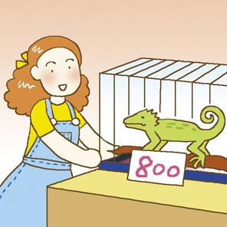
二、請注意聽廣播中的句子，選出適當的回應句，並將正確答案的英文代碼A、B或C劃在答案卡上。
(每題2分，共6分)
5. (A) Of course I know. (B) Really? That’s great. (C) Forget it!
6. (A) They are born from eggs. (B) They want to keep warm. (C) They take a sunbath.
7. (A) It’s up to you. (B) So am I. (C) I’ll help you.
第二部分: 綜合測驗 (共80分)
一、文法選擇 (每題1分，共14分)
(8.~21.)
8. The man ___________ goes to work on foot is my uncle.
(A) where (B) what (C) who (D) which
9. I love to spend my weekend ____________ TV.
(A) watch (B) watching (C) to watch (D) in
10. Dan: In what year _____________ you born? Amy: In 1991. I am 17 years old.
(A) were (B) are (C) did (D) have
11. He bought a computer screen yesterday. It ____________ him NT$4000.
(A) spent (B) took (C) buys (D) cost
12. Why not _________ your shopping on the Net? It may be less expensive.
(A) do (B) to do (C) doing (D) done
13. Cathy: I can’t find the mouse __________ yesterday. Can you help me find it? Tom: No problem.
(A) is bought (B) which bought (C) I bought (D) buying
14. Randy: Did you grow the vegetables ____________? Amy and David: Yes, we did. They are good for your health.
(A) yourself (B) yourselves (C) myself (D) themselves
15. Kevin: Here _________ some fried chicken and hamburgers. Please dig in. Ginny: Thanks for your treat.
(A) has (B) have (C) is (D) are

【第一頁，共五頁，背面尚有試題，請繼續作答】

16. Angel: It’s never __________ late __________ say you’re sorry. Anne: I guess you’re right. I’ll apologize.
(A) so; to (B) too; to (C) so; for (D) too; for
17. Not only you but also Jack ___________ to play on-line games.
(A) love (B) loving (C) to love (D) loves
18. Sally’s read a book about making a website, and __________________.
(A) so is Mark (B) Mark didn’t either (C) so has Mark (D) Neither does Mark
19. The man ______________________ won’t go to the party tomorrow.
(A) which she likes (B) loves lizards (C) Sally goes out with him (D) I always dream about
20. You’ve already built a website about lizards. ____________ you need another one?
(A) How come (B) Why not (C) How about (D) No wonder
21. All the people who were at the party had a lot of fun last night ____________ Jimmy. He lost his job yesterday.
(A) about (B) except (C) besides (D) for
二、克漏字選擇
Philips: I need to write a report about dinosaurs, but there 22 much information in the library.
Carrie: 23 try the Internet?
Philips: I’ve 24 a lot of time surfing the Net already.
Carrie: I know someone who can help you with it.
Philips: Who is that?
Carrie: My college professor. He is a dinosaur 25 I told you about before.
Philips: That’s great! You’re my life saver.
Carrie: With his help, I believe you’ll finish your report 26 .
(每題2分，共16分)
(22.~29.)

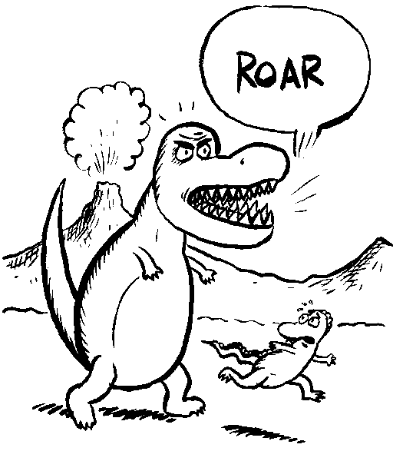
22. (A) has (B) have (C) isn’t (D) aren’t
23. (A) Why not (B) Why don’t (C) How about (D) How come
24. (A) spent (B) cost (C) taken (D) bought
25. (A) keeper (B) group (C) expert (D) knowledge
26. (A) for a while (B) up to you (C) myself (D) in a short time
My Best Friend
Ben and I have known each other for a long time. We’ve become best friends since elementary school because we 27 the same hobbies. For example, both Ben and I love to play basketball. And the singer we like 28 Jolin. We always help each other with our homework. I help him with his math. I really thank him for 29 me English. That’s what good friends are for. I hope we can be friends forever.
31 .


27. (A) interest (B) share (C) keep (D) save
28. (A) is (B) are (C) be (D) have
29. (A) teach (B) to teach (C) teaches (D) teaching
【第二頁，共五頁，背面尚有試題，請繼續作答】
三、閱讀測驗 (每題2分，共20分)
(30.~39.) Facts about Dogs and Cats
 | Dogs   | Cats  
Sweating | A dog sweats from its feet and nose. | A cat sweats from its feet and nose.
Eyesight | A dog sees better than a human at night. | A cat sees about six times better than a human at night.
Visual Range | A dog has a visual range of 250-280 degrees | A cat has a visual range of 185 degrees
Lifespan | A dog usually lives for 14-15 years. | A cat can usually live for more than 16 years.
Bathing | A dog usually has to take a bath every week. | A cat can do without bathing or once a month.
Teeth number | A dog has 42 teeth. | A cat has about 30 teeth.

sweat 流汗 eyesight 視力 visual range 視線範圍 lifespan 壽命 blind 瞎的 deaf 聾的
30. If you want to keep a pet but you don’t have time to wash it often, what kind of pet would you choose?
(A) A cat. (B) A dog. (C) Both of the above (D) None of the above.
31. If you stand a little behind an animal, which animal is more likely to see you?
(A) A cat. (B) A dog. (C) Both of the above (D) None of the above.
32. Which of the following statements is true?
(A) A cat has more than 40 teeth. (B) A dog sweats from its tail.
(C) A dog usually lives longer than a cat. (D) A dog’s visual range is wider than a cat’s.
Happy Mall On-line Store
Item Number: JJ112800  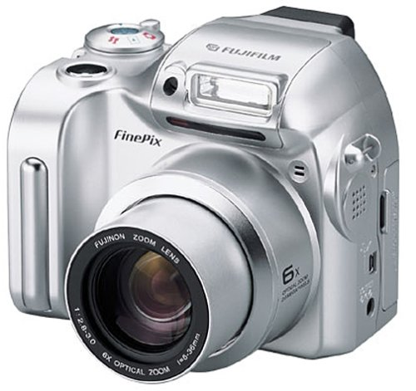  Price: NT$9000  Color: silver □ yellow  - black □ red  Image Sizes: □ 2592×1944 □ 2048×1536  1024×768 □ 640×480  Weight: 150 g  Quantity:  Shipping cost: NT$200 (less than 1 kg) | Name: Jeremy Yen  Phone: (02) 25678899  Cell Phone: 0912555333  E-mail: jeremy@happymall.com  Address: 20F No. 25, Rd. Long-Long, Taipei, Taiwan, R.O.C.  - Credit card  Card number: 1358-4112-5637-4789  Due Date (Month / Year): 12 / 10  □ ATM  - Total Amount: NT$9000  + NT$200 (shipping)  NT$9200  Send Now
【第三頁，共五頁，背面尚有試題，請繼續作答】
33. How will Jeremy pay for the camera?
(A) In cash. (B) By credit card. (C) By ATM. (D) By check.
34. How much will Jeremy pay if he wants to buy two cameras on HappyMall website?
(A) NT$9000. (B) NT$9200. (C) NT$18200. (D) NT$18400.
35. Which of the following statements is true?
(A) Jeremy lives in Taichung. (B) Jeremy can use his credit card until October, 2012.
(C) Jeremy doesn’t have a cell-phone. (D) The shipping cost for the camera is NT$200.
(Cathy and Betty are talking about different kinds of monsters.)
Ugly | Graceful | Beauty | Heady | Dummy
 |  |  |  | 
Coolie | Oldie | Dirty | Angry
 |  |  | 
Cathy: Betty, there are so many kinds of monsters here!
Betty: That’s interesting! What kind of monster do you like?
Cathy: I love the one which is dancing and has only a tie around its neck.
Betty: Oh, really? But I like the monster with only one eye and gloves.
Cathy: Who is the best swimmer?
Betty: I think it should be Coolie, which has a long tail.
Cathy: Well, which one can eat most food?
Betty: I guess that could be Dirty. He has a very large mouth.
Cathy: Don’t you see a monster that has three heads? I think it can eat more.
Betty: I’m so hungry now. Let’s eat like monsters!
36. Which monster does Betty like?
(A) Oldie. (B) Graceful. (C) Ugly. (D) Dirty.
37. Which monster does Cathy think that can eat most food?
(A) Heady. (B) Dirty. (C) Angry. (D) Beauty.
38. How do the monsters get their names?
(A) By their looks. (B) By their colors. (C) By their ages. (D) By their sizes.
39. Which of the following statements is true?
(A) Angry is the monster that wears a sweater. (B) Both Betty and Cathy like Dummy.
(C) Betty thinks the best swimmer is the one with a jacket. (D) Betty can eat a monster.
【第四頁，共五頁，背面尚有試題，請繼續作答】
四、文意字彙：請根據提示的首尾字母寫出合乎句意的英語單字 (每題2分，共12分)
40. Our l___________t product is a mouse that looks like a pig. I can also give you a discount if you want it.
41. The notebook computer is pretty light. It’s easy for me to c___________y around everywhere I go.
42. She couldn’t find Jack’s home. She forgot his home a____________s.
43. Mini skirts are getting more c___________n now. More and more girls in the streets are wearing them.
44. The Government bans smoking in public because smoking is h___________l to our bodies.
45. When I go to America for traveling, I would like to go to small towns and taste their l___________l food.

五、依提示作答 (每題2分，共10分)
46. Dan bought a computer. The computer is US$500. (用It cost… 合併成一句)
47. We finished the report. No one helped us. (加入反身代名詞)
48. The question is very difficult.
Tom can’t answer the question. (用too…to…合併成一句)
49. The writer was J.K. Rowling.
The writer wrote Harry Potter. (用關係代名詞合併句子)
50. I didn’t invite the girl to the party.
Everyone likes the girl. (用關係代名詞合併句子)

七、整句式翻譯 (每題3分，共18分，錯一處，扣1分)
51. 她是那個每天寫電子郵件給你的女孩，不是嗎?
52. 全世界最高的男人超過八英呎高。
53. 那個他們在網路上參加的討論群組是關於蜥蜴的。
54. 他總是惹上麻煩並帶給他家人頭疼的問題。
55. 網路上付賬單很方便。
56. 他不喜歡跟別人交換意見。他總是自己做事情。

【第五頁，共五頁，本試題到此結束，作答完畢，請確實檢查】
臺北市立龍山國中97學年度第1學期九年級英語科第3次定期評量答案卷
________ 年________ 班_________ 號 姓名 ________________ 任課教師: ________________

注意: | 1.本試題卷共有五頁，請記得換頁作答。  2.1-39題為單選選擇題，請以2B鉛筆將各題正確答案的英文代碼劃在答案卡上。  3.40-56題為寫作題，請在答案卷上作答。

四、文意字彙：請根據提示的首尾字母寫出合乎句意的英語單字 (每題2分，共12分)
40. |  | 41. |  | 42.
43. |  | 44. |  | 45.
五、依提示作答 (每題2分，共10分)
46.
47.
48.
49.
50.
六、整句式翻譯 (每題3分，共18分，錯一處，扣1分)
51.
52.
53.
54.
55.
56.

臺北市立龍山國中97學年度第一學期九年級英語科第3次定期評量答案卷
第一大題~第三大題
1. | 2. | 3. | 4. | 5. | 6. | 7. | 8. | 9. | 10. | 11. | 12. | 13. | 14. | 15. | 16. | 17. | 18. | 19. | 20.
A | B | B | B | C | C | A | C | B | A | D | A | C | B | D | B | D | C | D | A
21. | 22. | 23. | 24. | 25. | 26. | 27. | 28. | 29. | 30. | 31. | 32. | 33. | 34. | 35. | 36. | 37. | 38. | 39.
B | C | A | A | C | D | B | A | D | A | B | D | B | C | D | D | A | A | C
四、文意字彙：請根據提示的首尾字母寫出合乎句意的英語單字 (每題2分，共12分)
40. | latest | 41. | carry | 42. | address
43. | common | 44. | harmful | 45. | local
五、依提示作答 (每題2分，共10分)
46. | It cost Dan US$500 to buy the computer.
47. | We finished the report ourselves. No one helped us.
48. | The question is too difficult for Tom to answer.
49. | The writer who/that wrote Harry Potter was J.K. Rowling.
50. | I didn’t invite the girl who/that everyone likes to the party.
六、整句式翻譯 (每題3分，共18分，錯一處，扣1分)
51. | She is the girl who/that writes E-mails to you every day, isn’t she?/  She’s the girl who/that writes you E-mails every day, isn’t she?
52. | The tallest man in the world is over/more than eight feet tall.
53. | The discussion group which/that he joins(ed) on the Net/Internet is about lizards.
54. | He always gets into trouble and gives his family a big headache/gives a big headache to his family.
55. | Paying bills on the Net/on the Internet is (very) convenient. /It is (very) convenient to pay bills on the Net/Internet. To pay bills on the Net/Internet is (very) convenient.
56. | He doesn’t like to exchange opinions/ideas with others. He always does things himself.
聽力測驗
- 第一大題、請注意聽廣播中的敘述，符合圖意，填A；不符合圖意，填B。
1. The girl is too short to get the books.
2. The math question which is on the blackboard is very easy.
3. Judy usually goes to school herself.
4. It cost her 8000 dollars to buy the lizard.

- 第二大題-請注意聽廣播中的句子，選出適當的回應句，並將正確答案的英文代碼A、B或C劃在答案卡上。
5. How is your weekend going?
6. How do the lizards keep warm?
7. Should I choose to stay at home or join the winter camp this year?

