臺北市龍山國民中學97學年度第1學期七年級英語科第3次定期評量試題卷
版本: 翰林版一上 考試範圍: Unit6-Unit8，Reveiw3
(請將第1-34題的答案畫在電腦卡上)
第一部分：聽力測驗（共二十分）
本測驗共有四大題，每一小題都會播放兩次，請同學注意聽廣播，仔細作答
一、根據你所聽到的內容，選出你所聽到的單字。（每題一分，共五分）
1. | （A）grandpa | （B）grandson | （C）grandparents
2. | （A）Tuesday | （B）Monday | （C）Thursday
3. | （A）foot | （B）food | （C）fruit
4. | （A）weekend | （B）weather | （C）weekday
5. | （A）weekends | （B）week | （C）Wednesday

二、根據你所聽到的內容，選出符合圖意的句子。並將正確答案的英文代碼A、B或C劃在答案卡上。（每題一分，共三分）
 . 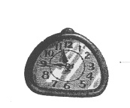 .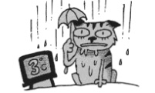
6
7
8

三、根據你所聽到的對話內容，選出正確的答案。（每題二分，共六分）

9. | （A）He is using the hula hoop.
 | （B）He is doing his homework.
 | （C）He is riding a bike.

10. | （A）David’s birthday is on Tuesday.
 | （B）David’s birthday is on Friday.
 | （C）David’s birthday is on Wednesday.

11. | （A）The Christmas party is at 8:15 at night.
. | （B）The Christmas party is at 8:20 p.m.
 | （C）The Christmas party is at 8:40 p.m.

四、聽下列對話，根據內容，回答第12~14題，選出最適合的答案。（每題二分，共六分）
12. | （A）It’s spring now.
 | （B）It’s summer now.
 | （C）It’s winter now.

13. | （A）It’s cloudy and cool in Taipei.
 | （B）It’s sunny and warm in Taipei.
 | （C）It’s hot and wet in Taipei.

14. | （A）Summer is Andy’s favorite season.
 | （B）Fall is Andy’s favorite season.
 | （C）Spring is Andy’s favorite season.

第二部分：綜合測驗（共三十分）
一、語法測驗（每題二分，共二十分）
15. Peter： Look! Isn’t that Mary?
Amy： No, . She’s listening to music in her room.
(A) it is (B) it isn’t (C) she is (D) he is not
16. Ken： are you doing now ?
Mary： I am studying English.
- How (B) Where (C) What (D) Who
17. My sister is sick. She is lying (躺) bed now .
(A) in (B) at (C) on (D) to
18. John： What day is today?
Sue： Monday.
(A) this (B) the (C) it (D) a
19. Amy: Is John’s birthday party 7:00 p.m.?
Ken : Yes, it is.
(A) on (B) at (C) in (D) for
20. Mom： is the weather like in your city today?
Son ： It is rainy and cold.
(A) What (B) Where (C) How (D) Who
21. Amy： Jack’s birthday party is Monday evening. Remember?
Tom： Oh, that’s right. Let’s go buy him a gift.
- to (B) in (C) on (D) at
22. There is rain today. Take an umbrella with you.
- a lot (B) many (C) a lot of (D) any
23. Mom：Avoid the TV when you do your homework. You have to study the desk.
John ：OK.
- on (B) at (C) to (D) with
24. Mary：What are John and Mary doing in the park? Judy：They kites in the park.
(A) is flying (B) fly (C) are flying (D) take

二、克漏字填空：（每題一分，共五分）
It’s Sunday morning now. Harry Porter is in the park. He 25 baseball with his friends.
Harry’s sister, Mary, is dancing with their grandma.
It’s afternoon. Harry and his family are 26 a farm. 27 many interesting farm animals.
Mary is playing with some rabbits, and Harry is riding a horse. Their parents are walking and
talking, and their grandparents 28 the monkeys near the tree.
It’s evening now. The Porter family 29 at home. They are having a barbecue in the yard. They are very happy.

25. | (A) is having | (B) is playing | (C) play | (D) playing
26. | (A) on | (B) in | (C) to | (D) for
27 | (A) It has | (B) There is | (C) There are | (D) It is
28. | (A) are feeding | (B) is feeding | (C) feed | (D) feeding
29. | (A) am | (B) is | (C) has | (D) have

三、閱讀測驗：（每題一分，共五分）
（一）
Day  Time | Sunday  (1/18) | Monday ~Thursday  (1/19~1/22) | Friday  (1/23) | Saturday  (1/24)
18:00~19:00 | Cartoons | Let’s Talk in English | Six Friends | Jenny’s Kitchen
19:00~20:00 | MTV Time | Taiwan News | Family | Movie:  Cats and Dogs
20:00~21:00 | Movie: Tomorrow | Talk Show | Sports News | Movie:  Cats and Dogs
21:00~22:00 |  | Sports News | Movie: Happy Feet | Cute Animals
30. It’s 8:30 p.m. on Saturday. What is on TV?
(A) Sports News. (B) Cats and Dogs.
(C) MTV Time. (D) Happy Feet.
31. What is on TV every day（每一天）from Monday to Friday?
(A) Taiwan News. (B) Let’s Talk in English.
(C) Sports News. (D) Talk Show.
32. Today is Sunday. Mary wants to see a movie. What movie is on TV?
(A)Tomorrow. (B) Happy Feet.
(C) Cats and Dogs. (D) Six Friends.

（二）
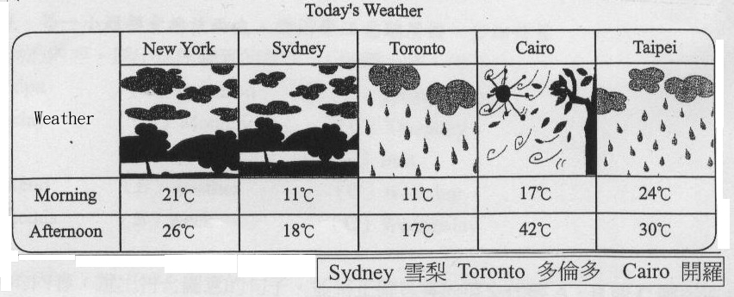
33. How is the weather in Taipei?
(A) It’s windy. (B) It’s sunny.
(C) It’s cloudy. (D) It’s rainy.
34. It’s hot and windy today. What city is it?
(A) Cairo. (B) Taipei.
(C) New Year. (D) Sydney.

第三部分：紙筆測驗（共五十分）
一、文意字彙：（每題二分，共十六分）
35. Tomorrow is Christmas. Amy is d ting the Christmas tree now.
36. Don’t go to bed after m t. （12:00） You have classes tomorrow.
37. Mike：What is your brother doing? Peter： He is k king a ball.
38. Leaves on the trees are yellow and orange in New York in a n.
39. Students go to school from Monday to Friday. They have no classes on the w nd .
40. There are many d t flowers and trees in spring in the park.
41. We are having a big t y on Christmas day.
42. John：The w d is too strong. Please close the windows.
二、根據提示寫出正確的動詞形式：(利用提示字完成各句, 並做適當變化)(每題二分,共十分)
wait run sit ride dance come watch take
43. Lulu: Hi, John. Who you for here?
John: My sister, Mary.
44.Girls, and dance with me.
45. Be careful! A little dog after your car.
46. Lisa’s parents a basketball game on TV now.
47. Ken: Aunt Sue on the sofa? John: No. She’s standing beside the table.

三、看圖詳答下面問題：（每題二分，共八分）
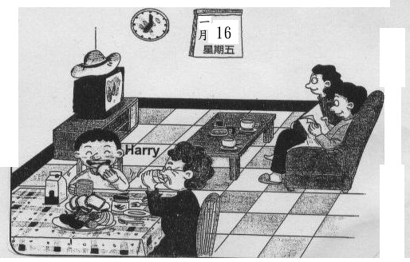

48. What season is it in the picture?
49. Where is the hat?
50. What is Harry doing?
51. How many people are there in the living room?

四、翻譯：（第52~53，55~56題，每題三分，54題四分，,每錯一處扣一分，共十六分））
52.一年有四季。
53. David正在跟他的爺爺一起打太極拳。
54.紐約的冬天對Kevin來說太冷了。
55.那些呼拉圈是今晚在Amy派對上要用的。
56.今天有一點熱。讓我們吃一些冰淇淋吧！
It’s a bit hot today. !

（試題結束，同學請仔細檢查。）

臺北市立龍山國民中學97學年度第1學期七年級英語科第3次定期評量（聽力稿）
版本： 考試範圍:
第一部分：聽力測驗
本測驗共有四大題，每一小題都會播放兩次，請同學注意聽廣播，仔細作答
- 根據你所聽到的內容，選出你所聽到的單字。
  - 唸：John is talking with his grandson on the phone.
  - 唸：Today is Tuesday, and it is 9:30 now.
  - 唸：My favorite food is ice cream.
  - 唸：The weather today is really bad. Don’t go out.
  - 唸：The comic books are interesting. I usually read them on weekends.

- 根據你所聽到的內容，選出符合圖意的句子。並將正確答案的英文代碼A、B或C劃在答案卡上。
6、A：The boy is playing with his grandfather.
B：The boy is waiting for his grandfather.
C：The old man is talking with the boy.
7、A：It is eleven forty-five.
B：It’s nine o’clock.
C：It’s nine thirty.
8、A：It’s sunny and hot.
B：It’s raining and cold.
C：It’s warm and dry.

- 根據你所聽到的對話內容，選出正確的答案。
唸 9、Amy：Is John riding a bike?
Brain：No, he isn’t. He is using the hula hoop.
Q：What is John doing?

10、Mike：Today is David’s birthday. Remember?
Mary：Today? Isn’t his birthday on Thursday?
Mike：No, it’s on Wednesday.
Q：What day is David’s birthday?

11、Mary：What time is the Christmas party at Amy’s house?
Ken ： It’s at eight fifteen p.m.
Mary： I see. Then, see you later.
Q：Whet time is the Christmas party?

四、聽下列對話，根據內容，回答12~14題，選出最適合的答案。
（Andy and Patty are talking on the phone .）
Andy：Hey! How’s the weather in New York?
Patty：It’s cool here.
Andy：Cool? It’s hot today in Taipei.
Patty：How is the summer in Taipei?
Andy：It’s hot and wet.
Patty：Summer is my favorite season. How about you?
Andy：Fall is my favorite season. It’s cool and windy, and the leaves on the trees are beautiful. And it’s a good time for a barbecue.
Patty：That’s nice. Oh, it’s 11:30 p.m. Time for bed. Good night.
Andy：OK. Good night.
12、Q：What season is it now?
13、Q：What’s the weather like in summer in Taipei?
14、Q、What’s Andy’s favorite season?

聽力測驗結束

臺北市立龍山國民中學97學年度第1學期七年級英語科第3次定期評量答案卷
______年______班______號 姓名：_______________ 任課教師：_______________

注意： | 1.本試題卷共有五頁，請記得換頁作答。
注意： | 2. 1- 34題為單選選擇題，請以2B鉛筆將各題正確答案的代碼劃在答案卡上。
注意： | 3. 35- 56題為寫作題，請在答案卷上作答。
一、文意字彙：請根據提示的首尾字母寫出合乎句意的英語單字(每題二分，共十六分)
35. |  | 36. |  | 37. |  | 38.
39. |  | 40. |  | 41. |  | 42.
二、根據提示寫出正確的動詞形式：(利用提示字完成各句, 並做適當變化) (每題二分,共十分)
43. |  |  | 44. |  |  | 45.
46. |  |  | 47.

三、看圖詳答下面問題：（每題二分，共八分）

48.
49.
50.
51.
六、翻譯（共十六分）
（二）整句式翻譯：（第52~53，55~56題，每題三分，54題四分，,每錯一處扣一分，共十六分）
52.
53.
54.
55.
56.

臺北市立龍山國民中學97學年度第1學期七年級英語科第3次定期評量答案
______年______班______號 姓名：_______________ 任課教師：_______________
聽力答案:
1. B | 2. A | 3. B | 4. B | 5. A | 6. C | 7. A | 8. B | 9. A | 10. C
11.A | 12.B | 13. C | 14 B | 15.B | 16.C | 17.A | 18.C | 19.B | 20. A
21.C | 22.C | 23. B | 24.C | 25.B | 26.A | 27.C | 28.A | 29.B | 30.B
31.C | 32.A | 33. D | 34.A

注意： | 1.本試題卷共有五頁，請記得換頁作答。
注意： | 2. 1- 34題為單選選擇題，請以2B鉛筆將各題正確答案的代碼劃在答案卡上。
注意： | 3. 35- 58題為寫作題，請在答案卷上作答。
一、文意字彙：請根據提示的首尾字母寫出合乎句意的英語單字(每題二分，共十六分)
35. | decorating | 36. | midnight | 37. | kicking | 38. | autumn
39. | weekend | 40. | different | 41. | turkey | 42. | wind

二、根據提示寫出正確的動詞形式：(利用提示字完成各句, 並做適當變化) (每題二分,共十分)
43. | are | waiting | 44. | come |  | 45. | is | running
46. | are watching |  | 47. | Is | sitting

三、看圖詳答下面問題：（每題二分，共八分）

48. | It’s winter.
49. | The hat / It is on the TV.
50. | He is eating.
51. | There are four people in the living room.
六、翻譯（共十六分）
（二）整句式翻譯：（第52~53，55~56題，每題三分，54題四分，,每錯一處扣一分，共十六分）
52. | There are four seasons in a year.
53. | David is doing tai chi with his grandfather / grandpa.
54. | The winter in New York is too cold for Kevin.
55. | These hula hoops are for Amy’s party tonight.
56. | Let’s have / eat some ice cream!

