臺北市立龍山國民中學97學年度第1學期九年級英語科第2次定期評量
版本：康軒國中英語 考試範圍：第五冊第4課 ~ Review 2 考試時間：50分鐘

注意： | - 本試卷共有五頁，請記得翻頁作答。  - 1- 35題為單一選擇題，請以2B鉛筆將各題正確答案的代碼劃在答案卡上。  - 36-52題，請在答案卷上作答。

第一部分 共有四大題：60% (請在答案卡上劃記)
- 聽力測驗：10% (每題2分)
        - 聽廣播中的句子，選出符合圖意的句子。
  1.  Peter’s  Susan’s  Sam’s |   2.  Sally |   3.  How are you?  I’m fine, and you?  George  Mary
        - 聽廣播中的對話及問題，選出最適當的答案
  - (A) Her dog misses her a lot. (B) Her dog is gone. (C) The boy doesn’t want to help her.
  - (A) He likes traveling alone. (B) He likes both. (C) He likes traveling with a group of people.
- 語法測驗：10% (每題1分)
  - Bob: James is a cook.
Mandy: No wonder he often reads books __________ cooking.
(A) in (B) with (C) of (D) about
  - Frank has always wanted to visit England since he ________ Harry Potter.
(A) reads (B) was reading (C) read (D) has read
  - Julia: Carol and I have two similar T-shirts.
April: But I remember Carol’s is red and ________ is black, right?
(A) you (B) your (C) yours (D) yourself
  - Nancy: There are many tall building in New York, aren’t there? Mark: ___________
(A) Yes, there are. (B) Yes, they are. (C) No, they aren’t. (D) No, there aren’t.
  - Cathy: Hello, may I speak to Jason?
May: I’m sorry. He’s not home.
Cathy: Can I call him later?
May: Well, he _________ to Ilan. Maybe you can try his cell phone number.
(A) have been (B) have traveled (C) has been (D) has gone
  - Linda: Did you hear someone _______ loudly last night?
Jason: Yes, did you hear that, too? It was so annoying.
(A) sang (B) singing (C) to sing (D) sung
  - Laura: Who __________ dinner for your family?
Bob: My mom and my grandma do.
(A) cooks (B) cook (C) cooked (D) is cooking
  - While we were talking about ________, our teacher walked in. So, we stopped talking.
(A) anything new (B) everything fun (C) nothing interesting (D) something exciting
  - Monica: __________ have you learned to play the piano?
Jack: For more than seven years, I think.
(A) How long (B) How often (C) How many times (D) How many
  - Jay: Mandy has never visited the British Museum before, ________? Vivian: No, never.
Jay: No wonder she looks forward to the trip so much.  look forward to 期待
(A) doesn’t she (B) does she (C) hasn’t she (D) has she
- 克漏字測驗：14% (每題2分)
(16-19)
Dear Lori,  How’s everything in Taipei? I’m happy to get your letter.  You know what? My parents 16 to England to visit me right now. We went to London last weekend. We had a good time but it rained on Sat. Have you been to the British Museum? It’s so big! I spent hours in the Egyptian section. Can you believe they have real mummies on display! We also 17 on Oxford street and at Harrods. I think my mom bought enough gifts for everyone.  We 18 Stratford next week. My friends told me it’s a lovely town. It’s also Shakespeare’s hometown. I’m so 19 the trip.  Hope you can come to visit me next summer vacation.  Sincerely,  Vicky   Egyptian section 埃及區 mummy 木乃伊 display 展覽 | Lori Chen
 | 46, NaNing Rd
 | Taipei, 108
 | Taiwan, ROC
  - (A) come (B) came (C) have come (D) will come
  - (A) will go jogging (B) goes dancing (C) went shopping (D) go biking
  - (A) go to (B) are going to (C) have gone to (D) went to
  - (A) interesting to (B) excited about (C) surprising to (D) bored with
(20-22)
Hank: Hi, Alice. Did you decide where to go during winter vacation?
Alice: Yeap, I will take a trip to Tokyo with my sister. What about you?
Hank: 20 Do you have any suggestions?
Alice: How about Bali Island? You love the sunshine and the beach, don’t you?
Hank: Sounds good. 21
Alice: Then, why not go to Kenting? You still can enjoy the sunshine and have fun at the beach.
Hank: That’s a good idea. I can also visit some famous scenes of Cape No. 7.
 suggestion 建議
 Cape No. 7 海角七號
 forecast 預報
Alice: By the way, 22 I don’t know what kind of clothes I should bring.
Hank: I have no idea, either. Maybe you can check the weather forecast from the Internet.
  - (A) I haven’t decided yet. (B) I’ve been to Tokyo many times.
(C) Congratulations! How did you do that? (D) Thank you for inviting me.
  - (A) I’d like to visit Bali Island. (B) But I don’t have enough money.
(C) I need to make a list. (D) You won’t want to miss anything.
  - (A) are you ready to go to Tokyo? (B) can I get something special in Tokyo?
(C) are jeans and T-shirts OK in Tokyo? (D) what’s the weather like in Tokyo now?
- 閱讀測驗：26% (每題2分)
(23-25)
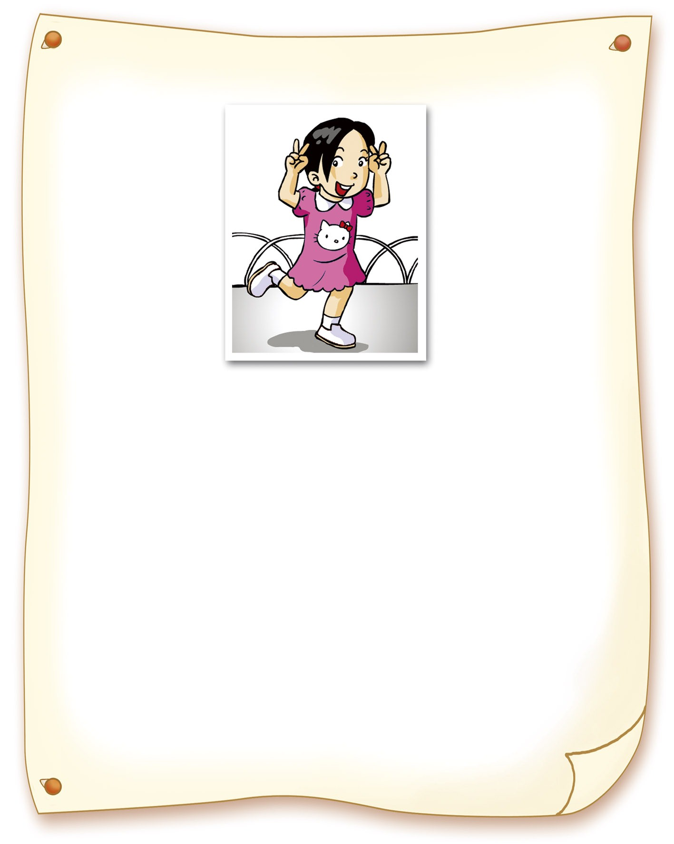  Date: Nov. 25, 2005  Name: Gina Huang  Date of Birth: Feb. 25, 1998  Age Now: 10  Eyes: Black Hair: Black  Clothes: a pink Hello Kitty dress  Missing: Oct. 10, 2005  Missing From: Youth Park, Taipei | Gina was last seen with her dog in Youth Park, Taipei, on October 10, 2005, between 3:00 and 3:30 p.m. The dog was found the next day but not Gina. Nobody has seen her since that day. She was wearing a pink Hello Kitty dress and white tennis shoes. If you see her, please call the help line: 0800-049-588.
  - What happened to Gina Huang?
(A) She was hurt in an earthquake. (B) She moved to Taipei.
(C) She was gone with her dog. (D) She was missing.
  - When was Gina last seen?
(A) On Nov. 25, 2005. (B) On Feb. 25, 1998.
(C) On Oct. 10, 2005 (D) On Oct. 11, 2005
  - How long has Gina been missing?
(A) One month. (B) Three years.
(C) Four years. (D) Ten years.
(26-28)
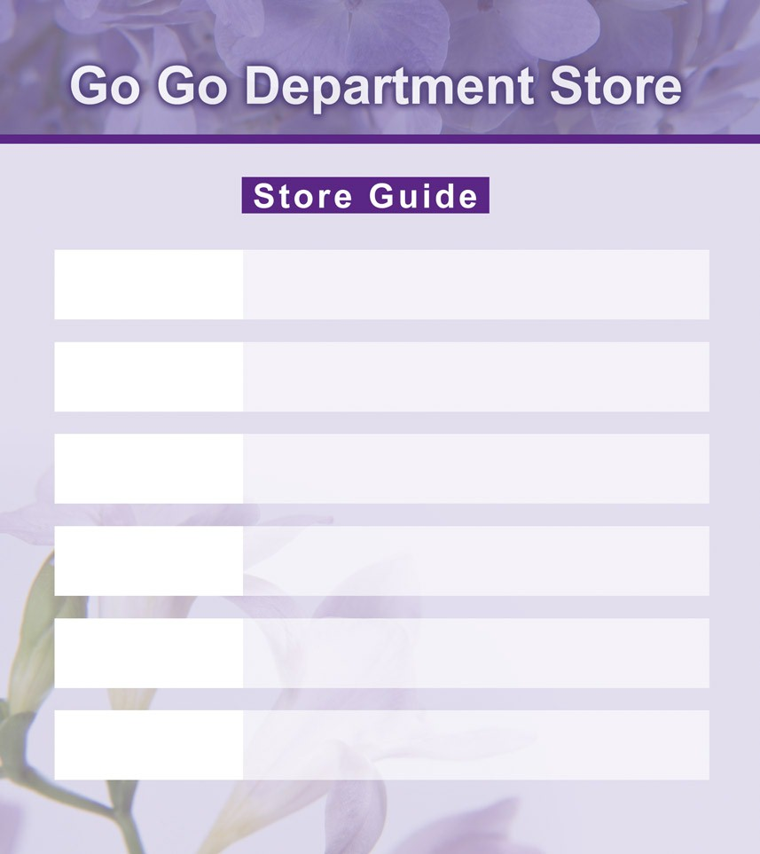
＊＊＊ Happy Department Store ＊＊＊
Third Floor Men’s Wear Seventh Floor Queen Theater

Second Floor Women’s Wear Sixth Floor Children’s Wear

Ground Floor Kiki Supermarket / Yum Restaurant Fourth Floor Radios / TVs / Computers

First Floor Shoes / Beauty Products Fifth Floor Toys / Sports

  - Ms. Chen wants to get some food to cook dinner for her family. Which floor is the right place for her?
(A) The ground floor. (B) The seventh floor.
(C) The first floor. (D) The sixth floor.
  - Jeff and his girlfriends are on the seventh floor. What can they do there?
(A) They can eat dinner. (B) They can watch a movie.
(C) They can buy a dress. (D) The sounds of kangaroos.
  - Jeff is looking for something for his Dad as a birthday gift on the third floor. What is he looking for?
    - An MP3. (B) A jacket. (C) A dress. (D) A Teddy bear.
(29-32)

Good morning, everyone. I’m your guide, Jessica. I will show you around in London in next three days.
On the first day, we‘ll visit Buckingham Palace in the morning. You’ll see the changing of the guard. In the afternoon, we’ll visit London Zoo. There are many different kinds of animals there. You may take pictures if you want.
On the second day, we’ll go to Tower Bridge. The scenery there is beautiful. You’ll love it. After that, we’ll visit the British Museum. You can spend the whole afternoon there looking at treasures from all over the world.
On the third day, I’ll show you the most famous train station in London: King’s Cross Station. Thanks to J. K. Rowling and her Harry Potter books, hundreds of thousands of visitors go there for a look every year. And before you have to go home, I’ll take you for an exciting ride on London Eye. You’ll see London from high above. The view is wonderful. So, are you all ready? Let’s go!

  - What will the visitors do on the second day morning in London?
(A) They will have a ride on London Eye. (B) They will see the treasures from all over the world.
(C) They will take pictures with animals. (D) They will visit Tower Bridge and enjoy the scenery.
  - Sam is a big fan of Harry Potter. Which place may be his favorite?
(A) King Cross Station. (B) London Eye. (C) Tower Bridge. (D) Buckingham Palace.
  - Megan is interested in old treasures and the changing of the guards. She will be excited to visit __________.
(A) Buckingham Palace and the British Museum (B) London Zoo and Buckingham Palace
(C) King Cross Station and Tower Bridge (D) London Eye and the British Museum
  - Which is true?
(A) Visitors will go to Buckingham Palace for Harry Potter.
(B) Visitors will spend the whole morning in the British Museum.
(C) Jessica will spend three days showing visitors around London.
(D) Visitors will visit London Bridge on the second day.
(33-35)

Each year, many teenagers run away from their home. Parents get worried and start to think- why do so many teenagers run away?
There are many reasons that teens run away or go missing from home.
Some young boys and girls think their parents don’t understand them and care about them. They can’t get along well with their parents, so they leave home. Some may meet problems at school. For example, they have difficulties in their studies and don’t know what to do. Or, some may spend too much time and money playing on-line games and making net-pals. They choose to leave home and just want to stay in the Internet café or with net-pals.
 reason原因 organization 機構  offer 提供 dial 撥號
If your kid runs away, you can…
- Call the police right away.
- Call everyone your child knows and ask for help.
- Search everywhere.
- Check everything your kid left, such as phone bill. It’s helpful to find the kid.
In Taiwan, many organizations offer help for missing or runaway teenagers. You can get help from…
- The Police (by calling 119 from any phone)
- Child-line (children and young people can dial 0800-049-880 for help)
- Missing Kids TW ( http:// www.missingkids.org.tw/ or e-mail to missing@cwlf.org.tw)
  - Which is NOT the reason that teenagers run away or go missing?
(A) They can’t get along with their parents. (B) They decide to stay with net-pals.
(C) They have difficulties in playing on-line games. (D) They don’t know what to do to their study difficulties.
  - If your kid runs away, what can you do?
(A) Call 119 right away. (B) Call everyone your child knows.
(C) Look for him/ her in every place. (D) All of the above.
  - Which is true?
(A) Young kids can call 0800-049-880 for making friends.
(B) Teenagers can make net-pals by e-mail to missing@cwlf.org.tw.
(C) Having difficulties in studies is the only reason that teenagers run away.
(D) One of the reasons that teens run away is that they can’t get along well with their parents.
第二部分 共有四大題：40% (請在答案卷上作答)
- 根據文意，填入適當的單字：12% (每題2分)
  - On my way to school, a f r asked me how to go to the World Trade Center.
  - It’s getting colder. Carter wants to buy a new pair of g s.
  - We can get more k e by asking questions.
  - Pet: Did you hear of the surprising news? Do you believe it? Peggy: I don’t know. P s it’s true.
  - The g d was still wet because of heavy rain yesterday.
  - Jill: When I called you last night, n y answered the phone. Where did you go?
Steve: Oh, I went to a movie with my parents.
- 依提示作答：10% (每題2分)
  - The man is a popular singer. The man has long hair. (用介係詞合併兩句為一句)
44. Mrs. Green

  - Mr. Lin has a beautiful wife. (在句尾加入附加問句)
  - Can’t Mrs. Green dance? (根據圖片簡答)
  - David moved to London three years ago. David still lives in London now.
(請用現在完成式合併成一句)
  - Lisa’s dress is NT$ 1500 dollars. My dress is NT$ 1000 dollars.
(以Lisa’s dress …為句首，並用「比較級」和「所有代名詞」將兩句合併 )
- 翻譯：18% (每題3分)
  - 你曾經夢想過成為一位警官嗎？
  - 美式英語在很多方面不同於英式英語。
  - 雖然我們的旅館裡有毛巾和牙刷，但我們仍須帶我們的。
  - 抽煙讓Tim的健康更糟。他很快地就對此後悔了。
  - 例如，節目這個字，在英式英語中拼為programme.
  - 那位穿著灰色外套的男孩昨天幫助Nana 找到她的雨傘。

臺北市立龍山國民中學97學年度第1學期九年級英語科第2次定期評量 聽力測驗
(稿件) (每題唸兩次，每題間隔2秒，總長度請在7分鐘內結束)
一、 聽廣播中的句子，選出符合圖意的句子。
- (A) The sweater is Sam’s.
(B) The dress is Susan’s.
(C) The jeans are Peter’s.

2. (A) Sally has studied for twenty minutes.
(B) Sally has studied since ten o’clock.
(C) Sally has studied for three hours.

3. (A) Mary and George speak the same language.
(B) Mary and George are talking in different languages.
(C) Mary and George are talking in Chinese.
二、 聽廣播中的對話及問題，選出最適當的答案。
4. Boy: You look unhappy. What happened?
Girl: My dog’s missing. I’ve looked for him for more than two weeks.
Boy: Oh, I’m sorry to hear that.
Question: Why is the girl unhappy?

5. Man: Jane, do you like to travel alone or with a group of people?
Woman: I prefer to travel alone. How about you, Sam?
Man: I like to travel with a group of people because it’s much safer than traveling alone.
Question: Which does Sam like, traveling alone or traveling with a group of people?

臺北市立龍山國民中學97學年度第1學期九年級英語科第2次定期評量
版本：康軒國中英語 考試範圍：第五冊第4課 ~ Review 2 考試時間：50分鐘

班級_____ 座號_____ 姓名_____________
組別_____ 教師_____________

注意： | - 本試卷共有五頁，請記得翻頁作答。  - 1- 35題為單一選擇題，請以2B鉛筆將各題正確答案的代碼劃在答案卡上。  - 36-52題，請在答案卷上作答。

第二部分 共有四大題：40% (請在答案卷上作答)

- 根據文意或中文，填入適當的單字：12% (每題2分)
36 | 37 | 38 | 39 | 40 | 41

- 依提示作答：10% (每題2分)
42
43
44
45
46

- 翻譯：18% (每題3分)
47
48
49
50
51
52

臺北市立龍山國民中學97學年度第1學期九年級英語科第2次定期評量
版本：康軒國中英語 考試範圍：第五冊第4課 ~ Review 2 考試時間：50分鐘
第一部分 共有四大題：60% (請在答案卡上劃記)
1 | B | 2 | C | 3 | A | 4 | B | 5 | C
6 | D | 7 | C | 8 | C | 9 | A | 10 | D
11 | B | 12 | A | 13 | D | 14 | A | 15 | D
16 | A | 17 | C | 18 | B | 19 | B | 20 | A
21 | B | 22 | D | 23 | D | 24 | C | 25 | B
26 | A | 27 | B | 28 | B | 29 | D | 30 | A
31 | A | 32 | C | 33 | C | 34 | D | 35 | D

第二部分 共有四大題：40% (請在答案卷上作答)
- 根據文意或中文，填入適當的單字：12% (每題2分)
36 | 37 | 38 | 39 | 40 | 41
foreigner | gloves | knowledge | Perhaps | ground | nobody
- 依提示作答：10% (每題2分)
42 | The man with long hair is a popular singer.
43 | Mr. Lin has a beautiful wife, doesn’t he?
44 | Yes, she can.
45 | David has lived in London for three years/ since three years ago.
46 | Lisa’s dress is more expensive than mine.
- 翻譯：18% (每題3分)
47 | Have you ever dreamed about being a police officer?
48 | American English is different from British English in many ways.
49 | Though there are towels and toothbrushes in our hotel, we still need to bring ours. /  Though our hotel has towels and toothbrushes, we still need to bring ours.
50 | Smoking makes Tim’s health worse. He soon regrets it.
51 | For example, the word “program” is spelled as “programme” in British English.  The word “program,” for example, is spelled as “programme” in British English.
52 | The/That boy in a gray jacket/coat helped Nana find/to find her umbrella yesterday.

