龍山國中97學年度第1學期九年級英語科第1次定期評量試題卷
版本:康軒 考試範圍: Get Ready-Review1
1
第一部分: 聽力測驗 (共 10 分)
注意： | 1.本試題卷共有五頁，請記得翻頁作答。
注意： | 2. 1- 30題為單一選擇題，請以2B鉛筆將各題正確答案的代碼劃在答案卡上。
注意： | 3. 31- 47題，請在答案卷上作答。
本測驗共有兩大題，每一小題都會唸兩次，請同學們注意聽，仔細作答。
- 請仔細聽廣播中的句子，並將最能符合句意的圖片代碼劃在答案卡上。(每題2分，共6分)
Q 1 |  | Q 2 |  | Q 3
A | B | A | B | A | B
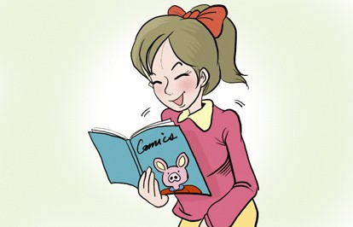 | 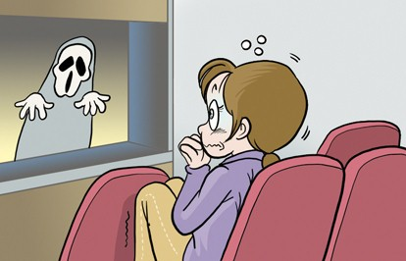 | 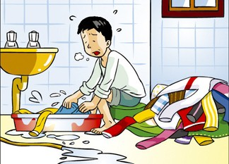 | 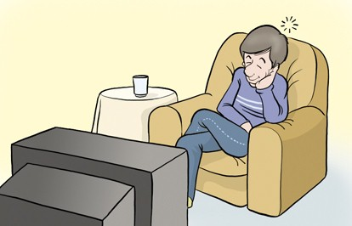 | 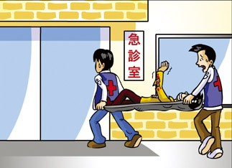 | 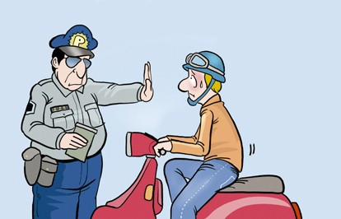
二、請仔細聽廣播中的對話與問題，並將問題的正確答案的代碼劃在答案卡上。(每題2分，共4分)
4. | (A) In a classroom.
 | (B) In a book fair.
 | (C) On the telephone.
5. | (A) He feels interested in it.
 | (B) He feels tired of it.
 | - He feels nervous.

第二部份: 綜合測驗(共90分)
一、語法與字彙測驗 (每題2分，共16分)
6. I was with the TV program and decided to go to bed.
(A) excited | (B) bored | (C) interested | (D) afraid
7. English in many of the elementary schools in Taiwan now.
(A) is teaching | (B) is taught | (C) taught | (D) teaches
8. Mr. Brown, my history teacher, is very , so he is popular with many students.
(A) boring | (B) interested | (C) bored | (D) interesting
9. He was excited passing the exam.
(A) at | (B) to | (C) about | (D) that
10. Traffic rules should always by all drivers at any time.
(A) be followed | (B) are followed | (C) follow | (D) followed
11. the tickets to the final baseball game out last night?
(A) Did ; sell | (B) Was ; sold | (C) Were ; sold | (D) Were ; selling
12. After a day of work, he felt and didn’t want to do anything.
(A) tiring ; tired | (B) tired ; tiring | (C) exciting ; excited | (D) excited ; exciting
13.It’s to have the MRT system for people in Taipei.
(A) convenient | (B) wisely | (C) excited | (D) famous
- 克漏字測驗(每題2分，共16分)
2
【A】
Paul: My sister (14) to the hospital last night. She fainted when she was taking a bath.
Jean: I am (15) the news. What happened to her? Is it serious?
Paul: To become thinner, she took some medicine bought on the Internet.
Jean: In fact, eating less food and (16) more exercise are the best ways to keep fit.
(17) carefully before you buy anything. I hope she could learn a lesson from the
terrible experience.

※ faint昏倒

14. (A) walked | (B) was sent | (C) drove | (D) was invited
15. (A) surprised at | (B) good at | (C) moved by | (D) proud of
16. (A) do | (B) done | (C) to do | (D) doing
17. (A) Think | (B) To think | (C) Thinking | (D) Though
【B】

( On the phone )
Lucy: Staying at home alone makes me feel bored. (18)
Mary: I’d like to, but I can’t. I was asked to clean my room and (19) I also need to
prepare for a math test.
Lucy: Wait, you have a new pet. I never heard of it. Is taking care of pets tiring?
Mary: Sure, it’s not easy. You have to feed it, wash it, and take it out for a walk. Therefore, if you are planning to keep a pet, think twice.
Lucy: That’s true. (20)
Mary: I can have him sit down, shake hands and catch a ball. Why not come to my house and play with him?
Lucy: Sounds like a good idea! (21)
Mary: Great! You can also teach me math. See you later.

18. | (A) How did you feel today? | (B) What happened to you?
 | (C) How about seeing a movie with me? | (D) How will you spend your weekend?
19. | (A) to wash my dog. | (B) to wash my father’s car.
 | (C) to finish my homework. | (D) to buy something in the supermarket.
20. | (A) Where did you buy it? | (B) What does it do?
 | (C) How often do you wash it? | (D) What can it do?
21. | (A) I hope next time you can go to the movies with me.
 | (B) Maybe I can help you wash it.
 | (C) We can have lunch together before the movie starts.
 | (D) Let’s meet at the theater after one hour.
三、閱讀測驗(每題2分，共18分)
【A】There are two houses for sale.
3

A
B

- 30 pine (2 rooms with TV/bath)
- Near Singpu station
- NT$ 3000000
- Call Mr. Wang at
(02) 2336-2788 ( day )
0950-332200 ( night )

- 33 pine( 3rooms )
- Near the bus stop
- NT$ 3500000
- A free car parking
- Call Susan at
(02) 2336-2555( day )
0958-345789 ( night )

※ pine坪

22. Mr. White needs a house. His parents also live with them. He has a 16-year-old son. Which telephone number should he call after 8:00 p.m.?
(A) (02) 2336-2788 | (B) 0950-332200 | (C) (02) 2336-2555 | (D) 0958-345789
23. Which is true?
(A) House A is sold at a lower price.
(B) If you are interested in House B, you can send e-mail to Susan .
(C) House A is bigger than House B.
(D) You can park your car for nothing if you live in House A.
【B】
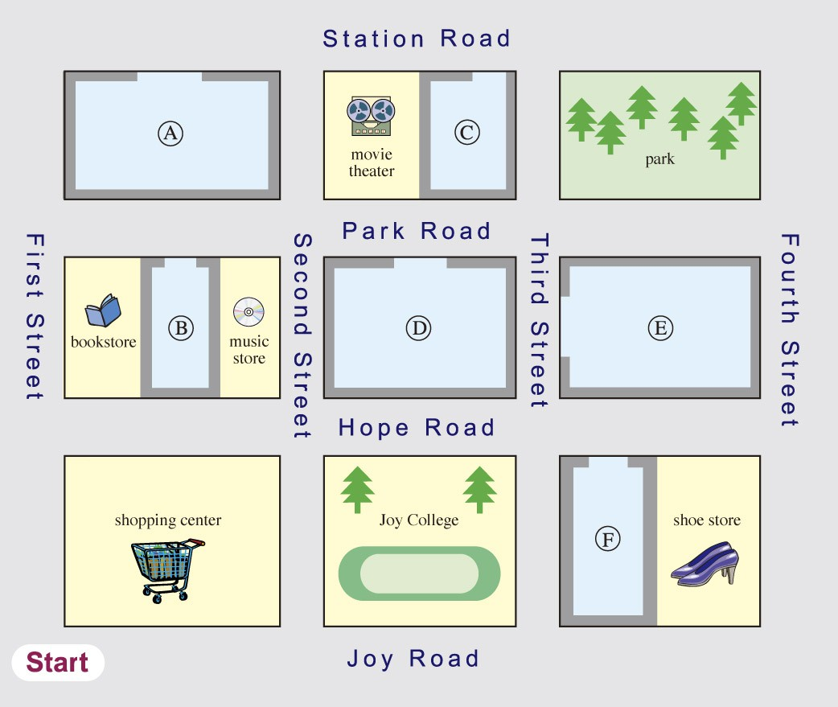
※ advice建議
Jeff: Excuse me. Can you show me how to go to Happy Department Store?
Lucy: Go along the street for two blocks. Take a right turn on Park Road. When you see a movie theater, it’s next to the theater. There’s a bus stop in front of the shopping center. You can also take the bus 33 to go there. It is faster.
Jeff: Thanks for your advice. I’ll take the bus. By the way, is there a 7-11 near here?
Lucy: Well, there’s a 7-11 on Park Road, just between a bookstore and a music store.
Jeff: Thanks a lot again.

24. | Where is Happy Department Store?  4
 | (A) A (B) B (C) C (D) D
25. | What is true about the 7-11?
 | (A) It is beside a shoe store. | (B) It is between First Street and Second Street.
 | (C) It is next to a movie theater. | (D) It is in front of Joy College.
26. | Which is true?
 | (A) The shoe store is on Third Street. | (B) Happy Department Store is on Station Road.
 | (C) Jeff will walk to Happy Department Store. | (D) Jeff will go to Happy Department Store with Lucy.
【C】Mrs. Bush got an invitation.

Date : October 8 ~ 14 ( 10:00a.m. ~ 5:00p.m.)
Place : Taipei World Trade Center
Price : Adult : $200
Children ( Under 12 years old ): half – price
- We have many kinds of rings, necklaces, earrings of all the latest designs.
- All hand-made products are at least 40 % off.
- Special gifts are given to the first 10 guests on the first day.

※ jewelry 珠寶 necklace項鍊 earring耳環 design 設計
27. How long does the fair last?
(A) Six days. | (B) Seven days. | (C) Eight days. | (D) Nine days.
28. Which one is true about the invitation?
(A) The price of the children ticket is $100.
(B) All rings, necklaces, earrings are 40 % off.
(C) The first 10 guests will get special gifts every day.
(D) The fair opens for six hours a day.
【D】
To face high oil price, more and more people take the MRT or ride bicycles instead of driving. Going bicycle riding not only saves energy but also makes us stay healthy. However, there is something to be known before you ride. First, pick up a suitable bike according to your budget and need. For example, fold bicycle is popular because of its small size and is easy to carry around. Second, you must wear a helmet and check your bike before you ride. Avoid wearing a long skirt to keep safe. Third, if you have to ride at night, wear bright color clothes and turn on your lights. Finally, always follow the traffic rules and watch out for other cars when you ride on the street. Beautiful girls don’t forget to do sunburn protection work. Let’s enjoy your wonderful bicycle trip!

※ instead of代替 suitable合適的 according to根據 budget成本 fold摺疊 helmet安全帽 protection保護

29. What is the best title of the reading?
5
(A) How to Ride a Bike?
(B) How to Buy a Cheap Bike?
(C) Traffic Rules for Riding a Bike.
(D) Smart Tips for a Safe Bike Ride.
30. Which is not safe when you ride a bike?
(A) Avoid riding in the dark.
(B) Don’t wear earphones to listen to music.
(C) You must wear a helmet when you ride.
(D) It’s graceful to wear a long skirt.
四、文意字彙 (每題2分，共12分)
31. I have a c e to my favorite country, Japan. I’ll go there on business next week.
32. My father likes to go fishing at the r r in his free time.
※ model 機型
33. The a t is for a computer sale. It says all the models are 30% off.
34. My grandmother is 85 years old. She can’t see clearly w t a pair of glasses.
35. A: Excuse me, where is the nearest bookstore? B: Turn l t and you’ll see it on the
corner.
※ corner 轉角
36. All children in the world are t es to their parents.
37. | { | It may rain tomorrow. |  | ( 用If為句首將兩句合併成一句 )
37. | { | Tom won’t go dancing in the park. |  | ( 用If為句首將兩句合併成一句 )
38. | { | I saw our school team last Friday.  They played baseball on that day. | ( 將兩句合併成一句 )
39. | { | He is tired.  He has to do so much homework. | ( 合併成一句 )
五、依提示作答(每題2分，共10分)
40. Did Mike break the window yesterday? ( 這句改成被動)
41. The soccer game was exciting to everyone. (用 Everyone 改寫)

六、整句式翻譯(每題3分，共18分，錯一處，扣1分)
42. 雖然這個故事是用英文寫的，但是我看得懂。
43. 這個令人震驚的消息可以在報上看到。
44.看漫畫會比收集郵票有趣嗎?。
45. 一個好廣告應該吸引我們的目光去買這個產品。
46. 她家旁邊種了許多種類的花。
47. 許多學生沒有好好利用空閒時間做自己喜歡的活動。
【試題結束。】
臺北市立龍山國民中學九十七學年度第一學期九年級英語科第一次定期考査(聽力稿)
第一部分: 聽力測驗
本測驗共有兩大題，每一小題都會唸兩次，請同學們注意聽，仔細作答。
一、 請仔細聽廣播中的句子，並將最能符合句意的圖片代碼劃在答案卡上。

1. | The girl read an interesting comic book.
2. | The man is tired of washing too many dirty clothes.
3. | The man was stopped by a police officer.

二、請仔細聽廣播中的對話與問題，並將問題的正確答案的代碼劃在答案卡上。

Mary: | Steven, you look unhappy. Are you ready for the English test?
Steven: | Not yet. In fact, I’m nervous now. Too much homework always makes
 | me feel tired. I was too busy to prepare for the test.
Mary: | Why do you say so? What did you do last night?
Steven: | Well, I didn’t do well on the history test yesterday. The teacher asked me to do more exercise. Then I spent one hour doing the tiring homework. I needed something interesting to relax. So I watched TV all night.
Mary: | You spent whole night watching TV. No wonder you was “ so “ busy.
 | Here comes the English teacher. Let’s go back to our seats. You will have more homework tonight.

4. | Where was Steven?
 | (A) In a classroom.
 | (B) In a book fair.
 | (C) On the telephone.
5. | How does Steven feel about the English test?
 | (A) He feels interested in it.
 | (B) He feels tired of it.
 | (C) He feels nervous.

龍山國中97學年度第一學期九年級英語科第1次定期評量答案卷
______年______班______號 姓名：___________ 組別：______ 任課教師：___________
四、文意字彙：請根據提示的首尾字母寫出合乎句意的英語語詞(每題2分，共12分)
注意： | 1.本試題卷共有五頁，請記得翻頁作答。
注意： | 2. 1- 30題為單一選擇題，請以2B鉛筆將各題正確答案的代碼劃在答案卡上。
注意： | 3. 31 - 47題，請在答案卷上作答。
31. |  | 32. |  | 33.
34. |  | 35. |  | 36.

五、依提示作答((每題2分，共10分)
37.
38.
39.
40.
41.

六、整句式翻譯(每題3分，共18分，錯一處，扣1分)
42.
43.
44.
45.
46.
47.

【做答完畢，再檢查一下喔!】

龍山國中97學年度第1學期九年級英語科第1次定期評量答案卷
______年______班______號 姓名：___________ 組別：______ 任課教師：___________
四、文意字彙：請根據提示的首尾字母寫出合乎句意的英語語詞(每題2分，共12分)
注意： | 1.本試題卷共有五頁，請記得翻頁作答。
注意： | 2. 1- 30題為單一選擇題，請以2B鉛筆將各題正確答案的代碼劃在答案卡上。
注意： | 3. 31 - 47題，請在答案卷上作答。
1. | A | 2. | A | 3. | B | 4. | A | 5. | C | 6. | B | 7. | B | 8. | D | 9. | C | 10. | A
11. | C | 12. | A | 13. | A | 14. | B | 15. | A | 16. | D | 17. | A | 18. | C | 19. | A | 20. | D
21. | B | 22. | D | 23. | A | 24. | C | 25. | B | 26. | B | 27. | B | 28. | A | 29. | D | 30. | D
31. | chance | 32. | river | 33. | advertisement
34. | without | 35. | left | 36. | treasures
五、依提示作答((每題2分，共10分)
37. | If it rains tomorrow, Tom won’t go dancing in the park.
38. | I saw our school team play / playing baseball last Friday.
39. | He is tired of much homework.
 | He is tired of doing so much homework.
40. | Was the window broken by Mike yesterday?
41. | Everyone was excited about the soccer game.
六、整句式翻譯(每題3分，共18分，錯一處，扣1分)
42. | Though the story is written in English, I can read / understand it.
43. | The surprising news can be seen / read in the newspaper.
44. | Is reading comic books more interesting than collecting stamps?
45. | A good advertisement should catch our eye to buy the product.
46. | Many kinds of flowers are grown beside / next to her house.
47. | Many students don’t use their free time well / wisely for their favorite activities.
47. | Many students don’t make good use of their free time to do their favorite activities.

