臺北市立龍山國民中學九十六學年度第二學期八年級英語科第二次定期評量試題卷
版本:康軒 考試範圍: Lesson4-Review2
第一部分: 聽力測驗 (共 20 分)
注意： | 1.本試題卷共有六頁，請記得翻頁作答。
注意： | 2. 1- 36題為單一選擇題，請以2B鉛筆將各題正確答案的代碼劃在答案卡上。
注意： | 3. 37- 52題，請在答案卷上作答。
1
本測驗共有三大題，每一小題都會唸兩次，請同學們注意聽，仔細作答。
- 請仔細聽廣播中的句子，並將最能符合句意的圖片代碼劃在答案卡上。(每題2分，共8分)
Q 1 Q 2
A | B
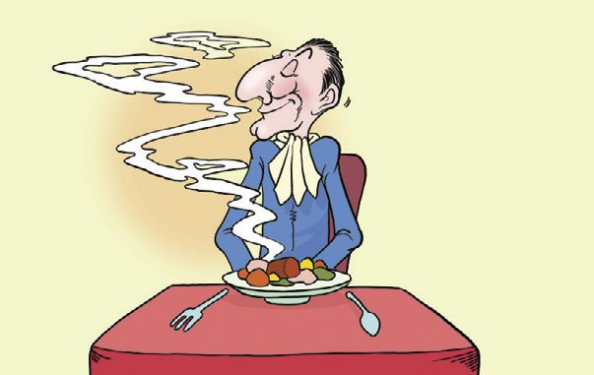 | 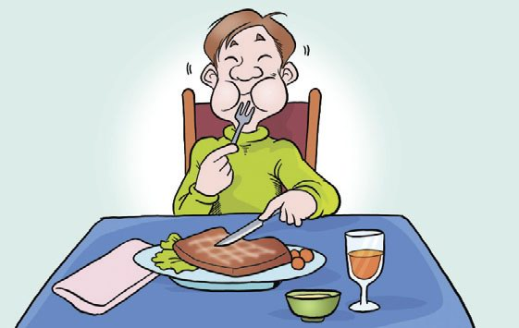
A | B
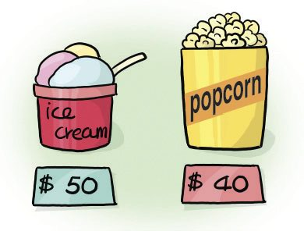 | 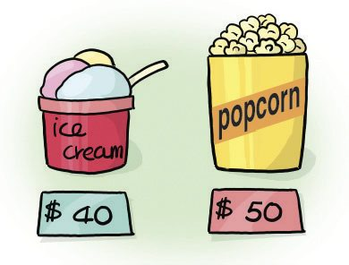
Q 3 Q 4
A | B
A | B
二、聽廣播中的句子，選出最適當的回應句的英文代號。(每題2分，共6分)
5. | Tim lost 15 pounds in three weeks.
6. | Listen! Do you hear someone call for help?
7. | Did you feel the whole house shake five minutes ago?
三、請仔細聽廣播中的文章與問題，並將問題的正確答案的代碼劃在答案卡上。
8. | (A) In a department store.
 | (B) In a restaurant.
 | (C) In their office.
9. | (A) Amy ordered seafood for dinner last Sunday.
 | (B) Amy is really a considerate girl.
 | - Amy bought her mother a birthday gift last Sunday.
10. | (A) Mark spent a lot of money on the dinner.
 | (B) Mark was sorry for being late.
 | (C) Mark should bring more money next time.

第二部份: 綜合測驗(共80分)
2
一、語法與字彙測驗 (每題1分，共10分)
11. The children like to listen to the old woman her stories.
(A) told | (B) tell |  | (C) tells | (D) to tell
12.The weather in Kaohsiung is usually than that in Taipei.
(A) cold | (B) colder |  | (C) hot | (D) hotter
13. It is a basic manner to your cell phone during a movie.
(A) pick up | (B) turn on |  | (C) turn off | (D) learn about
14. He looks than before because he made many friends here.
(A) more happy | (B) happy |  | (C) happily | (D) happier
15. It’s getting . Don’t forget to bring an umbrella with you.
(A) rainy | (B) rain |  | (C) rains | (D) raining
16. Follow the receipt, you can make a delicious cake.
※ receipt食譜
(A) so | (B) and |  | (C) but | (D) or
17. He becomes after he stops taking exercise every day.
(A) heavier | (B) cleaner |  | (C) more serious | (D) thinner
18. Tim: I can something climbing up my neck.
Sam: I don’t see anything. Let’s not sit under the tree.
(A) sound | (B) smell |  | (C) taste | (D) feel
19. Customer: The sweater is too small. Can you have a one?
Clerk: Yes, wait a minute.
(A) larger | (B) more popular | (C) taller |  | (D) cheaper
20. Susan: What happened?
Paul: The glasses just down and broke into pieces.
(A) fall | (B) falls | (C) falling |  | (D) fell
- 克漏字測驗(每題2分，共12分)
【A】
( Peter meets John. )
Peter: Hey, John. What’s wrong?
John: (21) .
Peter: Is it serious?
John: Luckily. I only hurt my foot. However, (22) .
Peter: It’s a pity that you can’t play the final game.
John: I know. I learned a lesson: (23`) .

※ pity遺憾 accident意外
21. | (A) I caught a cold.
 | (B) I didn’t do well on the test.
 | (C) I had a car accident yesterday.
 | (D) I left my money in the taxi.

22. | (A) I can’t play the piano for two weeks.
 | (B) I can’t move for two weeks.
 | (C) I can’t write for two weeks.
 | (D) I can’t practice basketball for two weeks.
23. | (A) It’s better to share than to get nothing in the end.
 | (B) We should follow the traffic rules at any time.
 | (C) Always be considerate to others.
 | (D) We should work hard and be honest in everything we do.
【B】
3
Dear Maggie, 2008/5/3
I have a 14-year-old daughter. Since she went to junior high school, she has changed a lot. To become thinner, she eats (24) than before. The problem is that she is NOT heavy at all. Besides, she also asks me to give her more and more pocket money, just as (25) as her dad. She doesn’t care about her studying. All she does all day is talking to her friends on the phone.
Last night, she got angry when she saw me (26) her diary. She even has a boyfriend. I am really worried about her, and I don’t know what to do. Can you help me?
A worried mother
Sue

24. (A) less | (B) more | (C) little | (D) few
25. (A) many | (B) much | (C) more | (D) a lot
26. (A) reading | (B) to read | (C) watching | (D) to watch

※ daughter女兒 besides而且
三、閱讀測驗(每題2分，共20分)
【A】
※ Find a faster way to get out of the building.
※ Never try to open a door without checking if it is hot.
※ Keep away from the smoke.
※ If you can’t get out of the building, just stay next to the windows.

27. | What are the tips about?  ※ without沒有 smoke煙 typhoon颱風 fire火災 flood水災
 | (A) An earthquake.
 | (B) A typhoon.
 | (C) A fire.
 | (D) A flood.

28. | Which telephone number can we call for help?
 | (A) 119.
 | (B) 110.
 | (C) 113.
 | (D) 105.
【B】
4
Joy Department Store sale
skirt | ＄1000
shoes | ＄1500
sweater | ＄1200
pants | ＄﹖
hat | ＄700
＊ If you buy two skirts, you can get 20％off price for the second one.
＊ If you buy over ＄4000, you can get 10％ discount and park your car for free.
Opening time: 11:30 a.m.-10:00 p.m. weekdays
11:00 a.m.-10:00 p.m. weekends

Only 3/9-3/19

※ pants褲子 discount 折扣

29. May bought two skirts, a pair of shoes and a hat. How much did she spend?
(A)＄4000. | (B)＄4200. | (C)＄3560. | (D)＄3600.
30. A pair of pants is more expensive than a hat, but it is cheaper than a sweater. How much
does it may cost?
(A)＄600. (B)＄900. (C)＄1300. (D)＄1500.
31. Which is true?
※ cost價值 anyway無論如何
(A) It is opened for ten hours every day.
(B) You can park your car for free anyway.
(C) A sweater is more expensive than a pair of pants.
(D) The sale is only for 10 days.
【C】
Everyone knows we only have one earth. However, many people don’t take care of it. We see them waste lots of energy and make terrible pollution. To keep a more comfortable place for our children, we should try our best to save the earth. In fact, it’s not difficult for
us to protect it. We can save energy in our life. For example, take the public transportation instead of driving or riding to work. Sometimes, it’s also a good idea to share the car with friends to work. Turn off the light when we leave a room. Taking a shower uses less water than taking a long bath. When we go shopping, don’t forget to bring our own bags to carry what we buy. Finally, recycle used papers, glass, plastic bottles.
Follow these ways, saving energy is just like “ a piece of cake “. We can not only save our money but also save our Mother Earth.

※ waste浪費 pollution污染 transportation運輸 instead of代替 plastic塑膠
32. What does “ a piece of cake “ in line 9 means?
(A) difficult | (B) delicious | (C)popular | (D) easy
33. Which one is NOT the tip for saving energy?
(A) Go to work by MRT.
(B) Drink less water every day.
(C) Reuse shopping bags.
(D) Turn off the light when you don’t need it.
34. What is the best title of the reading?
※ title 標題
(A) How to save our earth in our lives
(B) How to save our life in an earthquake
(C) How to save our money when we go shopping
(D) How does the earth become more convenient
5
【D】There are four text messages on Lucy’s cell phone. Read them and answer the questions.
message1
Lucy, this is Max. Don’t forget to bring your history homework tomorrow. By the way, our math test is changed to next week. Take it easy.
message2
Can you come home next weekend? You didn’t return home for past one month. Call me when you get the message.
message3
Hi, Lucy, this is Susan. How’s everything? I saw you and a handsome boy eating lunch in a restaurant. Is he your new boyfriend? Call me back. See you.
message4
Hello, Lucy. It’s me, Bob. We are going to celebrate the win of our baseball team. Would you like to come to the BBQ party this Friday evening? Call me before Wednesday
if you can come.

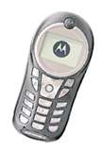

※ text 文字 return返回
35. Why did Bob send the message to Lucy?
6
(A) He saw Lucy’s new boyfriend.
(B) He wanted to remind Lucy to bring her history homework.
※ remind 提醒
(C) He wanted Lucy to come home next weekend.
(D) He asked Lucy if she can come to the BBQ party.
36. Which one is true?
(A) Lucy eats dinner with her parents every day.
(B) Lucy has to bring her history homework tomorrow
(C) Lucy worries about her history homework.
(D) Today, Susan and Lucy ate lunch together.

四、文意字彙 (每題2分，共10分)
37. He worked very late and he missed some important p ts of his favorite TV program.
38. Go bicycle riding is a healthy and an out-door a y.
※out-door戶外的
39. It is d s for women to walk alone on the dark road at night.
40. My first trip to Japan was a wonderful e e. I will never forget about it.
41. I don’t like shopping because the air becomes dirty in a c ed store.

五、依提示作答(每題2分，共10分)
42. {
Tim and Lisa ate dinner together.
Susan saw them. (合併成ㄧ句)
43. {
The storybook is three hundred dollars.
The dictionary is five hundred dollars. (用cheaper合併成ㄧ句)
44. {
There are two doors in the classroom.
The doors are close. (用of合併成ㄧ句)
45. It took me twenty minutes to move the closet. (用spend改寫)
46. This kind of fruit smells terrible. (依畫線部分造原問句)

六、整句式翻譯(每題3分，共18分，錯一處，扣1分)
47. 看漫畫比看電視有趣。
48. 在1999年，ㄧ個可怕的地震突然襲擊台灣。
49. 不只是你還有Peter都喜歡玩電腦。
50. 早點起床，否則你會錯過校車。
51. 這個故事聽起來有點嚴肅。我想要聽一個快樂點的。
52. 這間辦公室的每個人看起來都如此地忙碌，所以沒人注意到我。

【試題結束。】

臺北市立龍山國民中學九十六學年度第二學期八年級英語科第二次定期考査(聽力稿)
第一部分: 聽力測驗
本測驗共有三大題，每一小題都會唸兩次，請同學們注意聽，仔細作答。
一、 請仔細聽廣播中的句子，並將最能符合句意的圖片代碼劃在答案卡上。
1. | The ice cream is cheaper than the popcorn.
2. | The food smells delicious.
3. | I felt afraid when I heard someone walking behind me last night.
4. | Take away your garbage when you leave a theater.
二、聽廣播中的句子，選出最適當的回應句的英文代號。
5. | Tim lost 15 pounds in three weeks.  (A) Sounds good. Would you like to try some?  (B) The story is a little sad and serious.  (C) I heard about it. He became thinner than before.
6. | Listen! Do you hear someone call for help?  (A) Let’s look for the voice and call the police.  (B) Be quiet! Don’t wake up the baby.  (C) I can speak louder than you.
7. | Did you feel the whole house shake five minutes ago?  - Yes, I enjoyed the movie a lot.  - Yes, there was a good one at six-thirty.  - Was it an earthquake? I never experienced one in America.

三、請仔細聽廣播中的文章與問題，並將問題的正確答案的代碼劃在答案卡上。
Mark and Amy had a date last Sunday. First, they went to a department store
to buy the gifts for the coming Mother’s Day. After they finished shopping, they
enjoyed the dinner in a restaurant near their office. Mark ordered a steak and
Amy did, too. Not only the chairs looked comfortable but also the music sounded
beautiful. But the food was more expensive than others. After the meal, Mark found
he didn’t bring enough money. Finally, Amy paid the bill and didn’t blame him at all.
However, Mark felt so sorry to Amy and would never forget the terrible experience.

8. | Where did they eat the dinner last Sunday?
. | (A) In a department store.
 | (B) In a restaurant.
 | (C) In their office.
9 | Which one is true about Amy?
 | (A) Amy ordered seafood for dinner last Sunday.
 | (B) Amy is really a considerate girl.
 | - Amy bought her mother a birthday gift last Sunday.
10. | Which one is true about Mark?
 | (A) Mark spent a lot of money on the dinner.
 | (B) Mark was sorry for being late.
 | (C) Mark should bring more money next time.

臺北市立龍山國民中學九十六學年度第二學期八年級英語科第二次定期評量答案卷
______年______班______號 姓名：___________ 組別：______ 任課教師：___________
四、文意字彙：請根據提示的首尾字母寫出合乎句意的英語語詞(每題2分，共10分)
注意： | 1.本試題卷共有六頁，請記得翻頁作答。
注意： | 2. 1- 36題為單一選擇題，請以2B鉛筆將各題正確答案的代碼劃在答案卡上。
注意： | 3. 37 - 52題，請在答案卷上作答。
37. |  | 38. |  | 39.
40. |  | 41.

五、依提示作答((每題2分，共10分)
42.
43.
44.
45.
46.

六、整句式翻譯(每題3分，共18分，錯一處，扣1分)
47.
48.
49.
50.
51.
52.

【做答完畢，再檢查一下喔!】

臺北市立龍山國民中學九十六學年度第二學期八年級英語科第二次定期評量答案卷
______年______班______號 姓名：___________ 組別：______ 任課教師：___________
四、文意字彙：請根據提示的首尾字母寫出合乎句意的英語語詞(每題2分，共10分)
注意： | 1.本試題卷共有六頁，請記得翻頁作答。
注意： | 2. 1- 36題為單一選擇題，請以2B鉛筆將各題正確答案的代碼劃在答案卡上。
注意： | 3. 37 - 52題，請在答案卷上作答。
1. | B | 2. | A | 3. | B | 4. | B | 5. | C | 6. | A | 7. | C | 8. | B | 9. | B | 10. | C
11. | B | 12. | D | 13. | C | 14. | D | 15. | A | 16. | B | 17. | A | 18. | D | 19. | A | 20. | D
21. | C | 22. | D | 23. | B | 24. | A | 25. | B | 26. | A | 27. | C | 28. | A | 29. | D | 30. | B
31. | C | 32. | D | 33. | B | 34. | A | 35. | D | 36. | B |  |  |  |  | .
37. | parts | 38. | activity | 39. | dangerous
40. | experience | 41. | crowded
五、依提示作答((每題2分，共10分)
42. | Susan saw Tim and Lisa eat/eating dinner together.
43. | The storybook is cheaper than the dictionary.
44. | The doors of the classroom are close.
45. | I spent twenty minutes moving the closet.
46. | How does this kind of fruit smell?
六、整句式翻譯(每題3分，共18分，錯一處，扣1分)
47. | Reading comic books is more interesting than watching TV.
47. | To read comic books is more interesting than to watch TV.
48. | In 1999, a terrible earthquake hit Taiwan suddenly.
48. | A terrible earthquake hit Taiwan suddenly in 1999.
49. | Not only you but (also) Peter likes to play computer games.
49. | Not only you but (also) Peter likes playing computer games
50. | Get up early, or you will miss the school bus.
51 | The story sounds a little serious. I want to hear a happier/happy story/one.
52. | Everyone in/at the office looked very busy, so/and nobody noticed me.
52. | Everyone in/at the office looks very busy, so/and nobody notices me.

