臺北市立龍山國民中學九十六學年度第一學期八年級英語科第三次定期考査試題卷
第一部分: 聽力測驗 (共 20 分)
注意： | 1.本試題卷共有6頁，請記得翻頁作答。
注意： | 2. 1-32題為單一選擇題，請以2B鉛筆將各題正確答案的代碼劃在答案卡上。
注意： | 3. 33-47題，請在答案卷上作答。
本測驗共有三大題，每一小題都會唸兩次，請同學們注意聽，仔細作答。
- 請仔細聽廣播中的句子，並將最能符合圖意的句子代碼劃在答案卡上。 (每題2分，共10分)
1. | 2. | 3. | 4. | 5.
  Bob | 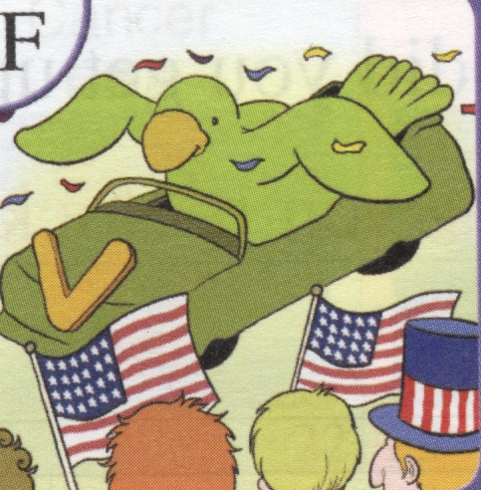 | 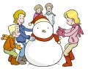 | 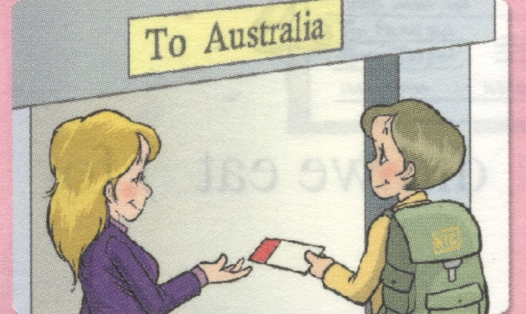  Tina | 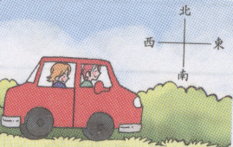

二、 請仔細聽廣播中的問題，根據下列圖表，將正確答案的代碼劃在答案卡上。 (每題2分，共4分)
~Thank U Party~
Date: 11/25
Time: 19:00~21:00
Place: Tasty Restaurant
(20 Chungshao Rd. Taipei )
Join us for the Thanksgiving dinner.

6. | (A) Christmas. | (B) Thanksgiving. | (C) National Day.
7. | (A) December 25. | (B) February 25. | (C) November 25.

三、請仔細聽廣播中的對話與短文，並將問題的正確答案的代碼劃在答案卡上。 (每題2分，共6分)
8. | How often does Amanda practice speaking English with her friends?
9. | Which one is true?
10. | (A) They can catch fish easily.
 | (B) They can watch out for danger.
 | (C) They can dance and fly.
【第1頁，尚有試題】

第二部份: 綜合測驗(共80分)
一、語法與字彙測驗 (每題2分，共20分)

11. There is going to ______ a book fair in the World Trade Center.
＊book fair 書展 World Trade Center 世貿中心
(A) have | (B) has |  | (C) is |  | (D) be
12. Sam: When did you go to the concert?
Tina: I went to the concert ______ Sunday evening. ＊concert 演唱會
(A) on | (B) in |  | (C) at |  | (D) ×
13. Mary: Do you ever roller-blade? It’s interesting.
John: No, ______.
(A) she seldom does |  | (B) she usually does |  | (C) I seldom do |  | (D) I usually do
14. Amanda: Wow! You play basketball very well. ______ do you practice it?
John: I practice basketball almost every day.
(A) How long | (B) How often |  | (C) How many |  | (D) How much
15. Some people enjoy their holidays, but some have to work ______ holidays.
(A) in | (B) on |  | (C) at |  | (D) ×
16. Karen: We have a family reunion in Kaohsiung. I have to go back. There are always a lot of cars during Chinese New Year.
Mark: You can ______ the high-speed train or go ______ plane. ＊high-speed train高鐵
(A) by; on | (B) take; on |  | (C) by; take |  | (D) take; by
17. I will go to the class reunion, but Mike ______.
(A) will | (B) won’t |  | (C) does |  | (D) doesn’t
18. Mr. and Mrs. Brown got married ______1987. This is the ______ year of their marriage. ＊get married 結婚 marriage 婚姻
(A) in/ twenty | (B) at/ thirty |  | (C) in/ twentieth |  | (D) on/ thirtieth
【第2頁，尚有試題】
臺北市立龍山國民中學九十六學年度第一學期八年級英語科第三次定期考査試題卷
19. Linda: Which ______ do you like best?
Bob: I like fall because it gets cooler. It makes me feel comfortable.＊comfortable 舒適的
(A) fruit | (B) food |  | (C) season |  | (D) animal
20. Tom: Do you know the ______ of “TKS?”
Amy: It’s “thanks.”
(A) meaning | (B) month |  | (C) kind |  | (D) show
二、克漏字測驗 (每題2分，共14分)
People around the world celebrate New Year in different ways. In Taipei, people enjoy the Taipei 101fireworks.The fireworks are very famous, so many foreigners come __(21) groups to see them (22) their own eyes and take pictures (23) the beautiful fireworks. In New York, people come together in Time Square. People count down when the ball drops. They (24) “ Happy New Year!” to each other when the ball gets to the bottom. In Japan, thousands of people go to temples. They (25) wishes.
New Year is very important because it means a start. Some people do something meaningful, like giving a hand to the poor people. (26) , some people just have parties or go shopping. They buy something new, and they should (27) something new and different. Don’t forget to make plans for the new year.

＊firework 煙火 Time Square時代廣場 drop 落下 temple 寺廟 give a hand to ~ 幫助~
【第3頁，尚有試題】
21.(A) on | (B) in | (C) at | (D) for
22.(A) with | (B) by | (C) of | (D) for
23.(A) in | (B) with | (C) of | (D) for
24.(A) talk | (B) tell | (C) say | (D) speak
25.(A) take | (B) took | (C) made | (D) make
26.(A) For example | (B) However | (C) This way | (D) By the way
27.(A) will learn | (B) learned | (C)learns | (D) learn
三、閱讀測驗 (每題2分，共10分)
【28~29】
People all over the world are facing the same problem- global warming. Everyone has to do their part to save our earth. Here are the ways:
★ Ride a bike or walk to work.
★ Reuse paper. Use both sides of a piece of paper.
★ Recycle paper or bottles.
★ Turn the water off while you’re brushing your teeth.
★ Donate books, toys and clothes to other people. This way, they can save money and
reuse these things. ＊global warming 全球暖化 recycle 回收

28. What does “Donate” mean in this reading?
(A) Write. (B) Give. (C) Show. (D) Teach.
29. Which is true?
(A) Sell books, toys and clothes to the poor people.
(B) Drive to work.
(C) Use two sides of a piece of paper.
(D) When you are brushing your teeth, turn the water on.
【30~31】
Taipei | 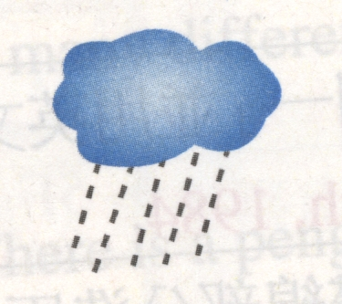 | 10~15℃
San Francisco | 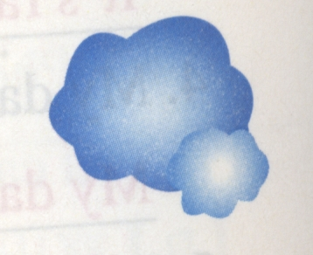 | 8~11℃
New York | 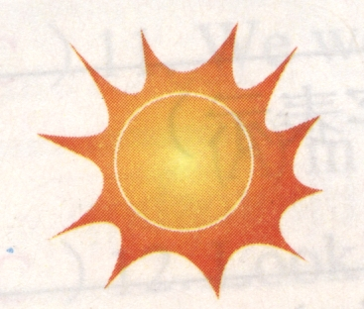 | -4~8℃
London |  | -5~6℃
Tokyo |  | 5~12℃
Sydney |  | 22~28℃

【第4頁，尚有試題】
臺北市立龍山國民中學九十六學年度第一學期八年級英語科第三次定期考査試題卷
30. Teresa loves sunshine. She doesn’t like to wear heavy clothes. She is going on a
trip. Which city would be good for her? ＊sunshine 陽光
(A) Sydney. (B) Tokyo. (C) London. (D) New York.
31. Kerry: How’s the weather there?
Tim: It’s so cold.
Kerry: You can see snow in winter. I envy you.
Tim: It’s humid. It rains a lot. And it makes me feel uncomfortable. I don’t think it’s good
for our health.
Which city may Tim live in? ＊humid 潮濕的 uncomfortable 不舒適的
(A) Sydney. (B) Taipei. (C) San Francisco. (D) London.

【32】

Easter is one of the important holidays. It always falls on a Sunday from March 22 to April 25. People paint eggs in different colors and draw some pictures on them. They have two games- the Easter Egg Hunt and Easter Egg Roll. As for Easter Egg Hunt, people usually hide the eggs in the park and invite children to find them. And in Easter Egg Roll, people have to roll the eggs and can’t break them. Easter Bunny plays an important
part, too. Easter Egg and Easter Bunny mean new life. People have interesting games on this special day. They also give gifts or send cards to greet their friends.

＊roll 滾 bunny 兔子 greet 問候
32. Which is Not true?
(A) People dye eggs.
(B) People find out the eggs and break them.
(C) Easter Bunny is one of the symbols.
(D) People buy gifts for their friends.
＊dye 染色 symbol 象徵

【第5頁，尚有試題】

四、文意字彙：根據提示的字首字母寫出合乎句意的語詞 (每題2分，共12分)
33. Helen is always busy with her work. She has to go to America on b s every month.
34. Janet loves taking a trip. She went to many c ies and wrote guide books.
＊guide book 導覽書
35. Sandy and Susan study and play the piano together. They are just like sisters.
They cherish their f p. ＊cherish 珍惜
36. The train to Taipei will a e in two minutes. Please wait a minute.
37. Students start their new semester in S r after a long summer vacation.＊semester 學期
38. It’s c y and it’s going to rain. Bring an umbrella with you.

五、依提示作答 (每題2分，共6分)

39. It rained a lot three days ago. (以We… 改寫句子)
40. We went on a picnic last week. (以next week 改寫句子)
41. Mrs. White reads stories to her children. (加入7:00、yesterday evening 改寫句子)

六、翻譯 (每題3分，共18分)
42. 我記得有次我們在沙灘上慶祝聖誕節。
43. 你知道有關母親節的故事嗎?
44. Linda 多久一次探訪她的祖父母?
45. 你是否曾經想念在你家鄉的風景?
46. 我將與我的叔叔們與阿姨們在車站會面。
47. 黑面琵鷺通常在10月或11月時抵達臺南沿岸。

【第6頁，試題結束，請仔細檢查】

臺北市立龍山國民中學九十六學年度第一學期八年級英語科第三次定期考査(聽力稿)
第一部分: 聽力測驗
本測驗共有三大題，每一小題都會唸兩次，請同學們注意聽，仔細作答。
一、 請仔細聽廣播中的句子，並將最能符合圖意的句子代碼劃在答案卡上。
1. | (A) Bob and his parents will walk to Kaohsiung.
 | (B) Bob is going to Kaousiung by plane.
 | (C) Bob and his parents will take a train to Kaohsiung.
2. | (A) People celebrate Teacher’s Day.
 | (B) People celebrate the national day of the ROC.
 | (C) People celebrate the national day of the USA.
3. | (A) The children play in the snow.
 | (B) People celebrate Christmas at the beach.
 | (C) I go to church with my family.
4. | (A) Tina is going to visit America.
 | (B) Tina is going to visit Africa.
5. | (C) Tina is going to visit Australia.  (A) They are going to drive to the east.  (B) They will go south by car.  (C) They are going to fly east.
二、 請仔細聽廣播中的問題，根據下列圖表，將正確答案的代碼劃在答案卡上。
6. | What’s this card for?
7. | When is the party?

三、請仔細聽廣播中的對話與短文，並將問題的正確答案的代碼劃在答案卡上。
For Questions 8～9, please listen to the dialogue.
Dialogue:
Jack: Amanda, you always get good grades on English tests. How do you do it?
Amanda: Jack, I study English for one hour every day.
Jack: I study English every day, too. But I just can’t get good grades.
Amanda: How about listening to English CDs? I do it two times a week.
Jack: I’ll try it.
Amanda: And I practice speaking English with my friends every Sunday.
Jack: Can I practice English with you?
Amanda: Of course. Let’s start next week.
8. | How often does Amanda practice speaking English with her friends?
 | (A) Once a week.
 | (B) Two times a week.
 | (C) Three times a week.
9. | Which one is true?
 | (A) Jack studies English very well.
 | (B) Amanda studies English for two hours every day.
 | (C) Jack will practice English with Amanda next week.

For Question 10, please listen to the following passage.
Passage :
There are only several hundred black-faced spoonbills now. They have black faces. Because their bills are like spoons, they can get fish easily. They stand on one leg, so they can watch out for danger.
Question 10:Why do black-faced spoonbills stand on one leg?

臺北市立龍山國民中學九十六學年度第一學期八年級英語科第三次定期考查答案卷
八年______班______號 姓名：___________

四、文意字彙：根據提示的字首字母寫出合乎句意的語詞 (每題2分，共12分)
33. |  | 34. |  | 35.
36. |  | 37. |  | 38.

五、依提示作答 (每題2分，共6分)
39.
40.
41.

六、翻譯 (每題3分，共18分)
42.
43.
44.
45.
46.
47.
本試題到此結束，
作答完畢，
請確實檢查。

臺北市立龍山國民中學九十六學年度第一學期八年級英語科第三次定期考查答案
1. | C | 2. | C | 3. | A | 4. | C | 5. | A | 6. | B | 7. | C | 8. | A | 9. | C | 10. | B
11. | D | 12. | A | 13. | C | 14. | B | 15. | B | 16. | D | 17. | B | 18. | C | 19. | C | 20. | A
21. | B | 22. | A | 23. | C | 24. | C | 25. | D | 26. | B | 27. | D | 28. | B | 29. | C | 30. | A
31. | D | 32. | B
四、文意字彙：根據提示的字首字母寫出合乎句意的語詞 (每題2分，共12分)
33. | business | 34. | countries | 35. | friendship
36. | arrive | 37. | September | 38. | cloudy

五、依提示作答(每題2分，共6分)
39. | We had a lot of/ much rain three days ago.
40. | We will go on a picnic next week.  We are going to go on a picnic next week.
41. | Mrs. Brown read stories to her children at 7:00 yesterday evening.

六、翻譯 (每題3分，共18分)
42. | I remember once we celebrated Christmas at/ on the beach.
43. | Do you know the story/stories about Mother’s Day?
44. | How often does Linda visit her grandparents?
45. | Do/Did you ever miss the scenery in your hometown?
46. | I will meet my uncles and aunts at the station.  I am going to meet my uncles and aunts at the station.
47. | (The) black-faced spoonbills usually arrive at the coast of Tainan in October or November.

