臺北市立龍山國民中學九十五學年度第一學期八年級英語科第一次定期考查(聽力稿)
第一部份: 聽力測驗
本測驗共有三大題，每一小題都會唸兩次，請同學們注意聽，仔細作答。
一、 | 請仔細聽廣播中的句子，並將最能符合圖意的句子代碼劃在答案卡上。
 | 1. | (A) Fanny got up late this morning.
 |  | (B) Fanny got home late last night.
 |  | (C) Fanny got to the restaurant early.
 | 2. | (A) Mr. Chen did exercise in the morning.
 |  | (B) Mr. Chen grew flowers in the garden.
 |  | (C) Mr. Chen walked slowly in the park.
 | 3. | (A) Brian had an exam at school.
 |  | (B) Brian studied hard in his room.
 |  | (C) Brian ate some snacks happily.
 | 4. | (A) Kevin started a healthy way of life.
 |  | (B) Kevin was heavy, and he was on a diet.
 |  | (C) Kevin was heavy, but he still ate a lot.
二、 | 請仔細聽廣播中的句子，並將適當回應句的代碼劃在答案卡上。
 | 5. | We went to many places and had a wonderful time.
 |  | (A) I envy you. | (B) I worry about you. | (C) I miss you.
 | 6. | I’m going to Canada with my friends next week.
 |  | (A) It’s okay. (B) Let’s start. (C) Have a nice trip.
 | 7. | I still couldn’t play the piano well.
 |  | (A) I was, too. (B) I didn’t, either. (C) I couldn’t, either.
 | 8. | Where were you last week, Tony?
 |  | (A) I could visit my uncle and aunt.
 |  | (B) I went to Ilan for two days.
 |  | (C) I’m at my grandmother’s place.
三、 | 請仔細聽廣播中的對話與問題，並將正確答案的代碼劃在答案卡上。
 | 9. | Frank: Hi, Cindy. Why didn’t you go to school last Friday?
 |  | Cindy: My parents took me back to Tainan and had a family reunion.
 |  | My grandparents still live there. They don’t live with us in Taipei.
 |  | Question: Where do Cindy’s grandparents live?
 | 10. | Dad: Why is Nancy sad?
 |  | Mom: She wanted some ice cream, but I don’t agree.
Dad: But she loves ice cream very much.
背面還有題目，請翻面繼續錄音！
 |  | Mom: Yes, I know. However, it is not good for her. She is too heavy, and the doctor said she needs less junk food and more exercise.
 |  | Question: What is not good for Nancy?
 | 11. | Ms. Wu: Was the math homework hard for you, Michael?
 |  | Michael: Yes, it was really hard, Ms. Wu. But I was lucky. My father helped me a lot, and he taught me nicely.
 |  | Ms. Wu: Yes, you were really lucky. I believe all your classmates envy you.
 |  | Question: Why was Michael lucky?
 | 12. | Sue: Ted, I called you three days ago, but you weren’t home. Where did you go?
 |  | Ted: My brothers and I had a trip to Kenting.
 |  | Sue: What did you do there?
 |  | Ted: We swam and had a picnic. Kenting is really a nice place. I miss everything there and expect to go there again.
 |  | Question: How does Ted like his trip in Kenting?

臺北市立龍山國民中學九十五學年度第一學期八年級英語科第一次定期考查試題卷

注意： | 1.本試題卷共有四頁，請記得翻頁作答。
注意： | 2. 1- 37題為單一選擇題，請以2B鉛筆將各題正確答案的代碼劃在答案卡上。
注意： | 3. 38 - 54題，請在答案卷上作答。

第一部份: 聽力測驗（共20分）
本測驗共有三大題，每一小題都會唸兩次，請同學們注意聽，仔細作答。
一、請仔細聽廣播中的句子，並將最能符合圖意的句子代碼劃在答案卡上。(每題1分，共4分)
1. | 2. | 3. | 4.
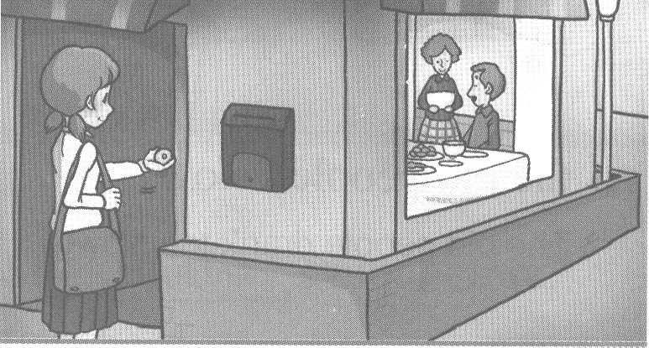 | 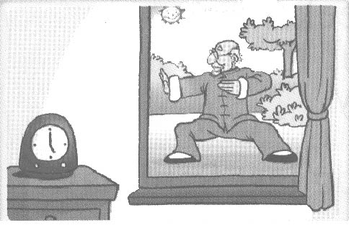 | 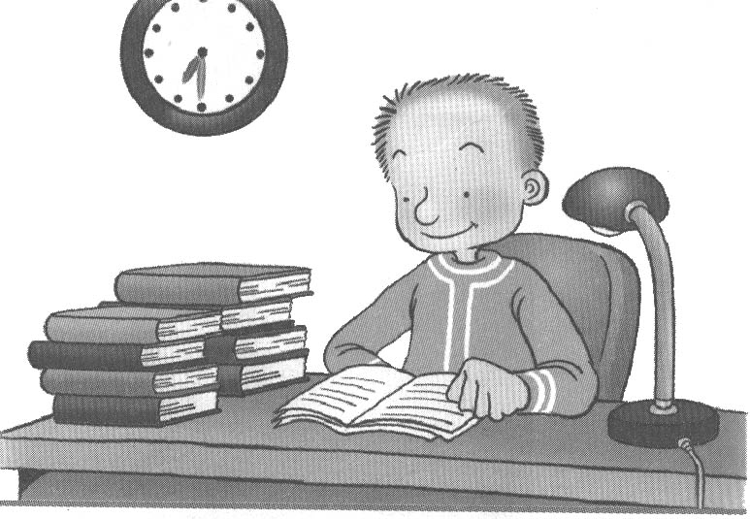 | 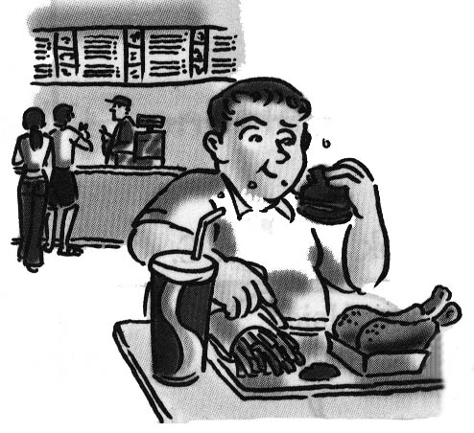
二、請仔細聽廣播中的句子，並將適當回應句的代碼劃在答案卡上。(每題2分，共8分)
5. We went to many places and had a wonderful time.
6. I’m going to Canada with my friends next week.
7. I still couldn’t play the piano well.
8. Where were you last week, Tony?
三、請仔細聽廣播中的對話與問題，並將正確答案的代碼劃在答案卡上。(每題2分，共8分)
9. (A) In Tainan. (B) At Cindy’s home. (C) In Taipei.
10. (A) Less junk food. (B) More exercise. (C) More ice cream.
11. (A) Ms. Wu helped him a lot.
(B) His father taught him nicely.
(C) His classmates envy him.
12. (A) He really enjoys it very much.
(B) He wouldn’t like to go to Kenting again.
(C) He lost all his things in Kenting.
第二部份: 綜合測驗(共80分)
一、語法測驗 (每題1分，共10分)
13. _____ fresh air!
(A) Which (B) Where (C) What (D) How
14. Grace can use a computer. She learned it _____ Tom.
(A) to (B) of (C) with (D) from
15. My daughter is so thin. She has to eat _____ food.
(A) more (B) many (C) less (D) little
【 第一頁，共四頁，背面尚有試題，請繼續作答 】
16. Rick can _____ some Chinese words now.
(A) said (B) say (C) speak (D) talk
17. Joe was wonderful. He _____ five pounds in two weeks.
(A) losing (B) loses (C) lose (D) lost
18. A: Did Jimmy walk to school? B: No, he _____ a bicycle to school.
(A) rides (B) ride (C) rode (D) riding
19. Who made a lot of good food for you? B: Peter _____.
(A) is (B) does (C) was (D) did
20. A: Please come again. B: Yes, _____.
(A) I did (B) I love (C) I’d love (D) I’d love to
21. Sam: The exam is not _____. Dad: That means you have to work _____ for it.
(A) easy; hard (B) easy; easily (C) hard; easily (D) hard; easy
22. Mike _____play baseball before, but now he _____. He is too old.
(A)can; couldn’t (B) can’t; could (C) couldn’t; can (D) could; can’t
二、克漏字測驗(每題2分，共10分)
＊＊＊＊＊ Denny’s Diary ＊＊＊＊＊
Monday, October 9, 2006
My family and I went back to Grandpa’s house 23. weekend. We did a lot of things there. Grandpa 24. rice. My sister, Wendy, climbed the trees. My puppy, Spot, 25. in the pond. Grandpa’s cat, Mimi, 26. a fish from the pond. Dad sat under a big tree. Everyone 27. happy and had a wonderful time.
※ house:房子；pond:池塘
23. (A) on (B) last (C) this (D) next
24. (A) growing (B) grows (C) grow (D) grew
25. (A) swim (B) swims (C) swam (D) swimming
26. (A) caught (B) catch (C) ran (D) run
27. (A) is (B) was (C) are (D) were
三、閱讀測驗(每題2分，共20分)
(一) Allen’s Exercise And Food Every Day
(一)
Wake up: 6:00 a.m. Go to bed: 11:00 p.m.
Exercise:
► Jog 1/2 hour before breakfast every morning
►Swim 1 hour after school from Monday to Friday
►Play basketball 1 hour in the afternoon on weekends
Diet:
►Breakfast : 3 fruits, one glass of milk, one bottle of water
►Lunch : 3 vegetables, chicken and a bowl of rice, 500 c.c. of juice
►Dinner : 2 vegetables, fish and 1/2 bowl of rice, 2 fruits
28. How many hours does Allen sleep every day?
(A) 6. (B) 7. (C) 8. (D) 9.
【 第二頁，共四頁，尚有試題，請繼續作答 】
29. It is 6:25 a.m. now. What exercise is Allen doing?
(A) Playing basketball. (B) Swimming. (C) Jogging. (D) All of the above.
30. What does Allen not have?
(A) Milk. (B) Rice. (C) Chicken. (D) Beef.
31. Which is not true?
- Allen swims five days a week. (B) Allen eats only vegetables for lunch.
(C) Allen has fruit, milk, and water in the morning.
(D) Allen plays basketball every Saturday and Sunday.
(二)
I’m Steven. Last weekend, my new classmate, Jack, invited my cousin, Simon and me to his home in Kaohsiung. There we met Jack’s big family. He has parents, one brother, and three sisters. His grandma also lives with his family. She can cook very well. We ate a lot of good food. We also met Jack’s old friends, Paul and Andy. They took us to many places, and we saw many things there. We all had a very good time. ※ met:遇見(過去式)
32. Who is Jack?
(A) Paul’s cousin. (B) Andy’s brother.
(C) Simon’s old friend. (D) Steven’s new classmate.
33. How many people does Jack’s family have?
(A) 8. (B) 7. (C) 6. (D) 5.
34. Who is a good cook?
(A) We don’t know. (B) Jack’s grandmother.
(C) Jack’s sister. (D) Jack’s mother.
(三) Read Dick’s letter from his sister and answer the questions.
Dear Dick,
I’m in Japan for a short trip now. The weather here is very good, not too hot and not too cold. I stay at my friend Sandra’s place. She has a four-year-old son, Leo. Leo is very cute. Sandra took me to many places. I really had a lot of fun here. Yesterday we went to a department store. I bought some presents for you, Mom and Dad. I hope you like them. We are going to a garden in the afternoon. That’s all for now. I miss you. See you next week.
Love,
Joyce
※weather: 天氣；department store:百貨公司
35. Who is Dick?
(A) He’s Joyce’s son. (B) He’s Sandra’s friend.
(C) He’s Leo’s dad. (D) He’s Joyce’s brother. .
36. Sandra and Leo are ________.
(A) friends (B) brother and sister (C) mother and son (D) father and daughter
37. How is Joyce’s trip in Japan?
(A) Great. (B) She doesn’t like Leo.
(C) Sandra is not good to her. (D) The weather is bad.
【 第三頁，共四頁，背面尚有試題，請繼續作答 】
四、文意字彙：請根據提示的首尾字母寫出合乎句意的英語語詞(每題2分，共14分)
38. There are twelve m_____hs in a year.
39. We visited a m_____m last Saturday and saw many old things.
40. Billy is eating with a fork and a knife, not c_____ks.
41. Jerry could speak only a little Chinese, but now his Chinese is e_____t.
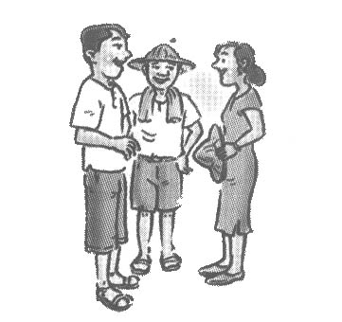
42. Look at the picture. Uncle Eric is standing b_____n his
wife and son.
43. Our house was too small, and I s____ed a room with my
younger brother.
44. The White family live in the m_____ns. They enjoy the air
and the life there.
五、整句式翻譯(每題3分，共18分，錯一處，扣1分)
45.請再為我做一件事。
46.台灣的人們有趣又友善。
47.我們以前常常一起去那家有名的餐廳。
48.新鮮的水果和蔬菜是美味和健康的食物。
49.我沒想到在山區裡有這麼多美麗的風景。
50.幾個月前，她來我家鄉度假。
六、依提示作答(每題2分，共8分)
51. Yes, Maggie did her homework.
( 請根據劃線部分造原問句 )
52. Amy jogs with her boyfriend, and Lisa envies her.
( 請將句中的動詞改為「過去式」，再重寫整句 )
53. Betty and Susan are my good friends, and we like music.
(請將all和both分別加入句中適當的位置，再重寫整句)
54. Jenny is a player, and she plays tennis.
( 請將beautiful 和 beautifully分別加入句中適當的位置，再重寫整句)

【 第四頁，共四頁，本試題到此結束，作答完畢，請確實檢查 】

臺北市立龍山國民中學九十五學年度第一學期八年級英語科第一次定期考查答案卷
______年______班______號 姓名：___________ 組別：______ 任課教師：___________

注意： | 1.本試題卷共有四頁，請記得翻頁作答。
注意： | 2. 1- 37題為單一選擇題，請以2B鉛筆將各題正確答案的代碼劃在答案卡上。
注意： | 3. 38 - 54題，請在答案卷上作答。
四、文意字彙：請根據提示的首尾字母寫出合乎句意的英語語詞(每題2分，共14分)
38. |  | 39. |  | 40. |  | 41.
42. |  | 43. |  | 44.
五、整句式翻譯(每題3分，共18分，錯一處，扣1分)
45.
46.
47.
48.
49.
50.
六、依提示作答((每題2分，共8分)
51.
52.
53.
54.

臺北市立龍山國民中學九十五學年度第一學期八年級英語科第一次定期考查答案
注意： | 1.本試題卷共有四頁，請記得翻頁作答。
注意： | 2. 1- 37題為單一選擇題，請以2B鉛筆將各題正確答案的代碼劃在答案卡上。
注意： | 3. 38 - 54題，請在答案卷上作答。
注意：下列是答案卡1- 37題的正確答案
1. | B | 2. | A | 3. | B | 4. | C | 5. | A | 6. | C | 7. | C | 8. | B | 9. | A | 10. | C
11. | B | 12. | A | 13. | C | 14. | D | 15. | A | 16. | B | 17. | D | 18. | C | 19. | D | 20. | D
21. | A | 22. | D | 23. | B | 24. | D | 25. | C | 26. | A | 27. | B | 28. | B | 29. | C | 30. | D
31. | B | 32. | D | 33. | A | 34. | B | 35. | D | 36. | C | 37. | A
（各題配分：一分／第1 - 4題；第13 - 22題 二分／第5 - 12題；第23 - 37題）
四、文意字彙：請根據提示的首尾字母寫出合乎句意的英語語詞(每題2分，共14分)
38. | months | 39. | museum | 40. | chopsticks | 41. | excellent
42. | between | 43. | shared | 44. | mountains
五、整句式翻譯(每題3分，共18分，錯一處，扣1分)
45. | Please do one more thing for me.
46. | The people in Taiwan are interesting and friendly.
47. | We often went to that famous restaurant together before.  (We often went to the famous restaurant together before.)
48. | Fresh fruit and vegetables are delicious and healthy food.
49. | I didn’t expect so much beautiful scenery in the mountains.  (I don’t expect so much beautiful scenery in the mountains.)
50. | Several months ago, she came to my hometown for her vacation.
六、依提示作答((每題2分，共10分)
51. | Did Maggie do her homework?
52. | Amy jogged with her boyfriend, and Lisa envied her.
53. | Betty and Susan are both my good friends, and we all like music.  (Both Betty and Susan are my good friends, and we all like music.)
54. | Jenny is a beautiful player, and she plays tennis beautifully.  Jenny is a beautiful player, and she beautifully plays tennis.

