臺北市立龍山國民中學94學年度第一學期八年級英語科第二次定期評量試題
第一部分：共三大題(第1-30題) 60% (請在電腦卡上劃記)
一、聽力測驗：30% (每題2分)
A. 聽廣播中的句子，選出符合圖意的句子。10 %
1 | 2 | 3 | 4 | 5
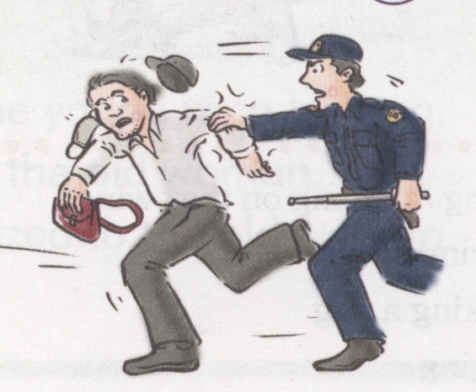 | 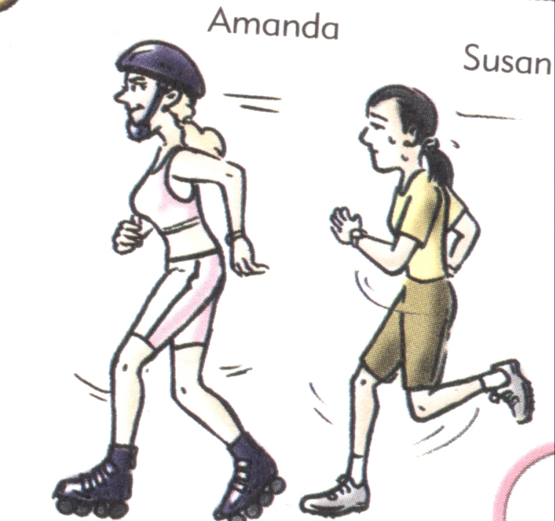  Susan | 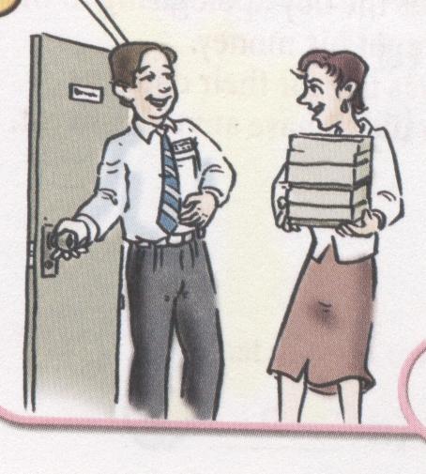 | 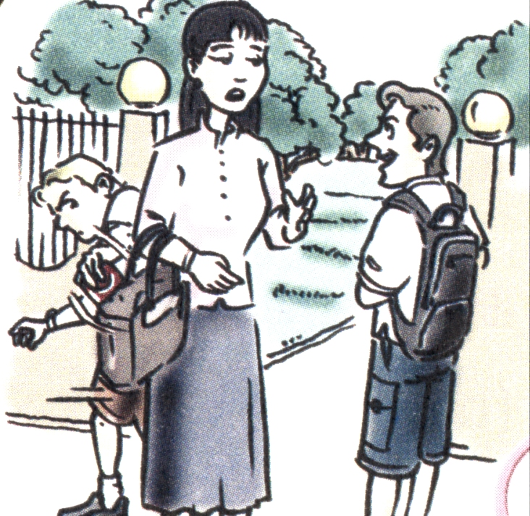 | 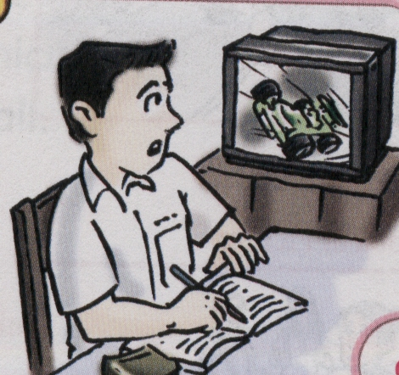
B. 聽廣播中的句子，選出最適當的回應句的英文代號。10 %
- What are you thankful for? A □ B □ C □
- Thank you for your great Thanksgiving dinner. A □ B □ C □
- Someone stole my cell phone. A □ B □ C □
- Excuse me, where’s the entrance to your school? A □ B □ C □
10. Do you have the time? A □ B □ C □
C. 聽廣播中的短文與問題，選出最適當的答案。10%
11. (A).In the year 1602. (B) In the year 1612. (C) In the year 1620.
12. (A) They went there by train. (B) They went there by ship. (C) They went there by plane.
13. (A) The air was bad and they didn’t have enough money. (B) The weather was bad and they didn’t have enough time. (C) The weather was bad and they didn’t have enough food.
14. (A) The Hobe people helped them.(B) The Indian people helped them. (C) The A-mei people helped them.
15. They invited the Indians and celebrated the harvest (A) with a big lunch. (B) with a big dinner. (C) with a big party.
二、語法測驗：10% (每題2分)
16. I _____ my old friends in the park a few days ago.
(A) meet (B) meeting (C) meets (D) met
17. Tom ________baseball at all.
(A) likes (B) isn’t liking (C) doesn’t like (D) liked
18. I ______ my room when my mother came home.
(A) cleaning (B) was cleaning (C) clean (D) cleans
19. Before I got up, ___________.
(A) Mom makes breakfast (B) and Mom makes breakfast
(C) but Mom made breakfast (D) Mom made breakfast
20. A: Did you see my basketball? B: ____________
(A) Are you sure? (B) I put it back after I played it.
(C) No wonder you are so angry. (D) No, it is in your room. 【 第一頁，共四頁，背面尚有試題，請繼續作答 】
臺北市立龍山國民中學94學年度第一學期八年級英語科第二次定期評量試題
三、閱讀測驗：20%
(A)
Cell phones are very popular now, especially with young people. They talk to their friends, send messages, listen to music, and play games with them. Some people even have several cell phones. They buy new cell phones like buying new clothes and new shoes.
Many people do not take good care of their cell phones. Cell phones are small. Some careless owners often forget about them. In Taiwan, many cell phones can’t find their owners every year. Do you have a cell phone? Do you take good care of it?

specially 尤其是 careless 粗心的

21. What’s the best title?
(A) Clothes and shoes (B) Careless owners
(C) Music (D) Cell phones
Title標題
22. What can people do with their cell phones?
(A) Talk to their friends. (B) Send messages. (C) Play games. (D) All above.
23. Which is Not true?
(A) Cell phones are very popular now. (B) Cell phones are small. (C) Some people even
have several cell phones. (D) Only students use cell phones.
24. What kind of people often forget about their cell phones?
(A) The careless owners. (B) The old man. (C) The children. (D) The students.
25. Why many people do not take good care of their cell phones?
(A) Cell phones are too heavy. (B) Cell phones are small.
(C) Cell phones are too noisy. (D) Cell phones are expensive.
(B)
Amy’s father bought her a new cell phone last week. She always hangs her beautiful cell phone on her schoolbag. Everyone likes that cell phone very much. They also want to buy one like hers, but it’s too expensive. So, Amy is very proud when everyone sees it.
Everyone can see it, and of course, a thief can see this, too. Finally, someone stole it yesterday. Amy was very sad. She called the police officer, but he couldn’t help her, either. Now she knows she won’t do this again when she buys a new one.
The story tells us we should take care of our things, and we shouldn’t show our things off.
show off 炫耀

26. Where did Amy hang her beautiful cell phone on ?
(A) In her pocket. (B) In her schoolbag. (C) On her schoolbag. (D) On her hand.
【 第二頁，共四頁，尚有試題，請繼續作答 】

臺北市立龍山國民中學九十四學年度第一學期八年級英語科第二次段考試題
27. What does Amy show?
(A) Her schoolbag. (B) Her watch. (C) Her money. (D) Her beautiful cell phone.
28. Who stole Amy’s cell phone?
(A) Her friends. (B) A thief. (C) The police officer. (D) Everyone.
29. Who can help Amy to find her cell phone?
(A) Her classmates. (B) Her father. (C) The police officer. (D) Nobody.
30. What can we learn from this story?
(A) We shouldn’t show our things off. (B) We should show our things off.
(C) We shouldn’t take care of our things. (D) We shouldn’t buy any cell phones.
第二部分：共四大題 40% (請在答案卷上作答)
一、看中文寫出適當的英語單字：5%
1. 廁所 2. 約會 3. 邀請 4. 謹慎的 5. 慶祝
二、根據提示的首尾字母寫出合乎句意的英語單字：10%
1. The farmers had a good h__________t this year. They are happy.
2. The really important thing about Thanksgiving is always t___________s.
3. You did something wrong. You have to a e for it.
4. Mary’s mother is always c_______e. She takes good care of her children.
5. Officer: Excuse me. What’s in your bag?
Thief: Nothing. Just some p_________l things.
三、 依提示回答問題：10% (每題2分)
- Amanda was angry. (加入 not at all 改寫句子)
- Tom ate dinner first.
Then he went to a cram school. ( 用 before 合併)
- What do you usually do?
You don’t know how to do your homework. ( 用 when合併)
4. Superman does exercise. (加入 usually改寫句子)
5. Mike met his girlfriend.
Mike was staying in Taiwan. ( 用 when合併)

四、翻譯：15% (第1-3題，每格一分；第4-6題，每題3分)
1.我很確定這是我的手機。
I ❶ ❷ this is my cell phone.
2. 舉例說，我們以前常常一起出去玩。
❸ ❹ , we often went out.
3. 我沒有好好照顧她。
I didn’t ❺ good ❻ of her. 【 第三頁，共四頁，尚有試題，請繼續作答 】
臺北市立龍山國民中學九十四學年度第一學期八年級英語科第二次段考試題
4. 我的手機可以記憶、照相和上網。
5. 我很感恩父母都很健康，而且我們全都在一起。
6. 昨晚當你打電話給我時，我正在煮晚餐。

【 第四頁，共四頁，作答完畢，請確實檢查 】

臺北市立龍山國民中學九十四學年度第一學期八年級英語科第二次段考
聽力測驗(每題請唸二次)30%(每題兩分)
A.聽廣播中的句子，選出符合圖意的句子。10%
- (A) The thief caught the police officer.
(B) The police officer caught the thief.
(C) The thief was walking when the police saw him.
- (A) Amanda is jogging.
(B) The two girls are both roller-blading.
(C) Amanda is roller-blading, and Susan is jogging.
- (A) The man is considerate.
(B) The man is blaming the woman.
(C) The man is apologizing to the woman.
- (A) The woman was talking to the police officer at the entrance to school.
(B) The boy was stealing the woman’s money.
(C) The woman was stealing the man’s money.
- (A) Tom watched TV after he did his homework.
(B) Tom watched TV before he did his homework.
(C) Tom was watching TV when he was doing his homework.
B. 聽廣播中的句子，選出最適當的回應句的英文代號。10%
  - Girl: What are you thankful for?
Boy: (A) He is thankful he has a good girlfriend.
(B) I’m thankful I have wonderful parents.
(C) You are thankful you won the basketball game.
  - Boy: Thank you for your great Thanksgiving dinner.
Girl: (A) I hope you enjoyed our lunch.
(B) The food was terrible.
(C) We are happy you enjoyed it.
  - Boy: Someone stole my cell phone.
Girl: (A) Let’s call the police.
(B) You are lucky.
(C) I am happy.
  - Girl: Excuse me. Where’s the entrance to your school?
Boy: (A) I’m glad you know me.
(B) Don’t worry.
(C) It’s over there.
  - Girl: Do you have the time?
Boy: (A) Sorry, I forget your name.
(B) Sorry, I don’t have a watch.
(C) Sorry, I was late.
C. 聽廣播中的短文與問題，選出最適當的答案。10% (短文與問題請唸二次)
In the year 1620, several hundred Pilgrims moved to the New World on a little ship, the Mayflower. In the first year, they had many problems. The weather was bad and they didn’t have enough food. Many people were sick and died. But the Pilgrims were not afraid. They worked hard. The Indian people also helped them. They had a good harvest the next year. Everyone was happy and thankful. They invited the Indians and celebrated the harvest with a big dinner.
11. When did several hundred Pilgrims move to the New World?
12. How did the Pilgrims go to the New World?
13. What problems did the Pilgrims have in the New World in the first year?
14. Who helped the Pilgrims when they first came to the New World?
15. How did the Pilgrims celebrate their harvest the next year?

臺北市立龍山國民中學94學年度第一學期八年級英語科第二次定期評量答案卷
班級:_____ 姓名:______________ 座號:_____ 組別:_____組 任課教師:____________老師
第二部分：共四大題 40% (請在答案卷上作答)
一、看中文寫出適當的英語單字：5%
1. | 2. | 3. | 4. | 5.
二、根據提示的首尾字母寫出合乎句意的英語單字：10%
1. | 2. | 3. | 4. | 5.
三、依提示回答問題：10% (每題2分)
1.
2.
3.
4.
5.
四、翻譯：15% (第1-3題，每格一分；第4-6題，每題3分)
1. | ❶ | ❷
2. | ❸ | ❹
3. | ❺ | ❻
4.
5.
6.

臺北市立龍山國民中學94學年度第一學期八年級英語科第二次定期評量答案
第一部分：共三大題(第1-30題) 60% (請在電腦卡上劃記)
1 | B | 2 | C | 3 | A | 4 | B | 5 | C
6 | B | 7 | C | 8 | A | 9 | C | 10 | B
11 | C | 12 | B | 13 | C | 14 | B | 15 | B
16 | D | 17 | C | 18 | B | 19 | D | 20 | B
21 | D | 22 | D | 23 | D | 24 | A | 25 | B
26 | C | 27 | D | 28 | B | 29 | D | 30 | A

第二部分：共四大題 40% (請在答案卷上作答)
一、看中文寫出適當的英語單字：5%
1. restroom | 2. date | 3. invite | 4. careful | 5. celebrate
二、根據提示的首尾字母寫出合乎句意的英語單字：10%
1. harvest | 2. thankfulness | 3. apologize | 4. considerate | 5. personal
三、依提示回答問題：10% (每題2分)
1. Amanda was not angry at all.
2. Before Tom went to a cram school, he ate dinner.
或 Tom ate dinner before he went to a cram school.
3. When you don’t know how to do your homework, what do you usually do?
或 What do you usually do when you don’t know how to do your homework?
4. Superman usually does exercise.
5. Mike met his girlfriend when he was staying in Taiwan.
或 When Mike was staying in Taiwan, he met his girlfriend.
四、翻譯：15% (第1-3題，每格一分；第4-6題，每題3分)
1. | ❶ am | ❷ sure
2. | ❸ For | ❹ example
3. | ❺ take | ❻ care
4. | My cell phone can remember, take pictures and surf the net.
5. | I’m thankful (my) parents are healthy, and we are all together.
6. | When you called me last night/yesterday evening, I was cooking dinner.

