臺北市立龍山國民中學九十四學年度第一學期八年級英語科第一次段考
聽力測驗(每題請唸二次)
A.聽廣播中的句子，選出符合圖意的句子。
- (A) Fanny worked hard.
(B) Fanny played basketball happily.
(C) Fanny got up early.
- (A) The waiters worked busily.
(B) The waiters enjoyed their dinner.
(C) The waiters played tennis happily.
- (A) Mark and Sally drank the tea slowly.
(B) Mark and Sally sat on the sofa.
(C) Mark and Sally studied history.
- (A) Jane helped her sister clean the room.
(B) Jane climbed the mountains with her sister.
(C) Jane and her sister climbed the tree.
- (A) They had dinner at a wonderful restaurant.
(B) They visited their grandparents last weekend.
(C) They had a picnic under a tree.
B. 聽廣播中的句子，選出最適當的回應句的英文代號。
  - Girl: I am going to visit Disney Land in Japan tomorrow.
Boy: (A) Have a nice trip.
(B) Let’s start.
(C) Yes, I agree.
  - Boy: How was your summer vacation?
Girl: (A) I was tall and thin.
(B) It was too expensive.
(C) I had a good time with my family in America.
  - Boy: What did Emily love?
Girl: (A) She couldn’t swim before.
(B) Fast food was her favorite.
(C) Her grandma was a great cook.
  - Girl: Come again any time.
Boy: (A) I’d love to.
(B) Don’t worry.
(C) I envy you.
  - Girl: Do you need forks and knives?
Boy: (A) Sorry, I didn’t.
(B) It’s okay.
(C) No, I can use chopsticks.
C. 聽廣播中的對話與問題，選出最適當的答案。
11. Amy: Sam, does your grandfather still work in a restaurant?
Sam: No, he grows apples in the mountains in Taichung. Last weekend, we went to
his farm and had some delicious apples.
Question: What does Sam’s grandfather grow in Taichung?
12.Boy: The ice cream here is excellent. Don’t you want some?
Girl: Do you forget? I’m on a diet now.
Question: What does the girl mean?
13. May: Helen eats too much and she eats a lot of snacks. She doesn’t do much exercise.
Mike: No wonder she cannot lose her weight.
Question: How is Helen now?
14. Mary: Tom, I called you yesterday, but you weren’t home. Did you go to the movies yesterday?
Tom: No, Adam and I went to the National Taiwan Museum. We saw a lot of old things and old stones.
Question: What did Tom do yesterday?
15. Amanda: What did Amy write in her letter, Sam?
Sam: She said that she missed us and the Chinese food very much. She was coming to Taipei again this winter. And she could stay in Taipei during the Chinese New Year.
Amanda: That’s wonderful.
Question: What did Amy say in her letter?

臺北市立龍山國民中學94學年度第一學期八年級英語科第一次定期評量試題
第一部分：共三大題(第1-35題) 60% (請在電腦卡上劃記)
一、聽力測驗：30% (每題2分)
A. 聽廣播中的句子，選出符合圖意的句子。10 %
1 | 2 | 3 | 4 | 5
 | 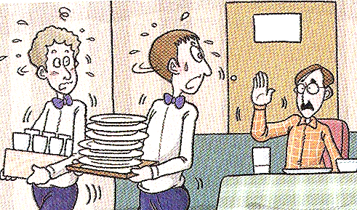 |  | 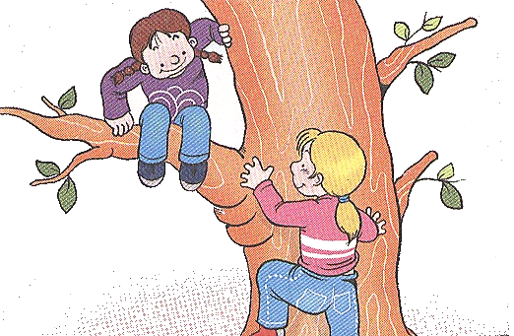 | 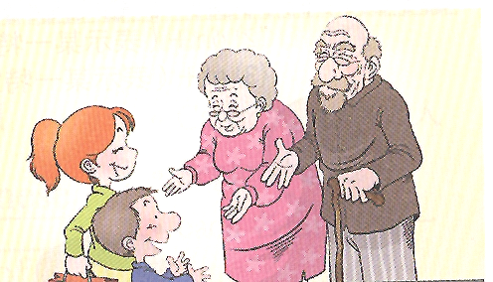
B. 聽廣播中的句子，選出最適當的回應句的英文代號。10 %
- I am going to visit Disney Land in Japan tomorrow.
- How was your summer vacation?
- What did Emily love?
- Come again any time.
- Do you need forks and knives?
C. 聽廣播中的對話與問題，選出最適當的答案。10%
11. (A) Rice. (B) Fruit. (C) Vegetables.
12. (A) She says no to ice cream. (B) She is hungry. (C) She wants to eat some ice cream.
13. (A) She cooks a lot. (B) She is slender. (C) She is heavy.
14. (A) He visited the museum. (B) He slept at home. (C) He went to the movies.
15. (A) She didn’t have a good time in Taiwan. (B) She was going to visit Taiwan again.
(C) She asked Sam to visit the USA.
二、語法測驗：10% (每題1分)
16. Jake came back to Taiwan last year, but Jack ______.
(A) didn’t (B) doesn’t (C) isn’t (D) wasn’t
17. Ted and David are ______ my classmates.
(A) all (B) both (C) two (D) either
18. The singer sings ______.
(A) good (B) beautiful (C) beautifully (D) careful
19. Tom: How do you ______“goodbye” in Japanese? Mr. Yamata: Sayonara.
(A) speak (B) say (C) tell (D) talk
20. Our new P.E. teacher teaches us how to swim. I ______ swim before, but now I ______.
(A) can; could (B) can’t; could (C) couldn’t; can’t (D) couldn’t; can
【 第一頁，共四頁，背面尚有試題，請繼續作答 】

21. Son: Wow, ______ delicious chicken! Mother: Would you like some?
(A) how (B) what (C) however (D) where
22. John was really hungry. He ate three hamburgers ______ ten minutes.
(A) in (B) on (C) at (D) between
23. We can buy ______ in the market.
(A) tomato (B) banana (C) hot dog (D) lemons
24. The boys ______ bicycles in the park an hour ago.
(A) ride (B) rode (C) is riding (D) rides
25. Chinese is ______ but ______.
(A) hardly; interesting (B) hardly; interestingly
(C) hard; interesting (D) hard; interestingly
三、閱讀測驗：20%
(A)
There is an Italian restaurant in my neighborhood. On my way home, I often see many people waiting outside it. Last night, my aunt invited me to dinner there. We had buns and soup first. Then my aunt had some spaghetti with mushrooms and shrimps, and I had pork with vegetables. After the main course, we drank some coffee and had some dessert. The food was very wonderful, and the service was good. Now I realize why the restaurant is so popular.

neighborhood 鄰近地區 buns 小圓麵包 shrimp 小蝦 main course 主菜

26. Who did the writer go to the restaurant with?
(A) The writer’s boyfriend. (B) The writer’s aunt.
(C) The writer’s parents. (D) The writer’s grandparents.
writer 作者
27. What did they drink at dinner?
(A) Juice. (B) Tea. (C) Coffee. (D) Milk tea.
28. What didn’t they have for dinner?
(A) Pizza. (B) Spaghetti. (C) Vegetables. (D) Buns and soup.
(B)
Dear Peggy:
Long time no see. How are things with you? Now my twin brother, Sam, and I are junior high school students in Taipei, but we don’t study in the same class. Our campus is big and clean. My classmates are friendly, and my teachers are kind. They teach us a lot. I enjoy my school life very much. Last Wednesday, we celebrated Teacher’s Day at the Student Activity Center. We expressed our thanks to the teachers for their teaching. We sent cards and sunflowers to our teachers. How did you celebrate your Teacher’s Day? I’d like to know about it.
Love,
Lisa
【 第二頁，共四頁，尚有試題，請繼續作答 】
campus 校園 express 表達
臺北市立龍山國民中學九十四學年度第一學期八年級英語科第一次段考試題
29. Who studies in Taipei?
(A) Peggy. (B) Lisa.
(C) Peggy and Sam. (D) Lisa and Sam.
30. Which is the picture of the sunflower?
(A) | (B) | (C) | (D)
 |  | 

31. What didn’t Lisa and her classmates send to their teachers?
(A) Cards. . (B) Flowers.
(C) Their thanks to the teachers. (D) Money.
(C)
Last Saturday, Ms. Ma took some of her students to the National Palace Museum. They saw many wonderful things there. Jane, one of the students, liked the Chinese paintings and the calligraphy. Her classmate, Nancy, liked the Jade Cabbage. It looked like a real cabbage. Some tourists from Japan and America visited the museum that day, too. They greatly appreciated those old things. All the students were proud of being a Chinese. Time passed quickly! The students couldn’t see everything there. They hoped that they could visit the museum again.
painting 畫 calligraphy 書法 Jade Cabbage 翠玉白菜 tourist 觀光客
appreciate 激賞 proud 驕傲

32. What is Jane’s favorite in the museum?
(A) The Jade Cabbage. (B) The Chinese paintings.
(C) The Americans. (D) The real cabbage.
33. What’s the treasure of the museum?
(A) The Jade Cabbage. (B) The Chinese paintings.
(C) The Chinese calligraphy. (D) All of the above.
treasure 珍藏品
above上述的
34. Who visited the museum that day, too?
(A) Some foreigners. (B) Some elementary school students.
(C) Some baseball players. (D) Some cooks.
35. Did the students like the trip last Saturday?
(A) No, they didn’t. (B) Yes, they did.
(C) Not really. (D) We don’t know.
【 第三頁，共四頁，背面尚有試題，請繼續作答 】

第二部分：共四大題 40% (請在答案卷上作答)
一、看中文寫出適當的英語單字：5%
1. 農田 2. 慢跑 3. 叔(伯)父 4. 昨天 5. 家鄉
二、根據提示的首尾字母寫出合乎句意的英語單字：10%
1. I s ed my room with my sister when I was a little girl.
2. Many people visit Japan for the beautiful s y.
3. My grandpa is seventy, but he is still h y.
4. J.K. Rowling wrote the f s novel “Harry Potter.”
5. It’s great to swim in the cool water in hot s r.
三、整段式填充：10% 根據文意填入正確的動詞、形容詞或副詞，必要時予以適當的變化。
Tina didn’t sleep (1) (good) for days. She (2) (have) several important exams last week. Tina (3) _(study) hard for them. She (4) (get) up early and went to bed very
(5) (late). The only thing she did every day was sit at the desk and study. She (6) (eat) less food and she (7) (lose) 4 pounds. Her parents (8) (worry) about her. They hoped that Tina could take it (9) (easy) and pass the exams (10) (lucky).
四、翻譯：15% (第1-3題，每格一分；第4-6題，每題3分)
1. Susan: 我們就要搬到台南去了。 Nancy: 保重！
Susan: We’re going to move to Tainan. Nancy: ❶ ❷ .
2. 上星期日我們在溪裡戲水、抓魚。
We played and ❸ ❹ in the stream last Sunday.
3. 我可以再來一杯咖啡嗎？
May I have ❺ ❻ cup of coffee?
4. 幾個星期前我們在淡水舉辦同學會。(在淡水in Danshui)
5. 我沒想到你有這麼多的嗜好。
6. Mike在節食。現在他在正餐之間不吃點心。

【 第四頁，共四頁，作答完畢，請確實檢查 】

臺北市立龍山國民中學94學年度第一學期八年級英語科第一次定期評量答案
第一部分：共三大題(第1-35題) 60% (請在電腦卡上劃記)
1 | C | 2 | A | 3 | B | 4 | C | 5 | B
6 | A | 7 | C | 8 | B | 9 | A | 10 | C
11 | B | 12 | A | 13 | C | 14 | A | 15 | B
16 | A | 17 | B | 18 | C | 19 | B | 20 | D
21 | B | 22 | A | 23 | D | 24 | B | 25 | C
26 | B | 27 | C | 28 | A | 29 | D | 30 | C
31 | D | 32 | B | 33 | D | 34 | A | 35 | B

第二部分：共四大題 40% (請在答案卷上作答)
一、看中文寫出適當的英語單字：5%
1. farm | 2. jog | 3. uncle | 4. yesterday | 5. hometown
二、根據提示的首尾字母寫出合乎句意的英語單字：10%
1. shared | 2. scenery | 3. healthy | 4. famous | 5. summer
三、整段式填充：10% 根據文意填入正確的動詞、形容詞或副詞，必要時予以適當的變化。
1. well | 2. had | 3. studied | 4. got | 5. late
6. ate | 7. lost | 8. worried | 9. easy | 10. luckily
四、翻譯：15% (第1-3題，每格一分；第4-6題，每題3分)
1. | ❶ Take | ❷ care
2. | ❸ caught | ❹ fish
3. | ❺ one | ❻ more
4. | We had a class reunion in Danshui several weeks ago.
5. | I don’t(didn’t) expect you have(had) so many hobbies.
6. | Mike is on a diet. Now he doesn’t eat snacks between meals.

