臺北市立龍山國民中學九十三學年度第二學期八年級英語科第三次段考 ( 聽力稿 )
第一部份: 聽力測驗
本測驗共有四大題，每一小題都會唸兩次，請同學們注意聽，仔細作答。
I. | 下面1至6題，請選出所聽到的單字，並將正確的代碼劃在答案卡上。
 | 1. | bawl | 2. |  | dairy
 | 3. | flare | 4. |  | naught
 | 5. | pall | 6. |  | stream
II. | 下面7至10題，請根據所聽到的句子，選擇符合句意的圖片，並將正確的代碼劃在答案卡上。
 | 7. | Most of the boys are riding bicycles.
 | 8. | Mrs. Lee let her children play at the beach.
 | 9. | Judy swims as fast as her brother.
 | 10. | The Chinese test is the most difficult of the three tests.
III. | 下面11至15題，請仔細聽句子，選出最適當的回應句，並將正確的代碼劃在答案卡上。
 | 11. | Hey, I have an idea.
 |  | (A) I’m not sure. | (B) What is it?
 |  | (C) I heard about that news, too.
 | 12. | My mom is sick and has to stay in bed.
 |  | (A) Congratulations! | (B) I’m sorry to hear that.
 |  | (C) That sounds great!
 | 13. | Will one of his daughters come back to Taiwan?
 |  | (A) Yes, they will. | (B) Yes, he only has a daughter.
 |  | (C) Yes. And she’ll stay with us for a few days.
 | 14. | Too bad I can’t go to the airport with you.
 |  | (A) Don’t feel sorry. Maybe next time. |  | (B) Oh, I see. That’s wonderful.
 |  | (C) Wow, I’m so happy you are here.
 | 15. | David hurt his knee while he was playing basketball yesterday.
 |  | (A) Really? What happened to him? |  | (B) Good idea. I’m glad to hear that.
 |  | (C) Poor David. Can we do something for him?
IV. | 下面16至20題，請根據所聽到的敘述與問題，選出最適當的答案，並將正確的代碼劃在答案卡上。
 | 16. | John is taller than Mark. Mark is taller than Paul.  Question: Who is the shortest boy of the three?
 | 17. | The fish is＄300. The pork is＄180. The chicken is＄210.  Question: Which is the most expensive?
 | 18. | Sally got to school at 7:00, Cindy at 7:40, and Betty at 7:15.  Question: Who was the earliest?
 | 19. | There are 30 students in my class. Only five students got 100 on Test 1. Twenty-two got 100 on Test 2. Sixteen got 100 on Test 3.  Question: Which test is the easiest?
 | 20. | The horse is 18 years old, the lion is 12, and the bear is 14.  Question: Which is true?

臺北市立龍山國民中學九十三學年度第二學期八年級英語科第三次段考試題卷
P1.

注意： | 1.本試卷共有四頁，請記得翻頁作答。
注意： | 2. 1- 45題為單一選擇題，請以2B鉛筆將各題正確答案的代碼劃在答案卡上。
注意： | 3. 46 - 61題，請在答案卷上作答。

第一部份: 聽力測驗 (共30分 )
I. | 下面1至6題，請選出所聽到的單字，並將正確的代碼劃在答案卡上。(每題一分，共6分)
 | 1. |  | (A) bare |  |  |  |  |  | (B) bawl |  | 2. |  | (A) dairy |  | (B) dead
 | 3. |  | (A) flare |  |  |  |  |  | (B) flea |  | 4. |  | (A) neat |  | (B) naught
 | 5. |  | (A) pall |  |  |  |  |  | (B) pare |  | 6. |  | (A) stream |  | (B) strawy
II. | 下面7至10題，請根據所聽到的句子，選擇符合句意的圖片，並將正確的代碼劃在答案卡上。  (每題一分，共4分)
 | 7. |  |  | (A)  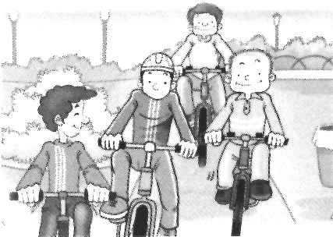 |  |  |  | (B)  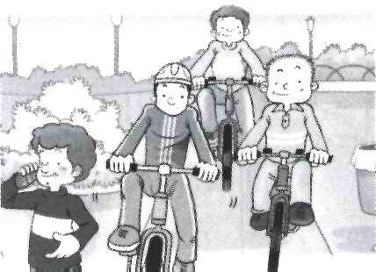 |  | 8. |  | (A)  Mrs. Lee  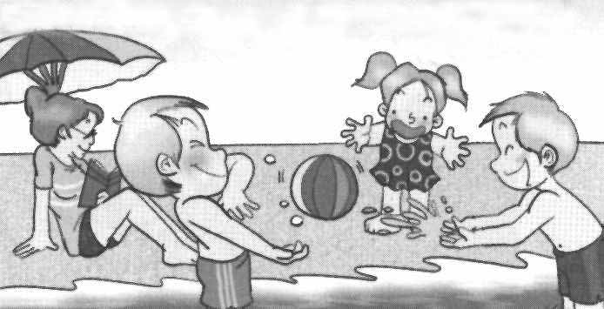 |  | (B)  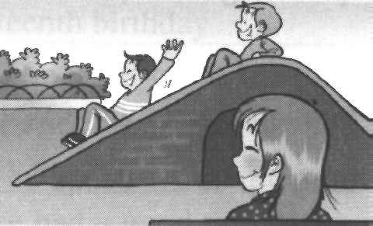  Mrs. Lee
 |  | 9. |  | (A)  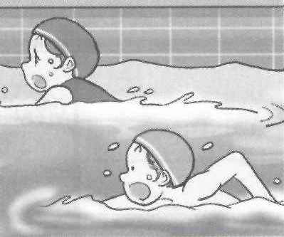  Judy |  |  |  | (B)  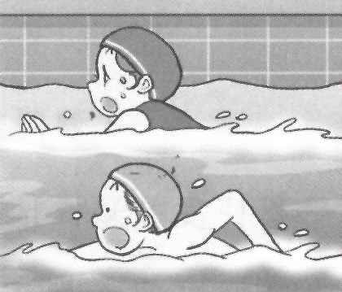  Judy |  | 10. |  | (A)  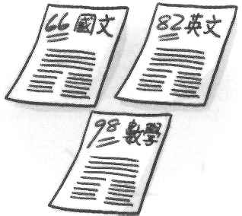 |  | (B)  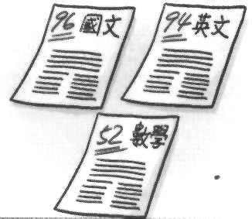
III. |  | 下面11至15題，請仔細聽句子，選出最適當的回應句，並將正確的代碼劃在答案卡上。  (每題二分，共10分)
 |  | 11. |  |  | Hey, I have an idea.
 |  | 12. |  |  |  | My mom is sick and has to stay in bed.
 |  | 13. |  |  |  | Will one of his daughters come back to Taiwan?
 |  | 14. |  |  |  | Too bad I can’t go to the airport with you.
 |  | 15. |  |  |  | David hurt his knee while he was playing basketball yesterday.
IV. |  | 下面16至20題，請根據所聽到的敘述與問題，選出最適當的答案，並將正確的代碼劃在答案卡上。(每題二分，共10分)
 |  | 16. |  |  |  |  | (A) John. | (B) Mark. |  | (C) Paul.
 |  | 17. |  |  |  |  | (A) The fish. | (B) The pork. |  | (C) The chicken.
 |  | 18. |  |  |  |  | (A) Sally. | (B) Cindy. |  | (C) Betty.
 |  | 19. |  |  |  |  | (A) Test 1. | (B) Test 2. |  | (C) Test 3.
 |  | 20. |  |  |  |  | (A) The horse is as old as the lion. |  |  | (B) The lion is older than the bear.
 |  |  |  |  |  |  | (C) The horse is the oldest of the three. 請翻面繼續作答
第二部份: 綜合測驗 (共70分)
P2.
- 文法選擇(每題二分，共10分)
21. Some of _____ in our school don’t eat breakfast before they come to school.
(A) student (B) the student (C) students (D) the students
22. Jimmy and Frank are brothers, and _____ like monkeys very much.
(A) all of them (B) both of them (C) two of them (D) one of them
23. All of the beef _____ very cheap yesterday.
(A) is (B) are (C) was (D) were
24. Mr. Wang _____ his son wash the dog this morning.
(A) had (B) needed (C) asked (D) told
25. In Taiwan, July is usually _____ month of the year.
(A) hot (B) hotter (C) the hotter (D) the hottest
- 克漏字測驗(每題一分，共14分)
( I )
Mr. Green is a teacher. He teaches at a 26. school near my home. Every morning Mr. Green gets up early and drives his car to work. But he doesn’t drive these days 27. someone stole his car last month. Mr. Green felt very sad. He not only asked the police 28. him but also spent a lot of time 29. for his car. However, he just couldn’t find 30. . Finally, he decided to buy a new 31. .
26. (A) girl (B) girl’s (C) girls (D) girls’
27. (A) and (B) because (C) so (D) but
28. (A) to help (B) helping (C) help (D) helped
29. (A) looked (B) to look (C) looking (D) look
30. (A) ones (B) it (C) one (D) them
31. (A) one (B) ones (C) them (D) it
(II)
I have some good friends in my class. Peter is 32. of all. He often 33. me many interesting jokes or stories. Lisa is 34. student in my class. She always gets good grades on all the tests and helps me 35. my homework 36. time to time. Helen is my 37. friend in the class. She’s very 38. and helps others all the time. I think she is 39. than any other student in my class.
32. (A) interesting (B) the more interesting (C) more interesting (D) the most interesting
33. (A) tells (B) talks (C) says (D) speaks
34. (A) the smarter (B) smart (C) the smartest (D) smarter
35. (A) does (B) do (C) doing (D) did
36. (A) during (B) at (C) from (D) about
37. (A) worse (B) worst (C) better (D) best
38. (A) considerate (B) more considerate (C) most considerate (D) the most considerate
39. (A) nice (B) nicer (C) the nicer (D) the nicest

還有題目，請繼續作答
- 閱讀測驗((每題一分，共6分) P3.
Last Tuesday, a car hit Eric while he was going home from school. Eric got seriously hurt and couldn’t come to school. Many of his classmates and friends sent him cards and hoped him to get well soon.
1.
Dear Eric,
When will you come back to school? We miss you a lot!
Take care!

Class 813

Dear Eric,
We will bring your favorite strawberries when we visit you this Saturday.

May and Sue

2.

Dear Eric,
We miss you! Please get well soon and come back to join us. We won the ball game and took several photos for you yesterday. We’ll bring them to you next Wednesday.

Gary, Jeff, and Kevin
Dear Eric,
Be brave! You’ll get better soon. And I’ll make you an apple pie and some delicious candy. See you on Thursday.
Love,

Grandma
3.
4.
40. Why couldn’t Eric come to school?
(A) He joined in a ball game. (B) A car hit him on his way home.
(C) He went to his grandma’s house. (D) Going to school made him tired.
41. When did Eric get hurt?
(A) Next Wednesday. (B) This Saturday.
(C) On Thursday. (D) Last Tuesday.
42. Who is going to visit Eric next Wednesday?
(A) Class 813. (B) May and Sue.
(C) Gary, Jeff, and Kevin. (D) His grandma.
43.Who will give Eric an apple pie?
(A) Class 813. (B) May and Sue.
(C) Gary, Jeff, and Kevin. (D) His grandma.
44.What will May and Sue bring to Eric?
(A) Photos. (B) An apple pie.
(C) Strawberries. (D) Some candy.
45. What does them in line 6 in the third card mean?
(A) Photos. (B) An apple pie.
(C) Strawberries. (D) Some candy.
- 根據提示的首尾字母寫出合乎句意的英語語詞(每題二分，共10分)
46. Lin Chi-ling (林志玲) is one of the most popular m_____ls in Taiwan. Many people
are crazy about her.
47. Hunting in Yangmingshan National Park is i_____l.
背面還有題目，請翻面繼續作答
48. An e_____t has a very long nose. It is the biggest animal in Taipei City Zoo. P4.
49. Nobody knows what will happen in the f_____e.
50. I don’t know that man over there. He is a s_____r to me.
- 看圖寫作(每格一分，共7分)
1.  Mr. Lu  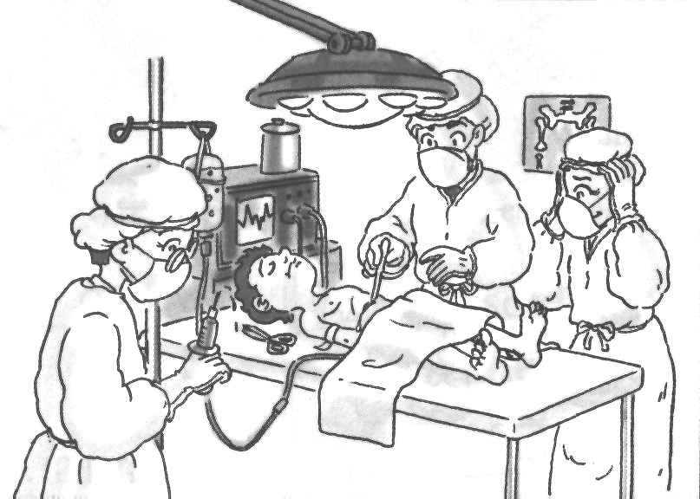  Gina  Iris | 2.  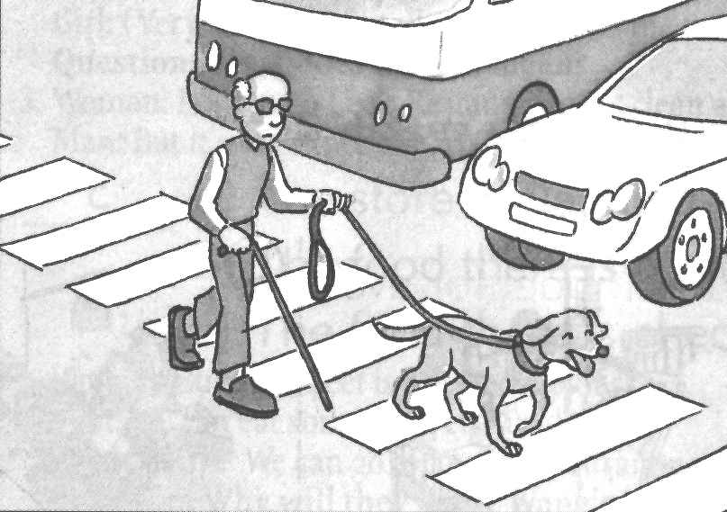
51. Mr. Lu is a ______. Iris and Gina are ______. They all work in the ______.
52. The ______ old man needs the dog to ______ ______ ______ for him.
- 依提示作答(每題二分，共8分)
53. Mr. Wu is too weak. Mr. Wu can’t walk fast.
( 請用because … 將兩句合併成一句 )
54. Mother wants me to do exercise every morning.
( 請把句中的動詞改用make，並將句子做必要的改變後，再重寫整句 )
55. Jason gave his cousin a beautiful poem book.
( 請加入適當的介系詞，並用 … gave a … 改寫本句 )
56. You can keep a zoo animal. You have to pay NT$ 100 a month.
( 請用 … by ＋ Ving … 將兩句合併成一句 )
- 翻譯(每題3分，共15分)
(一)引導式：（一格填一字，每格1分，共9分）
57.她很開朗而且常常面帶微笑。
She is very ______ and often ______ a ______ on her face.
58.請在這一頁的下方作筆記。
Please take ______ at the ______ of this ______.
59.他有嚴重的心臟問題，因此必須每天服藥。
He has a serious ______ problem and has to ______ ______ every day.
(二)整句式：（每題3分，共6分，錯一處，扣1分）
60.昨天她畫了這兩張綿羊和無尾熊的圖片。
61.長頸鹿是動物園裡最優雅的動物。

本試題到此結束

臺北市立龍山國民中學九十三學年度第二學期八年級英語科第三次段考答案卷
班級：______姓名：__________座號：______ 組別：______上課教室：______任課教師：__________

注意： | 1.本試卷共有四頁，請記得翻頁作答。
注意： | 2. 1- 45題為單一選擇題，請以2B鉛筆將各題正確答案的代碼劃在答案卡上。
注意： | 3. 46 - 61題，請在答案卷上作答。

四、根據提示的首尾字母寫出合乎句意的英語語詞(每題二分，共10分)
46. |  | 47. |  | 48. |  | 49. |  | 50.
五、看圖寫作(每格一分，共7分)
51.
52.
六、依提示作答((每題二分，共8分)
53.
54.
55.
56.
七、翻譯(每題3分，共15分)
(一)引導式：（一格填一字，每格1分，共9分）
57. | She is very __________ and often __________ a __________ on her face.
58. | Please take __________ at the __________ of this __________.
59. | He has a serious __________ problem and has to __________ __________ every day.
(二)整句式：（每題3分，共6分，錯一處，扣1分）
60.
61.

臺北市立龍山國民中學九十三學年度第二學期八年級英語科第三次段考答案
四、根據提示的首尾字母寫出合乎句意的英語語詞(每題二分，共10分)
46. | models | 47. | illegal | 48. | elephant | 49. | future | 50. | stranger
五、看圖寫作(每格一分，共7分)
51. | doctor |  | nurses |  | hospital
52. | blind | lead |  | the |  | way
六、依提示作答((每題二分，共8分)
53. | Because Mr. Wu is too weak, he can’t walk fast. /  Mr. Wu can’t walk fast because he is too weak.
54. | Mother makes me do exercise every morning.
55. | Jason gave a beautiful poem book to his cousin.
56. | You can keep a zoo animal by paying NT$ 100 a month.
七、翻譯(每題3分，共15分)
- 引導式：（一格填一字，每格1分，共9分）
57. | She is very cheerful and often wears a smile on her face.
58. | Please take notes at the bottom of this page.
59. | He has a serious heart problem and has to take medicine every day.
(二)整句式：（每題3分，共6分，錯一處，扣1分）
60. | She drew the / these two pictures of sheep and koalas yesterday.
61. | The giraffe is the most graceful animal in the zoo. /  The giraffes are the most graceful animals in the zoo.

注意：下列是答案卡1- 45題的正確答案
1. | B | 2. | A | 3. | A | 4. | B | 5. | A | 6. | A | 7. | B | 8. | A | 9. | B | 10. | A
11. | B | 12. | B | 13. | C | 14. | A | 15. | C | 16. | C | 17. | A | 18. | A | 19. | B | 20. | C
21. | D | 22. | B | 23. | C | 24. | A | 25. | D | 26. | D | 27. | B | 28. | A | 29. | C | 30. | B
31. | A | 32. | D | 33. | A | 34. | C | 35. | B | 36. | C | 37. | D | 38. | A | 39. | B | 40. | B
41. | D | 42. | C | 43. | D | 44. | C | 45. | A

