臺北市立龍山國中九十三學年第二學期八年級英語科第一次段考試題卷 （康軒版L1--R1 50mins） 班級______ 座號______ 姓名__________ 組別______ 授課老師_______________ P.1
注意：(1) 1—36題為單一選擇題，請以2B鉛筆將各題正確答案的代碼劃在電腦答案卡上
(2) 37—63題，請寫在答案卷上
第一部分：
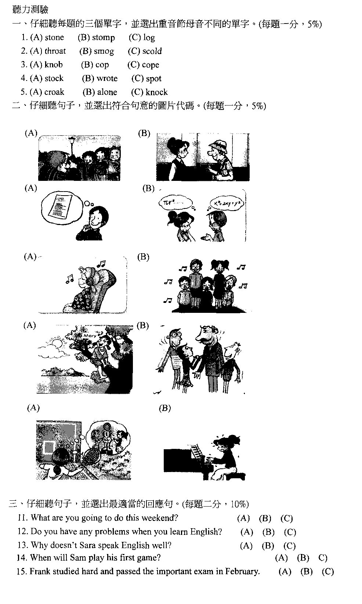
(背面還有試題，請繼續作答)
P.2
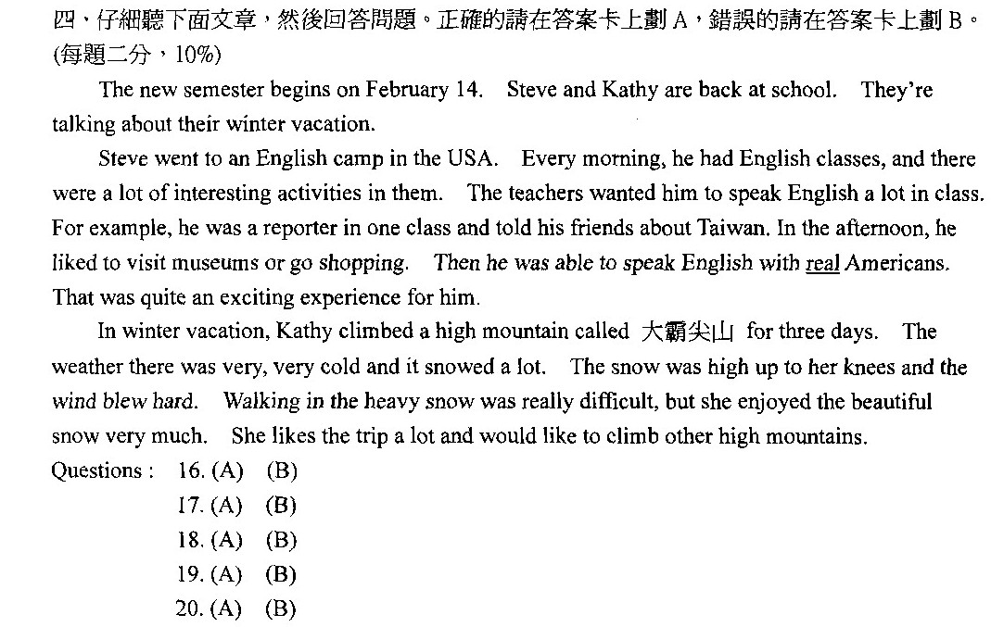

第二部分：綜合測驗
- 選擇 (每題一分，10%)
21. __________ so many people in the gym. They all came to cheer for their school teams.
(A) They had (B) There are (C) There was (D) There were
22 .Bob usually talks ________ his close friends ________ his school life.
  - about, with (B) with, about (C) to, at (D) with, from
- The naughty child kept __________ in class and didn’t listen to his teacher at all.
(A) talking (B) talk (C) to talk (D) play naughty頑皮的
- The factory will be closed in two weeks. Tom is worrying about _________ his job in the factory.
(A) lose (B) losing (C) to lose (D) having
- Jane wishes to get good grades _______ English exams _______ the new semester, but she doesn’t
study hard. (A) in, in (B) on, in (C) on, on (D) for, at
- Everyone _________ ‘Honesty is the best policy.’ policy政策
(A) is knowing (B) know (C) knows (D) say
- The first monthly exam _________ on March 23 and 24. Let’s begin to prepare for it.
(A) is going to (B) will (C) was (D) will be monthly每月的
- How is the weather tomorrow? It ________ rainy.
(A) may (B) may be (C) maybe (D) will
- ______ me you’re sorry, or you may not go. (A) Say (B) Talk (C) Speak (D) Tell
- You got some red envelopes on the Chinese New Year. What are you going to buy _______ the money?
(A) about (B) from (C) with (D) for red envelope紅包

- 閱讀測驗 (每題二分，12%)
Tom lives near David, and they are classmates. They usually go home together every afternoon. On
weekends, they like to play basketball on the playground near their houses.
(背面還有試題，請繼續作答)

P.3
Last Saturday, they went to the playground to play basketball. The weather was not very fine, but it was not raining. Tom’s mother told him to bring an umbrella with him, but David didn’t bring anything except a basketball. They began to play at two o’clock. It began to rain at two thirty. Then they had to stop playing because it rained heavily. Finally they had to go home, but they had only one umbrella. So when they got home at three o’clock, both of them were very wet. except除了 stop停止 wet濕
- Which of the following is true?
(A) Tom and David live together. (B) Tom and David are not in the same class.
(C) Tom and David like to play basketball every day. (D) David only brought a basketball
- They began to play basketball at two o’clock. It began to rain at two thirty.
- They went to the playground at two o’clock. (B) They played basketball for an hour.
(C) They played basketball for thirty minutes. (D) They did not play at all.
33. ‘The weather was not very fine, but it was not raining.’ The sentence means _____________.
(A) It was cloudy. (B) It was rainy. (C) The sun was shining. (D) It was snowy.

Bill, Lisa, and Kathy are kind and energetic. They often visit old people and young children on the weekend and try to help them. They sometimes have a picnic with them. Lisa knows many interesting stories. She often reads the stories to them. Kathy is good at singing. She loves to sing beautiful songs for them. Bill can cook well. He likes to prepare delicious food for them. He also likes to talk with them and
cheer them up. They always have a good time together.
Next Saturday is Lisa’s birthday. Bill and Kathy are having a birthday party for her. They’re going to invite all their friends to the party. They’ll send an invitation card to everyone. It’s like this:

Hi, dear friends,
We’re having a birthday party for Lisa. The party is at Merry House, on Saturday, April 16, at 6:00.
Everyone is welcome to the party.
Bill and Kathy cheer…up使…振作起來
34. On what date is the party?
(A) It’s at six o’clock. (B)It’s on April 16. (C) It’s on Saturday. (D) It’s at Merry House.
35. What do Bill, Lisa, and Kathy often do on the weekend?
(A) They often sing songs at karaoke. (B) They often cook delicious food at home.
(C) They often go on a picnic with their family. (D) They often visit old people and young children.
36. Why will they have a party?
(A) They want to invite their friends. (B) They’ll have it for Lisa’s birthday.
(C) They want to have the party for fun. (D) They’ll go to the party for delicious food.

三、文意字彙 (每題一分，10%)
37. They often have s hes and fresh milk for breakfast. fresh milk鮮奶
38. Jay likes painting and collecting stamps very much. They’re his favorite h ies.
- Allen hurt his hand in an accident yesterday, and the injury is really s s. injury傷
- Don’t do your homework at the last m e.
- Almost everyone can learn English well with good m ds.
- Susan does so well at school, and her parents are really p d of her.
- Using chopsticks is often d t for Americans.
- Ms. Chen likes to watch American TV p ms and movies.
- He tried hard to i e his English skills, and he made it.
- Sam worked so hard, and he finally r ed his dream. Now he’s a great basketball player.

四、以下是一篇日記，請將括弧中提示的動詞，以適當的形式填入空格中，使成為一篇完整的日記
(每格二分，12%) (背面還有試題，請繼續作答)
Date : March 17 P.4
Dear Diary,
My parents are thinking of (47) (move) to Taichung because my father finds a new job there. But I
don’t want (48) (leave) here at all. (49) (say) goodbye to my old friends here is sad for me.
Mother says I have (50) (learn) to make new friends. But (51) (remember) new names is hard. I have a poor memory for names. I wish (52) (find) out answers to the problem. Can you help me? memory記憶力
Alice
五、看圖詳答下列問題 (每題二分， 6%)
53. Linda has a date with Mr. Wu at 4:00 pm. It’s already 4:05 now. What does Linda worry about?
54. Jack hurt the old woman’s back. What did Jack keep saying to the old woman? back背部
55. How much beef is Mr. Bush going to buy?
53. 54. 55.
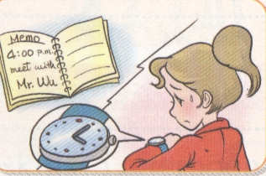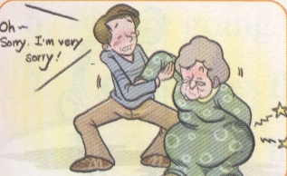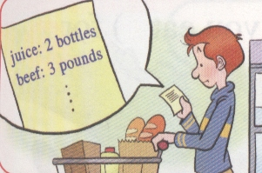
六、依提示作答 (每題二分， 6%)
56. Mrs. Chen makes different kinds of snacks. (在句中適當的位置加入be able to，並作適當的變化，
再重寫此句)
57. Jay is careful when he studies math. (用is careful about…改寫此句)
58. He’ll have an important game in Tainan in two days. (用be going to…改寫此句)

七、翻譯 (59--61題每格一分，62—63題每題三分，14%)
59. Emily ______ a ______ in English every day. Emily每天用英文寫日記。
60. She usually ______ ______ English ______ her American friends. 她經常和美國朋友練習說英語。
61. She likes ______ to English songs and ______ them ______ her free time.
她在空閒時喜歡聽英文歌唱英文歌。
62. 學習英語對她而言不難。
63. 我們將以盛大宴會來慶祝勝利。

(英語科第一次段考試題結束)

臺北市立龍山國中九十三學年第二學期八年級英語科第一次段考答案卷
班級______ 座號______ 姓名__________ 組別______授課老師______________

注意：(1) 1—36題為單一選擇題，請以2B鉛筆將各題正確答案的代碼劃在答案卡上
(2) 37—63題，請在此答案卷上作答
第一部分：聽力測驗
- 仔細聽每題的三個單字，並選出重音節母音不同的單字。 (每題一分，5%)
1. A | 2. B | 3. C | 4. B | 5. C
- 仔細聽句子，並選出符合句意的圖片代碼。 (每題一分，5%)
6. B | 7. A | 8. A | 9. B | 10. B
- 仔細聽句子，並選出最適當的回應句法。 (每題二分，10%)
11. A | 12. B | 13. B | 14. C | 15. B
- 仔細聽下面文章，然後回答問題。正確的請在答案卡上劃A，錯誤的請在答案卡上劃B。 (每題二分，10%)
16. B | 17. B | 18. A | 19. B | 20. A

第二部分：綜合測驗
- 選擇 (每題一分，10%)
21. D | 22. B | 23. A | 24. B | 25. B
26. C | 27. D | 28. B | 29. D | 30. C

二、閱讀測驗 (每題二分，12%)
31. D | 32. C | 33. A | 34. B | 35. D | 36. B

三、文意字彙 (每題一分，10%)
37. sandwiches | 38. hobbies | 39. serious | 40. minute
41. methods | 42. proud | 43. difficult | 44. programs
45. improve | 46. realized

四、以下是一篇日記，請將括弧中提示的動詞，以適當的形式填入空格中，
使成為一篇完整的日記 (每格二分，12%)
47. moving | 48. to leave | 49. Saying
50. to learn | 51. remembering | 52. to find

五、看圖詳答下列問題 (每題二分，6%)
53. She worries about being late for the date.
54. He kept saying sorry to her.
55. He’s going to buy three pounds of beef.

六、依提示作答 (每題二分，6%)
56. Ms. Chen is able to make different kinds of snacks.
57. Jay is careful about studying math.
58. He’s going to have an important game in Tainan in two days.

七、翻譯 (59--61題每格一分，62—63題每題三分，14%)
59. Emily keeps a diary in English every day.
60. She usually practices speaking English with her American friends.
61. She likes listening to English songs and singing them in her free time.
62. Learning English is not difficult for her.
63. We’ll celebrate the winning with a big party.

