臺北市立龍山國民中學九十二學年度第二學期八年級英語科第一次段考試卷
Class ______ NO. ____Name ___________

第一部份： 聽力測驗
一、聽錄音帶中的句子，選出各題符合圖意的句子代號。10%
- 1. Sara CNN | 2. Jimmy  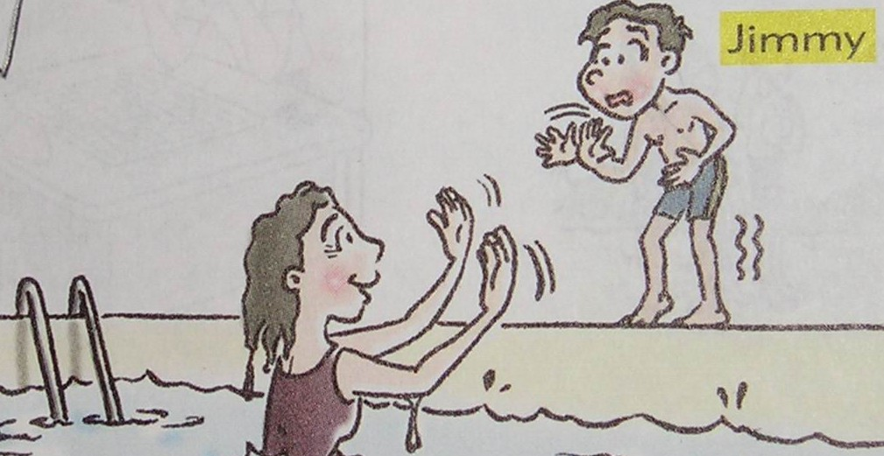 | 3.  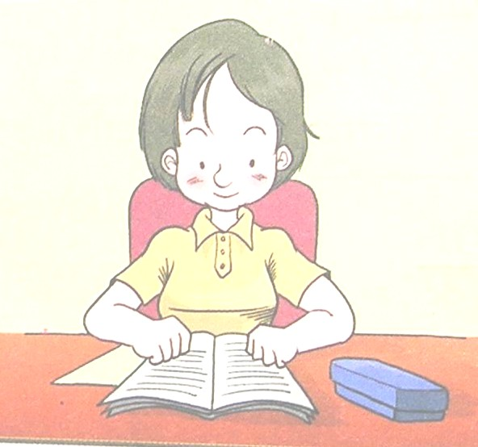 | 4.   | 5. Welcome 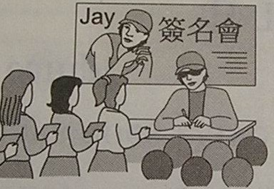
二、聽錄音帶中的句子，選出最適當的回應，並將代號塡在空格裡。10%
1. (A) Good luck to you.
(B) Wow, that’s cool.
(C) Poor you. Is it serious?
2. (A) She doesn’t need to be.
(B) That’s very helpful.
(C) I’m proud of you.
3. (A) What a pity!
(B) What a surprise!
(C) What a small world!
4. (A) I went to a movie.
(B) I am going to feed the dog.
(C) I am cooking dinner.
5. (A) I’m sorry to hear that.
(B) Come on, don’t be sad.
(C) Congratulations!
三、請看海報，依據海報的資料，仔細聽錄音帶的敘述，若符合海報內容，請寫T，
否則請寫F。10%

Lincoln School vs. Beach School
Date: March 25, 2004
Time: 10:00A.M.
Place: School gym

Come and cheer for the home team.

第二部份
一、文意字彙 10%
1. A new year means a new b_____g.
2. A: What’s your favorite p_____m? B: Super Sunday.
3. Here’s the doctor’s a____e for you: stop smoking .
4. A: I got 98 on my English test. B: That’s t_____c! You did a good job.
5. You can i_____e your English by studying and practicing it every day.
6. There are two s_____rs in a school year.
7. It’s easy for you to do it. It’s not d_____t.
8. Elva is a very popular singer. She is like a s_____r.
9. Mark keeps a d_____y about his school life every day.
10. Jolin finally passed the exam. Let’s have a c_____n for her.
二、寫出英文單字(11-13)或片語(14-15)5%
11. 技巧 | 12. 嚴重的 | 13. 腳踝 | 13. 要求 | 14. 一直
三、填充題5%
1. A: What do you usually do _____ your free time? B: Reading.
2. He plays soccer _____ the school team.
3. I’ll finish the work _____ two days.
4. He got the first place. His parents were proud _____ him.
5. Do you know Makiyo? Yes, she’s a cute girl _____ Japan.
四、選擇20%
1. Jane asked me _____ math with her this evening.
( 1. studied 2. to studied 3. study 4. to study )
2. The boys kept_____ in class, and the teacher was angry.
( 1. to talk 2. talking 3. talked 4. talk )
3. A: How is the weather tomorrow? B: It _____ cloudy.
( 1. maybe 2. may 3. may be 4. is )
4. Sam _____ his first game tomorrow.
( 1. is playing 2. plays 3. will play 4. will going to play )
5. _____ computer games _____ a lot fun.
( 1. Playing, is 2. Play, are 3. Play, is 4. To play, are )
6. I___ my hand when I tried to move the heavy chair.
( 1. hurted 2. hurts 3. was hurt 4. hurt )
7. There _____ a concert on TV this Saturday. I hope I can watch it.
( 1. will be 2. will have 3. is going to have 4. are going to be )
8. A: May I use your phone? B:_____
(1. Sure. It’s over there. 2. No, thanks. 3. Excuse me. 4. Yes, it’s nice of you. )
9. A: It’s the weekend and we can have fun together. B: Yeah!_____
( 1. What a nice day! 2. What a great feeling! 3. How come? 4. What happened? )
10. A: How was your vacation? B:_____
( 1. It’s great. 2. Gook luck. 3. Poor you. 4. Not bad. )

五、填入適當形式10%(含動詞形式及時態)
Dick 1 (be) 16 years old next month. He decides 2 (start) a new life from now on（從現在起）。. He hopes 3 (get) good grades on all the tests.
Last year, he didn’t study very hard. He usually practiced 4 (play) basketball for two hours after school. And he often thought about 5 (talk) to his Internet friends when he did his homework. He also enjoyed 6 (study) on the bed, but he soon fell asleep.
Dick really has to 7 (change) his bad habits（習慣）。 8 (be) a computer engineer is his dream. He knows he needs 9 (spend) more time on his study. Will he 10 (realize) his dream some day? Let’s see.
六、看圖回答問題（詳答）8%
1. | 2. | 3. | 4.
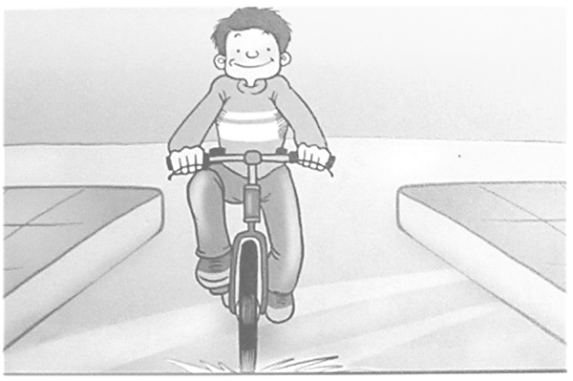 | 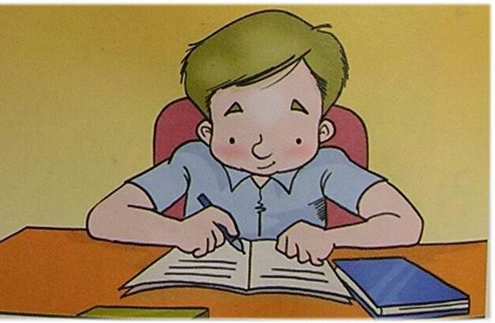 | 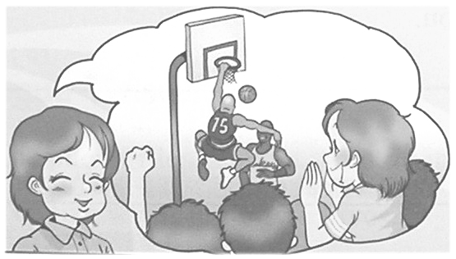 | 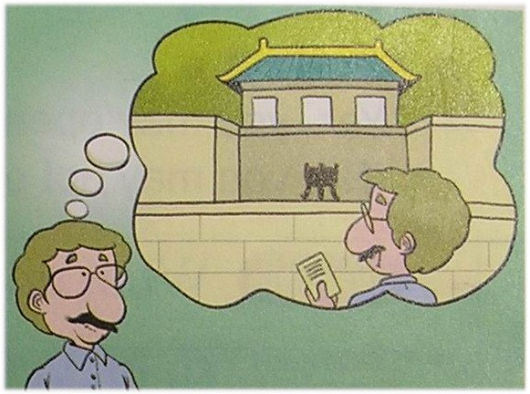
- 1. What is easy for Tom?
- 2. What is Eric careful about?
- 3. Is Sally going to stay at home this weekend?
- 4. What did Mr. Green plan to do last Sunday?
七、翻譯12% （1-2每格一分，3-4每題三分）
1. 最重要的是，他努力工作而且從不放棄。
_____ _____, he works hard and never _____.
2. 如果你用正確的方法研讀，學英文就不會那麼難了。
_____ English is not so hard if you study it _____ the right _____.
3. 當你說英語時別怕犯錯。(Don’t…)
4. 盡力而為，那麼對你而言就沒什麼是不可能的了。(…, and…)

龍山國中九十二學年度第二學期英語科八年級第一次定期考查聽力測驗
本測驗每題念兩次
【錄音稿】
一、聽錄音帶中的句子，選出各題符合圖意的句子代號。

1. (A) To be a player is Sara’s dream.
(B) Sara hopes to be a cook.
(C) Being a reporter is Sara’s hope.

2. (A) Jimmy is active in swimming.
(B) Jimmy is afraid of swimming.
(C) Jimmy is careful about swimming.

3. (A) I am going to do the housework.
(B) I will play the piano.
(C) I am going to do the homework.

4. (A) Susan wants to fly in the sky.
(B) Susan hopes to drive a car.
(C) Susan wants to play baseball.

5. (A) Many girls are afraid of Jay.
(B) Many girls are crazy about Jay.
(C) Many girls worry about Jay.

二、聽錄音帶中的句子，選出最適當的回應，並將代號塡在空格裡。
1. I hurt my hand yesterday.
2. She is afraid of making mistakes when she speaks English.
3. Happy birthday! This is a present for you.
4. What are you going to do?
5. We won the game!

三、請先看海報，依據海報的資料，仔細聽錄音帶的敘述，若符合海報內容，請寫T，否則請寫F。
1. There will be a baseball game on March 24.
2. Beach School and Lincoln School will play the game.
3. The two teams will play the game in the playground.
4. The game will start at 10:00 in the morning.
5. The students are welcome to the game.

臺北市立龍山國民中學九十二學年度第二學期八年級英語科第一次定考答案卷
Class ________ Name ___________ No. ______
第一部份： 聽力測驗 30%
一、聽錄音帶中的句子，選出各題符合圖意的句子代號。10% (每題兩分)
1 | C | 2 | B | 3 | C | 4 | A | 5 | B

二、聽錄音帶中的句子，選出最適當的回應，並將代號塡在空格裡。10% (每題兩分)
1 | C | 2 | A | 3 | B | 4 | B | 5 | C

三、請先看海報，依據海報的資料，仔細聽錄音帶的敘述，若符合海報內容，請寫T，否則請寫F。10% (每題兩分)
1 | F | 2 | T | 3 | F | 4 | T | 5 | T

第二部分： 綜合測驗 70%
一、文意字彙 10% (每題一分)
二、寫出英文單字(11-13)或片語(14-15)5% (每題一分)
1 | beginning | 2 | program | 3 | advice | 4 | terrific | 5 | improve
6 | semesters | 7 | difficult | 8 | superstar | 9 | diary | 1  0  0 | celebration
三、填充題5% (每題一分)
1  1 | skill | 12 | ankle | 13 | win | 14 | ask for | 15 | all the time
1 | in | 2 | on | 3 | in | 4 | in | 5 | from

四、選擇20% (每題兩分)
1 | 4 | 2 | 2 | 3 | 3 | 4 | 3 | 5 | 4
6 | 1 | 7 | 1 | 8 | 1 | 9 | 2 | 1  0 | 4

五、填入適當形式10%(每題一分)
1 | will be/  is going to be | 2 | to start | 3 | to get | 4 | playing | 5 | talking
6 | studying | 7 | change | 8 | To be/ Being | 9 | to spend | 1  0 | realize
六、 看圖回答問題（詳答）8% (每題兩分)
1 | Riding a bicycle is easy for Tom.
2 | He is careful about doing his homework.
3 | No, she is going to watch a ball game.
4 | He planned to visit the National Palace Museum.

七、翻譯 12% （1-2每格一分，3-4每題三分）
1 | Above | all | quit
2 | Learning | with | methods
3 | Don’t be afraid of making mistakes when you speak English.
4 | Do your best, and (then) nothing will be impossible for you.

