臺北市立龍山國民中學九十一學年度第一學期二年級英文科第二次定考試題
class ________ name ________ No. ________
壹﹑聽力測驗30%
I.把你聽到下列各句中遺漏的生字填上10%
1. Cathy hates up early in the morning, so she likes a lot.
2. In Taiwan, we have in January.
3. He found some posters in a bookstore, but they were a little
4. Joseph is going to Hong Kong. He’s going to take a plane and his is
next Sunday.
5. On Eve, my family usually go to together after dinner.
II.下列各題，請看圖片聽錄音帶中的問題選出正確答案10%
1. 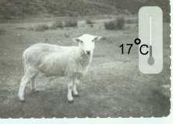 | 2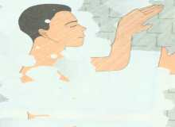. | 3.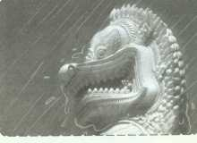 | 4.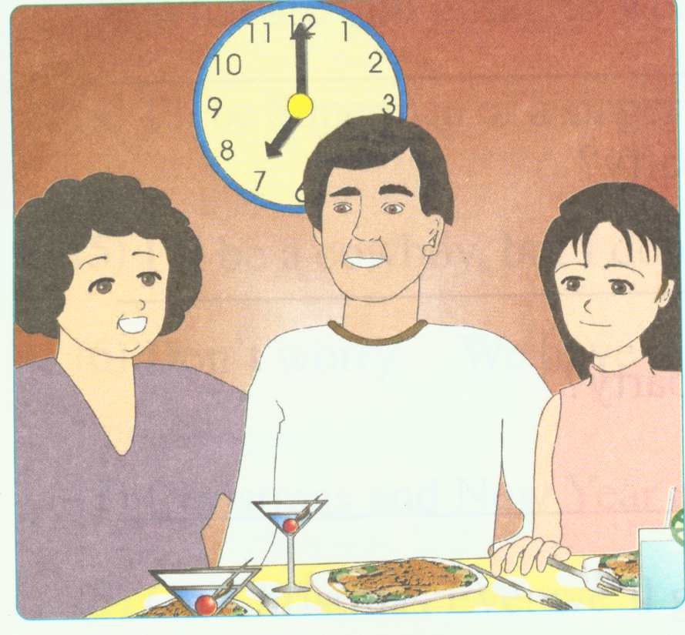 | 5.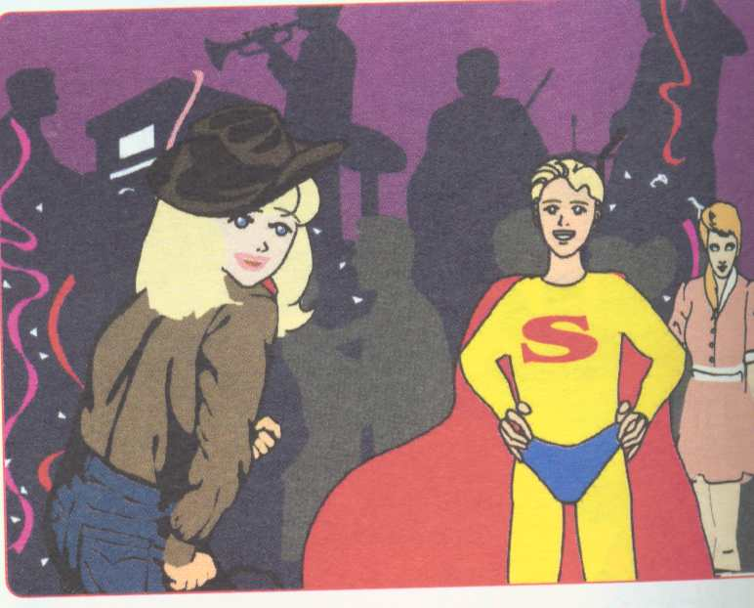
( ) 1. It’s cool. It’s hot. It’s warm.
( ) 2. He’s taking a bath .He will take a bath. He likes to take a bath.
( ) 3. No, it’s not. Yes, it is. Yes, it does.
( ) 4. Yes, he will. No, they won’t. No, they don’t.
( ) 5. He likes Superman. He will be Superman. He has a good time.
III.請聽下列兩篇短文及問題，選出正確的回答10%
( ) 1. Yes, he did. No, he didn’t. He liked it very much.
( ) 2. A computer game. A watch. Two comic books.
( ) 3. Basketball. Baseball. Soccer.
( ) 4. Yes, he sometimes is. No, he doesn’t.. Yes, he sometimes does.
( ) 5. Twice a week. Twice a day. Two hours a day.

貳﹑綜合測驗 70%

I. 字彙測驗 20﹪
- 看中文寫英文 20﹪
  - 餐後甜點 2. 潮濕的 3. 壓歲錢 4. 牛仔 5. 足球
6. 十一月 7. 攤販 8. 人們 9. 成人 10. 溫泉

臺北市立龍山國民中學九十一學年度第一學期二年級英文科第二次定考試題
- 文意字彙 10﹪
1. You can look up(查) the words in a d y.
2. Basketball is a t m sport. That means you play it together.
3. O r 10 is Double Tenth Day.
4. We are going to d e our classroom with pictures.
5. Don’t w y. You can do it.
6. There will be a party t w afternoon.
7. We took a t i to the train station.
8. A: How would you like your s k ?
B: Well-done.(全熟)
9. Children get red e es during Chinese New Year.
10. My sister likes to go s g in the department stores. .

II. 文法選擇 20﹪
- Miss Lin is our Chinese teacher. She teaches _______ Chinese.
(we our ours us )
- Cathy is sick. Can you take her ____ the doctor? (in at to for )
- Today is my sister’s ______ birthday.
(twenty twentyth twentith twentieth )
- It’s very cold ____ December____ every year.
(on；× at；in in；× on；in )
5. There ____ going to be a basketball game and a baseball game next week.
( is are will )
6. Amy ____ the book on the desk and then read it. ( put puts putting )
7. A: How ______ do you practice baseball?
B: Never.
(ever never often usually)
8. Peter______ late for school. (never is never never is )
9. My brother enjoyed ______ fishing very much last year.
(go goes going went)
10. Jay: Does Mike play softball______?
David：Yes, he does. He is ______ at it.
(good；well well；good good；nice well；bad)

【尚有試題】

臺北市立龍山國民中學九十一學年度第一學期二年級英文科第二次定考試題
III. 填入適當的字詞 10﹪
1. Mr. Lin is a businessman. He came to Taiwan business last month.
2. Jane had a big dinner her family yesterday.
3. We have no work Saturday afternoon. .
4. He bought some presents his wife and daughter.
5. What’s so special Halloween (萬聖節)?

IV. 對話與完成句子 5﹪
- Rose：I will take a trip to Sydney (雪梨) on Christmas.
How’s the weather there?
Jack: ________________________________________
It’s warm. It’s hot. There is a lot of rain. It snows. (下雪)
- Mike：Next Sunday is my birthday. Can you come to my home?
Tom：________________. That’s great.
No way! Sorry, I can’t. Of course, I’ll come. That’s too bad.
- Susan：I will go to the party, but I don’t have a hat.
Helen：I have a hat at home. I give it to you.
Susan：_____________________________
Can I help you? What about you?
You’re welcome. Great! That will really help.
- Clerk: May I help you?
Customer(顧客)：Yes, I want a jacket.
Clerk: __________________________
OK. Thank you. What about the blue one? Excuse me.

【尚有試題】

臺北市立龍山國民中學九十一學年度第一學期二年級英文科第二次定考試題
- Mark：___________________________
Tony: They can get lucky money.
When do you like Chinese New Year? Why do you like Chinese New Year?
How do you love Chinese New Year? Why don’t you love Chinese New Year?

V. 翻譯 (中翻英) 15﹪
- Peter 在晚餐後吃了藥。
- 我們談了很多關於我們在美國的朋友。
- 你將要穿什麼去派對?
- 我很少看電視上的球賽。
- 林先生的兒女們都回來過年。

臺北市立龍山國民中學九十一學年度第一學期二年級英文科第二次月考聽力稿
I. 把你聽到下列各句中遺漏的生字填上10%
1. Cathy hates getting up early in the morning, so she likes holidays a lot.
2. In Taiwan, we never have typhoons in January.
3. He found some special posters in a bookstore, but they were a little expensive.
4. Joseph is going back to Hong Kong. He’s going to take a plane and his flight is next Sunday.
5. On Christmas Eve, my family usually go to church together after dinner.
II. 下列各題，請看圖片聽錄音帶中的問題選出正確答案10%
- What’s the weather like in January in New Zealand?
- What will Mr. Chen do at 10:30?
- Does it rain a lot in Singapore in November?
- Will the Wang family have dinner at 5:30?
- What will Joseph be at the party?
III.請聽下列兩篇短文及問題，選出正確的回答10%
( A ) I have a twin brother , Bill. Yesterday was our birthday. We got some presents. Bill gave me two comic books and I bought him a computer game. Grandma gave me a watch and she gave Bill a dictionary. We liked our presents very much.
Question 1: Did Bill get a watch on his birthday?
Question 2: What present did Bill’s brother buy him?
( B ) Tina and Peter are good friends. They both like sports. Tina is on the school basketball team and practices basketball every day. Peter likes soccer and baseball. He practices soccer two hours a day. Sometimes he plays baseball on Sunday.
Question 3: What sports does Tina like?
: Question 4: Does Peter sometimes play baseball on Sunday?
Question 5: How often does Peter practice soccer?
臺北市立龍山國民中學九十一學年度第一學期二年級英文科第二次月考
class ________ name ________ No. ________
I. 把你聽到下列各句中遺漏的生字填上10%
1. Cathy hates up early in the morning, so she likes a lot.
2. In Taiwan, we have in January.
3. He found some posters in a bookstore, but they were a little
4. Joseph is going to Hong Kong. He’s going to take a plane and his is
next Sunday.
5. On Eve, my family usually go to together after dinner.
II..下列各題，請看圖片聽錄音帶中的問題選出正確答案10%
1. | 2. | 3. | 4. | 5.
( ) 1. It’s cool. It’s hot. It’s warm.
( ) 2. He’s taking a bath .He will take a bath. He likes to take a bath.
( ) 3. No, it’s not. Yes, it is. Yes, it does.
( ) 4. Yes, he will. No, they won’t. No, they don’t.
( ) 5. He likes Superman. He will be Superman. He has a good time.
III.請聽下列兩篇短文及問題，選出正確的回答10%
( ) 1. Yes, he did. No, he didn’t. He liked it very much.
( ) 2. A computer game. A watch. Two comic books.
( ) 3. Basketball. Baseball. Soccer.
( ) 4. Yes, he sometimes is. No, he doesn’t.. Yes, he sometimes does.
( ) 5. Twice a week. Twice a day. Two hours a day.

臺北市立龍山國民中學九十一學年度第一學期二年級英文科第二次月考答案卷
class ________ name ________ No. ________

I. 把你聽到下列各句中遺漏的生字填上10%
II..下列各題，請看圖片聽錄音帶中的問題選出正確答案10%
1. | 2. | 3. | 4. | 5.
III.請聽下列兩篇短文及問題，選出正確的回答10%
1. | 2. | 3. | 4. | 5.

