臺北市立龍山國民中學九十六學年度第二學期七年級英語科第二次定期評量試題卷
第一部分: 聽力測驗 (共 24 分)
注意： | 1.本試題卷共有四頁，請記得翻頁作答。
注意： | 2. 1-34題為單一選擇題，請以2B鉛筆將各題正確答案的代碼劃在答案卡上。
注意： | 3. 35-54題，請在答案卷上作答。
本測驗共有三大題，每一小題都會唸兩次，請同學們注意聽，仔細作答。

一、 請仔細聽廣播中的句子，並選出最能符合圖意的句子的英文代號。 (每題1分，共4分)
1. | 2. | 3. | 4.
Mrs. Li  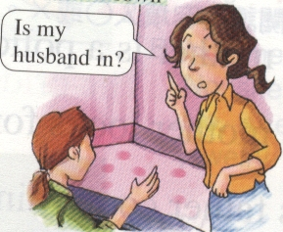 | Mr. Brown  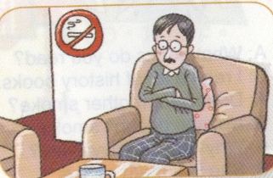 | Mary  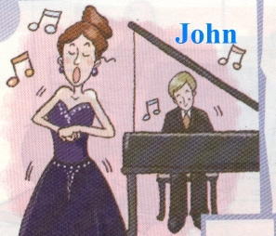 | 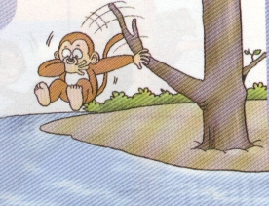

二、請仔細聽廣播中的對話，並選出能與對話配合的圖片的英文代號。 (每題2分，共10分)
5. | 6. | 7. | 8. | 9.

A | B | C | D | AB | AC | AD
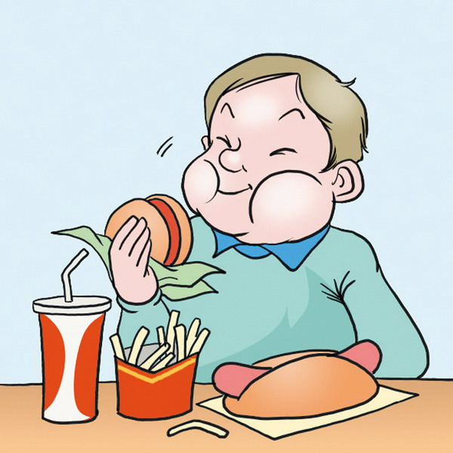 | 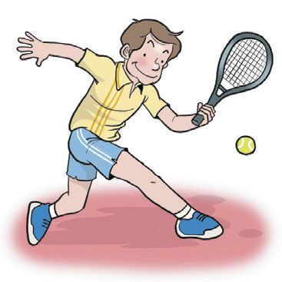 | 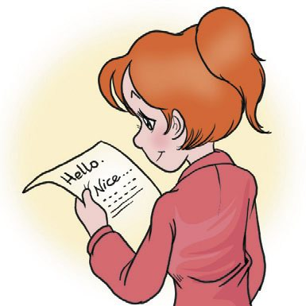 | 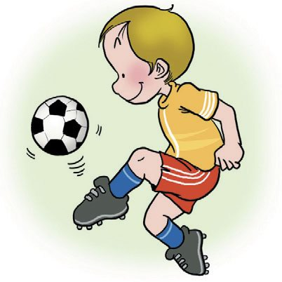 |  | 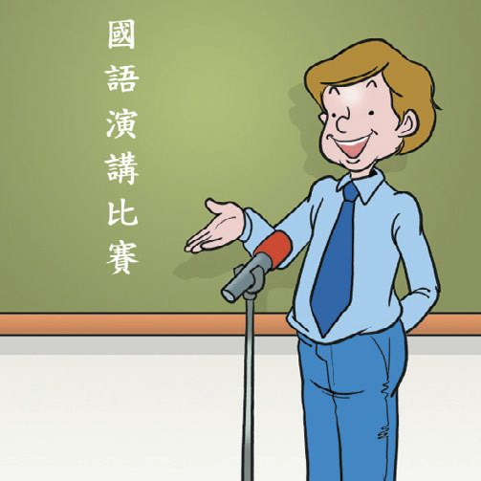 | 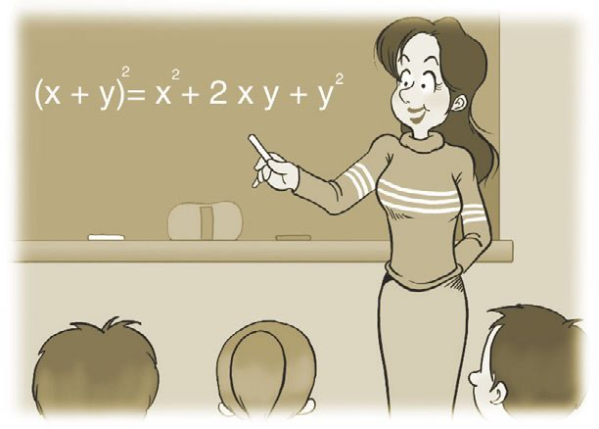

三、請仔細聽廣播中的句子，選出最適當回應句子的英文代號。(每題2分，共10分)
10. | (A) I don’t like her. | (B) Wow! I envy her. | (C) She’s thin.
11. | (A) I do, too. | (B) I’m not, either. | (C) I don’t, either.
12. | (A) I get home in the morning. | (B) I get up at 6:30. | (C) I get up every morning.
13. | (A) She likes baseball. | (B) She likes apples. | (C) She likes jewelry.
14. | (A) It’s a present. | (B) It’s on the desk. | (C) It’s for my friend, Cindy.

【第一頁，尚有試題】
第二部份: 綜合測驗 (共76分)
一、語法測驗 (每題1分，共10分)
15. ________ Mary and Mark study in the library? (A) Is (B) Are (C) Do (D) Does
16. My sister, Amanda, ________ our dog in the garden every weekend.
(A) wish (B) wishes (C) wash (D) washes
17. Ted: Who ________ this jacket for you? It looks good on you.
Amy: My parents buy it for me as a birthday present.
(A) buy (B) buys (C) play (D) plays
- Cindy: ________ Eric: It’s Sunday.
(A) What time is it? (B) What day is today? (C) Where is it? (D) What is it?
- The question is so hard. Nobody ________ the answer. question 問題
(A) ask (B) asks (C) know (D) knows
- Mike eats ________ fast food. He does not play basketball ________. No wonder he is heavy.
(A) a lot , a lot of (B) a lot of, a lot (C) a lot , very much (D) very much, a lot of
- Sara: I’m very busy. Can you help me ________ the housework? Peter: Sure. housework 家事
(A) with (B) on (C) for (D) in
- Ella: Do you have to get up early? Sam: ________
(A) No, he doesn’t. (B) Yes, he does. (C) No, I don’t. (D) Yes, I am.
- Gary: What does your father do? Iris: ________
(A) He’s a diplomat. (B) He is reading newspapers. (C) He’s tall. (D) He gets up at six.
- I like baseball, ________.
(A) and they are, too (B) and they do, either (C) but Mary does, too (D) but Mary doesn’t
二、克漏字測驗 (每題2分，共10分)
Kerry: What are you doing?
Jason: I’m reading an e-mail (25) my sister, Helen. And look, this is her picture.
Kerry: She looks (26) . How can she look so good?
Jason: She jogs and dances a lot. She doesn’t eat junk food.
Kerry: Can I meet your sister?
Jason: No, you can’t.
Kerry: Why not?
Jason: But she’s not in Taiwan.
Kerry: (27) does she live?
Jason: She lives in the USA. She is very busy with her job, but she helps some students do their
homework (28) Sunday.
Kerry: I really envy her. She uses her time well. I want to know more about her.
Jason: Maybe you can read her blog to know more about her.
Kerry: (29)

jog慢跑 dance跳舞 use使用 want想要 more更多 blog部落格

【第二頁，尚有試題】
臺北市立龍山國民中學九十六學年度第二學期七年級英語科第二次定期評量試題卷
25. | (A) with | (B) from | (C) on | (D) in
26. | (A) terrible | (B) bad | (C) slender | (D) heavy
27. | (A) What | (B) Who | (C) Where | (D) How
28. | (A) at | (B) on | (C) in | (D) to
29. | (A) What a small world! | (B) Take it easy. | (C) Just a moment. | (D) That’s a good idea.
三、閱讀測驗 (每題2分，共10分)
Hi, I’m Lily. Father’s Day is coming. We want to give our grandfather some nice things
that day.
My father works late every day. He comes home early that day and makes a big dinner. My mother buys a jacket for Grandfather. It keeps him warm when he goes out.
Grandfather is learning Japanese, and Uncle Sam and Aunt Amy buy him a CD player as a present. It can help him learn Japanese well.
I make a nice card with beautiful pictures. My cousin, Mary, is only four years old. She gives Grandfather a kiss.
We all like Grandfather. Happy birthday, Grandfather.
grandfather 祖父 keep 保持 warm 溫暖 Japanese 日文 with 有 CD player CD播放器

30. What does Lily’s mother buy for their grandfather?
(A) A card. (B) A big dinner. (C) A CD player. (D) A jacket.
31. What does the word big mean in line three? mean 意指
(A) Bad. (B) Great. (C) Terrible. (D) Strong.
32. What does it mean in line six?
(A) Japanese. (B) A jacket. (C) A CD player. (D) A kiss.
33. What is in the card?
(A) Pictures. (B) CDs. (C) A jacket. (D) Japanese.
34. Which is true?
(A) Mother’s Day is coming. (B) Uncle Sam and Aunt Amy buy a CD for Grandfather.
(C) Mary gives a kiss to Grandfather. (D) Grandfather is learning English.
【第三頁，尚有試題】
四、文意字彙 (每題2分，共20分)
35. I want this cell phone, but it is too e e. I don’t have enough money for it. enough 足夠的
36. Don’t s e, John. It’s not good for your health. health 健康
37. Mr. Lin plays t s with his friends after work.
38. Look at the calendar. The day before Friday is T y. calendar 日曆 before 在…之前
39. Jack listens to m c on weekends.
40. More and more people come to Taiwan to learn C e. more 更多的 people 人們
41. Ted is a reporter. He needs a fax m e for his job.
42. Rose is an e c girl. She swims and plays baseball every morning.
43. The winter c es are on sale at the store. We can buy some jackets there. on sale 拍賣 store 店
44. Your room is in mess. C n your room now. mess 凌亂
五、依提示作答 (每題2分，共8分)
圖 1
George
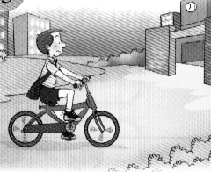
45. Does George walk to school? (先簡答再詳答，圖1)
46. Jane is studying math. (加入every day 改寫)
47. I have to feed Lucky. (將I改為Mark 改寫)
48. Mrs. Li gets home at noon. (依劃線部分造原問句)
六、 翻譯（每題三分，共18分）
49. 這位作家每天晚上讀歷史故事。
50. Tim 很聰明。他說三種語言。
51. 這隻猴子爬上樹，閉上他的雙眼，然後跳下來。
52. 這位大學生彈鋼琴。他也喜歡運動。
53. Karen是個天才。她教我許多事情。
54. 這些警察們尋找失蹤的孩童們。

【試題結束，作答完請確實檢查 】
臺北市立龍山國民中學九十六學年度第二學期七年級英語科第二次定期評量(聽力稿)
第一部分: 聽力測驗
本測驗共有三大題，每一小題都會唸兩次，請同學們注意聽，仔細作答。
一、 請仔細聽廣播中的句子，並選出最能符合圖意的句子的英文代號。
1. | (A) Mrs. Li is looking for her friend.
 | (B) Mrs. Li is looking at her husband.
 | (C) Mrs. Li is looking for her husband.
2. | (A) Mr. Brown smokes a lot at home.
 | (B) Mr. Brown doesn’t smoke at home.
 | (C) Mr. Brown can smoke at home.
3. | (A) Mary plays the piano and John sings.
 | (B) Mary sings and John plays the piano.
 | (C) Mary speaks English and John plays the piano.
4. | (A) The monkey jumps into the water.
 | (B) The monkey catches a ball.
 | (C) The monkey swims in the water.
二、請仔細聽廣播中的對話，並選出能與對話配合的圖片的英文代號。
5. | Irene: What languages does the girl speak?  Tim: She speaks Chinese and English.
6. | John: What are you doing?  Lisa: I’m reading a letter from my cousin, Bill.
7.  8.  9. | Amy : What does your sister do?  Ted: She teaches math at a junior high school.  Grace: Do you have to play tennis on Friday?  Peter: No, I have to play tennis on Wednesday.  Ella: Why is Tom heavy?  David: He eats a lot of fast food.

三、請仔細聽廣播中的句子，選出最適當回應句子的英文代號。
10. | CD: My teacher can swim. She can play baseball and basketball, too.
11. | CD: Sara doesn’t drink tea.
12. CD: What time do you get up?

13. CD: What sport does your mother like?

- CD: It’s a good book. Who is it for?

臺北市立龍山國民中學九十六學年度第二學期七年級英語科第二次定期評量答案卷
七年______班______號 姓名：___________

四、文意字彙 (每題2分，共20分)
35. |  | 36. |  | 37.
38. |  | 39. |  | 40.
41. |  | 42. |  | 43.
44.

五、依提示作答(每題2分，共8分)
45.
46.
47.
48.

六、翻譯(每題3分，共18分)

49.
50.
51.
52.
53.
54.
本試題到此結束，
作答完畢，
請確實檢查。

臺北市立龍山國民中學九十六學年度第二學期七年級英語科第二次定期評量答案

1 | C | 2 | B | 3 | B | 4 | A | 5 | AB | 6 | C | 7 | AD | 8 | B | 9 | A | 10 | B
11 | C | 12 | B | 13 | A | 14 | C | 15 | C | 16 | D | 17 | B | 18 | B | 19 | D | 20 | B
21 | A | 22 | C | 23 | A | 24 | D | 25 | B | 26 | C | 27 | C | 28 | B | 29 | D | 30 | D
31 | B | 32 | C | 33 | A | 34 | C

四、文意字彙 (每題2分，共20分)
35. | expensive | 36. | smoke | 37. | tennis
38. | Thursday | 39. | music | 40. | Chinese
41. | machine | 42. | energetic | 43. | clothes
44. | Clean

五、依提示作答(每題2分，共8分)
45. | No, he doesn’t. He doesn’t walk to school.  No, he doesn’t. He rides a bicycle to school.
46. | Jane studies math every day.
47. | Mark has to feed Lucky.
48. | When does Mrs. Li get home?

六、翻譯(每題3分，共18分)

49. | This(The) writer reads history stories every evening.
50. | Tim is very smart. He speaks three languages.
51. | This(The) monkey climbs up the tree, closes his eyes , and jumps.
52. | This(The) college student plays the piano. He also likes exercise(sports).  He likes exercise(sports), too.
53. | Karen is a genius. She teaches me many(a lot of ) things.
54. | These police officers look for missing children.

