臺北市立龍山國民中學九十六學年度第一學期七年級英語科第二次定期考査試題卷
第一部分: 聽力測驗 (共 24 分)
注意： | 1.本試題卷共有四頁，請記得翻頁作答。
注意： | 2. 1-27題為單一選擇題，請以2B鉛筆將各題正確答案的代碼劃在答案卡上。
注意： | 3. 28 – 48題，請在答案卷上作答。
本測驗共有三大題，每一小題都會唸兩次，請同學們注意聽，仔細作答。
一、 請仔細聽廣播中的句子，並選出最能符合圖意的句子的英文代號。 (每題2分，共8分)
1. | 2. | 3. | 4.
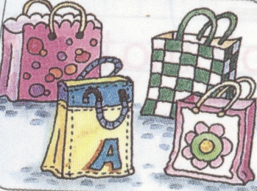 | 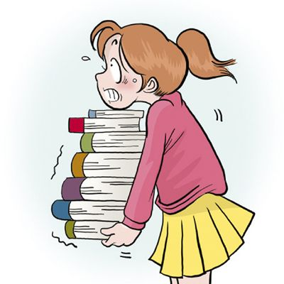 | 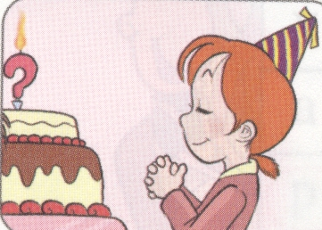 | 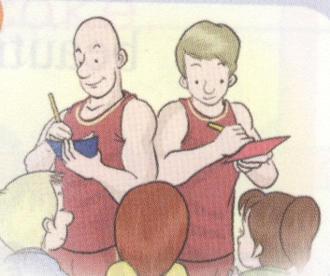

二、請仔細聽廣播中的對話，並選出能與對話配合的圖片的英文代號。 (每題2分，共8分)
5.
A  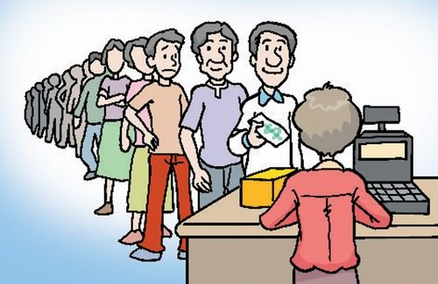 | B  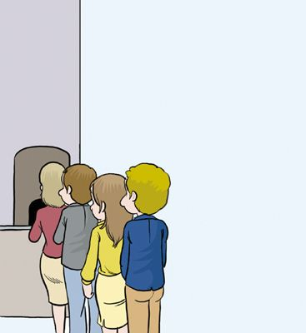
6.
A    Tom Amy | B    Tom Amy
7.
A   | B  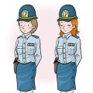
【第一頁，尚有試題】
8.
A  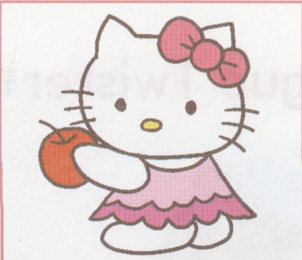 | B  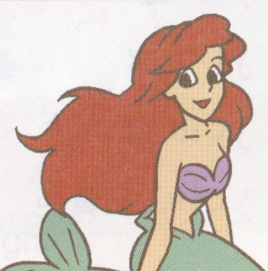
三、請仔細聽廣播中的句子，選出最適當回應句子的英文代號。(每題2分，共8分)
9. | Who’s that girl?
10. | Look! What’s that?
11. | Bill, are Ted and Amanda friends?
12. | Happy birthday, Linda!

第二部份: 綜合測驗 (共76分)
一、語法測驗 (每題2分，共10分)
13. Miss Lin: Please _______ up and answer the question. answer 回答 question 問題
Linda: Okay.
(A) sit (B) sitting (C) stand (D) standing
14. Bob: How is your car?
May: It’s old but _______.
(A) new (B) slow (C) fast (D) bad
15. Sam: Look, are these Peter’s puppies?
Amy: _________________________
- Yes, it is his puppy.
- Yes, they are Petty’s puppies.
- No, it is not his puppy.
- No, they are Petty’s puppies.
16. Tim: What’s in the box? Rita: Maybe it’s _______, not a bomb.
(A) money (B) box (C) bag (D) baseball
17. ________ Mike and Kerry the diplomats from Canada?
(A) Am (B) Are (C) Is (D) Be
二、閱讀測驗 (每題2分，共10分)
A new student is in our class. Her name is Tina. She is from the USA.
She is good, and we like her. Her father, George, is a diplomat. He is very busy.
Her mother, Grace, is a reporter. She is busy, too. Tina’s pet, Lucky, is very cute. Tina and her parents go to many countries, like Canada, Japan… They come to Taiwan and learn Chinese.
＊ like 喜歡 busy 忙碌的 go 去 country 國家 like 像 learn 學習 Taiwan 台灣 Chinese中文

【第二頁，尚有試題】
臺北市立龍山國民中學九十六學年度第一學期七年級英語科第二次定期考査試題卷
18. What is George?
(A) A student. (B) A diplomat. (C) A reporter. (D) A pet.
19. What does her mean? mean 意指
(A) Lucky. (B) Grace. (C) George. (D) Tina.
20. Where is Tina from?
(A) Canada. (B) The USA. (C) Japan. (D) Taiwan.
21. Who is Lucky?
(A) Tina’s pet. (B) Tina’s father. (C) Tina’s mother. (D) Tina’s student.
22. Which is true? true 真的
(A) Lucky is very busy.
(B) Grace is a cute diplomat.
(C) Tina is a new student.
(D) Lucky and Tina are brother and sister.
三、克漏字測驗(每題1分，共5分)
Bill and Jack are twin brothers. Today is (23) birthday. A cake is on the table.
It is (24) them. Bill and Jack (25) wishes and cut the cake. They get a present
(26) the English teacher. (27) is an English storybook. They thank her very much.

＊twin 雙胞胎 today 今天 table 桌子 them 他們 get 得到 storybook 故事書
四、文意字彙 (每題2分，共18分)
23. (A) our | (B) their | (C) his | (D) her
24. (A) for | (B) from | (C) to | (D) in
25. (A) open | (B) close | (C) make | (D) move
26. (A) in | (B) to | (C) from | (D) for
27. (A) I | (B) You | (C) He | (D) It
28. John is five years old. Put five c es on the cake. years old 歲
29. Betty is a b l girl with long hair and big eyes. with 有 hair 頭髮
30. Sara sells books. She is a s n. sell 賣
31. We eat and talk with our m hs. eat 吃 talk 說話
32. It is very cold. Put on a j t, Peter. cold 冷的 put on 穿上
【第三頁，尚有試題】
33. I have l h with my classmates at 12:05.
34. Jenny is tall, but Kelly is short. They are d t.
35. Let’s take a picture. Look here, e y. picture 照片
36. The chair is light, not h y. chair 椅子

五、依提示作答(每題3分，共15分)
37. That tall boy is Miss Lin’s student. (依畫線部分造原問句)
38. This line is long. (依畫線部分造原問句)
39. Please open the door. (改成否定祈使句)
40. Is he a good baseball coach? (改為複數句)
41. Are these bags? (請詳答)
41.
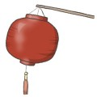
_______________________________

六、翻譯(42-44每格1分，45-48每題3分，錯一處，扣1分，共18分)
42. 在這個大南瓜上畫一個臉。 (1) a (2) on the big (3) .
43. 順便一提，你來自哪裡? (4) the (5) , where are you from?
44. 笑ㄧ下。Say“ (6) .”
45. 他們的雙親也是工程師嗎?
46. 他是一位小矮人。他的鼻子不小。
47. 難怪Jay是一位好的籃球選手。
48. 這部新的電腦是給那位醫生的嗎？

【試題結束】

臺北市立龍山國民中學九十六學年度第一學期七年級英語科第二次定期考査(聽力稿)
第一部分: 聽力測驗
本測驗共有三大題，每一小題都會唸兩次，請同學們注意聽，仔細作答。
一、 請仔細聽廣播中的句子，並選出最能符合圖意的句子的英文代號。
1. | (A) They are four bombs.
 | (B) They are four lunch boxes.
 | (C) They are four bags.
2. | (A) The books are very heavy.
 | (B) The books are very light.
 | (C) The girl is very heavy.
3. | (A) Blow out the candles and cut the cake.
 | (B) Close your eyes and make a wish.
 | (C) Put a candle in the pumpkin.
4. | (A) The basketballs are good.
 | (B) The basketball coaches are short.
 | (C) The basketball players are tall.
二、請仔細聽廣播中的對話，並選出能與對話配合的圖片的英文代號。
5. | Tom: This line is very long.  Irene: That’s too bad.
6. | John: Please look here, Tom and Amy. Don’t move and say “cheese.”  Tom &Amy: Cheese.
7.  8. | Amy : Are they police officers?  Ted: No, they are not police officers. They are salespersons.  Grace: Wow! She is very beautiful.  Peter: And her eyes are very big.

三、請仔細聽廣播中的句子，選出最適當回應句子的英文代號。
9. | Who’s that girl?
 | (A) She is John’s sister, Mary.
 | (B) She is from America.
 | (C) She is not a good computer engineer.
10. | Look! What’s that?
 | (A) It’s in the small box.
 | (B) They are Sam’s books.
 | (C) It’s a big birthday cake.
11. Bill, are Ted and Amanda friends?
(A) No, they are husband and wife.
(B) Yes, they are brother and sister.
(C) No, they are friends.
12. Happy birthday, Linda!
(A) Don’t open your eyes.
(B) Thank you very much.
(C) Nice to meet you.

臺北市立龍山國民中學九十六學年度第一學期七年級英語科第二次定期考查答案卷
七年______班______號 姓名：___________
四、文意字彙 (每題2分，共18分)
28. |  | 29. |  | 30.
31. |  | 32. |  | 33.
34. |  | 35. |  | 36.

五、依提示作答(每題3分，共15分)
37.
38.
39.
40.
41.

六、翻譯(42-44每格1分，45-48每題3分，錯一處，扣1分，共18分)

42. | (1) | (2) |  | (3)
43. | (4) |  | (5)
44. | (6)
45.
46.
47.
48.
本試題到此結束，
作答完畢，
請確實檢查。

臺北市立龍山國民中學九十六學年度第一學期七年級英語科第二次定期考查答案
1. | C | 2. | A | 3. | B | 4. | C | 5. | A | 6. | B | 7. | A | 8. | B | 9. | A | 10. | C
11. | A | 12. | B | 13. | C | 14. | C | 15. | D | 16. | A | 17. | B | 18. | B | 19. | D | 20. | B
21. | A | 22. | C | 23. | B | 24. | A | 25. | C | 26. | C | 27. | D

四、文意字彙 (每題2分，共18分)
28. | candles | 29. | beautiful | 30. | salesperson
31. | mouths | 32. | jacket | 33. | lunch
34. | different | 35. | everybody | 36. | heavy

五、依提示作答(每題3分，共15分)
37. | Who is that tall boy?
38. | How is this line?
39. | Please don’t open the door.
40. | Are they good baseball coaches?
41. | No, they are not bags. / No, they are lanterns.

六、翻譯(42-44每格1分，45-48每題3分，錯一處，扣1分，共18分)

42. | (1) Draw | (2) face |  | (3) pumpkin
43. | (4) By |  | (5) way
44. | (6) cheese
45. | Are their parents engineers , too?
46. | He is a dwarf. His nose is not small.
47. | No wonder Jay is a good basketball player.
48. | Is this new computer for that doctor?

