臺北市立龍山國中九十五學年度第二學期七年級英語科第三次定期評量試題卷
翰林版Unit 7- Review 3
本試卷第1 ~ 35 題請在電腦卡上劃記
第一部分
聽力測驗：共 24%
- 請注意聽下列句子，選出最適當的回應 (一題2分，12%)
1. (A) No, I wasn’t. I was seldom happy.
(B) I was always sad.
(C) No, I ’m not. I’m seldom happy.
2. (A) Yes, she was.
(B) It was her wedding day.
(C) No, she wasn’t.
3. (A) She was late for school last Friday.
(B) She was never late for school.
(C) No. She is never late.
4. (A) Yes, she was.
(B) She was eighteen years old then.
(C) She was at home last Saturday.
5. (A) I usually read comic books.
(B) I’m reading now.
(C) I never read on weekends.
6. (A) She goes there on Sundays.
(B) She often goes there by MRT.
(C) She can’t go there by bicycle.

- 請根據對話或短文內容，判斷各句敘述是否正確。正確在電腦卡上劃記A，不正確劃記B。 (一題2分，12%)
- 對話
- Steve and Kate go bicycle riding after lunch.
- They go home at eight twenty-five.
- Steve and Kate go to the park on foot.

（二）短文
- Jason often rides a bicycle in the park.
- Jason usually goes to the supermarket with Tim.
- Tim often goes mountain climbing with his parents in the evening.

【請翻頁繼續作答】 1
第二部分
- 語法測驗 (請選出最適當的答案，每題二分，26% )
- He always ______ home.
(A) take a bus (B) take a taxi (C) by taxi (D) takes the MRT
- Sorry, I don’t have _____.
(A) some changes (B) many change (C) any change (D) two changes
- Amy _____ in her free time.
(A) is always (B) always sleep (C) always listen to music (D) always goes shopping
- Mark _____.
(A) never goes swimming (B) never go shopping (C) never go swimming
(D) never go fishing
- Mary was nine years old three years _____.
(A) then (B) old (C) ago (D) before
- Lucy _____ short then, but she _____ tall now.
(A) is；was (B) was；is (C) are；were (D) was；were
- Hunk: What are you _____? Ben: Jay’s album.
(A) eating (B) shouting (C) listening to (D) drawing
- Judy: Does your brother swim well? Mary: _____.
(A) Yes, I am usually a good player. (B) No, I usually win second prize.
(C) No, I never swim. (D) Yes, he always wins first prize.
- Mr. Wang often _____ to his office.
(A) run (B) walks (C) by bus (D) on foot
- You looked sad. We _____ very worried _____ you.
(A) was；about (B) was；with (C) were；about (D) were；with
- Where was John on Monday evening? B: _____.
(A) He is sad. (B) He isn’t in Taipei. (C) He was surprised. (D) He was at home.
- Peter: _____. Julia: Yes, she usually takes a bus there.
(A) Where’s the bus stop? (B) Does she usually take a bus to the restaurant?
(C) Does she usually go to the bookstore by taxi? (D) How does she usually go to the park?
- Cindy: _____ at this stop. Here we are. Bob: OK.
(A) Get off (B) Get up (C) Study English (D) Jump rope

- 克漏字填充(請選出最適當的答案，每題二分，10%)
Milk is important to our __(26)__ diet. A cow usually has her __(27)__ calf when she is two years old. A cow gives milk for 300 days. __(28)__ cows give more milk than their calves __(29)__, so there is __(30)__ a lot for people.

(important重要的；calf小牛（複數為calves）；when當；give供給；more… than更多於...)

【請翻頁繼續作答】 2
26. (A) Monday (B) Friday (C) Sunday (D) everyday
27. (A) one (B) two (C) first (D) second
28. (A) Now (B) Also (C) Ago (D) Last
29. (A) take (B) need (C) cut (D) buy
30. (A) still (B) never (C) seldom (D) sure

- 閱讀測驗 (請選出最適當的答案，每題二分，10%)
【A】
Lilian likes to make plans. Here’s her weekly plan for what she does after school.
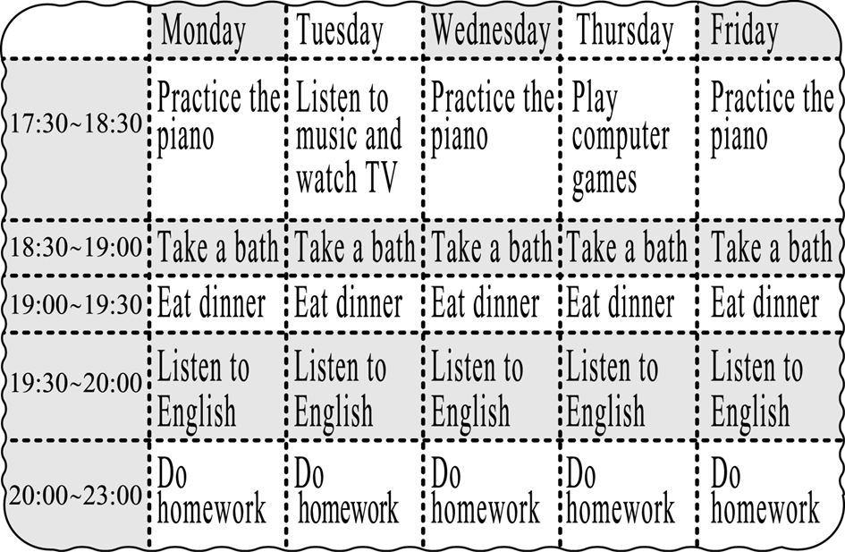
（practice練習；take a bath洗澡）

31. What does Lilian usually do right after dinner? She .
(A) does her homework (B) watches TV
(C) plays computer games (D) listens to English
32. How many hours does Lilian do her homework every day?
(A) Two hours. (B) Three hours. (C) Four hours. (D) Five hours.
【B】
When I was five years old, I played with my friends. There was always food on the table. Mother always took care of me. I didn’t have any worry every day. Those were happy days!
When I was a teenager, I lived in the country. I had a girlfriend. We went to the community club on Wednesday evenings to dance. Then we usually went to the restaurant for a glass of Coke. Those were happy days!
(took care of照顧；teenager青少年；country 鄉下；community club社區俱樂部；would 將會)

【請翻頁繼續作答】 3

33. Why was the man happy when he was five years old?
(A) His mother did everything for him. (B) He lived in the country.
(C) He made food for his friends. (D) He was never afraid.
34. When did they go to the community club ?
(A) On Monday mornings. (B) On Wednesday evenings.
(C) On Wednesday mornings. (D) On Friday evenings.
35. Which is true?
(A) He is an angry man. (B) He hates swimming.
(C) He enjoys his life. (D) He wants to win the prize again.

本試卷第36 ~ 50 題請寫於答案卷上

- 文意字彙 (每題一分，5%)
36. What weekend a y do you do? I go bicycle riding with my friends.
37. Jimmy e es on weekends. He always goes jogging.
38. It’s raining o e. Take an umbrella with you.
39. Can we ride a m e to the library?
40. Was Jenny n s on her first day of school?

- 依提示作答 (每題二分，10%)
41. Ken seldom goes to the railway station by bicycle. (用ride改寫)
42. What does Susan do in the morning? (用usually / go swimming詳答)
43. Annie’s parents are worried about her. (加入last night改寫此句)
- He rides a bicycle to the museum.（依畫線部分造原問句）
- There / hospital / ways / to / the / different / are / go / to（依提示字組合成一完整句子）

八、翻譯 (每題三分，15%)
46. 前天Lisa在哪裡？
47. 這張照片裡你是害怕的嗎？
48. 我空閒時通常去健行。
49. Karen三小時前獨自在家。
50. 我的表妹常常步行到市立圖書館。(用~ go to ~)

【試題結束，請細心作答與檢查】 4
臺北市立龍山國中九十五學年度第二學期七年級英語科第三次定期評量答案卷
____年____班____號 姓名：__________ 任課老師：__________
第二部份
六、文意字彙(每題一分，5%)
36. |  | 37. |  | 38. |  | 39. |  | 40.

七、依提示作答(每題兩分，10%)
41.
42.
43.
44.
45.

八、翻譯(每題三分，15%)
46.
47.
48.
49.
50.
臺北市立龍山國中九十五學年度第二學期七年級英語科第三次定期評量(答案)
第一部份
聽力測驗24% (每題2分)
一、
1. | C | 2. | B | 3. | C | 4. | A | 5. | A
6. | B
二、
7. | B | 8. | B | 9. | B | 10. | A | 11. | A
12. | B
三、語法測驗 10%（每題2分）
13. | D | 14. | C | 15. | D | 16. | A | 17. | C
18. | B | 19. | C | 20. | D | 21. | B | 22. | C
23. | D | 24. | B | 25. | A
四、克漏字填充 10%（每題2分）
26. | D | 27. | C | 28. | A | 29. | B | 30. | A
五、閱讀測驗 10%（每題2分）
31. | D | 32. | B | 33. | A | 34. | B | 35. | C

第二部份
六、文意字彙 5%（每題1分）
36. | activity | 37. | exercises | 38. | outside | 39. | motorcycle | 40. | nervous
七、依提示作答 10%（每題2分）
41. | Ken seldom rides a bicycle to the railway station.
42. | She usually goes swimming in the morning.
43. | Annie’s parents were worried about her last night.
44. | How does he go to the museum?
45. | There are different ways to go to the hospital.
八、翻譯 15%（每題3分）
46. | Where was Lisa the day before yesterday?
47. | Were you afraid in this picture?
48. | I usually go hiking in my free time.
49. | Karen was alone at home three hours ago.
50. | My cousin often goes to the city library on foot.

