臺北市立龍山國中95學年第2學期七年級英語科第2次定期評量試題卷
翰林版 Unit 4-Review 2
第一部分：請將第1-36題的答案畫記於電腦卡上
七年級第二次定考英語聽力測驗 (第1-15題，每題二分，共三十分)
- 根據句子的敘述選出最能表達句意的圖片。
1. | 2. | 3. | 4. | 5.
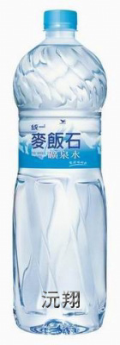  (A) 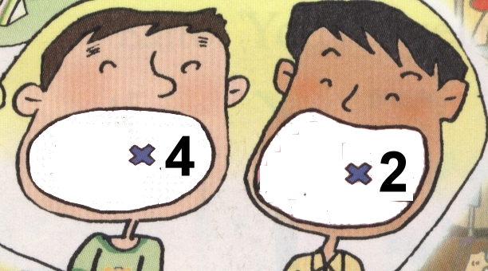  (B)  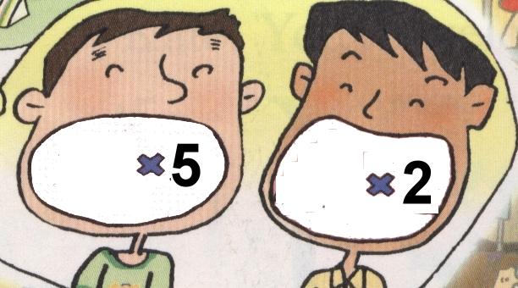 | (A) 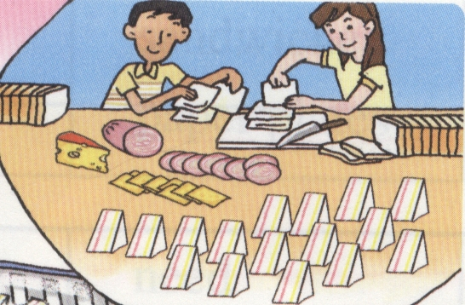  (B)  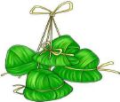 | (A) 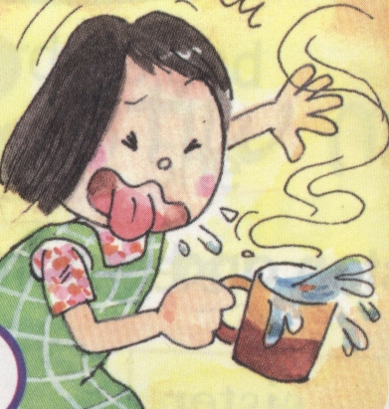  (B) 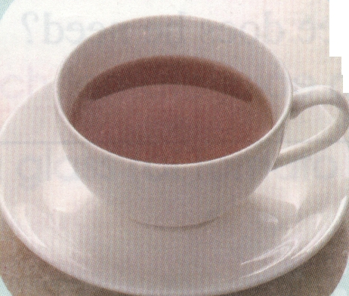 | (A) 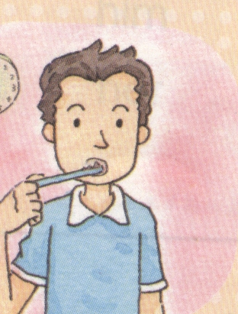  (B) 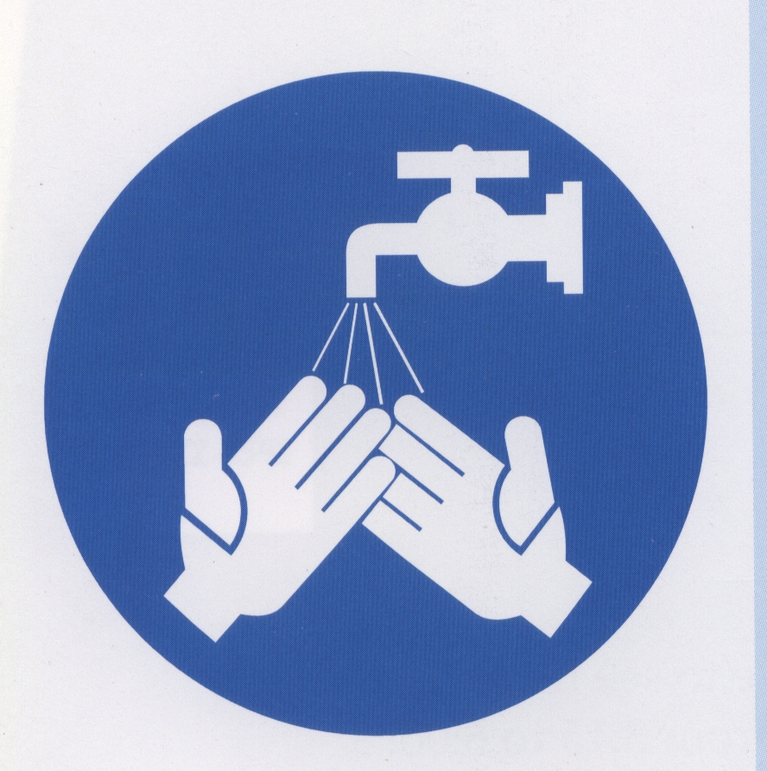 | (A) 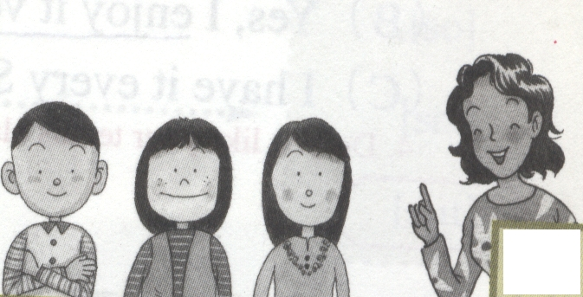  (B) 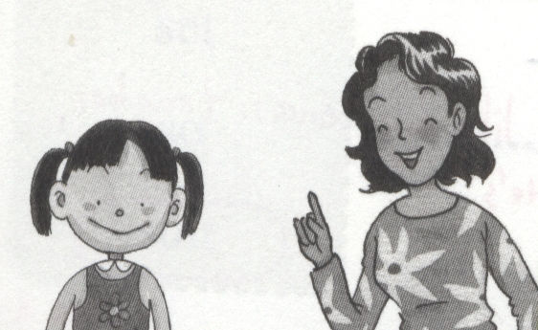

二、根據對話內容選出最適當的答案。
6. (A) The red dress. (B) The yellow dress. (C) Both.
7. (A) The red apples. (B) The green apples. (C) Both.
8. (A) Everything. (B) Milk tea. (C) Water.
9. (A) Well, she likes oolong tea very much.
(B)Yes, she likes black tea, too.
(C) No, she doesn’t like green tea.
10. (A) On Saturdays, she eats at a restaurant.
- We can have lunch together on Saturday.
(C) Let’s have something to eat.

三、根據對話或短文內容，判斷各句敘述是否正確，正確選A，不正確選B。
(1) 11. Kate has a piano class on the weekend.
12. Miss White is very sick. She can’t come to the piano class.
13. Jane and Kate have a piano class together on Friday.
(2) 14. There are four people in Jane’s family.
15. Jane’s father eats dinner at home every day.
第二部分：綜合測驗
(p.1， 背面還有試題，請繼續作答)
四、語法測驗 (請選出最適當的答案，第16-22題，每題一分，共七分)
16. _______ English teacher is from the U. S. A. He can speak good English.
(A) He’s (B) She’s (C) They’re (D) Their
17. My grandfather doesn’t like hamburgers and ice cream. He doesn’t eat _______.
(A) it (B) they (C) them (D) us
18. My brother is a good boy. I’m a good girl. Dad and Mom love ______ very much.
(A) we (B) he and I (C) them (D) us
19. Mike likes art, and I like art, too. ________ both like art.
(A) We (B) You (C) They (D) You and Mike
20. A: _______ does the little boy want, a comic book or a storybook? storybook故事書
B: He wants a storybook.
(A) What (B) Which (C) How many (D) How much
21. A: How many bowls and plates _______ Mom need in the dining room?
B: Twelve bowls and twelve plates.
- are there (B) do (C) does (D) is there
22. A: When does your father usually come home? usually通常
B: He usually comes home ________.
- from 8:00 a.m. to 6:00 p.m. (B) at six o’clock in the evening
(C) at the picnic (D) on a diet

五、克漏字測驗 (請選出最適當的答案，第23-27題，每題一分，共五分)
Amy: What are you doing, Mom?
Mom: I 23 some pancakes. 24 for breakfast.
Amy: 25 do you make it?
Mom: Just take some flour, milk, water, and eggs. Then stir 26 together into batter and fry the batter on a pan.
Amy: Let me try some. Mm…The pancake 27 some honey. Then it will be great.

pancake薄煎餅 flour麵粉 stir攪拌 batter麵糊物 honey蜂蜜

23. (A) do (B) make (C) am doing (D) am making
24. (A) It is (B) This is (C) They are (D) There are
25. (A) How (B) What (C) Where (D) How many
26. (A) it (B) they (C) some (D) them
27. (A) is (B) needs (C) makes (D) has

六、閱讀測驗 (請選出最適當的答案，第28-36題，每題二分，共十八分
(P.2，背面還有試題，請繼續作答)
(1) George is from New York. He is studying Chinese in Taiwan. He’s a busy student and
has a part-time job at 7-Eleven. Before school, he eats breakfast at home. He likes soy bean milk and steamed bun. He eats rough rice, greens, some pork or some fish soup every day.
He likes organic food. It is clean and safe. He eats well, but he doesn’t eat much.

soy bean milk豆漿 steamed bun饅頭 rough rice糙米 greens蔬菜 organic 有機的

28. Where does George have his breakfast?
(A) At 7-Eleven. (B) At home. (C) At school. (D) In New York.
29. What kind of food does George like? kind種類
(A) American food. (B) Fast food. (C) Organic food. (D) Sweet food.
30. Does George eat much pork and fish every day?
(A) Yes, he does. (B) No, he isn’t. (C) Yes, he can. (D) No, he doesn’t.

(2) Alan has an important exam this month, and he makes a study plan for it. This is Alan’s study plan in May. Read it and answer the questions.
time day | Mon. | Tue. | Wed. | Thu. | Fri.
7:30-7:50 | test | test | test | test | test
8:00-10:00 | English | English | English | social studies | English
10:20-12:20 | math | social studies | math | math | math
1:40-3:40 | social studies | Chinese | Chinese | Chinese | Chinese
4:00-6:00 | science | science | social studies | science | science
6:10-6:30 | test | test | test | test | test

exam考試 plan計畫

31. When does Alan have an important exam? He has an important exam ________.
(A) in May (B) in summer vacation
(C) every morning and every afternoon (D) from Monday to Friday
32. When doesn’t Alan study English? He doesn’t study English _______.
(A) on Mondays, Tuesdays, Wednesdays, and Fridays (B) on Tuesday mornings
(C) on Thursday mornings (D) from 8:00 a.m. to 10:00 a.m.
33. How many days a week does Alan study social studies?
(A) Three days. (B) Four days. (C) Five days. (D) Two days.

- Mother’s Day is on May 13th this year. Tina’s family will be together on the day. They will wish dear Mom a happy Mother’s Day. Tina is in a supermarket now. She needs some
(P.3，背面還有試題，請繼續作答)
flowers, food, and drinks for the day. Read the list and answer the questions.
Item | Unit Price | Quantity
carnation | a red one NT$30,  a pink one NT$25 | 12  12
honey cake | a piece of honey cake NT$ 50,  a honey cake NT$ 600 (10 pieces) | 0  1
cherry | a box of cherry NT$ 180  two boxes NT$ 350 | 2
apple | an apple NT$ 30,  seven apples NT$200 | 7
milk | a bottle of milk NT$ 64,  the second one is 50% off | 2

carnation康乃馨 cherry櫻桃

34. How much are 12 red carnations and 12 pink ones?
(A) NT$360. (B) NT$300. (C) NT$330. (D) NT$660.
35. How much does Tina have to pay for milk?
(A) NT$ 64. (B) NT$ 96. (C) NT$128. (D) NT$114.
36. What’s on sale in the supermarket? on sale廉售
(A) Fruit and milk. (B) Milk and cake. (C) Flowers and cake. (D) Fruit and cake.

請將第37-53題的答案寫於答案卷上
七、文意字彙 (第37-42題，每題二分，共十二分)
37. Don’t eat with your hands. Use c ks or a fork.
38. The watch is NT$100,000. It’s nice and beautiful, but it’s too e e.
39. My family eat at a nice r t on Mother’s Day every year.
And we express our love and thanks to Mom. express表達
40. The greens are NT$100. The fruit is NT$215. greens 蔬菜
The total is three h d and fifteen dollars.
41. Susan b hes her teeth every day. She has very pretty teeth.
42. Tom takes a water bottle to school. He d ks enough water every day. enough足夠的

八、依提示作答(第43-47題，每題二分，共十分，錯一處扣一分)
43 . Amy’s mother cooks very well.
Amy likes her food very much. (用連接詞合併成一句)
(P.4，背面還有試題，請繼續作答)
44. Mrs. Chen likes apples very much.
Mrs. Chen doesn’t like apple juice. (用連接詞合併成一句)
45. A: ? (請根據畫線部分造原問句，
B: Mrs. Chen needs one tomato for the soup. 請寫出完整的英文問句)
46. A: on the tale?
B: There are ten. (請根據畫線部分並以knife為主詞造原問句，請寫出完整的英文問句)
47. A: ? (請根據畫線部分造原問句，
B: Three bottles of water are NT$45. 請寫出完整的英文問句)

九、整句翻譯 (第48-53題，每題三分，共十八分，錯一處扣一分)
48. 我和Mike就讀於同一班。
49. 他早上6:20刷牙洗臉。 (時間請以英文寫出)
50. 我媽媽每個周末在公園運動。 (用on…寫出時間)
51. 我弟弟每週三每週六下午有鋼琴課。(用on…寫出時間)
52. 我媽媽現在在廚房做一些三明治。
53. 我們這次野餐要買兩條麵包。(Let’s……)

試題結束。請細心作答與細心檢查。

臺北市立龍山國中95學年第2學期七年級英語科第2次定期評量答案卷
翰林版 Unit 4-Review 2
班級_________ 座號________ 姓名_____________ 任課老師_______________
請將第37-53題的答案寫於答案卷上
七、文意字彙 (第37-42題，每題二分，共十二分)
37. | 38.
39. | 40.
41. | 42.

八、依提示作答(第43-47題，每題二分，共十分，錯一處扣一分)
43.
44.
45.

46.

47.

九、整句翻譯 (第48-53題，每題三分，共十八分，錯一處扣一分)
48.

49.
50.

51.

52.

53.

臺北市立龍山國中95學年第2學期英語科七年級第2次定期評量答案卷
翰林版 Unit 4-Review 2
第一部分：英語聽力測驗(一、二、三)
1.A | 2.B | 3.B | 4.B | 5.A | 6.B | 7.A | 8.C | 9.A | 10.B | 11.B | 12.B | 13.B | 14.A | 15.B

第二部分：綜合測驗(四、語法測驗，五、克漏字測驗，六、閱讀測驗)
16. D | 17.C | 18.D | 19.A | 20.B | 21.C | 22.B | 23.D | 24.C | 25.A
26.D | 27.B | 28.B | 29.C | 30.D | 31.A | 32.C | 33.B | 34.D | 35.B | 36.A

七、文意字彙 (第37-42題，每題二分，共十二分)
37.chopsticks | 38. expensive
39. restaurant | 40. hundred
41. brushes | 42. drinks

八、依提示作答(第43-47題，每題二分，共十分，錯一處扣一分)
43.Amy’s mother cooks very well, and she likes her food very much.
44.Mrs. Chen likes apples very much, but she doesn’t like apple juice.
45. How many tomatoes does Mrs. Chen need for the soup?
46. How many knives are there on the table?
47. How much are three bottles of water?

九、整句翻譯 (第48-53題，每題三分，共十八分，錯一處扣一分)
48.Mike and I study in the same class.
49.He brushes his teeth and washes his face at six twenty in the morning.
50.My mother exercises in the park on weekends.
51.My brother has piano class on Wednesday and Saturday afternoons.
52.My mother is making some sandwiches in the kitchen.
53.Let’s buy two loaves of bread for the picnic.

臺北市立龍山國中95學年第2學期英語科七年級第2次定考試題解析
1.Sam needs two bottles, and Tom needs four. 作聽力測驗時，請注意聽關鍵字。
2.Let’s make our own rice dumplings.
3.The tea is cold.
4.He washes his hands before lunch.
5.Miss Chen loves us very much.
6.The yellow dress is on sale. The price is OK.
7.The red apples are three for $100. Mr. Chen has $200, and he needs six apples.
8.I just need a bottle of water.
9.My mother likes green tea. …She likes oolong tea very much.
10.We can have lunch together on Saturday.
11.Karen has a piano class on Friday, not on the weekend.
12.Miss White is very busy, not very sick.
13.I can’t have a piano class. They don’t have a piano class on Friday.
14. They’re Jane’s father, mother, brother and Jane. There are four people.
15.Jane’s father comes home late at 9:00 p.m. He doesn’t have dinner at home.
16.Their English teacher…所有格＋名詞，所以選their
17.hamburgers and ice cream是複數名詞，eat＋受格，所以選them
18.Dad and Mom love my brother and I (=us) very much. love＋受格
19. Mike and I both like art. We both like art.
20.Which does the boy want, A or B? 兩者之中選一個用which
21.How many plates and bowls does Mom need? 助動詞＋主詞＋原形動詞?
22.When…?以He comes home at six in the evening.回答
23.What are you doing? 以I am making some pancakes.回答。是現在進行式。
24.上文是some pancakes所以用They are回答
25.下文是說明pancake的作法，所以用How do you make it?詢問
26.flour, milk, water, and eggs是複數名詞，stir＋受格，所以選them
27.The pancake needs some honey. Then it will be great.根據下文所以選needs
28.Before school, he eats breakfast at home.
29.He likes organic food.
30.He eats some pork and some fish soup every day. He doesn’t eat much.
31.Alan has an important exam this month. It’s May now.
32.Look at the study plan. He doesn’t study English on Thursday mornings.
33.Look at the study plan. He studies social studies four days a week.
34.12 red carnations are $30×12 and 12 pink carnations are $25×12. They’re $660.
35.A bottle of milk is $64, and the second one is $64×50% (=$32). They are $96.
36.Cherry, apples, and milk are on sale. So fruit and milk are on sale.
95學年第 2學期七年級第二次定考英語聽力測驗
(每題讀二次，請以正常速度讀出，並留適當時間給學生作答)
- 根據句子的敘述選出最能表達句意的圖片。
1. There are thirty students in our class. At the picnic, everyone needs a bottle of water. But Sam needs two bottles, and Tom needs four.
2. The rice dumplings here are too expensive. Let’s make our own rice dumplings.
We need some rice, pork, and eggs.
3. Mm… The tea is not very good. It’s cold. It needs some hot water.
4. What does Bill do before lunch? He washes his hands before lunch, and he brushes his teeth after it.
5. Does Miss Chen like you, students? Yes, she loves us very much.

二、根據對話內容選出最適當的答案。
6. A: Look, Jane. The dresses over there are so beautiful.
J: Yes. Mother’s Day is coming. Let’s buy one for Mom.
The red dress is $1980. It’s too expensive. We don’t have so much money.
A: How about the yellow one? It’s on sale.
J: Well, the color is nice, and the price is OK.
Question: What can Amy and Jane buy?
(A) The red dress. (B) The yellow dress. (C) Both.

7. A: How much are the apples?
B: The red apples are three for one hundred dollars, and the green ones are two for one hundred dollars.
Mr. Chen has two hundred dollars, and he needs six apples for a week.
Question: Which can Mr. Chen buy, the red apples or the green apples?
(A) The red apples. (B) The green apples. (C) Both.

8. A: Welcome to our garden party. We have everything here, juice, Coke, milk tea,
ice cream……. Which do you like?
B: After the game, I’m so thirsty. I just need a bottle of water. No need for juice Coke, or milk tea.
Question: What does Tony need?
(A) Everything. (B) Milk tea. (C) Water.

9. A: My mother likes green tea, but she doesn’t like black tea.
B: Can she make good tea?
A: Yes. Just put some tea in hot water for one minute and take it out.
Then you can have a cup of good tea. How about your mother?
- Well, she likes oolong tea very much.
- Yes, she likes black tea, too.
- No, she doesn’t like green tea.

10. A: There’s a good Chinese restaurant near the hospital.
B: What good food do they have?
A: They have pork and rice, rice dumplings and fried cake. Let’s have something there on the weekend. What do you say?
- On Saturdays, she eats at a restaurant.
- We can have lunch together on Saturday.
- Let’s have something to eat.
.
三、根據對話或短文內容，判斷各句敘述是否正確，正確選A不正確選B
(1) A: Kate, your new piano teacher, Miss White, is so nice and beautiful. Can I go to your piano class on Friday?
B: OK, Jane. See you then.
A: Hi, Kate. Where’s Miss White?
B: Oh, she’s so busy. I can’t have a piano class today.
(請留適當時間給學生回答11-13題)
11. Kate has a piano class on the weekend.
12. Miss White is very sick. She can’t come to the piano class.
13. Jane and Kate have a piano class together on Friday.

(2) Jane’s father is a busy businessman. Every day, he goes to work at 8:00 a.m. and comes home at 9:00 p.m. He’s very busy in the office. After work, he talks to Jane and her brother. On weekends, he goes shopping with Jane’s mother and does some housework.
(請留適當時間給學生回答14-15題)
14. There are four people in Jane’s family.
15. Jane’s father eats dinner at home every day.

