臺北市龍山國民中學95學年度第1學期七年級英語科第3次定期評量試題卷
版本: 一上翰林版 考試範圍: Unit5-Unit6,Reveiw2,Festival(Christmas)

(請將第1-44題的答案畫在電腦卡上)
第一部分: 聽力測驗 (共30分)
一、根據錄音內容，看圖片並選出適當的答案。(每題一分，共4分)
1.
(A) (B) (C)




2.
(A) (B) (C)


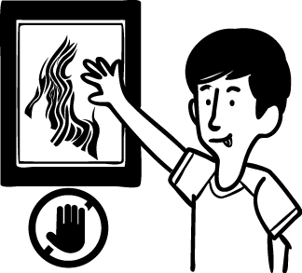

3.
(A) (B) (C)

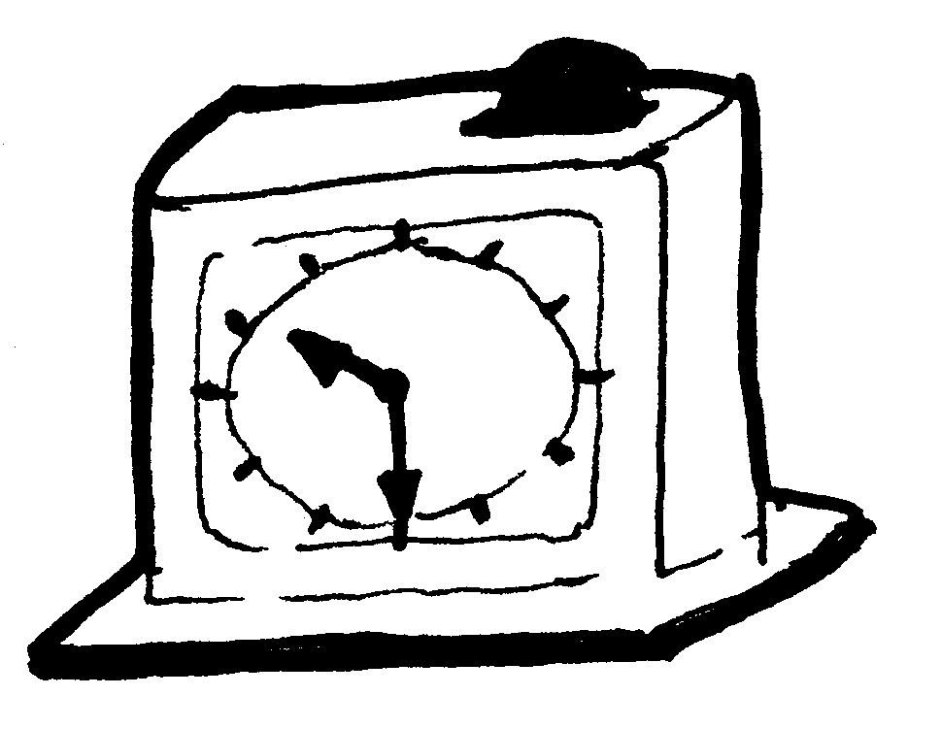
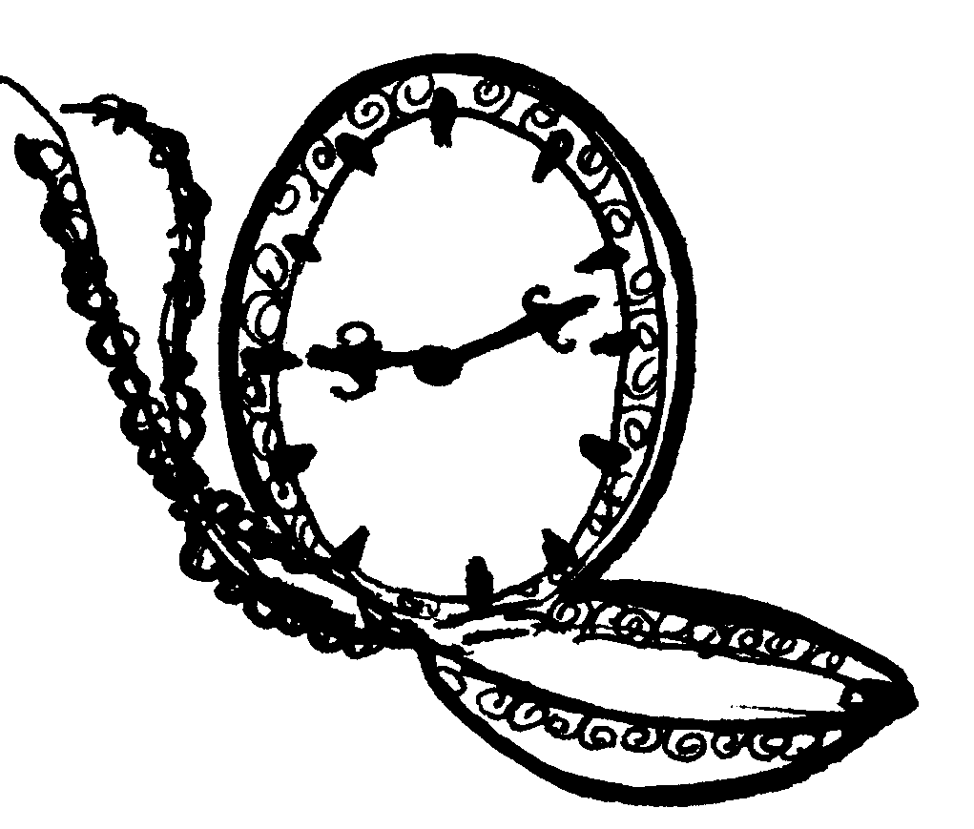

4.
(A) (B) (C)
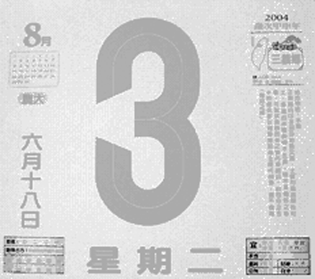
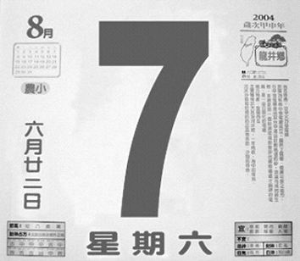
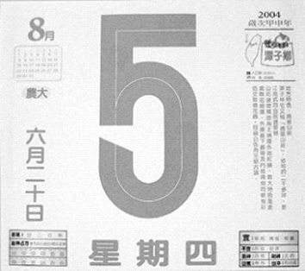

二、(A)仔細聽單字，並選出字首相同的音 (每題一分，共3分)
5. (A)monkey (B)Tom (C)nine
6. (A)four (B)pen (C)red
7. (A)clock (B)Bill (C) look
(還有試題，請繼續作答)

(B)仔細聽單字，並選出字尾相同的音 (每題一分，共3分)
8. (A)late (B)hello (C) ball
9. (A)your (B)brother (C)girl
10. (A)pie (B)bye (C)happy

三、根據圖片，選出適當的錄音內容。(每題二分，共10分)
根據圖片(一)，回答下列問題11.12.13題
Picture(I)

11. According to(根據) the picture (I), which is true(那一個是正確的)?
12. According to the picture (I), which is true?
13. According to the picture (I), which is true?

根據圖片(二)，回答下列問題14.15題
Picture (II)
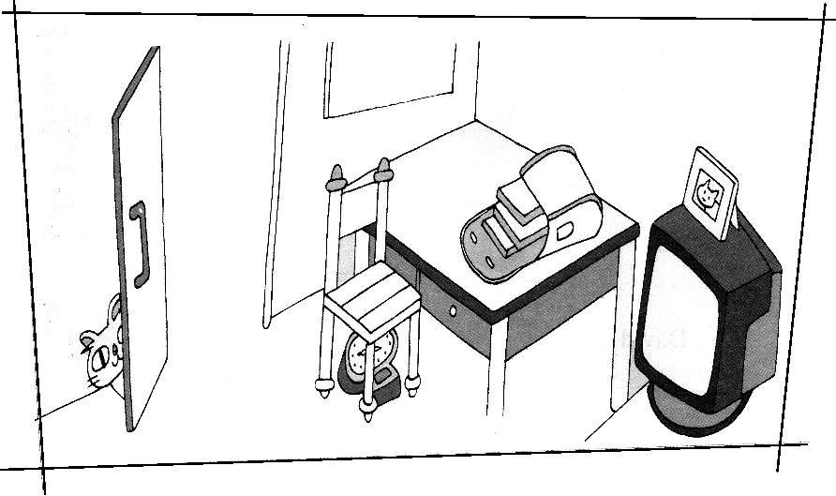

14. According to the picture (II), which is true?
15. According to the picture (II), which is true?
(還有試題，請繼續作答)

四、仔細聽對話和問題，並選出適當的答案 (每題二分，共10分)

- (A)They are looking at the picture.
(B) They are students.
(C) They are in the museum.
17. (A) They are singing songs.
(B) They are watching TV.
(C) They are in the living room.
- (A) It is Sunday.
(B) It is Monday.
(C) It is Tuesday.
- (A) It is 8:14.
(B) It is 8:30.
(C) It is 8:40.
- (A) He is eating.
(B) He is writing.
(C) He is reading.

第二部分: 綜合測驗 (共70分)
五、綜合測驗 (每題一分，共10分)
21. A: What time is the first(第一) class? B: It’s 8:30.
(A)at (B)  (C)on (D) in
22. mother is a police officer.
(A) Peter and Jenny (B)Peter’s and Jenny’s (C)Peter’s and Jenny (D)Peter and Jenny’s
23. On Christmas, people received(收到) many from(從) their friends.
(A)gifts (B)snowmen (C)wreaths (D)Christmas trees
24. late for the movie.
(A)Let’s not (B)Don’t be (C)Not be (D)Don’t
25. A: What day is it? B: It’s Sunday.
(A)at (B)on (C)in (D)
26. two birds the tree.
(A)There is, in (B)There are, in (C)There is, on (D)There are, on
27. Jenny and I playing baseball in the park.
(A)am (B) is (C) are (D) be
28. brings(帶來) many presents(禮物) to children(孩童) on Christmas.
(A)Snowman (B)Sleigh (C)Santa Claus (D)Stocking
29. Let’s eat in the library.
(A)not (B)don’t (C)aren’t (D)isn’t
30. Bob has(有) an English class Sunday morning.
(A)at (B)  (C) in (D) on
(還有試題，請繼續作答)

六、對話測驗 (每題二分，共10分)
31. A: B: It is slow.
(A) What’s its name?
(B) What’s wrong with your watch?
(C) How old is your dog?
32. A: English is very important (重要的) for you. B:
(A) I see.
(B) That’s all right.
(C) I’m sorry.
33. A: You cannot eat in the library. B:
(A) Good idea!
(B) Really?
(C) All right.
34. A: B: That’s very nice.
(A) Nice to meet you.
(B) Don’t talk(說話) in class.
(C) I am making a card.
35. A: Isn’t it Sunday today? B:
(A)It’s Sunday today.
(B) No, it’s Monday today.
(C) Yes, it’s Monday today.

七、閱讀測驗 (每題二分，共18分)
Day  Time | (日)  (1/14) | (一) ~ (四)  (1/15~1/18) | (五)  (1/19) | (六)  (1/20)
18:00~19:00 | Cartoons | Let’s Talk in English | Friends | Jenny’s Kitchen
19:00~20:00 | MTV Time | Taiwan News | NBA Show | Movie:  Happy Feet
20:00~21:00 | Movie:  Black Christmas | Talk Show | Sports News | Movie:  Happy Feet
21:00~22:00 | Movie:  Black Christmas | Sports News | Movie:  Night at the Museum | Wild Animal
22:00~23:00 | Night News | Night News | Movie:  Night at the Museum | MTV Time

36. It’s nine on Sunday evening. What’s on TV?
(A) Night at the Museum. (B)MTV Time. (C)Black Christmas. (D)Friends.
37. It’s eight p.m. Sports News is on TV. What day is today?
(A) Friday. (B)Saturday. (C)Sunday. (D) Monday.
38. It’s seven in the evening. MTV Time is on TV. What day is today?
(A)Friday. (B)Saturday. (C)Sunday. (D) Monday.
39. Sally likes cooking. What program(節目) can she watch?
(A)Cartoons. (B)Taiwan News. (C) Friends. (D) Jenny’s Kitchen.
(還有試題，請繼續作答)

Today is Saturday. Sunny’s family are at home. It’s Sunny’s birthday. Her mother is cooking dinner and her brother is cleaning in the living room. Her dog, Lucky, is playing ball next to the sofa. Sunny’s friend, Linda, is making a cake in the kitchen. There are some gifts on the chair. The beautiful flowers are on the table. Sunny is not home. She is studying English in the library. It’s five o’clock. It’s still early for Sunny’s birthday party. The party is at six o’clock.
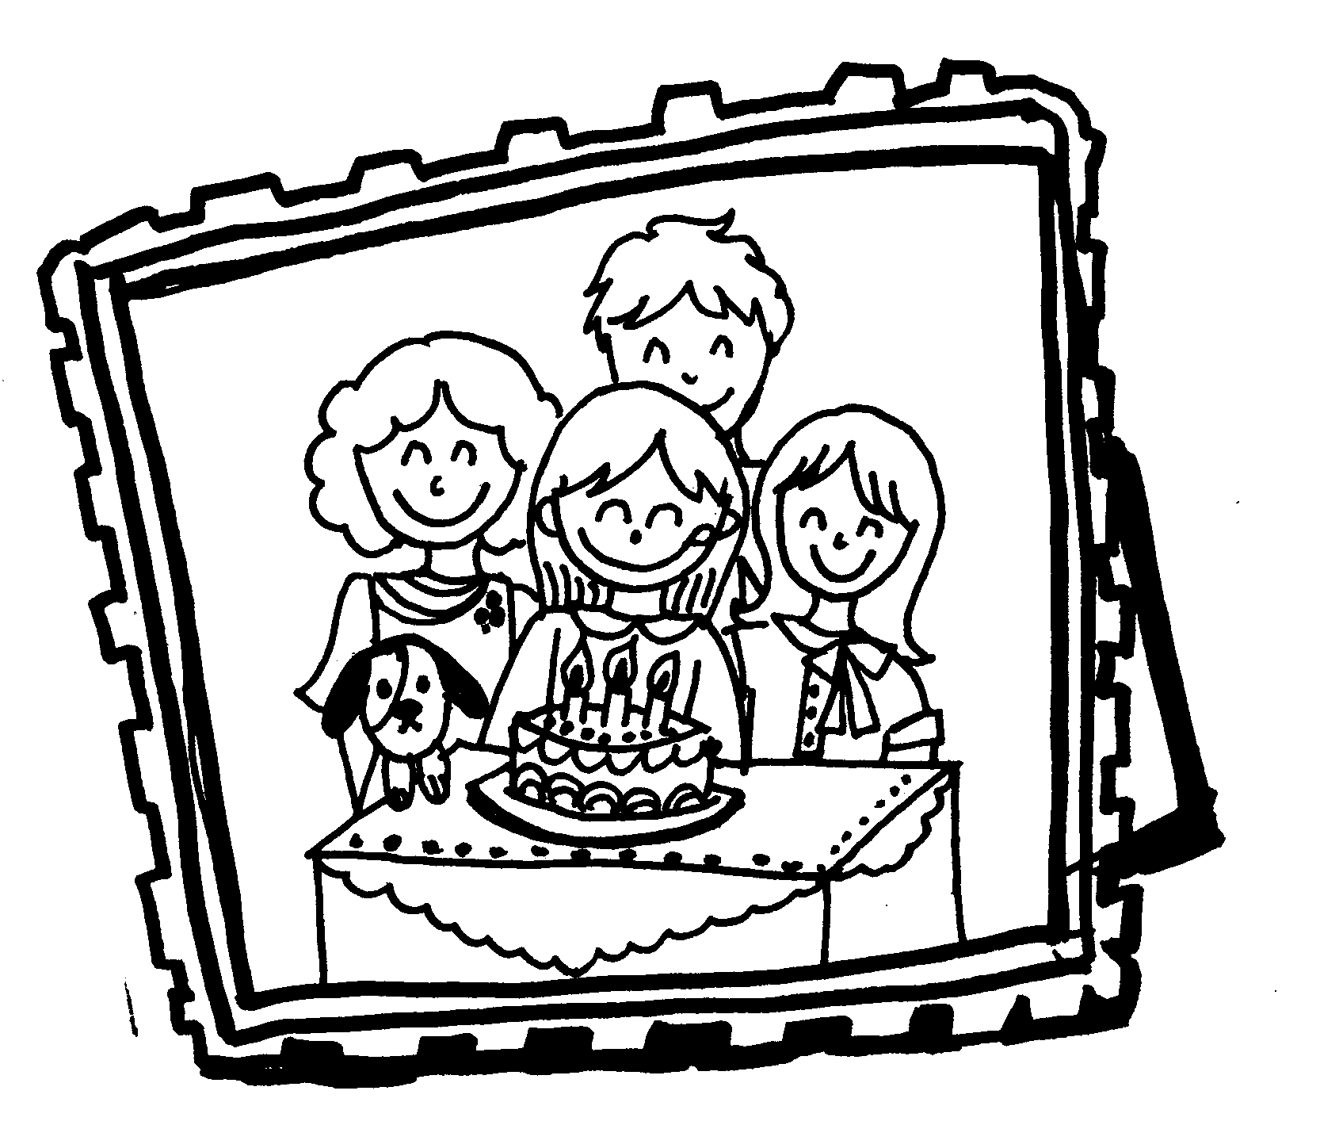

40. What day is it?
(A)It’s Sunday. (B) It’s 5:00. (C) It’s Saturday. (D) It’s her birthday party.
41. Where is Sunny?
(A)She’s in the library. (B) She is studying in the living room.
(C) She’s in the kitchen. (D) She is at home.
42. What’s next to the sofa?
(A) A dog. (B) Some flowers.
(C) Some gifts. (D) A cake.
43. What time is it?
(A) It’s five a.m. (B) It’s five p.m.
(C) It’s six a.m. (D) It’s six p.m.
44. Which is true(正確)?
(A) Sunny’s father is cleaning in the living room.
(B) Sunny’s mother is making a cake.
(C) Linda is at Sunny’s house.
(D) Sunny’s dog is playing under the sofa.

(請將第45~61題的答案寫在答案紙上)

八、字彙填充 (每題一分，共5分)
45. She is a b l girl.
46. Students! F w the class rules.
47. The day after(之後) Monday is T y.
48. I’m thirsty(渴). I need to drink s g.
49. The day before(之前) Friday is T y.

(還有試題，請繼續作答)

九、依提示作答 (每題二分，共8分)
50. It’s two o’clock. (造原問句)

51. It’s Sunday. (造原問句)

52. Please run here. (改成否定句)

53. We run in the park. (改成現在進行式否定句)

十、整句式翻譯 (54~56每題1分，57~61分每題三分，共19分)

54. 現在是七點四十五分。
It’s seven now.
55. Bob正坐在沙發上，Sally正在洗澡。
Bob is on the sofa, and Sally is a bath.
56.Bob正在博物館前拍照。
Bob is taking in front of the museum.
57.離早餐的時間還早。

58.在教室裡要聽老師們的話。

59.不要傷心。 我們要快樂。

60.請不要在公車上喊叫。

61.看這裡！ 這間電影院又髒又舊。

(試題結束，請專心作答，細心檢查。)
臺北市龍山國民中學95學年度第1學期七年級英語科第3次定期評量
聽力測驗
一 根據錄音內容，看圖片並選出適當的答案。(4%)
1. Let’s take a bath.
2. Don’t touch.
3. It’s 11:30.
4. Today is Thursday.
二 (A)仔細聽單字，並選出字首相同的音 (6%)
5. mom
6. rain
7. lunch
(B) 仔細聽單字，並選出字尾相同的音
8. call
9. four
10. study
三 根據圖片，選出適當的錄音內容。(10%)
根據圖片(一)，回答下列11.12.13三個問題
11. (A) Gary’s brother is in the living room.
(B) Gary’s brother is in the bathroom.
(C) Gary is drawing a picture.
(D) Gary is eating some food.
12. (A) The dining room is next to the living room.
(B) The dining room is next to the bedroom.
(C) The bathroom is next to the dining room.
(D) The bathroom is behind the dining room.
13. (A) Gary’s dad is playing computer games.
(B) Gary’s mom is watching TV.
(C) Gary’s sister is eating some food.
(D) Gary’s brother is taking a bath.

根據圖片(二)，回答問題14.15題
14. (A) The picture is on the desk.
(B) The cat is in front of the door.
(C) The clock is on the chair.
(D) The bag is on the desk.
15. (A) The picture is on the TV.
(B) The clock is on the desk.
(C) The bag is on the chair.
(D) There are two books in the bag.

四 仔細聽對話和問題，並選出適當的答案 (10%)

- A: Wow! Look at the picture!
B: It is so beautiful.
A: Hey! Don’t touch this picture. Don’t take a picture here.
Be quiet in this place, please.
B: OK.
Question: Where are they?
- Bob: That’s a good show on TV.
Tony: There are many singers there.
Bob: I like Jolin. How about you?
Tony: I like Jay. He is a good singer.
Bob: He is singing a song now.
Question: What are the boys doing?
- Sally: Is Uncle John’s birthday on Sunday?
Bob: Yes. How about you, Sally?
Sally: My birthday is on Monday.
Bob: I see. Today is Sunday?
Sally: No, today is Monday.
Bob: Oh. Dear Sally! Happy birthday!
Question: What day is today?
- A: Our first class is at 8:30. Our teacher is coming. But Jenny isn’t here.
B: Where is Jenny?
A: Maybe she is late. What time is it now?
B: It’s 8:40. Let’s call Jenny after class.
A: OK.
Question: What time is it now?
- (on the phone)
Sally: Hello! Tony, what are you doing now?
Tony: I am reading English books. How about you?
Sally: I am in the library and eating apples.
Tony: Oh! Please don’t eat in the library.
Sally: All right.
Question: What is Tony doing?

臺北市龍山國民中學95學年度第1學期七年級英語科第3次定期評量答案卷
年 班 號 姓名： 任課老師：

八、字彙填充 (每題一分，共5分)

45. |  | 46.
47. |  | 48.
49.

九、依提示作答 (每題二分，共10分)

50.
51.
52.
53.

十、翻譯 (54~56每空格一分，57~61每題三分，共19分)

54.
55.
56.
57.
58.
59.
60.
61.

臺北市龍山國民中學95學年度第1學期七年級英語科第3次定期評量答案
一~四、聽力部份 (30分)
1 | B | 2 | A | 3 | A | 4 | C | 5 | A
6 | C | 7 | C | 8 | C | 9 | A | 10 | C
11 | C | 12 | A | 13 | C | 14 | D | 15 | A
16 | C | 17 | B | 18 | B | 19 | C | 20 | C

五~七、綜合測驗 (文法、對話、閱讀選擇，共38分)
21 | A | 22 | D | 23 | A | 24 | B | 25 | D
26 | B | 27 | C | 28 | C | 29 | A | 30 | D
31 | B | 32 | A | 33 | C | 34 | C | 35 | B
36 | C | 37 | A | 38 | C | 39 | D | 40 | C
41 | A | 42 | A | 43 | B | 44 | C

八、字彙填充 (每題一分，共5分)
45. | beautiful | 46. | Follow
47. | Tuesday | 48. | something
49. | Thursday

九、依提示作答 (每題二分，共10分)
50. | What time is it?
51. | What day is it?
52. | Please don’t run here.
53. | We are not running in the park. We aren’t running in the park.

十、翻譯 (54~56每空格一分，57~61每題三分，共19分)
54. | forty-five
55. | sitting | taking
56. | pictures
57. | It’s still early for breakfast.
58. | Listen to the teachers in the classroom.
59. | Don’t be sad. Let’s be happy.
60. | Please don’t shout on the bus.
61. | Look here! This (The) theater is dirty and old.

(試題結束 請專心作答 細心檢查)

