臺北市立龍山國民中學94學年度第二學期七年級英語科第二次定期評量試題
第一部分：共四大題(第1-35 題) 60% (請在電腦卡上劃記)
一、聽力測驗：40% (每題2分)
A. 聽廣播中的句子，選出最適當的回應。（一題2分，共10分）
1. (A) No, she doesn’t like fast food.
(B) She’s very busy.
(C) No, she eats dinner at home every day.
2. (A) That’s his job.
(B) He works very late.
(C) My father doesn’t, either.
3. (A) It is at two thirty on Friday afternoon.
(B) I have music on Friday.
(C) It’s Friday today.
4. (A) He’s strong.
(B) No, he’s heavy.
(C) That’s a terrible idea.
5. (A) No, I don’t.
(B) I like history, too.
(C) I don’t, either.

B. 聽廣播中的句子，選出符合圖意的句子代號。（一題2分，共10分）
Peter
Linda
Ms. Lin
6.  | 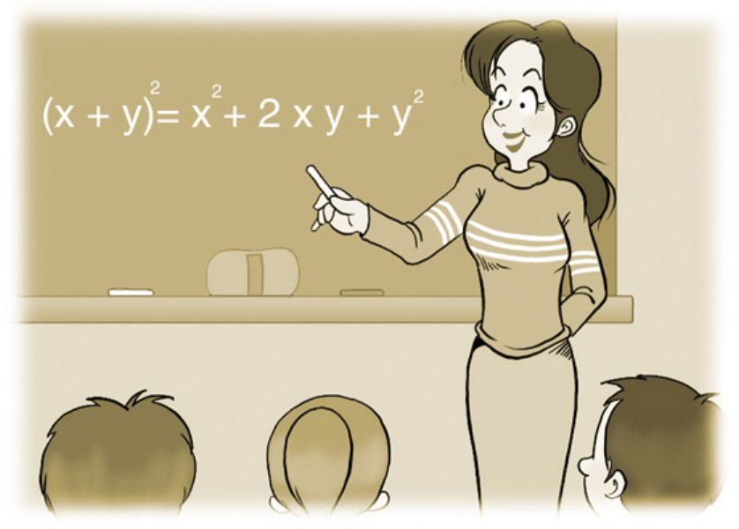  7. | 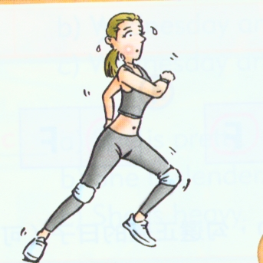  8. |   9. |   10.

C. 聽廣播中Jack和Mary的對話，各題中的敘述，若是與對話內容相符合，則在電腦卡上劃記A，
否則劃記B。（一題2分，共10分）
11. Jack likes exercise. Mary likes exercise, too.
12. Mary has art on Monday. Jack has art on Monday, too.
13. Mary’s father doesn’t like smoke. Her mother doesn’t like smoke, either.
14. Mary’s cousin lives in USA.
15. Mary’s mother makes breakfast for her family early in the morning.

【 第一頁，共四頁，背面尚有試題，請繼續作答 】

D. 聽廣播中的問句，根據表格內容，選出最適當的答句。（一題2分，共10分）
 | get up | do exercise | get home | go to bed
Tom | 6:00 am | 6:30 a.m. | 5:00 p.m. | 9:00 p.m.
George | 6:30am |  | 11:00 p.m. | 1:00 a.m.
Sarah | 5:00am | 6:00 a.m. | 4:30 p.m. | 11:00 p.m.
Candy | 7:15am |  | 6:00 p.m. | 10:30 p.m.

16. (A) At 6:00. (B) At 7:15. (C) At 6:30. (D) At 5:00.
17. (A) Tom and Sarah. (B) Tom and Candy. (C) Candy and George. (D) George and Sarah.
18. (A) Tom. (B) Candy. (C) George. (D) Sarah.
19. (A) Yes, he does. (B) No, he doesn’t. (C) Yes, he is. (D) No, he isn’t.
20. (A) At 11:00 p.m. (B) At 1:00 a.m. (C) At 10:30 p.m. (D) At 9:00 p.m.

二. 語法測驗 10%（一題1分，共10分）
Japanese 日語
21. Frank: Does David speak many languages?
Jane: Yes, he _____ Chinese, English, and Japanese.
(A) is speaking (B) speak (C) speaks (D) to speak
22. I don’t have to get up early on Sunday morning. My husband ________, either.
(A) isn’t (B) doesn’t (C) don’t (D) does
23. Bob likes sports. He swims and _______ tennis a lot.
(A) playing (B) plays (C) is playing (D) play
24. John: ______ is Nancy’s English not very good?
often 常常
Betty: She doesn’t often speak it.
(A) Why (B) What (C) Who (D) How
25. Sam: Does your sister like new clothes?
Mary: Yes, she does. But I _______.
(A) don’t like (B) like (C) likes (D) don’t
26. Amy: Jeff, can you help me ______ my math homework this afternoon?
Jeff: Yes, sure.
(A) to (B) for (C) with (D) at
27. Alice: ______ does Cathy do?
Joe: She teaches at our school.
(A) Who (B) What (C) How (D) Where
28. Carol: What is Linda doing? She looks worried.
Joe: She’s looking for her ________ dog.
Carol: No wonder.
worried 擔憂的
(A) missing (B) miss (C) misses (D) to miss

【 第二頁，共四頁，尚有試題，請繼續作答 】
29. Robert: Does Helen have to wash the car this morning?
Tom: .
(A) No, she washes it. (B) Yes, she has. (C)No, she has not. (D) Yes, she has to.
30. Jeff: ______ the lemon tea NT$ 30?
Paul: No, it’s NT$ 25.
(A) Is (B) Do (C) Does (D) Are

三. 閱讀測驗 10%（一題2分，共10分）
Dear Cathy,
Thanks for your letter.
I work in a computer store, and I am very busy. I go home late every day.
I live with my sister, Emily. She is eleven years old. We have a pet dog. Its name is Lucky.
I like reading, and I read a lot. I like seeing movies too. I often go to the movies on Saturday night.
Do you like music? I like music a lot, and I play the piano and the violin. My favorite singer is Jolin. I like her songs. They’re great!
Please write soon.
Yours, Tina

store 商店

31. Who writes the letter?
(A) Cathy. (B) Tina. (C) Cathy’s sister. (D) Tina’s sister.
32. How old is Emily?
(A) 10. (B) 11. (C) 12. (D) 13.
33. Which is not mentioned in the letter?
(A) Tina has a busy job.
mention 提到
(B) Tina goes to work early every day.
(C) Tina works very late.
(D) Tina likes music a lot.
34. Which of the following is true? (下列何者為真？)
(A) Tina lives with her parents.
(B) Tina has a pet cat.
(C) Tina’s sister studies in junior high school.
(D) Tina goes to the movies on the weekend.
mean 意指
35. What does “they” mean in the letter?
(A) Tina’s favorite singers.
(B) Jolin’s songs.
(C) Tina’s favorite movies.
(D) Tina’s books.
【 第三頁，共四頁，背面尚有試題，請繼續作答 】
第二部分：共四大題 40% (請在答案卷上作答)
一、看圖，根據句意寫出適當的英語單字：10%
1. Sally eats a lot of .
2. Lisa buys a lot of 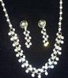.
3. We play 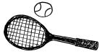 after school.
4. Mark’s father does not .
5. The old man lives in a small .
二、根據提示的首尾字母，寫出合乎句意的英語單字：10%
1. My brother is very smart, and he knows many things. I e y him.
2. Tom has to wash his family’s c_________s every evening.
3. Jack is only fifteen years old, but he is now a college student. He is really a g s.
4. It is so cold today. We have to w r our jackets to school.
5. Paul: Mom, do I have to c________n my room today? I have a lot of homework to do.
三、根據文意，在空格中填入正確的動詞形式。10%
Every day Sam ❶_______ (get) up at seven o’clock. Then he and his brother ❷_______ (eat) breakfast in the kitchen. Sam does not ❸_______ (drink) milk, but his brother drinks a lot. Sam
❹______ (eat) a lot of junk food, but his brother doesn’t. They ❺______ (like) different food.
四、翻譯：10 % (第1-2題每格1分；第3題，一題4分)
1. Amy是個作家，她寫兒童故事。
2. 我媽媽每星期三在我學校教歷史。
3. 母親節快到了。我在尋找一樣禮物給媽媽。
【 第四頁，共四頁，作答完畢，請確實檢查 】
臺北市立龍山國民中學94學年度第二學期七年級英語科第二次定期評量試題
一、聽力測驗：40% (每題2分)
本次聽力測驗，每題題目皆唸兩次，請同學仔細聆聽，謹慎作答。
A. 聽廣播中的句子，選出最適當的回應。（一題2分，共10分）
1. (CD: Does Linda like hamburgers?)
2. (CD: My father gets home at ten thirty every evening.)
3. (CD: What day is today?)
4. (CD: Look, this is my brother’s picture.)
5. (CD: Linda doesn’t like history.)
B. 聽廣播中的句子，選出符合圖意的句子代號。（一題2分，共10分）
Peter
Linda
Ms. Lin
6. | 7. | 8. | 9. | 10.

(CD:
6. A. Peter is playing baseball.
B. Peter is riding a bicycle.
C. Peter is playing tennis.
7. A. Ms. Lin teaches Chinese.
B. Ms. Lin is an art teacher.
C. Ms. Lin teaches math.
8. A. Linda is slender and energetic.
B. Linda is heavy but energetic.
C. Linda is strong and heavy.
9. A. The monkey is climbing up the tree.
B. The monkey is playing in the water.
C. The monkey is eating a banana.
10. A. The children have to feed the dog.
B. The children have to wash the dog.
C. The children have to look for the dog.)

C. 聽廣播中Jack和Mary的對話，各題中的敘述，若是與對話內容相符合，則在電腦卡上劃記A，否則劃記B。（一題2分，共10分）
11. (CD: Jack: I like exercise.
Mary: Me, too.)
12. (CD: Jack: Mary, what day do you have art?
Mary: I have art on Monday. How about you, Jack?
Jack: I have art on Tuesday. )
13. (CD: Jack: Mary, does your father like sports?
Mary: No, he doesn’t. My mother doesn’t like sports, either. )
14. (CD: Jack: What are you doing, Mary?
Mary: I am reading a letter from my cousin in America.)
15. (CD: Jack: Who makes breakfast for your family, Mary?
Mary: My father does. My mother has to go to work at five every morning.
Jack: So early!)
D. 聽廣播中的問句，根據表格內容，選出最適當的答句。（一題2分，共10分）

 | get up | do exercise | get home | go to bed
Tom | 6:00 am | 6:30 a.m. | 5:00 p.m. | 9:00 p.m.
George | 6:30am |  | 11:00 p.m. | 1:00 a.m.
Sarah | 5:00am | 6:00 a.m. | 4:30 p.m. | 11:00 p.m.
Candy | 7:15am |  | 6:00 p.m. | 10:30 p.m.

16. (CD: What time does Sarah get up every morning?)
17. (CD: Who doesn’t do exercise in the morning?)
18. (CD: Who gets home late in the evening?)
19. (CD: Does Tom go to bed early?)
20. (CD: What time does Sarah go to bed every day?)

台北市立龍山國民中學九十四學年度第二學期七年級第二次段考 英語科答案卷
班級：______ 姓名：__________ 座號：_____
第二部份
一、看圖，根據句意寫出適當的英語單字：10%
1. |  | 2. |  | 3. |  | 4. |  | 5.

二、根據提示的首尾字母，寫出合乎句意的英語單字：10%
1. |  | 2. |  | 3. |  | 4. |  | 5.

三、根據文意，在空格中填入正確的動詞形式。10%
1. |  | 2. |  | 3. |  | 4. |  | 5.

四、翻譯：10% (第1-2題每格1分；第3題，一題4分)
1.
2.
3.

台北市立龍山國民中學九十四學年度第二學期七年級第二次段考 英語科答案
班級：______ 姓名：__________ 座號：_____
第一部份
一、聽力測驗40% (每題2分)
1. | A | 2. | B | 3. | C | 4. | A | 5. | C
6. | B | 7. | C | 8. | A | 9. | A | 10 | B
11. | A | 12. | B | 13. | A | 14. | A | 15. | B
16. | D | 17. | C | 18. | C | 19. | A | 20. | A

二、語法測驗 10%（一題1分，共10分）
21. | C | 22. | B | 23. | B | 24. | A | 25. | D
26. | C | 27. | B | 28. | A | 29. | D | 30. | A

三、閱讀測驗 10%（一題2分，共10分）
31. | B | 32. | B | 33. | B | 34. | D | 35. | B

第二部份
一、看圖，根據句意寫出適當的英語單字：10%
1. | chocolate | 2. | jewelry | 3. | tennis | 4. | smoke | 5. | house

二、根據提示的首尾字母，寫出合乎句意的英語單字：10%
1. | envy | 2. | clothes | 3. | genius | 4. | wear | 5. | clean

三、根據文意，在空格中填入正確的動詞形式。10%
1. | gets | 2. | eat | 3. | drink | 4. | eats | 5. | like

四、翻譯：10% (第1-2題每格1分；第3題，一題4分)
1. | Amy is a writer, and she writes children’s stories.
2. | My mother teaches history in my school every Wednesday.
3. | Mother’s Day is coming. I am looking for a present for my mother.

