台北市立龍山國民中學九十三學年度第二學期七年級英語科第一次段考試題
第一部分：共三大題 (第1-35題) 70% (請在電腦卡上劃記)
一、聽力測驗：40% (每題2分)
A. 聽廣播中的英語語詞，選出正確圖片的英文代號。
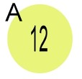 |  | 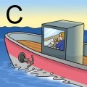 | 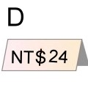 | 
B. 聽廣播中的句子，選出符合句意的圖片的英文代號。
6 | A |  | B | 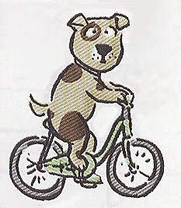 | C | 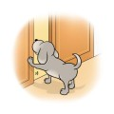
7 | A | 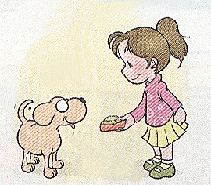 | B | 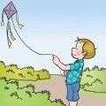 | C | 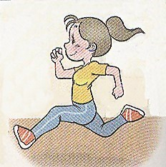
8 | A |  | B |  | C | 
9 | A | 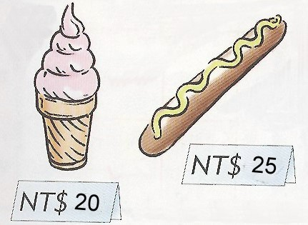 | B | 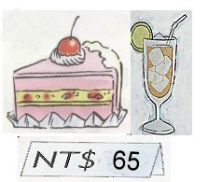 | C | 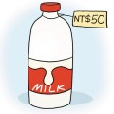
10 | A | 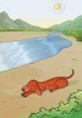 | B | 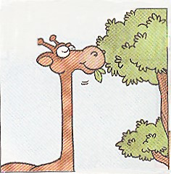 | C | 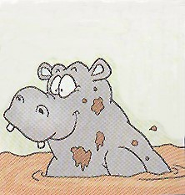
( 第一頁 共四頁 背 面 尚 有 試 題，請 繼 續 作 答 )
C. 聽廣播中的句子，選出最適當的回應句的英文代號。
11. (A) It’s 8:00 now. (B) At 8:00. (C) I don’t have a watch.
12. (A) It’s only thirty-nine dollars. (B) I don’t have money. (C) It’s great.
13. (A) Just a moment. (B) What a small world! (C) I can’t believe it!
14. (A) I like basketball very much. (B) No, I have to do my homework. (C) Yes, I sleep a lot.
15. (A) What a smart puppy! (B) What else can you do? (C) Uh-oh, I’m sorry.
D. 下列各題中的敘述，若是與廣播中的對話或短文相符合，則在電腦卡上劃記A，否則
劃記B。
16. The man wants to go to Taipei.
17. Doraemon can sing, but he can’t fly.
18. Both the boy and the girl like lemon tea.
19. Jane is going home to watch TV.
20. The girl is beautiful and smart.
二、語法測驗：20% (每題2分)
21. The cell phone ______ NT$ 9,990.
(A) is (B) are (C) do (D) does
22. My parents walk in the park ______ weekends.
(A) in (B) at (C) on (D) under
23. I have a lot of time, ______ I don’t have much money.
(A) and (B) but (C) or (D) so
24. _______ The car’s coming this way very fast.
(A) That’s nice. (B) Are you okay? (C) Never mind. (D) Watch out!
25. The baseball game is ______ two thirty.
(A) x (B) in (C) on (D) at
26. My parents work on Sunday, but I ______.
(A) am (B) am not (C) do (D) don’t
27. Miss Yamata has a cute cat. ______ name is Kitty.
(A) It (B) Its (C) It’s (D) Their
28. Peter sent ______ girlfriend 999 roses.
(A) he (B) his (C) him (D) she
sent 送 rose 玫瑰
29. Aren't they wonderful? Let’s give ______ a big hand.
(A) they (B) their (C) them (D) he
30. A: ______ B: It’s three fifty.
(A) What time is it? (B) How much is it? (C) What is it? (D) How is it?
( 第二頁 共四頁 尚 有 試 題，請 繼 續 作 答 )

台北市立龍山國民中學九十三學年度第二學期七年級英語科第一次段考試題
三、閱讀測驗：10% (每題2分)
[A]
Do you like tea? There is a great tea shop near my home. Mr. Wang and his wife own the shop. They are both from Nantou. In the shop, they sell green tea, black tea, and milk tea. They also sell delicious food made from tea. Both Mr. Wang and his wife are very friendly, and their tea and their food are wonderful, so many people like to go to their shop.

shop商店 own 擁有 sell 賣 delicious 可口的 made from 由…製作
friendly 友善的
31. Where is Mr. Wang from?
(A) Taipei. (B) Keelung. (C) Tainan. (D) Nantou.
32. What don’t they sell?
(A) Green tea. (B) Lemon tea. (C) Black tea. (D) Milk tea.
33. Which of the following is not correct?
(A) The food in the shop is delicious. (B) Mr. Wang and his wife are friendly.
(C) They sell coffee, too. (D) People like to drink or eat at the tea shop.
correct 正確的
[B]
I am Jane. Spot is my pet dog. It’s a birthday present from my grandma. Spot is very cute. It can jump. It can catch a ball and move it. It can close the door. It can pick up newspapers or trash from the ground. But Spot cannot catch mice.
On Sunday, I usually take Spot to the park, and we play happily there. Spot is my best friend.

pick up 撿起來 ground 地面 happily 快樂地 best 最好的
34. What can Spot catch?
(A) A fish. (B) Mice. (C) A ball. (D) A cat.
35. What do Jane and Spot usually do on Sunday?
(A) They go to the movies. (B) They go to the park.
(C) They are at home. (D) They go to their grandma’s house.

( 第三頁 共四頁 背 面 尚 有 試 題，請 繼 續 作 答 )

第二部分：共三大題30% (請在答案卷上作答)
一、看中文寫出適當的英語單字：5% (每題1分)
1. 白色 2. 分鐘 3. 蘋果 4. 男服務生 5. 圖書館

二、根據提示的首尾字母寫出合乎句意的英語單字：10% (每題2分)
1. Tom and Peter go home t r after school every day.
2. I study in Longshan J r High School in Taipei.
3. Jane: I’m sorry. I don’t r r your name.
Sara: That’s Ok. I’m Sara.
4. S e your hands, and say “ thank you.”
5. I don’t like m h. It is hard to study.

三、翻譯：15% (第1–4題，每格1分；第5–6題，每題3分)
1. 今天我上學遲到了。
I am ❶ ❷ school today.
2. 你要我用腳踏車載你一程嗎？
Do you ❸ a ❹ on my ❺ ?
3. 打開鉛筆盒，我就在這裡。
Open your pencil case, and ❻ I ❼ .
4. Peter：我們快一點！ Bill：別擔心。時間還早。
Peter: Let’s ❽ .
Bill: Don’t ❾ . It’s early.
5. 讓我們回家看電視吧。
6. 你可以下一次才付錢給我。

( 第四頁 共四頁 )

台北市立龍山國民中學九十三學年度第二學期七年級英語科第一次段考聽力測驗稿
每題請唸二次
A. 聽廣播中的英語語詞，選出正確圖片的英文代號。
- ship
- swim
- twelve
- drink milk
- twenty-four NT dollars
B. 聽廣播中的句子，選出符合句意的圖片的英文代號。
  - The dog can ride a bicycle.
  - Susan can run fast.
  - I walk to school at six fifty.
  - The ice cream and the hot dog are forty-five dollars.
  - I am not tall, but I am heavy.
C. 聽廣播中的句子，選出最適當的回應句的英文代號。
11. What time do you study English?
12. The cheese cake looks yummy. How much is it?
13. The beautiful woman is fifty-five years old now.
14. Do you go to the movies on Sundays?
15. My puppy can stand, sit, jump, and catch a ball.
D. 下列各題中的敘述，若是與廣播中的對話或短文相符合，則在電腦卡上劃記A，否則
劃記B。
16. Woman: Can I help you?
Man: Yes, I want a ticket to Taipei.
Woman: Just a moment.

17. Mother : What can Doraemon do?
Son: He can sing. He can dance. He can fly in the sky. And he can help his friends.
Mother: Wow, he can do a lot of things. No wonder you like Doraemon so much.
18. Mother : What do you want, lemon tea or apple tea?
Boy: I like a cold lemon tea.
Girl: I want a hot apple tea.
Mother: Here you are.
Boy and girl: Thanks, Mom.

19. Boy: Where are you going, Jane?
Jane: I’m going home.
Boy: Why are you walking so fast?
Jane: I’m late for the cartoon on TV at five ten.

20. Girl: I am not smart, but I study hard.
I am not beautiful, but I have a kind heart.
I don’t have a lot of money, but I have many friends.

聽力測驗結束

台北市立龍山國民中學九十三學年度第二學期七年級英語科第一次段考答案卷
班級 ______ 姓名 _______________ 座號 ______

第二部分：共有三大題 30%
一、看中文寫出適當的英語單字：5%（每題1分）
1. | 2. | 3. | 4. | 5.

二、根據提示的首尾字母寫出合乎句意的英語單字：10%（每題2分）
1. | 2. | 3. | 4. | 5.

三、翻譯：15% (第1–4題，每格1分；第5–6題，每題3分)
1. | ❶ | ❷
2. | ❸ | ❹ | ❺
3. | ❻ | ❼
4. | ❽ | ❾
5.
6.

台北市立龍山國民中學九十三學年度第二學期七年級英語科第一次段考答案
第一部分：共三大題 (第1-35題) 70% (請在電腦卡上劃記)
一、聽力測驗：40% (每題2分)
1. | C | 2. | E | 3. | A | 4. | B | 5. | D
6. | B | 7. | C | 8. | A | 9. | A | 10. | C
11. | B | 12. | A | 13. | C | 14. | B | 15. | A
16. | A | 17. | B | 18. | B | 19. | A | 20. | B
二、語法測驗：20% (每題2分)
21. | A | 22. | C | 23. | B | 24. | D | 25. | D
26. | D | 27. | B | 28. | B | 29. | C | 30. | A
三、閱讀測驗：10% (每題2分)
31. | D | 32. | B | 33. | C | 34. | C | 35. | B
第二部分：共三大題30% (請在答案卷上作答)
一、看中文寫出適當的英語單字：5% (每題1分)
1. | white | 2. | minute | 3. | apple | 4. | waiter | 5. | library
二、根據提示的首尾字母寫出合乎句意的英語單字：10% (每題2分)
1. | together | 2. | Junior | 3. | remember | 4. | shake | 5. | math
三、翻譯：15% (第1–4題，每格1分；第5–6題，每題3分)
1. | ❶ late | ❷ for
2. | ❸ want | ❹ ride | ❺ bicycle
3. | ❻ here | ❼ am
4. | ❽ hurry | ❾ worry
5. | Let’s go home and watch TV.
6. | You can pay me next time.

