台北市立龍山國民中學九十三學年度第一學期七年級英語科第三次段考 試題
第一部分 : 聽力測驗
第一大題，請在 電腦卡 上劃記。
Part A : 仔細聽三個單字，並選出字首發音不同的單字的代號(A), (B), 或(C)。每題一分，3%
- (A) (B) (C)
- (A) (B) (C)
- (A) (B) (C)
Part B : 仔細聽三個單字，並選出字尾發音不同的單字的代號(A), (B), 或(C)。每題一分，3%
4. (A) (B) (C)
- (A) (B) (C)
- (A) (B) (C)

第二大題 : 請在 電腦卡 上劃記。仔細聽句子，並依據圖意，選出適當的回應句。每題二分，10%
- (A) (B) (C)
- (A) (B) (C)
- (A) (B) (C)
- (A) (B) (C)
- (A) (B) (C)
7.  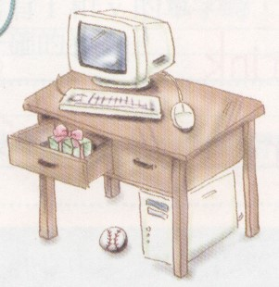 | 8.  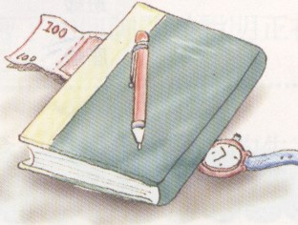 | 9.  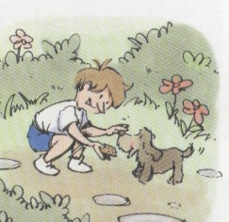 | 10.  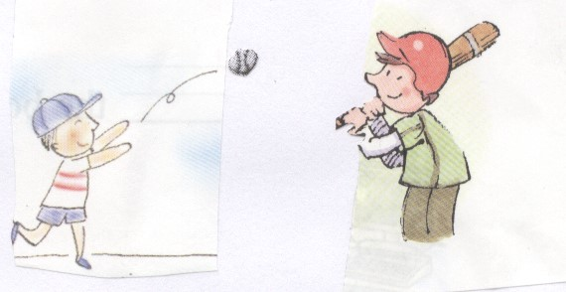 | 11.  

第三大題 : 請在 電腦卡 上劃記。仔細聽各題的問句，並選出適當的回應句。每題二分，8%
12. Who is helping Mrs. Stone in the kitchen?
(A) Her friends are.
(B) Yes, Mr. Stone is helping her.
(C) No, Mr. Stone is not helping her in the kitchen.
13. How are you today, Linda?
(A) Yes, I’m fine.
(B) Very well. Thank you.
(C) No, I don’t know.
14. You’re late again. Why?
(A) Too bad! It’s late again.
(B) Sorry. The bus is slow.
(C) Excuse me. Where’s my watch?
15. Peter : Hello?
Linda : Hello, ______________?
Peter : Yes, it’s me, Peter.
(A)are you Peter? (B)is this Peter? (C)is he Peter?

( 背 面 尚 有 試 題 )
第四大題 : 請在 電腦卡 上劃記。
仔細聽完對話，並回答問題，請選出正確的答案(A), (B), 或(C)。每題二分，6%
16. Who is calling Denis? (A) (B) (C)
17. Where’s Denis? (A) (B) (C)
18. What’s Denis doing? (A) (B) (C)

第五大題 : 請在 答案卷 上作答。仔細聽句子，並填入所聽到的字彙。每題二分，10%
19. Yes, I’m __________.
20. I’m with my __________ at home.
21. The police officer is __________ a boy.
22. He’s opening his birthday __________.
23. She’s __________ a good book.

第二部分：綜合考題
一、單字測驗：請在 答案卷 上作答。
Part A :寫出下列各中文的英文單字。每題一分，3%
1. 書包 2. 忘記 3. 最喜愛的
Part B : 文意字彙 每題二分，8%
4. One, two, three, four are n__________rs.
5. The little girl is wearing a pair of red s__________es. They look beautiful. (wear穿)
6. Mrs. Green likes to plant flowers in the g_________n. (plant flowers種花)
7. Mr. Brown put the money in his jacket p__________t.
二、翻譯：請在 答案卷 上作答。 14 %
第1-4題翻譯填充，每格一分。第5-6題整句翻譯，每題三分，錯一處，扣一分。
- 我們給周杰倫熱烈的掌聲吧！
Let’s ❶ Jay Chou a big ❷ .
- 你現在不可以看電視了。你得做你的家庭作業。
You cannot watch TV now. You ❸ ❹ do your homework.
- 我們現在玩得很開心。
We’re ❺ ❻ now.
- Amanda正在那裡洗車。
Amanda is washing her car ❼ ❽ .
- 或許Peter正在他的房裡睡覺。
- 你打錯電話了。
三、文法選擇：請在 電腦卡 上劃記。請從電腦卡 第19題 開始劃記。10 %
- A: ________ is my EasyCard? B: It’s in your desk.
( Who What How Where )
- A: What is Vivian doing? B: She ________ the cake.
( cut is cut is cuting is cutting )
- John is not home. Let’s ________ his cell phone.
( try is try is trying is tring )
- My pet fish is swimming ________ the bowl. (swim 游泳)
( from in on under )
- Look, _________!
( he comes he is come he is coming he is comeing)

台北市立龍山國民中學九十三學年度第一學期七年級英語科第三次段考 試題
四、填充：請在 電腦卡 上劃記。選填最適當的介系詞或副詞的 英文代號。 5 %
( A ) at | ( B ) on | ( C ) with | ( D ) for | ( E ) up

- A: Is your father ________ home? B: Sorry. He’s not in.
- Everybody is cheering _________ the tchoukball(巧固球) players at our school.
- John and Mary are ________ the way. Let’s wait for them.
- Wake ________, Linda! It’s 7:20.
- I’m having dinner ________ Sue.
五、對話：請在 電腦卡 上劃記。選擇最適當的答案。 10 %
- Teacher: You are early(早) today. Why? Student: __________
(A) My watch is too fast. (B) It’s okay.
(C) Oh, how dumb! (D) Oh, I’m sorry.
- Father: Where are Peter and Linda? Mother:___________
(A) They are watching TV. (B) They are fine.
(C) They are students. (D) Maybe they are at Taipei 101.
- Mrs. Brown: What are you doing? Bill: ________
(A) I’m in my room. (B) It’s me, Bill.
(C) I’m calling my friend, Sam. (D) It’s under the chair.
- Mrs. Liu: Is Peter in? Mr. Liu: ________ Maybe he is out. (out外出)
(A) No answer. (B) Let’s call him.
(C) He’s in his room. (D) He is smart.
- Linda: What time is it? Am I late? Mother: ________ It’s early.
(A) Never mind. (B) Take it easy.
(C) Oh, how nice. (D) No wonder!
六、閱讀測驗：請依據短文內容，題目敘述 正確 的請在 電腦卡 上劃記A；錯誤 的劃記B。10 %
Hi, my name is Q-be. I am a koala. I am male. I was born in Taiwan. My father is Patrick and my mother is Ligi. They are from Australia. Now we are in Taipei Zoo with Eva, Pearl and Matty. We are very cute and friendly. We eat and sleep all day in the trees. We sleep a lot. We don’t have a lot of energy and don’t run fast, so we are afraid of dogs. When you come to Taipei Zoo, remember to say hello to us.

male 雄性的 was born 出生 Australia 澳洲 friendly 友善的
afraid of 害怕 remember 記得 all day 整天

  - Q-be is ♂. ：♂ ：♀
  - Patrick is from South Africa.
  - Koalas and dogs are good friends.
  - Q-be and his parents eat under the trees.
  - Patrick, Ligi and Q-be are in Australia now.

台北市立龍山國民中學九十三學年度第一學期七年級英語科第三次段考答案卷
班級 ________ 座號 ________ 姓名 __________________
第一部分 : 聽力測驗
第五大題 : 仔細聽句子，並填入所聽到的字彙。每題二分，10%
19 | 20 | 21 | 22 | 23
第二部分：綜合考題
一、單字測驗
Part A : 請寫出下列各中文的英文單字 每題一分，3%
1 | 2 | 3
Part B : 文意字彙 每題二分，8%
4 | 5 | 6 | 7
二、翻譯：14 %
第1-4題翻譯填充，每格一分。第5-6題整句翻譯，每題三分，錯一處，扣一分。
1 | ❶ | ❷
2 | ❸ | ❹
3 | ❺ | ❻
4 | ❼ | ❽
5
6

台北市立龍山國民中學九十三學年度第一學期七年級英語科第三次段考答案
第一部分 : 聽力測驗
第五大題 : 仔細聽句子，並填入所聽到的字彙。每題二分，10%
19. fine | 20. parents | 21. helping | 22. present | 23. reading
第二部分：綜合考題
一、單字測驗
Part A : 請寫出下列各中文的英文單字 每題一分，3%
1. schoolbag | 2. forget | 3. favorite
Part B : 文意字彙 每題二分，8%
4. numbers | 5. shoes | 6. garden | 7. pocket
二、翻譯：14 %
第1-4題翻譯填充，每格一分。第5-6題整句翻譯，每題三分，錯一處，扣一分。
1 | ❶ give | ❷ hand
2 | ❸ have | ❹ to
3 | ❺ having | ❻ fun
4 | ❼ over | ❽ there
5 | Maybe Peter is sleeping in his room.
6 | You have the wrong number.
電腦卡答案
1. B | 2. B | 3. A | 4. A | 5. B
6. B | 7. B | 8. B | 9. C | 10. A
11. B | 12. A | 13. B | 14. B | 15. B
16. B | 17. C | 18. B | 19. D | 20. D
21. A | 22. B | 23. C | 24. A | 25. D
26. B | 27. E | 28. C | 29. A | 30. D
31. C | 32. A | 33. B | 34. A | 35. B
36. B | 37. B | 38. B

