台北市立龍山國民中學九十三學年度第一學期七年級英語科第二次段考試題
第一部分：聽力測驗：40 %
以下的聽力測驗，每題唸兩次，請同學仔細傾聽並認真作答。
一. 每題有兩個單字，若是發音完全相同，在空格中寫○，否則寫×：10 %

二. 寫出聽到的句子的英文代號A、B或C：10 %
- (A) Is that your English book?
(B) Is this your English book?
(C) Are they your English books ?
- (A) Maybe it’s just a lunch box.
(B) Maybe it’s just a book.
(C) They are good boys.
- (A) Tony, please stand up.
(B) Ted, please sit down.
(C) Ted, please stand up.
- (A) Are they Spiderman and Superman?
(B) Are those Batman and Superman?
(C) Are those Superman and Batman?
- (A) Look at the girl, everybody.
(B) Look here, everybody.
(C) Everybody, look here.
三. 聽廣播，選出符合圖意的句子代號：10 %
1.  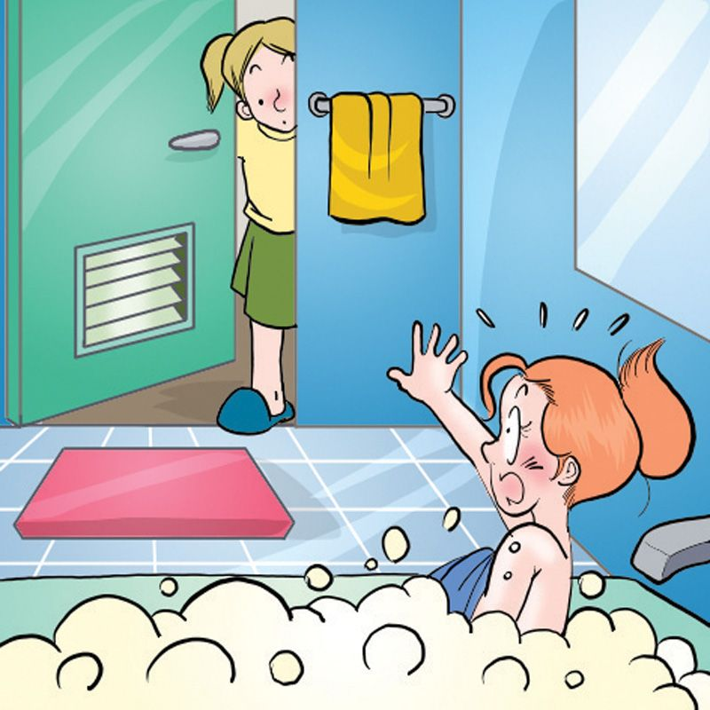 | 2.   | 3.   | 4.  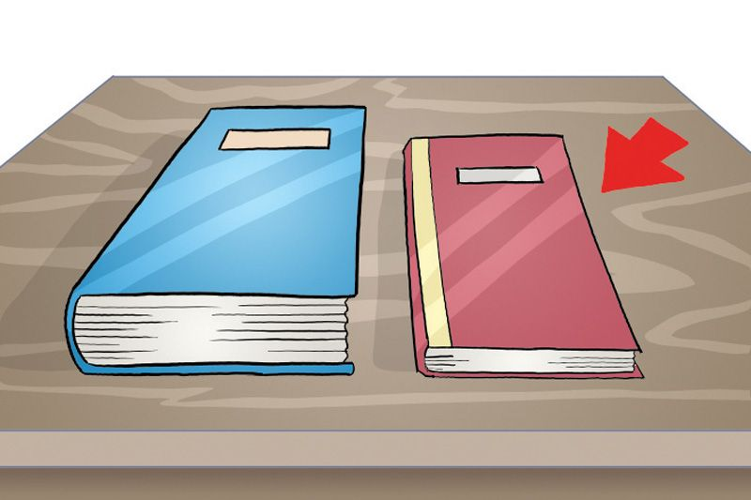 | 5.  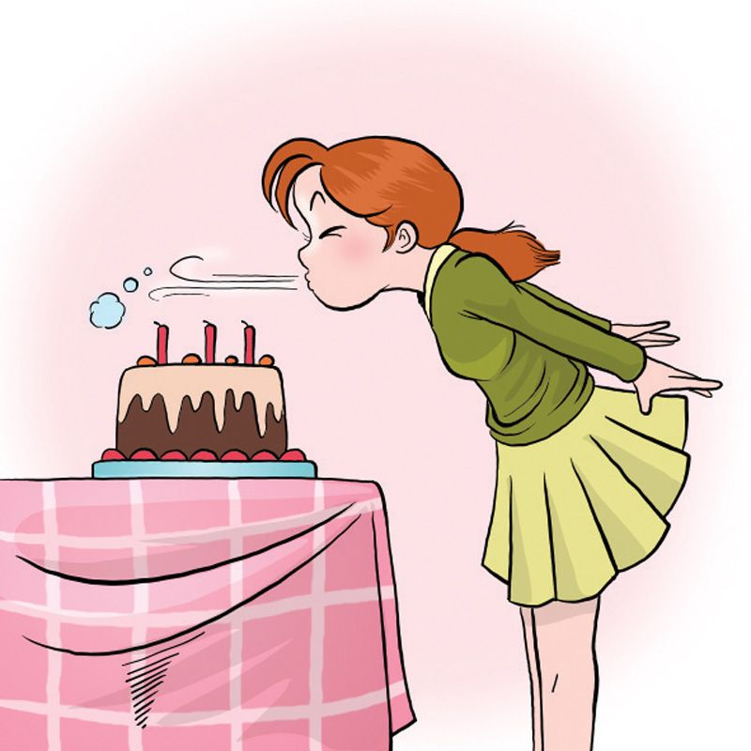
【背面尚有試題】
台北市立龍山國民中學九十三學年度第一學期七年級英語科第二次段考試題
四. 聽廣播中的句子，寫出最適當回應句子的英文代號A、B或C：10 %
- (A) Just open it.
(B) Thank you very much.
(C) You’re welcome.
- (A) Nice to meet you.
(B) Close your eyes.
(C) Too bad.
- (A) It’s a rabbit.
(B) They are cats.
(C) That’s his sister.
- (A) No, they are not my bags.
(B) Yes, they are Jane’s bags.
(C) No, they are not Jane’s bags.
- (A) Yes, she is short.
(B) No, he is tall.
(C) He is my brother.
----------------------------------------------------------------------------------------------------------
第二部分：綜合考題:60％
五. 單字測驗：15 %
(A) 看中文寫出適當的英語語詞：5 %
1. 夾克 2. 銷售員 3. 籃球 4. 順便一提 5. 怪不得
(B) 根據句意，寫出最適當的字彙：10 %
6. Susan, this is your b______y cake.
7. Wow! Your hair(頭髮) is so long and b________l.
8. The books are h y. Please open the door. Thank you.
9. This c______r(電腦) is cool. It’s light and fast.
10. A: Is your father an e________r? B: No, he’s not. He is a reporter.
台北市立龍山國民中學九十三學年度第一學期七年級英語科第二次段考試題
六、文法與對話選擇：10 %
1. They say “Good morning” ______ their friends.
(A) on (B) for (C) to (D) ×
2. Betty, _______ Peter a diplomat?
(A) am (B) is (C) are (D) ×
3. Gary and George are _____. Everybody likes(喜歡) them(他們).
(A) a good student (B) good very students (C) a very good student (D) very good students
4. Henry: I’m a coach. ______ Mark: I’m a baseball player.
(A) How about you? (B) Too bad. (C) How do you do ? (D) It’s all right.
5. Sam: Look here. ______ Boys and girls: Cheese！
(A) Cut the cake. (B) Stand up. (C) Close your eyes. (D) Say “cheese.”

七、閱讀測驗：10 %
.
Mary is short. She is my sister. My name is Peter.
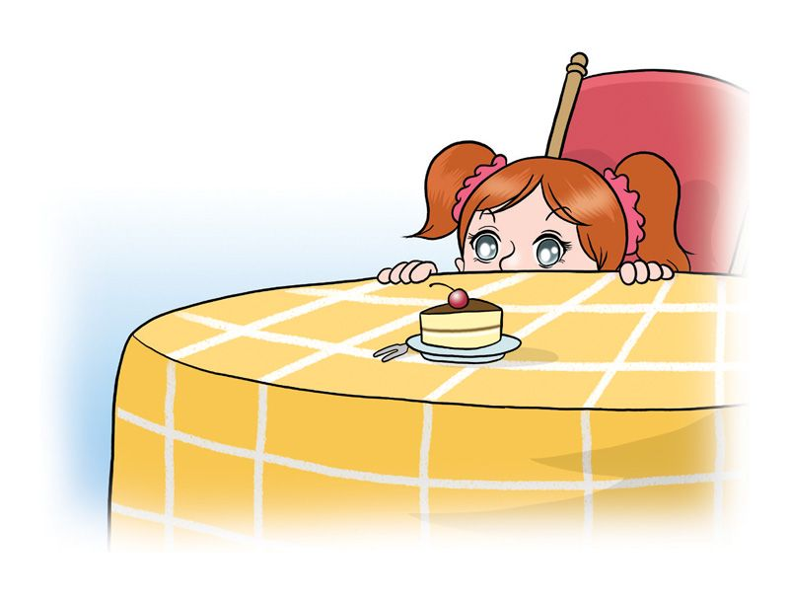
I am tall. And the table is tall, too. Mary’s eyes are
big. But the cake is small.

( )1.Who is short?(A) Mary. (B) Peter. (C)The table.
( )2.What is small? (A) Mary. (B)The table. (C) The cake.
( )3. Are Mary’s eyes small? (A)Yes, they are. (B) No, they’re not. They are big. (C)I don’t know.
( )4.Is the table short? (A)Yes, it is. (B) No, it’s not. (C)I don’t know.
( )5. Who is tall?(A) Peter. (B) Mary. (C) I don’t know.
【背面尚有試題】

台北市立龍山國民中學九十三學年度第一學期七年級英語科第二次段考試題
八、依提示作答：10 %
1.  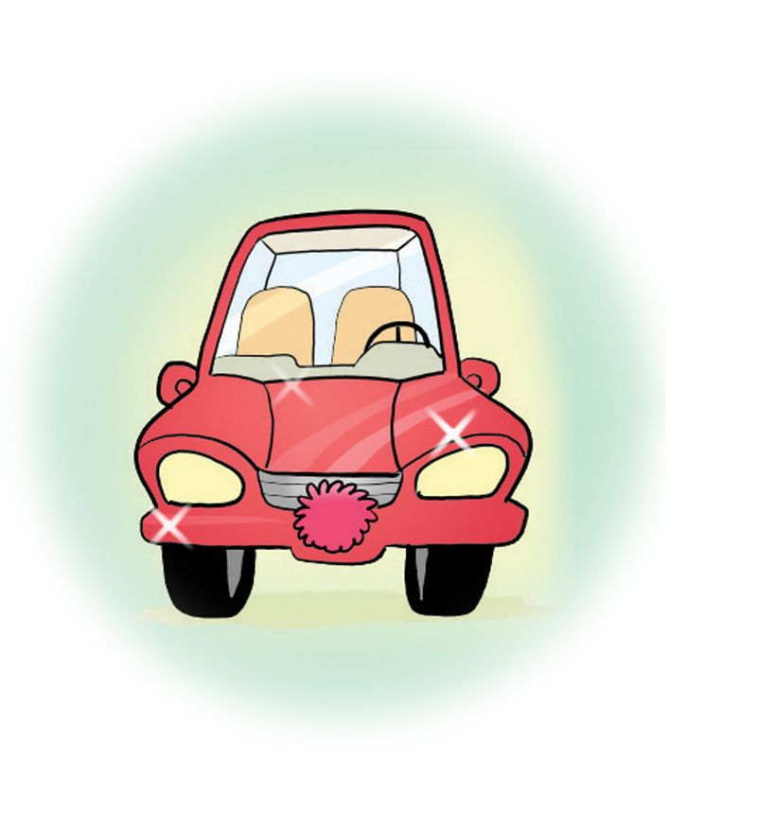 | 2.  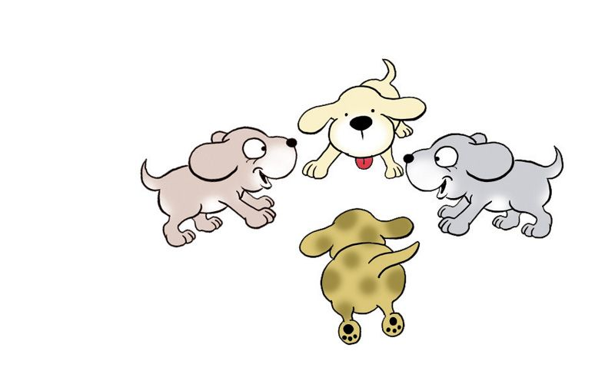 | 3.  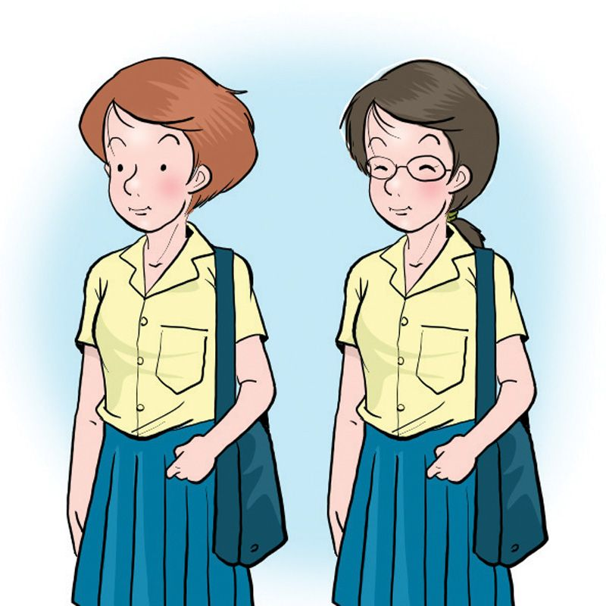

1. Is the car old?(請詳答)
2. What are they?
3. Are they police officers? (請詳答)
4. Is she a good wife? (請改成複數句)
5. Jerry, please come here.
Please cut the cake, Jerry. (請合併為一句)

九、翻譯：15 %
(A)引導式: 6%
1. Jolin, 吹熄蠟燭。Jolin, (1) out the (2) .
2. 我們向星星許願。We (3) a (4) to the stars(星星).
3. 別動！這是個炸彈。Don’t (5) . It’s a (6) .
(B)整句式: 9%
4. Miss Lin和 Mr. Li是新老師嗎?
5. 這部電腦是雙親給我的生日禮物。
6. 等一下!它是錢嗎?

台北市立龍山國民中學九十三學年度第一學期七年級英語科第二次段考 聽力稿
第一部分：聽力測驗：40 %
以下的聽力測驗，每題唸兩次，請同學仔細傾聽並認真作答。

一. 每題有兩個單字，若是發音完全相同，在空格中寫○，否則寫×：10 %
- 1. pet bad
- 2. waiter waiter
- 3. Kate gate
- 4. year here
5. drink drink
二. 寫出聽到的句子的英文代號A、B或C：10 %
- 1. Is this your English book?
- 2. Maybe it’s just a lunch box.
- 3. Ted, please stand up.
- 4. Are those Batman and Superman?
- 5. Look here, everybody.
三. 聽廣播，選出符合圖意的句子代號：10 %
1. A. John, don’t come in.
B. Mary, come in.
C. Sally, don’t come in.
2. A. The basketball is small and the baseball is big.
B. The basketball is big and the baseball is small.
C. The basketball and the baseball are small.
3. A. Jennifer is a TV reporter.
B. John is a computer engineer.
C. Jane is a computer salesperson.
4. A. It’s a heavy book.
B. It’s a light book.
C. It’s a thin book.
5. A. Cut the cake.
B. Blow out the candles.
C. Close your eyes.
四. 聽廣播的句子，寫出最適當回應句子的英文代號A、B或C：10 %
1. This is for you, Jay.
2. This line is so long.
3. What’s that?
4. Are these your bags?
5. Who’s that short boy?

親愛的監考老師 :
您好! 請在 聽力測驗實施前 更正以下題目( 1題):
麻煩您將題目寫在黑板上 謝謝 !
第一部分：聽力測驗：40 %
四. 聽廣播中的句子，寫出最適當回應句子的英文代號A、B或C：10 %
4. (C) No, they are Jane’s bags.
更正為 : (C) No, they are not Jane’s bags.
~非常感謝您的協助~

台北市立龍山國民中學九十三學年度第一學期七年級英語科第二次段考 答 案
班級 ________ 座號 ________ 姓名________________
第一部分：聽力測驗：40 %
一. 每題有兩個單字，若是發音完全相同，在空格中寫○，否則寫×：10 %（每題兩分）
1. | × | 2. | ○ | 3. | × | 4. | × | 5. | ○
二. 寫出聽到的句子的英文代號A、B或C：10 %（每題兩分）
1. | B | 2. | A | 3. | C | 4. | B | 5. | B
三. 聽廣播，選出符合圖意的句子代號：10 %（每題兩分）
1. | C | 2. | B | 3. | C | 4. | A | 5. | B
四. 聽廣播的句子，寫出最適當回應句子的英文代號A、B或C：10 %（每題兩分）
1. | B | 2. | C | 3. | A | 4. | A | 5. | C
第二部分：綜合考題:60％
五. 單字測驗：15 %
(A) 看中文寫出適當的英語語詞：5 %（每題一分）
1. | jacket | 2. | salesperson | 3. | basketball | 4. | by the way | 5. | no wonder
(B) 根據句意，寫出最適當的字彙：10 %（每題兩分）
6. | birthday | 7. | beautiful | 8. | heavy | 9. | computer | 10. | engineer
六、文法選擇：10 %（每題兩分）
1. | C | 2. | B | 3. | D | 4. | A | 5. | D
七、閱讀測驗：10 %（每題兩分）
1. | A | 2. | C | 3. | B | 4. | B | 5. | A
八、依提示作答：10 %（每題兩分）
1. | No, it is not old. / No, it is new.
2. | They are puppies.
3. | No, they are not police officers. / No, they are students.
4. | Are they good wives?
5. | Jerry, please come here and cut the cake. / Please come here and cut the cake, Jerry.

九、翻譯：15 % (第1-3題翻譯填充，每格一分。第4-6題整句翻譯，每題三分，錯一處，扣一分。)
1. | (1) blow | (2) candle(s) | 2. | (3) make | (4) wish
3. | (5) move |  | (6) bomb
4. | Are Miss Lin and Mr. Li new teachers?
5. | This computer is a birthday present from my parents.
6. | Wait.(!) Is it money?

