台北市立龍山國民中學九十二學年度第二學期七年級第三次段考英語科試題卷
一、聽力測驗（共40分）
I. 聽錄音帶，圈選各題單字所包含的讀音。（一題1分，共5分）
1. [o]  2. [ju]  3. [u] | []  [u]  [Λ] | 4. []  5. [o] | []  []

II. 聽錄音帶，選出最適當的回應。（一題1分，共5分）
- (A) No, we are not.  (B) We were friends.  (C) Yes, we were.  - (A) She is a teacher now.  (B) But she is tall and slender now.  (C) She likes exercise. |  | - (A) He likes computers.  (B) He likes tennis.  (C) He likes English.  - (A) No, I don’t have time.  (B) I get up at six.  (C) Yes, I have to.
3. (A) I collect baseball cards.
(B) I don’t have baseball cards.
(C) I like baseball cards.
III. 聽對話，勾選符合對話敘述的圖片。（一題2分，共10分）
1. A | B |  |   4. Now A |  |  |   Now B
2. A | B |  | 5. A  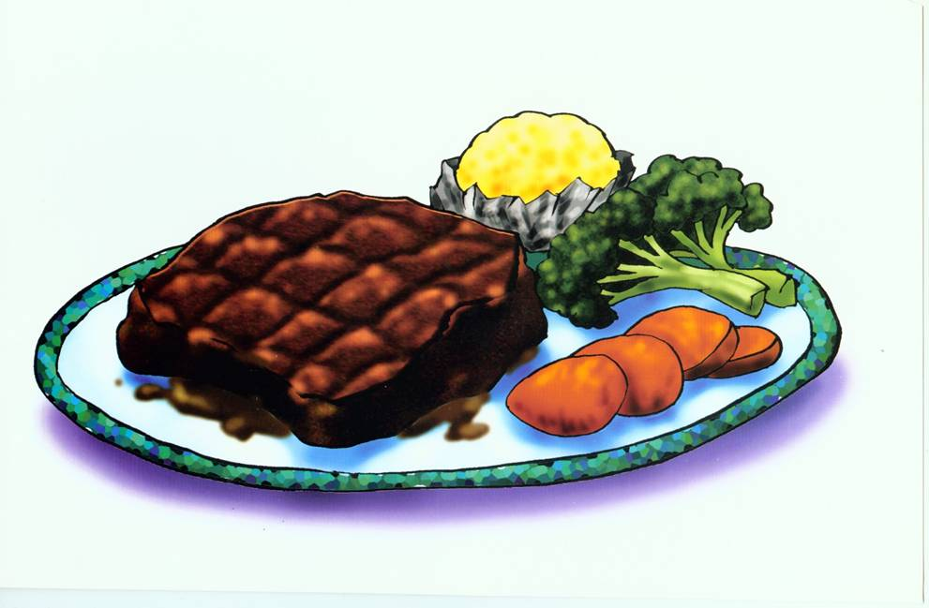 |  |  | 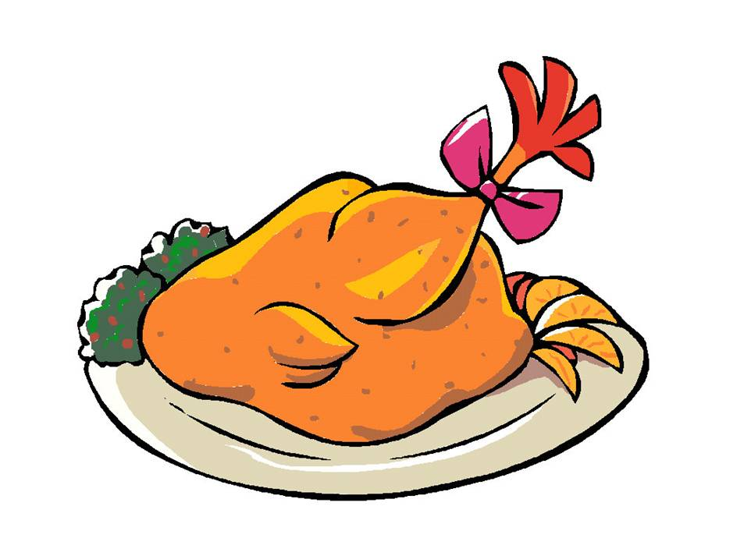  B
  3. A |   B

IV. 聽錄音帶中的短文及問題，選出最適當的答案。（一題2分，共10分）
- (A) It’s Sunday. (B) It’s Saturday. (C) It’s Friday.
- (A) They go to a movie. (B) They go to swim. (C) They go on a picnic.
- (A) A large pizza and a small cake. (B) A large pizza and a large cake.
(C) A small pizza and a small cake.
4. (A) Three bottles. (B) Four bottles. (C) Five bottles.
5. (A) It’s fresh. (B) It’s terrible. (C) It’s great.
【請翻面繼續作答】
V. 根據所聽到內容，在空格中填入正確的答案。（一題2分，共10分） P2.
1.
 | pork | beef | chicken | fish
Ms. Lin | _1 pound(s) | ___ pound(s) | ___ pound(s) | ___ pound(s)

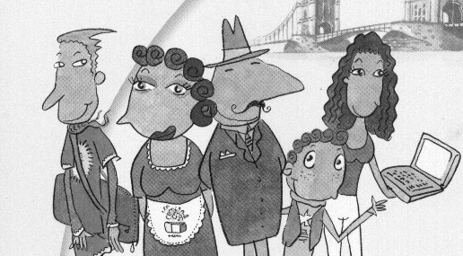
2.
Amanda ____
Mrs. Brown 47
Peter 13
Mr. Brown 55 ____

Bill ____

二、字彙測驗：（共15分）
(Ⅰ)看中文寫出適當的英語語詞：（一題1分，共5分）
1.兩者 2.頭髮 3.記帳員 4.客人 5.團聚

(Ⅱ)根據提示的首尾字母寫出合乎句意的英語語詞：（一題2分，共10分）
1. Our mother is very busy, but she still p es dinner for us.
2. Mr. Black is h e, and his wife is beautiful. We all envy them.
3. Sally p es English every day. Her English is really good.
4. Look! The watch is NT$50,000. It’s so e e.
5. Cindy is seven years old. She can go to e y school this year.

三、文法與對話選擇： （一題2分，共10分）
1. _____ children do Mr. and Mrs. White have?
(A) How many (B) How about (C) How much (D) How old
2. His brother doesn’t have to work in the afternoon, but he _____.
(A) has (B) has to (C) doesn’t have (D) doesn’t have to
3. A: Was your dad a cook _____? B: Yes, but it was a long time _____.
(A) ago, ago (B) ago, before (C) before, ago (D) before, before
4. A: Don’t you go to the movies tonight? B: I want to, but I can’t.
A: _____ B: I have a lot of homework today.
(A) Why? (B) Really? (C) And you? (D) Why not?
5. A: The chocolate cake is great. _____ B: Sure, I’m happy you like it. Here you are.
(A) Is it for me? (B) Is it too much?
(C) What else do you want? (D) Can I have more?

【還有題目，請繼續作答】
四、整段式文意選擇：（一題2分，共10分） P3.
Jerry: Hi, Lucy. How are you doing? Lucy: Sorry, I don’t remember you. You are …?
Jerry: It’s me, Jerry. We (1) classmates in the junior high school.
Lucy: Wow. (2) You’re Jerry? You are (3) 180 cm tall now. But you (4) short then.
Jerry: Yes, I (5) only about 150 cm at that time. So I play basketball and drink milk every day.
Lucy: Oh, I see.
1. (A) are (B) was (C) were (D) am
2. (A) That’s okay. (B) What a surprise! (C) What about you? (D) How old are you?
3. (A) almost (B) more (C) only (D) still
4. (A) am (B) are (C) was (D) were
5. (A) were (B) are (C) was (D) am

五、依提示作答：（一題2分，共10分）
1. Sam is a tennis fan, and his parents are, too. 【用過去式改寫整句】
2. He means the first row. He doesn’t mean the last row. 【用not將兩句合併成一句】
3. Tony watches TV every day, and he doesn’t like exercise. What can we call him? 【依照題意回答】
4. How much is the beef? 【用「一公斤二百元」回答】
5. Cathy has to study for the coming exam this week. 【根據畫線部分造原問句】

六、翻譯：（共15分）
(Ⅰ)引導式：（一格填一字，一格1分，共6分）
1. 他的座位在窗戶的旁邊。 His _____ is _____ to the window.
2. 花或樹木，你喜歡哪一樣呢？ _____ do you like, _____ or trees?
3. 也許我們可以帶我的美國朋友去野餐。 Maybe we can _____ my _____ friend to the picnic.

(Ⅱ)整句式：（一題3分，共9分）
1. 她的女兒至少有一千張的郵票。
2. 我待在家裡照顧我兒子。
- 我們很高興他想要在明天拜訪我們。

台北市立龍山國民中學九十二學年度第二學期七年級第三次段考英語科答案卷
班級：_____ 姓名：__________ 座號：_____
一、聽力測驗（共40分）
I. 聽錄音帶，圈選各題單字所包含的讀音。（一題1分，共5分）
1. [o]  2. [ju]  3. [u] | []  [u]  [Λ] | 4. []  5. [o] | []  []

II. 聽錄音帶，選出最適當的回應。（一題1分，共5分）
1. |  | 2. |  | 3. |  | 4. |  | 5.
III. 聽對話，勾選符合對話敘述的圖片。（一題2分，共10分）
1. A | B |  | 4. Now A |  |  | Now B
2. A | B |  | 5. A |  |  | B
3. A | B

IV. 聽錄音帶中的短文及問題，選出最適當的答案。（一題2分，共10分）
1. |  | 2. |  | 3. |  | 4. |  | 5.

V. 根據所聽到內容，在空格中填入正確的答案。（一題2分，共10分）
1.
 | pork | beef | chicken | fish
Ms. Lin | _1 pound(s) | ___ pound(s) | ___ pound(s) | ___ pound(s)

2.
Amanda ____
Mrs. Brown 47
Mr. Brown 55 ____

Bill ____

Peter 13

二、字彙測驗：（共15分）
(Ⅰ)看中文寫出適當的英語語詞：（一題1分，共5分）
1. |  | 2. |  | 3. |  | 4. |  | 5.

(Ⅱ)根據提示的首尾字母寫出合乎句意的英語語詞：（一題2分，共10分）
1. |  | 2. |  | 3. |  | 4. |  | 5.

三、文法與對話選擇： （一題2分，共10分）
1. |  | 2. |  | 3. |  | 4. |  | 5.

四、整段式文意選擇：（一題2分，共10分）
1. |  | 2. |  | 3. |  | 4. |  | 5.

五、依提示作答：（一題2分，共10分）
1.
2.
3.
4.
5.

六、翻譯：（共15分）
(Ⅰ)引導式：（一格填一字，一格1分，共6分）
1. | His ____________ is ____________ to the window.
2. | ____________ do you like, ____________ or trees?
3. | Maybe we can ____________ my ____________ friend to the picnic.

(Ⅱ)整句式：（一題3分，共9分）
1.
2.
3.

台北市立龍山國民中學九十二學年度第二學期七年級第三次段考英語科聽力稿
聽力測驗，共40分。
本次聽力測驗，每題題目皆唸兩次，請同學仔細聆聽，謹慎作答。
第一大題： 聽錄音帶，圈選各題單字所包含的讀音。（間隔約2秒）
1. code  2. glue  3. duck | 4. spy  5. frog

第二大題：聽錄音帶，選出最適當的回應。（間隔約3秒）
- Were you classmates before?
- She was short and heavy.
- What’s your hobby?
- What sport does your father like?
- Do you have to get up early?

第三大題：聽對話，勾選符合對話敘述的圖片。（間隔約3秒）
- Man: How many chairs do you need?
Woman: I need three chairs.
- Man: Which does Sally like, tennis or baseball?
Woman: She likes tennis.
- Man: What does Tom have to do?
Woman: He has to go to bed.
- Man: Was Grace in the garden?
Woman: No, she wasn’t. But she is in the garden now.
- Man: Do we need some food or drinks for the party?
Woman: Yes, we need some juice and chicken.

第四大題：聽錄音帶中的短文及問題，選出最適當的答案。
（文章唸兩次間隔約4秒，題目也唸兩次間隔4秒）
Today is Sunday. Mr. and Mrs. Wang and their two children go on a picnic. They buy some food for the picnic. They have a large pizza, a small cake and four bottles of juice. The food is good. They like it very much.

- What day is today?
- What do the Wang family do?
- What do they buy?
- How much juice do they buy?
- How is their food?

(背面還有題目)

第五大題：根據所聽到內容，在空格中填入正確的答案。（間隔約3秒）
- Man: Hi, can I help you?
Woman: Yes, I want one pound of pork and two pounds of beef.
Man: Do you need some chicken, too?
Woman: No, but I need some fish.
Man: How much?
Woman: One pound, please.
- Look at this picture. This is Peter’s family. There are five people in his family. They are Mr. and Mrs. Brown, Bill, Amanda and Peter.
Peter’s father is fifty-five years old and Peter’s mother is forty-seven. Amanda is twenty-four. Bill is eighteen and Peter, thirteen.

台北市立龍山國民中學九十二學年度第二學期七年級第三次段考英語科答案
一、聽力測驗（共40分）
I. 聽錄音帶，圈選各題單字所包含的讀音。（一題1分，共5分）
1. [o]  2. [ju]  3. [u] | []  [u]  [Λ] | 4. []  5. [o] | []  []

II. 聽錄音帶，選出最適當的回應。（一題1分，共5分）
1. | C | 2. | B | 3. | A | 4. | B | 5. | C
III. 聽對話，勾選符合對話敘述的圖片。（一題2分，共10分）
1. A | B |  | 4. Now A |  |  | Now B
2. A | B |  | 5. A |  |  | B
3. A | B

IV. 聽錄音帶中的短文及問題，選出最適當的答案。（一題2分，共10分）
1. | A | 2. | C | 3. | A | 4. | B | 5. | C

V. 根據所聽到內容，在空格中填入正確的答案。（一題2分，共10分）
1.
 | pork | beef | chicken | fish
Ms. Lin | _1 pound(s) | 2 pound(s) | 0 pound(s) | _1 pound(s)

2.
Amanda 24
Mrs. Brown 47
Mr. Brown 55 ____

Bill 18

Peter 13
二、字彙測驗：（共15分）
(Ⅰ)看中文寫出適當的英語語詞：（一題1分，共5分）
1. | both | 2. | hair | 3. | clerk | 4. | guest | 5. | reunion

(Ⅱ)根據提示的首尾字母寫出合乎句意的英語語詞：（一題2分，共10分）
1. | prepares | 2. | handsome | 3. | practices | 4. | expensive | 5. | elementary

三、文法與對話選擇： （一題2分，共10分）
1. | A | 2. | B | 3. | C | 4. | D | 5. | D

四、整段式文意選擇：（一題2分，共10分）
1. | C | 2. | B | 3. | A | 4. | D | 5. | C

五、依提示作答：（一題2分，共10分）
1. | Sam was a tennis fan, and his parents were, too.
2. | He means the first row, not the last row.
3. | We can call him a couch potato.
4. | It’s two hundred dollars a kilo.
5. | What does Cathy have to do this week?

六、翻譯：（共15分）
(Ⅰ)引導式：（一格填一字，一格1分，共6分）
1. | His seat is next to the window.
2. | Which do you like, flowers or trees?
3. | Maybe we can take my American friend to the picnic.

(Ⅱ)整句式：（一題3分，共9分）
1. | Her daughter has at least one thousand stamps.
2. | I stay ( at ) home and / to take care of my son.
3. | We are glad he’d like / wants to visit us tomorrow.

