台北市立龍山國民中學九十二學年度第二學期七年級第二次段考 英語科試題卷
一、聽力測驗（共40分）
I. 聽錄音帶，圈選各題字中的母音。（一題1分，共5分）
1. [e] [ε] [æ]  2. [e] [ε] [æ]  3. [e] [ε] [æ] | 4. [i] [I] [aI]  5. [i] [I] [aI]
II. 聽錄音帶，選出最適當的回應。（一題1分，共5分）
- (A) No, I don’t.
(B) Me, too.
(C) I don’t, either.
- (A) She has fifty dollars.
(B) She gets home at five thirty.
(C) She likes her job.
- (A) No, he doesn’t like junk food.
(B) No, he is energetic
(C) No, he studies history.
- (A) It is nine o’clock.
(B) I have art on Friday.
(C) Today is Friday.
- (A) He is washing the car.
(B) He is a P.E. teacher.
(C) He eats fast food.

III.選出正確描述圖片內容的句子，並將代號填入空格中。（一題2分，共10分）

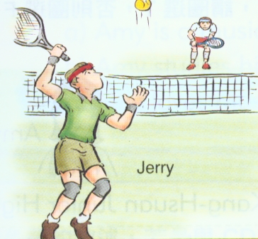  1.  Jerry | 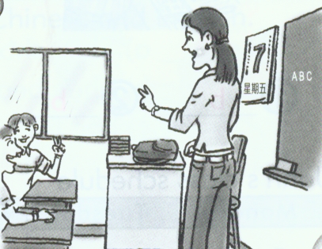  2.  ABC  星期五 | 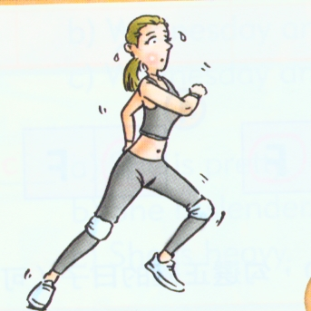  3. | 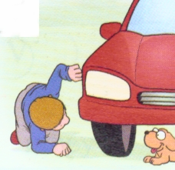  4. |   5.

IV. 聽錄音帶的敘述，根據圖片判斷，正確請寫T，否則寫F。（一題2分，共10分）

A
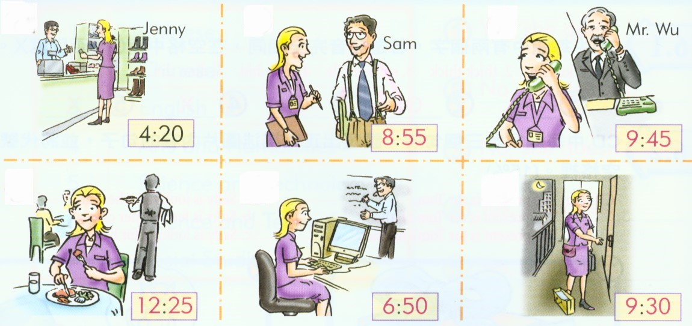  1-2 | B  3-5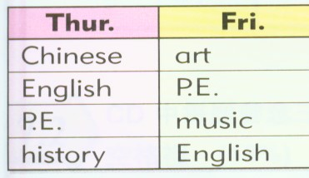

V. 聽錄音帶中的短文，下列每題的敘述符合請寫T，否則寫F。（一題2分，共10分）
( ) 1. The present is for Linda’s mother.
( ) 2. Linda’s father needs some new clothes.
( ) 3. Linda doesn’t know her father’s size.
( ) 4. Linda buys a jacket for her father.
( ) 5. Linda’s father doesn’t like the present.

二、綜合測驗（共60分）
- 字彙測驗（1-6題為文意字彙，7-10題為中翻英，一題1分，共10分）
__________ 1. My brother knows many things. I e y him.
__________ 2. Mike loves music and he plays the p o.
__________ 3. Amy likes e e. She is slender and energetic.
__________ 4. The weather is too cold. I w r a lot of clothes.
__________ 5. Chubby is a monkey and it can c b the tree.
__________ 6. It’s really hot today. I drink a lot of w r.
7. 星期三 8. 週末 9. 他們的 10. 主意

- 語法測驗（一題2分，共10分）
( ) 1. A: Who ______ fish? B: I do.
(A)like (B) are (C) is (D) likes
( ) 2. A: What does she _______ in her hands? B: A little dog.
(A)has (B)have (C)had (D)having
( ) 3. We are going to a movie ________ 2:30.
(A)in (B)× (C)at (D)on
( ) 4. ______ Mary like English?
(A)Does (B)Do (C)Are (D)Is
( ) 5. A: ________ do you go to school? At 7:30.
(A) What day (B) How much (C) What time (D) What else

- 完成句子與對話 （一題2分，共10分）
( ) 1. A: What does Mr. Lin do? B: _____________.
(A)He has a dog. (B)He likes to play basketball.
(C)He’s an English teacher. (D)He’s an old man.
( ) 2. A: Is Tom also a college student? B: _______________.
(A)Oh, that’s great. (B)Yes, he is. He studies music.
(C)No, he likes P.E. (D)Yes, he is my boyfriend.
( ) 3. A: What time does Mr. Wang usually get home? B: _______________.
(A) He gets home very late. (B) He gets home very early.
(C) He gets home every day. (D) He gets home at 7:00.
( ) 4. A: Do you go to school late? B: _______________.
(A)No, I go to school early. (B)No, I don’t like to go to school.
(C)Yes, it’s late now. (D)Yes, I go to school early.
( ) 5. A: Where is the letter from? B: _______________.
(A)It’s my friend. (B) It’s from my friend.
(C)Tom comes from the Japan. (D)It’s in Taipei.

- 克漏字測驗 （一題2分，共10分）
Bob is my good friend. He works ___1____. He likes ___2_____. Swims and basketball are his favorite. He is strong and

energetic. He studies English every day, _____3_____ his English is not very good. I know ___4____. He doesn’t speak ___5____！I speak English to my teacher and my classmates every day.
( ) 1. (A)good (B)late (C)happy (D)hard
( ) 2. (A)movies (B)monkeys (C)sports (D) girls
( ) 3. (A)and (B)× (C)but (D)or
( ) 4. (A)how (B)why (C)who (D)what
( ) 5. (A) it (B) them (C)her (D)one

- 閱讀測驗 （一題1分，共5分）
Jack’s mother is a police officer. She looks for missing children every day. That’s her job. She likes her job and works very hard. Many parents thank her very much.
She is very busy. But, every evening, she comes home and makes dinner for her family. Her husband and children all like her food. And Jack needs her help with his homework.
Today is Mother’s Day. Jack has a watch and a card for her. It says,“Thank you, Mom. I love you.”His mother is very happy.
( )1. What does Jack’s mother do?
(A) A school teacher. (B) A children’s writer.
(C) A police officer. (D) A baseball coach.
( )2. What does Jack’s mother look for every day?
She looks for __________ every day.
(A) money (B) bicycles (C) cars (D) missing children
( )3. Who cooks dinner for Jack’s family?
- Jack does. (B)Jack’s mother does.
(C) Jack’s father does. (D) We don’t know.
( )4. What presents does Jack give his mother on Mother’s Day?
Jack has __________ for his mother on Mother’s Day.
(A) a watch and a card (B) a car (C) a house (D) a cake
( )5. Why do many parents thank Jack’s mother very much?
(A) They work together. (B) Jack’s mother helps them look for their missing children
(C) They are good friends. (D) We don’t know.

- 中文翻譯成英文 (1-3題，一格1分；4-5題，一題3分；共15分)
1.她每個星期三有一節英文課。
She ______ an English class ________ ___________.
2.我媽媽不戴珠寶，但她喜歡新衣服。
My mother doesn’t ________ __________, but she likes new ____________.
3.我正在看一封我表哥Tom寄來的信。
I am _______ a letter _____ my _______, Tom.
4.我姊姊會彈鋼琴和寫兒童故事。
__________________________________________________________________
5.我不吃垃圾食物，也不抽煙。
__________________________________________________________________

台北市立龍山國民中學九十二學年度第二學期七年級第二次段考 英語科答案卷
班級：______ 姓名：__________ 座號：_____
一、聽力測驗（共40分）
I. 聽錄音帶，圈選各題字中的母音。（一題1分，共5分）
1. [e] [ε] [æ]  2. [e] [ε] [æ]  3. [e] [ε] [æ] | 4. [i] [I] [aI]  5. [i] [I] [aI] |  | 4. [] [] []  5. [] [] []
II. 聽錄音帶，選出最適當的回應。（一題1分，共5分）
1. |  | 2. |  | 3. |  | 4. |  | 5.

III. 選出正確描述圖片內容的句子，並將代號填入空格中。（一題2分，共10分）
1. |  | 2. |  | 3. |  | 4. |  | 5.

IV. 聽錄音帶的敘述，根據圖片判斷，正確請寫T，否則寫F。（一題2分，共10分）
1. |  | 2. |  | 3. |  | 4. |  | 5.

V. 聽錄音帶中的短文，下列每題的敘述符合請寫T，否則寫F。（一題2分，共10分）
1. |  | 2. |  | 3. |  | 4. |  | 5.

二、綜合測驗（共60分）
- 字彙測驗（1-6題為文意字彙，7-10題為中翻英，一題1分，共10分）
1. |  | 2. |  | 3. |  | 4. |  | 5.
6. |  | 7. |  | 8. |  | 9. |  | 10.

- 語法測驗（一題2分，共10分）
1. |  | 2. |  | 3. |  | 4. |  | 5.

- 完成句子與對話 （一題2分，共10分）
1. |  | 2. |  | 3. |  | 4. |  | 5.

- 克漏字測驗 （一題2分，共10分）
1. |  | 2. |  | 3. |  | 4. |  | 5.

- 閱讀測驗 （一題1分，共5分）
1. |  | 2. |  | 3. |  | 4. |  | 5.

- 中文翻譯成英文 (1-3題，一格1分；4-5題，一題3分；共15分)
1.
2.
3.
4.
5.

台北市立龍山國民中學九十二學年度第二學期七年級第二次段考
(請在12分鐘內完成)
第一部分：聽力測驗，共40分。
本次聽力測驗，每題題目皆唸兩次，請同學仔細聆聽，謹慎作答。
一、聽錄音帶，圈選各題單字的母音。（間隔約1-2秒）
1. late  2. catch  3. egg | 4. ship  5. ride

二、聽錄音帶，選出最適當的回應。（間隔約2秒）
- I don’t watch TV every day.
- What time does your mother get home?
- Does Mike like fast food?
- What day is today?
- What does your father do?

三、每題會唸三個句子，選出正確描述圖片內容的句子，並將代號填入空格中。
（間隔約1-2秒）
- A. Jerry is playing the piano.
B. Jerry is studying English.
C. Jerry is playing tennis.
- A. Ms. Lin teaches Chinese on Monday.
B. Ms. Lin teaches English on Friday.
C. Ms. Lin teaches history on Thursday.
- A. Linda is slender and energetic.
B. Linda is heavy but energetic.
C. Linda is strong and heavy.
- A. The boy is looking for his dog.
B. The boy is washing his dog.
C. The boy is looking at his dog.
- A. The girl sings an English song.
B. The girl reads an English letter.
C. The girl plays a computer game.

四、聽錄音帶的敘述，根據圖片判斷，正確請寫T，否則寫F。（間隔約2秒）
For questions1 and 2, please look at picture A. (念一遍)
1. Nancy eats lunch at twelve o’clock.
2. Nancy gets home at nine thirty.
For question 3 to 5, please look at picture B. (念一遍)
3. Peter has English class on Thursday.
4. Peter doesn’t have history class on Thursday.
5. Today is Friday. Peter doesn’t have art class.

五、聽錄音帶中的短文，下列每題的敘述符合請寫T，否則寫F。（間隔約2秒）
Father’s Day is coming. Linda is looking for a present for her father. Her father needs some new clothes. Linda knows his size. She buys a new jacket for her father. She has a card for her father, too. It says,” I love you, Dad.” Her father is very happy.

台北市立龍山國民中學九十二學年度第二學期七年級第二次段考 英語科答案卷
班級：______ 姓名：__________ 座號：_____
一、聽力測驗（共40分）
I. 聽錄音帶，圈選各題字中的母音。（一題1分，共5分）
1. [e] [ε] [æ]  2. [e] [ε] [æ]  3. [e] [ε] [æ] | 4. [i] [I] [aI]  5. [i] [I] [aI] |  | 4. [] [] []  5. [] [] []

II. 聽錄音帶，選出最適當的回應。（一題1分，共5分）
1. | C | 2. | B | 3. | A | 4. | C | 5. | B

III. 選出正確描述圖片內容的句子，並將代號填入空格中。（一題2分，共10分）
1. | C | 2. | B | 3. | A | 4. | A | 5. | B

IV. 聽錄音帶的敘述，根據圖片判斷，正確請寫T，否則寫F。（一題2分，共10分）
1. | F | 2. | T | 3. | T | 4. | F | 5. | F

V. 聽錄音帶中的短文，下列每題的敘述符合請寫T，否則寫F。（一題2分，共10分）
1. | F | 2. | T | 3. | F | 4. | T | 5. | F

二、綜合測驗（共60分）
- 字彙測驗（1-6題為文意字彙，7-10題為中翻英，一題1分，共10分）
1. | envy | 2. | piano | 3. | exercise | 4. | wear | 5. | climb
6. | water | 7. | Wednesday | 8. | weekend | 9. | their | 10. | idea

- 語法測驗（一題2分，共10分）
1. | D | 2. | B | 3. | C | 4. | A | 5. | C

- 完成句子與對話 （一題2分，共10分）
1. | C | 2. | B | 3. | D | 4. | A | 5. | B

- 克漏字測驗 （一題2分，共10分）
1. | D | 2. | C | 3. | C | 4. | B | 5. | A

- 閱讀測驗 （一題1分，共5分）
1. | C | 2. | D | 3. | B | 4. | A | 5. | B

- 中文翻譯成英文 (1-3題，一格1分；4-5題，一題3分；共15分)
1. | has | every | Wednesday
2. | wear | jewelry | clothes
3. | reading | from | cousin
4. | My sister can play the piano and write children’s stories.
5. | I don’t eat junk food, and I don’t smoke, either.

