台北市立龍山國民中學九十二學年度第一學期七年級第二次段考 英語科試題卷
一、聽力測驗（共40分）
I. 聽音辨字。（一題1分，共6％）
A. 根據字首的發音，圈選你聽到的單字。  例： fan tan van  1. ten den men  2. hear year wear  3. maze vase face | B. 根據字尾的發音，圈選你聽到的單字。  例： write rime ride  4. been being beam  5. these theme this  6. cave case cane

II. 聽錄音帶，寫下與題目相同的句子代號。（一題1分，共4％）
(請在空格中寫出句子代號A、B或C)
- What’s her telephone number?
- Is it in your schoolbag?
- What is she doing?
- There books are big and heavy.

III. 聽錄音帶，選出符合圖意的句子。（一題2分，共10％）
(請在空格中寫出句子代號A、B或C)
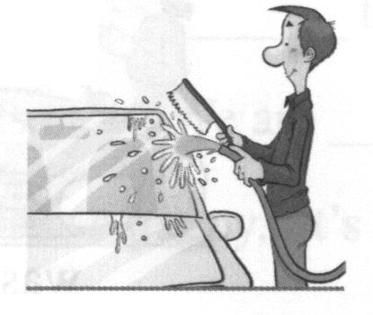  1. | 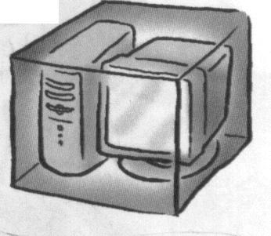  2. | 3.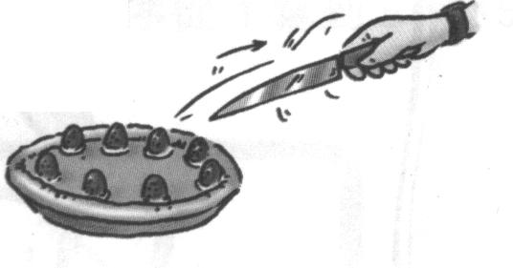 | 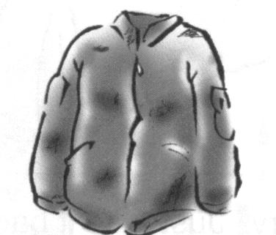  4. | 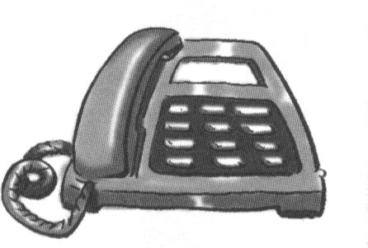  5.  2316-5789

IV. 聽錄音帶，根據對話內容，寫出正確圖片的代號。（一題2分，共10％）
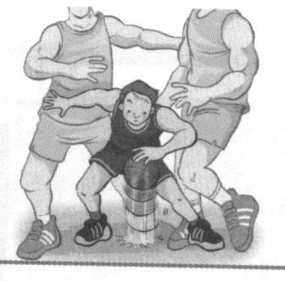  A. | 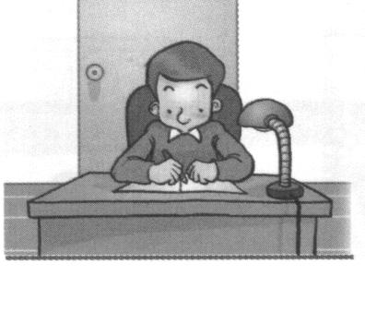  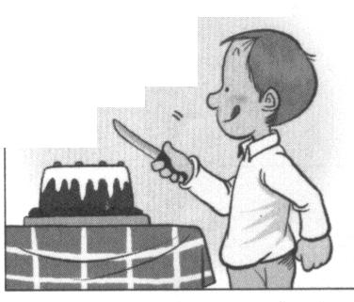  B. | 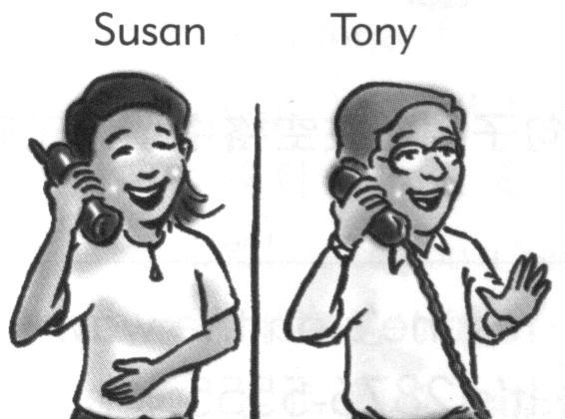  C. | 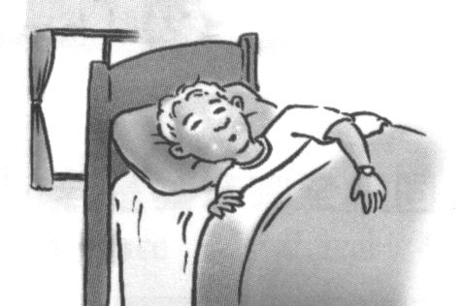  D.
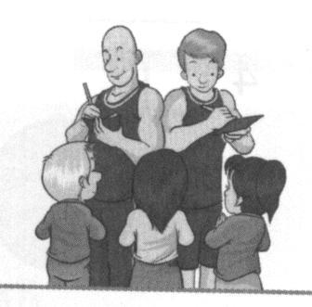  E. | F. | 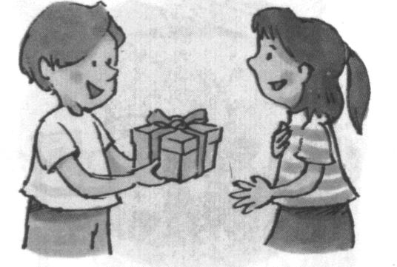  G. | H.

V. 聽錄音帶中的句子，選出適當的回應句子，並在空格中填入正確的代號。（一題2分，共10％）
A. Thank you.  B. Yes, I‘m fine.  C. No, I’m not.  D. Too bad! | F. She is in the classroom.  G. He is helping his mother.  H. Sorry, you have the wrong number.

二、字彙測驗（10％）
I. 看圖填入適當的英語語詞（一題1分，共4％）
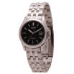  1. | 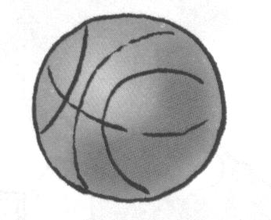  2. |   3.  門票 | 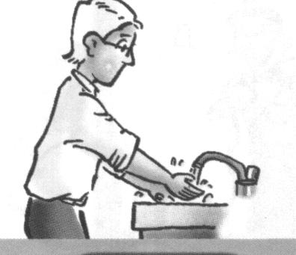  4.

II. 根據文意及字首字尾，填入適當的英語語詞（一題2分，共6％）
__________ 1. My new computer is beautiful and f t.
__________ 2. I d k milk every morning.
__________ 3. Amanda is in the g n and she is feeding the cat.

三、填充 10% (每格一分)
- Alan : Where’s David? Bill : He’s out _______________his friend, Helen.
- Andy : Happy New Year, Bob. Alice : This is _______________ you.
Bob : Oh, thank you very much.
- Diana : It’s very cold(冷的) today. _______________ open the door. Please close it.
Ted : Okay.
- Carol : _____________ that woman?
Betty : That’s J. K. Rowling. She’s a famous (著名的) writer.
- Ben : Is Cathy coming?
Jack : Yes, she’s ____________ the way here.
- Peter : Where are you _____________? Lisa : ROC.
- She’s _______________ a parade on Double Tenth Day. (雙十節)
- The students are cheering _______________ the beautiful singer.
- The girl is short, _______________ the table is tall. The cake is on the table. She can’t
get (拿到) the cake.
10. Tina : Is that house new? Kate : No, it’s _______________ old house.

四、文法選擇 6% (每題一分)
- _____________ a beautiful park! There are many flowers in it.
(1)How (2)What (3)Who (4)Where
- Mr. and Mrs. White ___________ late today. They feel(感覺) sorry.
- is (2)am (3)are (4)be
- Come on! Let’s ____________.
(1)sing to the music (2)calling her (3)waiting in line (4)don’t watch TV
- A : What are these? B : ______________
(1)These are my money. (2)They’re my socks. (3)These are dictionarys. (4)They’re boxs.
- Mr. Hill is _____________ engineer, and his cousin is, ______________.
(1)a, too (2)the, too (3)an, also (4)an, too
- Is Ms. Jones _____________?
- moving a heavy box (2)helpping the little boy (3)driveing a car (4)eatting lunch
五對話 5% (每題一分)
1. Police officer : ___________________ Peter : Yes, sir.
(1)Helping the old man. (2)What’s your name? (3)Don’t move. (4)What’s in the box?
- Tom : ______________ Gina : Yes, they are.
(1)Are these a long candle? (2)Are those cakes big? (3)Are they tall basketball player?
(4)Are the jacket too short for you?
- Vivian : Are you coming to the party? David : ______________
(1)No, it’s too late. (2)Yes, I’m at home. (3)Look, he’s coming. (4)No, you are not.
- Linda : _______________ Police officer : It’s over there.
(1)Sorry, sir. Where’s the bus 260? (2)Excuse me. Where’s the bus 260?
- Could you help my puppy? (4)Where’s my mother, please?
- Mom : Don’t forget your books. Peter : ________________
(1)Take it easy. (2)Never mind. (3)Let’s try it. (4)Oh, yes. Thanks.

六、閱讀測驗 6% (每題二分) 依據短文，題目敘述正確的填T，錯誤的填F
It’s a sunny Sunday. Kate goes to Yangmingshan with her family. Her
grandmother is taking a hot-spring bath there. Her father and mother are doing
exercise and enjoying the nice weather. Kate and her little sister, Monica, are feeding
fish in the pond. They also meet two Americans, and they speak a little English with
them. Her brother, Leo, sees his classmates, Gary and Denis. He’s flying a kite with them.
Look at the beautiful kites. They’re flying so high in the sky. Their dog, Funny, is running
here and there. He’s really happy. And Kate’s family all have a good time in the park.
sunny晴朗的 Yangmingshan陽明山 hot-spring溫泉 bath洗澡 exercise運動
enjoy享受 weather天氣 meet遇見 Americans美國人 fly飛

( )1. Kate goes to Yangmingshan with her family and her friends, Gary, and Denis.
( )2. There are six people in Kate’s family.
( )3. Kate’s family eat a lot of good food in the park and they all have fun there.

七、依提示作答 8% (每題二分)
1. Write your name here. (加入please)
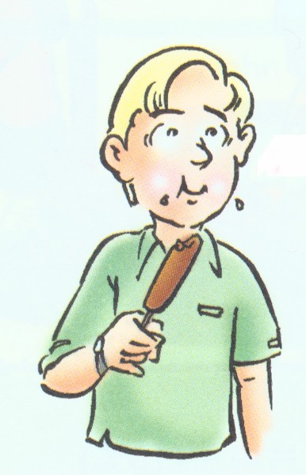

2. Come in, Peter. Close the door. (用連接詞把兩個句子合併成一個句子)
3.
3. Are the boys eating ice cream? (看圖詳答問題，須說出「在吃熱狗」)
4. We have fun in the park. (將動詞改成現在進行式)

八、翻譯 15% (每題三分)
1. 也許你的鞋子在桌下。 Maybe your ____________ are ___________ the ____________.
2. 那是你的父母送的禮物嗎? Is that a ____________ ____________ your ____________?
3. 怪不得她長得這麼高。
4. Brown太太正在切生日蛋糕嗎？
5. 我們給他熱烈的掌聲吧！

台北市立龍山國民中學九十二學年度第一學期七年級第二次段考 聽力稿
一、聽力測驗（共40分）
（本次聽力測驗，每題題目皆唸兩次，請同學仔細聆聽，謹慎作答。）
I. 聽音辨字。（6％）
A. 根據字首的發音，圈選你聽到的單字。  例： fan tan van  1. ten den men  2. hear year wear  3. vase dance face | B. 根據字尾的發音，圈選你聽到的單字。  例： write rime ride  4. been being beam  5. these theme this  6. cave case cane

II. 聽錄音帶，寫下與題目相同的句子代號。（一題1分，共4分）
(請在空格中寫出句子代號A、B或C)
- A. What’s his cell phone number?
B. What’s her telephone number?
C. What’s your phone number?
- A. Is it in your schoolbag?
B. Is it under your bed?
C. Is it on your notebook?
- A. How’s he doing?
B. Where is she going?
C. What’s she doing?
- A. This book is big but light.
B. These books are big and heavy.
C. These books are small and light.

III. 聽錄音帶，選出符合圖意的句子。（一題2分，共10分）
(請在空格中寫出句子代號A、B或C)
- A. Ted is washing his car.
B. Ted is blowing out the candle.
C. Ted is opening the door.
- A. The computer is on the box.
B. The computer is in the box.
C. The computer is under the box.
- A. Amy, don’t cut the cake.
B. Amy, cut the cake, please.
C. Amy, please don’t eat the cake.
- A. The jacket is new.
B. The jacket is long.
C. The jacket is old.
- A. My phone number is 2336-2789.
B. My phone number is 2316-5789.
C. My phone number is 2306-4789.
IV. 聽錄音帶，根據對話內容，寫出適當圖片代號。（一題2分，共10分）
- Woman: Hello, may I speak to Tony?
Man: This is Tony speaking.
- Man: Where is Peter?
Woman: He’s in his room.
Man: What’s he doing?
Woman: He’s studying.
- Boy: Happy birthday! This present is for you.
Girl: Thank you very much.
- Girl: Who’s that short boy?
Boy: He’s my brother. But he’s a good basketball player.
- Girl: Happy birthday, Sam! Now, cut the cake.
Boy: Okay.

V. 聽錄音帶中的句子，選出適當的回應句子，並在空格中填入正確的代號。（一題2分，共10％）
1.

台北市立龍山國民中學九十二學年度第一學期七年級第二次段考英語科答 案
一、聽力測驗（共40分）
I. 聽音辨字。（一題1分，共6分）
A. 根據字首的發音，圈選你聽到的單字。 | B. 根據字尾的發音，圈選你聽到的單字。
例： fan tan van | 例： write rime ride
1. ten den men | 4. been being beam
2. hear year wear | 5. these theme this
3. vase dance face | 6. cave case cane

II. 聽錄音帶，寫下與題目相同的句子代號。（一題1分，共4分）
(請在空格中寫出句子代號A、B或C)
1. | B | 2. | A | 3. | C | 4. | B

III. 聽錄音帶，選出符合圖意的句子。（一題2分，共10分）
(請在空格中寫出句子代號A、B或C)
1. | A | 2. | B | 3. | A | 4. | C | 5. | B

IV. 聽錄音帶，根據對話內容，寫出正確圖片的代號。（一題2分，共10分）
1. | C | 2. | B | 3. | G | 4. | A | 5. | F

V. 聽錄音帶中的句子，選出適當的回應句子，並在空格中填入正確的代號。（一題2分，共10分）
1. |  | 2. |  | 3. |  | 4. |  | 5.

二、字彙測驗（10％）
I. 看圖填入適當的英語語詞（一題1分，共4％）
1. | watch | 2. | basketball | 3. | ticket | 4. | wash
II. 根據文意及字首字尾，填入適當的英語語詞（一題2分，共6％）
1. | fast | 2. | drink | 3. | garden
三、填充 10% (每格一分)
1. with | 2. for | 3. Don’t | 4. Who’s | 5. on
6. from | 7. in | 8. for | 9. but | 10. an
四、文法選擇 6% (每題一分)
1. 2 | 2. 3 | 3. 1 | 4. 2 | 5. 4 | 6. 1
五對話 5% (每題一分)
1. 3 | 2. 2 | 3. 1 | 4. 2 | 5. 4

六、閱讀測驗 6% (每題二分) 依據短文，題目敘述正確的填T，錯誤的填F
1. F | 2. T | 3. F
七、依提示作答 8% (每題二分)
1. Write your name here, please. 或Please write your name here.
2. Come in, Peter, and close the door.
3. No, they’ re eating hot dogs.
4. We’re having fun in the park.
八、翻譯 15% (每題三分)
1. Maybe your shoes are under the table .
2. Is that a present from your parents ?
3. No wonder she’s so tall.
4. Is Mrs. Brown cutting a birthday cake?
5. Let’s give him a big hand.

