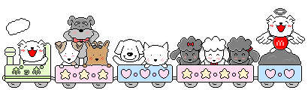
七年級校外教學學習單
—Animal Kingdom at Leofoo Village
Class: Number: Name:
1. Match the words and pictures.
(Those animals are all in the Animal Kingdom. Try to find them!! )
☆ Tigers  ● | ☆ Monkeys  ● | ☆ Goats  ● | ☆ Lions  ● | ☆ Camels  ●
●   | ●  ●   | ●   | ●   | ●  
2.Answer the questions.
(1) What animal likes to climb trees?
□ Tigers. □ Monkeys. □ Goats. □ Lions. □ Camels.
___________________________________________________
(2) What animals like to eat grass?
□ Tigers. □ Monkeys. □ Goats. □ Lions. □ Camels.
____________________________________________________
(3) What animal can live in the desert（沙漠）?
□ Tigers. □ Monkeys. □ Goats. □ Lions. □ Camels.
_____________________________________________________
(4) What animal is like a cat?
□ Tigers. □ Monkeys. □ Goats. □ Lions. □ Camels.
_____________________________________________________
(5) What animal sleeps a lot?
□ Tigers. □ Monkeys. □ Goats. □ Lions. □ Camels.
_____________________________________________________

(詹麗馨、魏秀珊老師製作)

