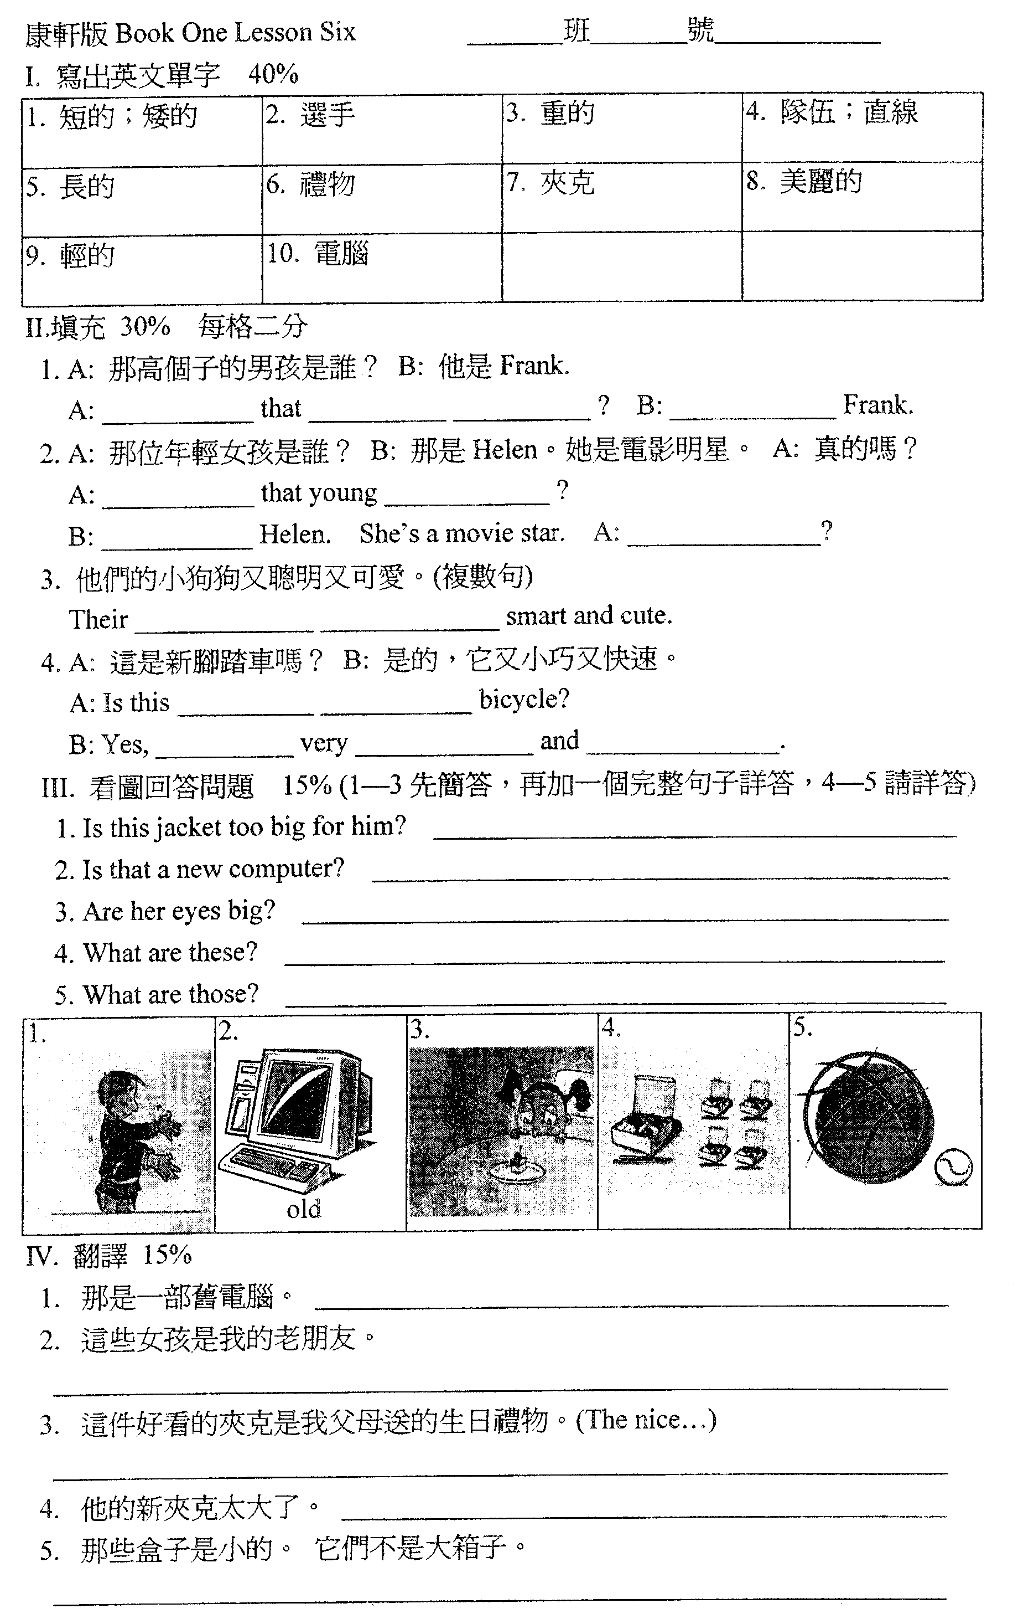

範圍：第一冊第六課－ 答案
一、寫出英文單字：
1. short 2. player 3. heavy 4. line 5. long 6. present 7. jacket 8. beautiful 9. light 10. computer
二、填充
1. Who's tall boy He's 2. Who's girl That's Really 3. puppies are
4. a new it's cute fast
三、看圖回答問題：
- No, it's not. It's too small for him.
2. No, it's not. It's an old computer.
3.Yes, they are. They are big.
4. They are lunch boxes.
5. They are a basketball and a baseball.
四、翻譯：
1. That is an old computer.
2. These / The girls are my old friends.
3. The nice jacket is a present from my parents.
4. His new jacket is too big.
5. Those / The boxes are small. They are not big boxes.

