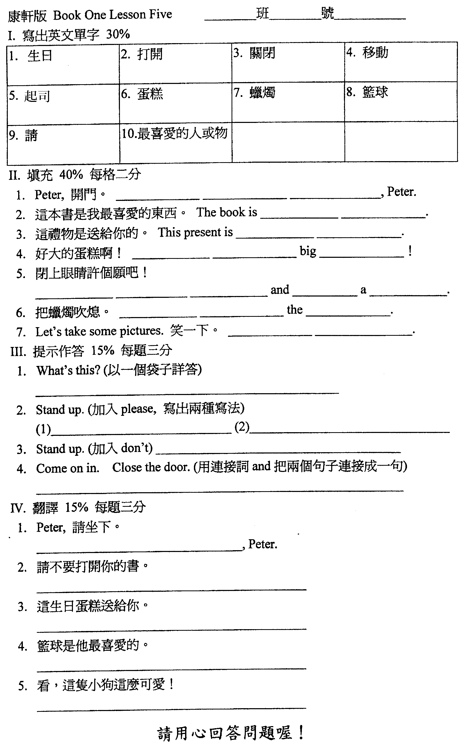
範圍：第一冊第五課－ 答案
一、寫出英文單字：
1. birthday 2. open 3. close 4. move 5. cheese 6. cake 7. candle
8. basketball 9. please 10. favorite
二、填充
1. Open the door 2. my favorite 3. for you 4. What a cake 5. Close
your / the eyes make wish 6. Blow out candles 7. Say "cheese."
三、提示作答：
1. It's a bag. 2. (1) Stand up, please. (2) Please stand up.
3. Don't stand up. 4. Come on in and close the door.
四、翻譯：
1. Please sit down
2. Please don't open your book./ Don't open your book, please.
3. This birthday cake is for you.
4. Basketball is his favorite.
5. Look! This puppy is so cute.

