I 把同一字母的大小寫連起來
C |  | - z |  | A |  | - d | Q |  | - t
K |  | - k |  | B |  | - a | T |  | - e
O |  | - w |  | U |  | - p | E |  | - l
R |  | - c |  | P |  | - b | L |  | - q
W |  | - x |  | D |  | - g | I |  | - i
X |  | - o |  | G |  | - n | J |  | - f
S |  | - s |  | M |  | - u | F |  | - j
Z |  | - r |  | N |  | - m | H |  | - h

II 把字連到對的顏色
red | -  | 
blue | -  | 
pink | -  | 
yellow | -  | 
green | -  | 
orange | -   後面還有題目 | 

III 圈對的圖30%
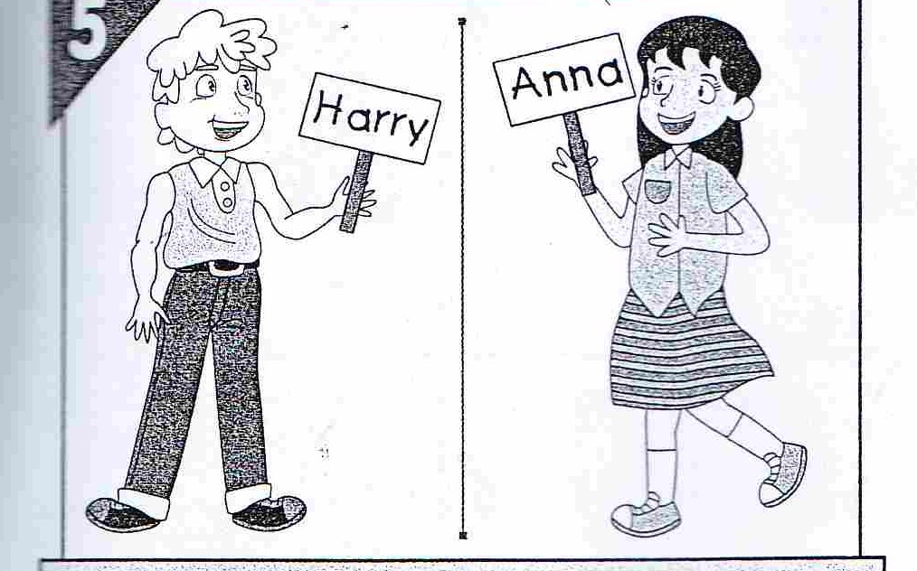  -What’s your name?  -My name is Harry. |  | 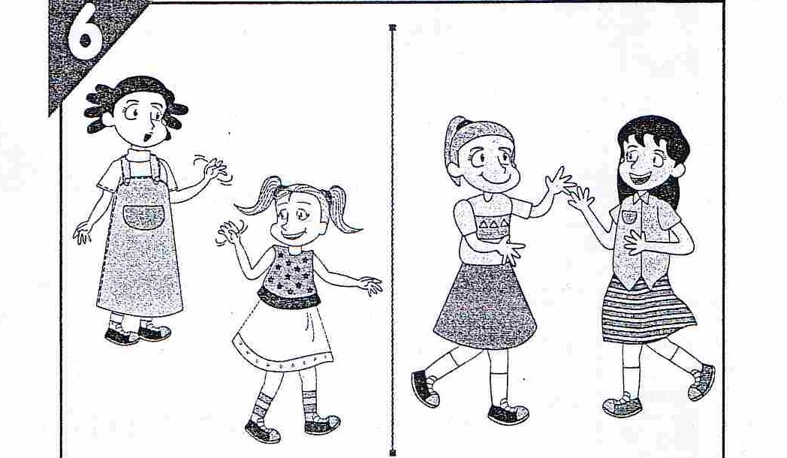  -How are you?  -Fine, thank you.
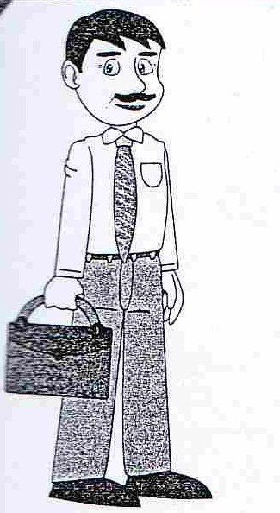 | 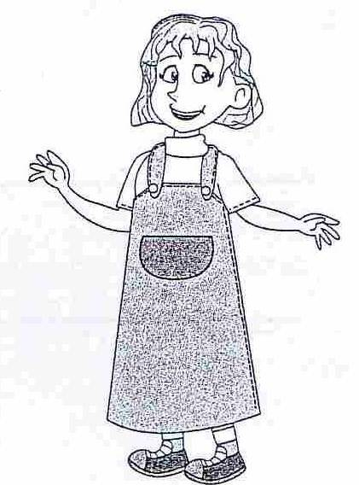 | 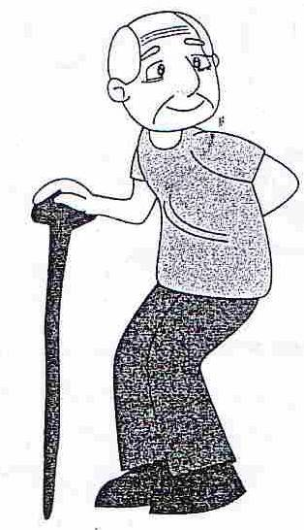 |  | 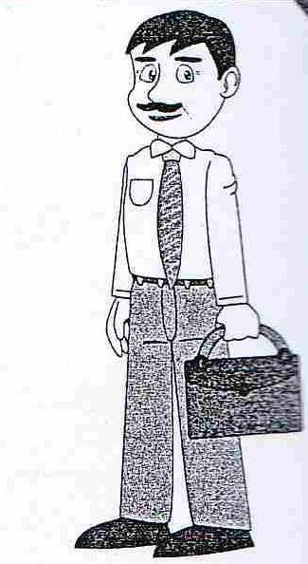
-This is my mom. |  | -This is my dad.
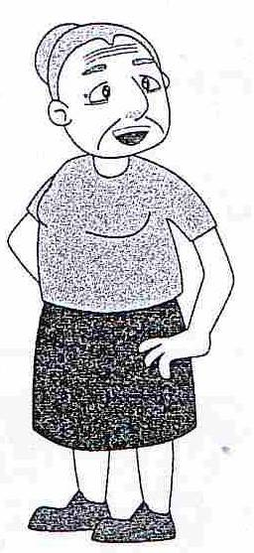  -This is my sister. | 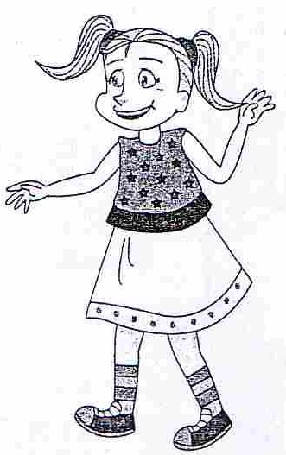 | 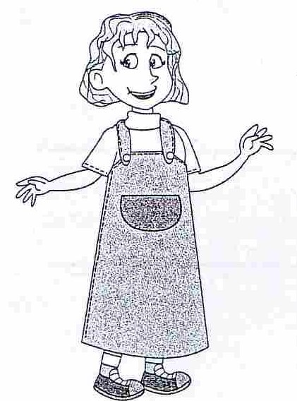  -This is my brother. |  | 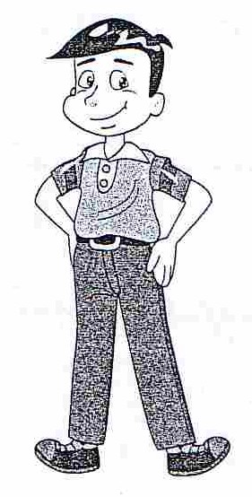
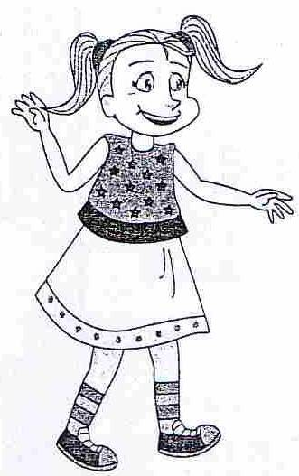 |  |  |  |  | 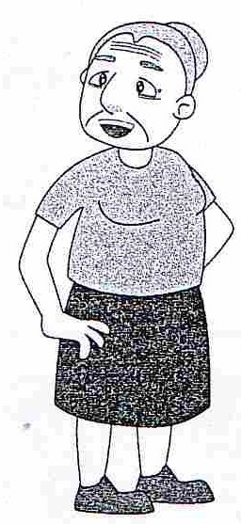
-This is my sister. |  | -This is my grandpa.
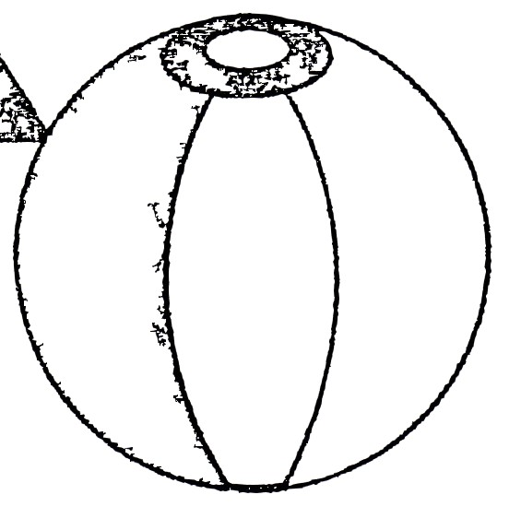 | 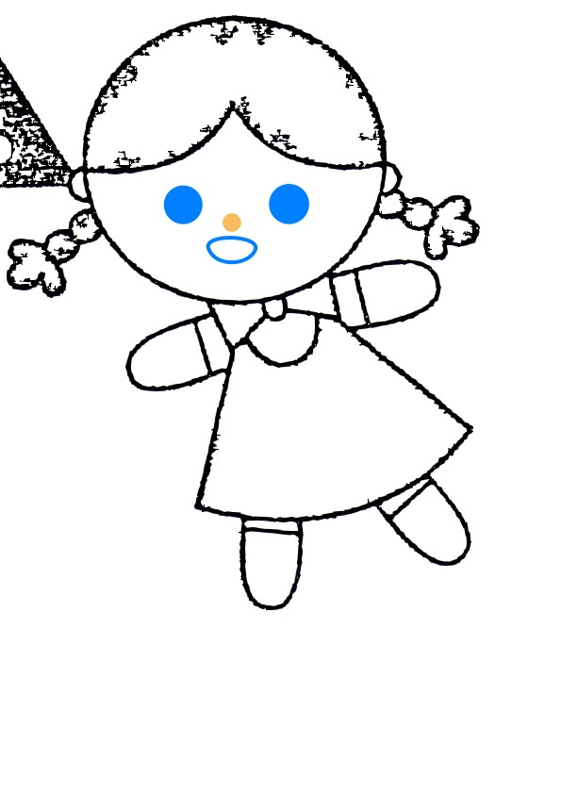 | 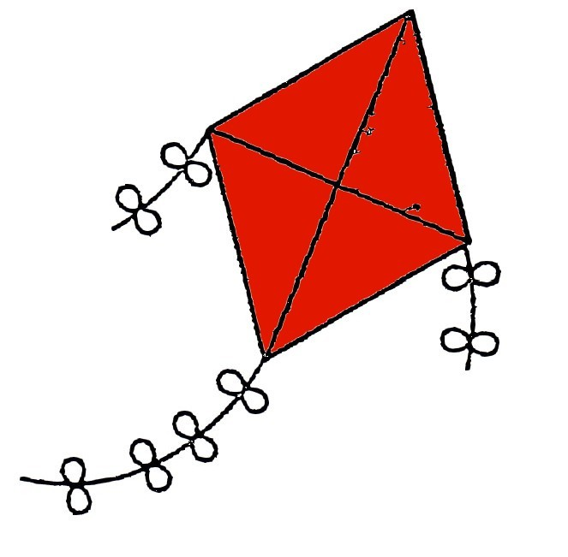 | 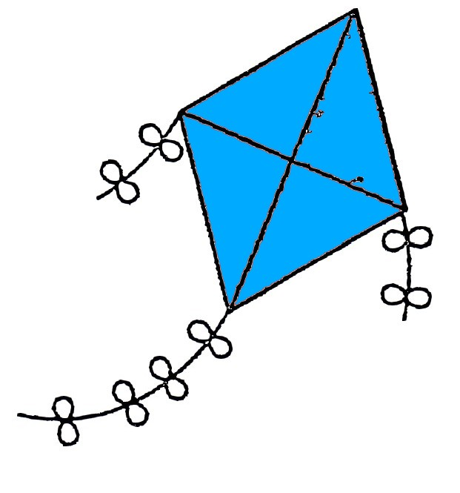
-I have a doll. |  | -I have a kite. It’s blue.
後面還有題目

-What’s your name?  -My name is Anna. |  | -Goodbye!  -Goodbye!
-This is my dad. |  | -This is my grandpa.
-This is my grandma. |  | -This is my mom.
-This is my brother. |  | -This is my grandma.
-I have a ball. |  | -I have a kite. It’s red.

後面還有題目

IV 圈對的字
 | 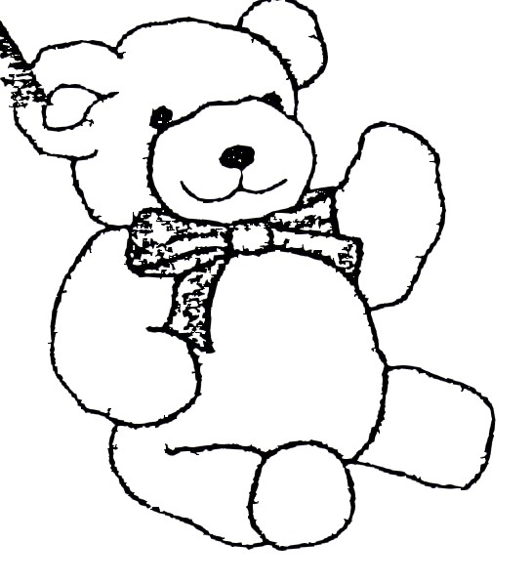 | I have a ( ball , teddy bear ).
 |  | This is a ( ball , hoop ).
 | 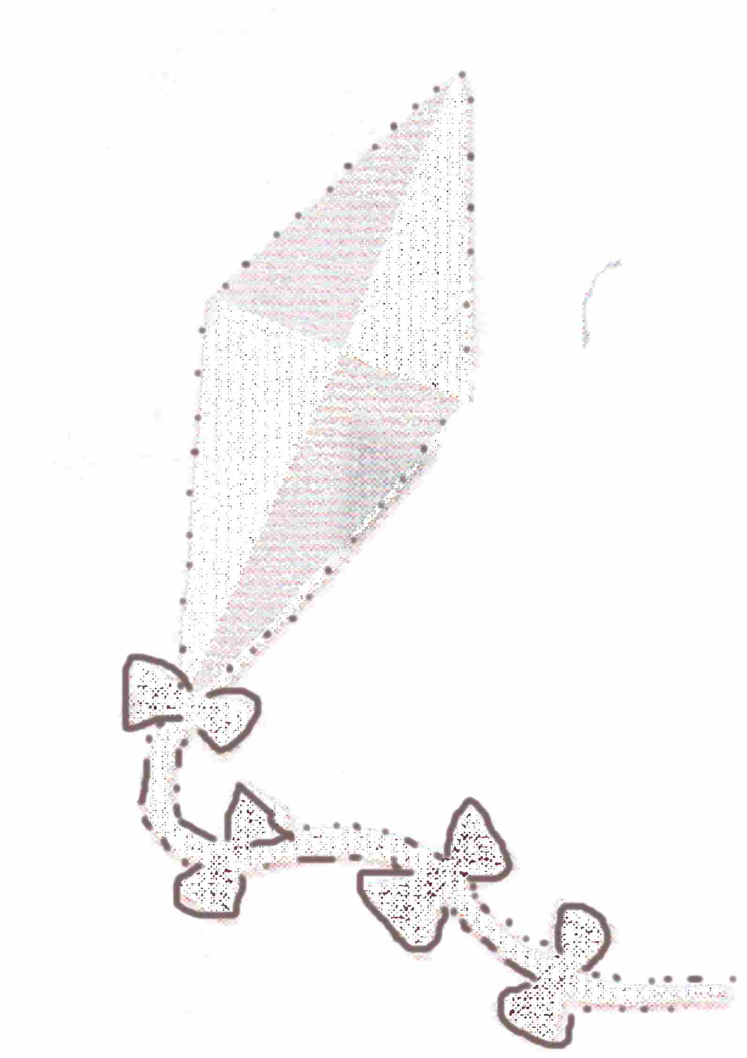 | Look! This is a ( hoop , kite ).
 |  | Look! I have a ( ball , dall ).
 | 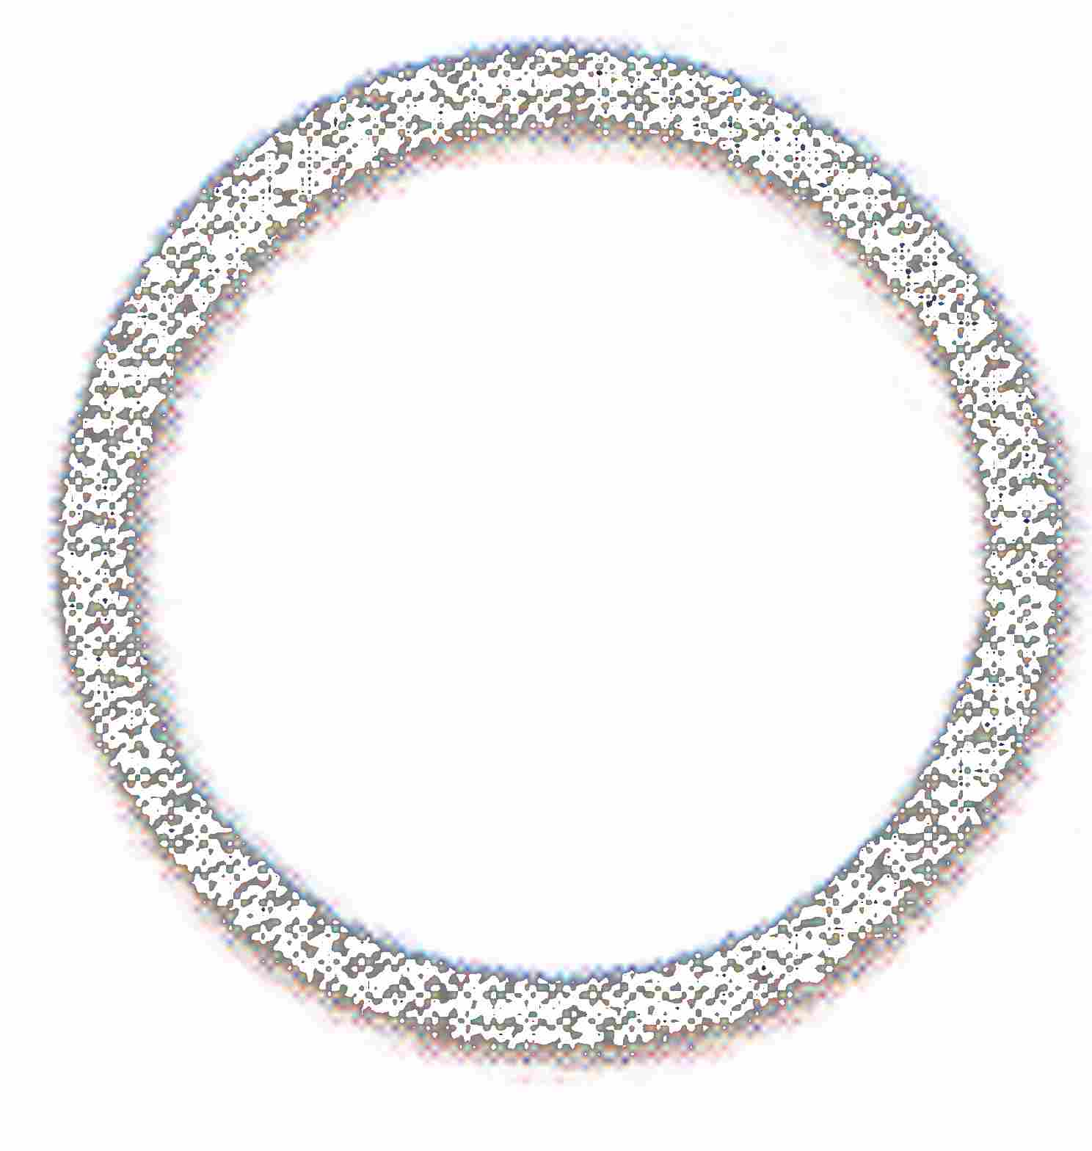 | This is a ( hoop , kite ).
 | 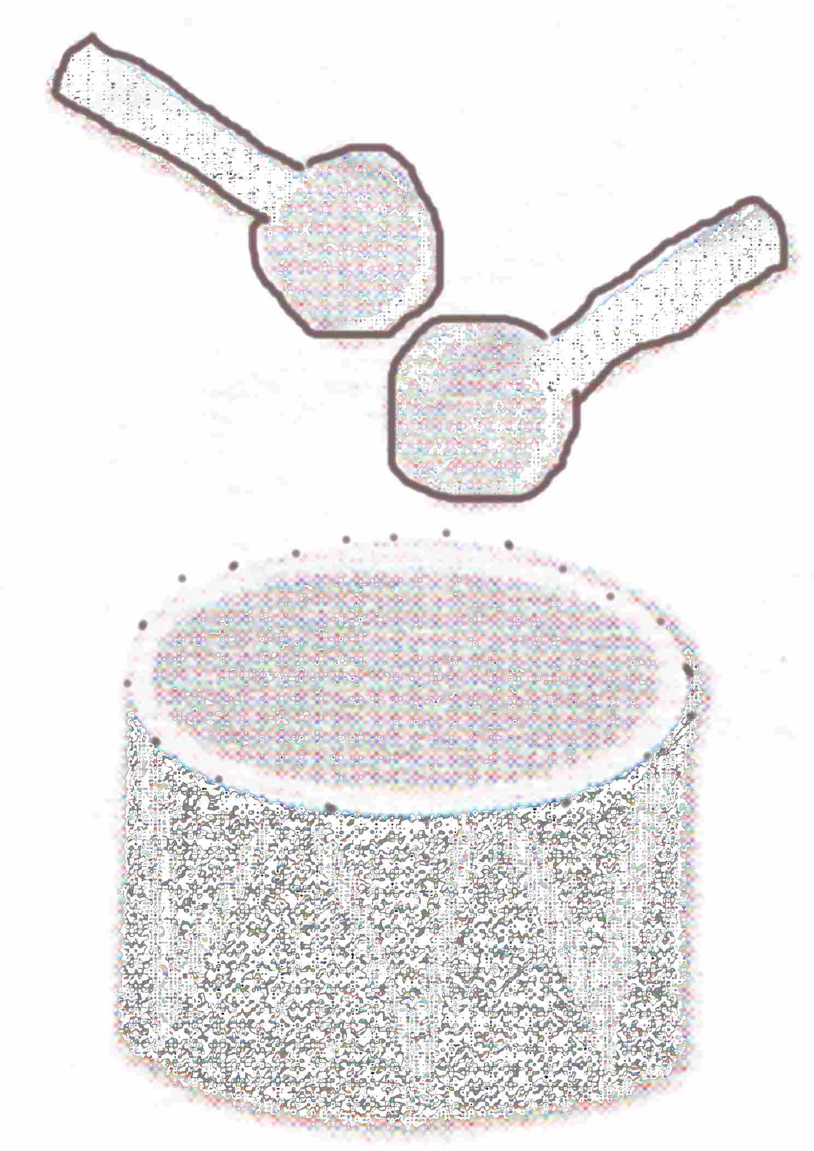 | I have a ( drum , kite ).
 | 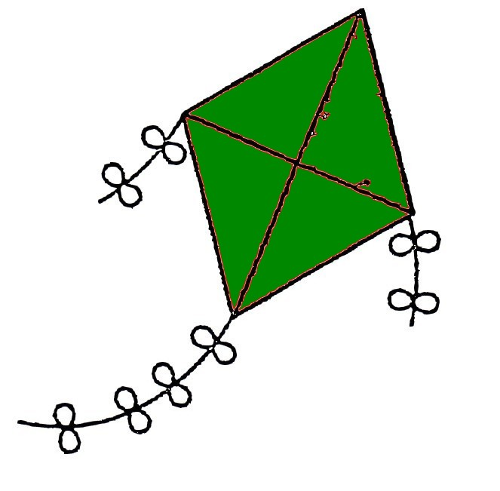 | I have a kite. It’s ( pink , green ).
 | 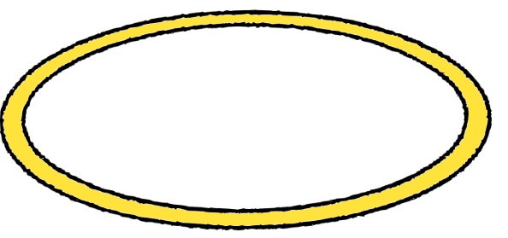 | Look! I have a hoop. It’s ( yellow , orange ).
 |  | I have a ( teddy bear , doll ).
 |  | This is a ( drum , ball ).
 |  | Look! This is a ( kite , drum ).
 |  | Look! I have a ( doll , ball ).
 |  | This is a ( kite , hoop ).
I have a ( hoop , drum).
後面還有題目
 | 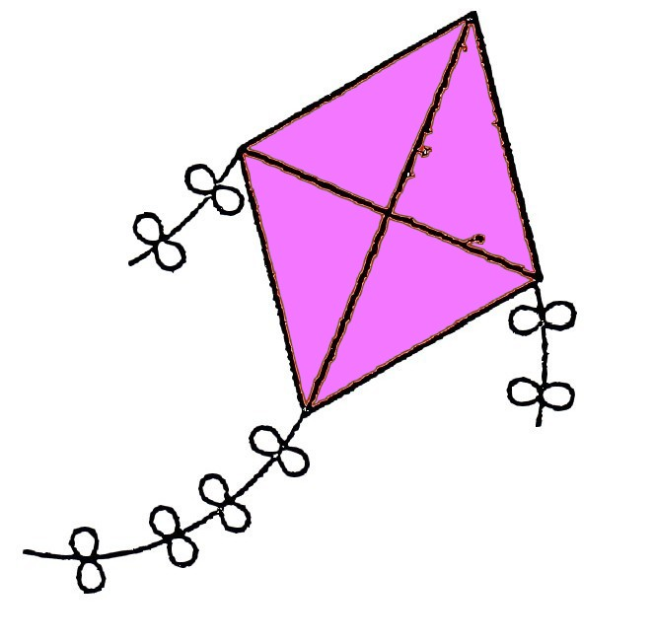 | I have a kite. It’s ( pink , green ).
 | 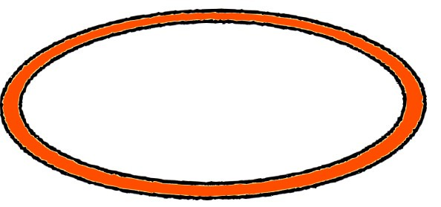 | Look! I have a hoop. It’s ( yellow , orange ).

V填上不見的字母
 | ____ om |  | ____ ister
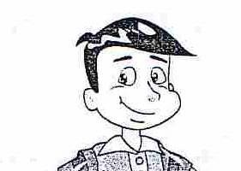 | ____ rother |  | ____ ad
 | grand____a |  | ____randma
後面沒有題目了

