成功國小何嘉仁版 100學年度英語 第一次試題測驗 四年 號姓名

ㄧ、聽力測驗：

- Listen and Number 仔細聽，依序將圖片編號。CD15
( ) ( )
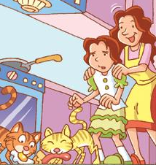 
( ) ( )
 
( )


- Listen and Circle 仔細聽，圈選出聽到的發音字。CD7
(1) rain ran
(2) tape tap
(3) cake cat
(4) sail sad
(5) pay pat

- Listen and Choose 仔細聽，選出聽到的圖片。CD10
(1)( )
a. b.
 
(2)( )
a. b.
 
(3)( )
a. b.


(4)( )
a. b.
(5)( )
a. b.

二、文法選擇：
- (A) Let’s go outside.
(B) It’s sunny.
(C) Come inside.
(D) Oh, no. It’s rainy.
(E) May I help you?
(1) ( ) (2) ( )

(3) ( ) (4) ( )
(5) ( )
…
…
…
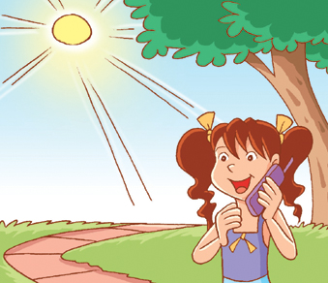
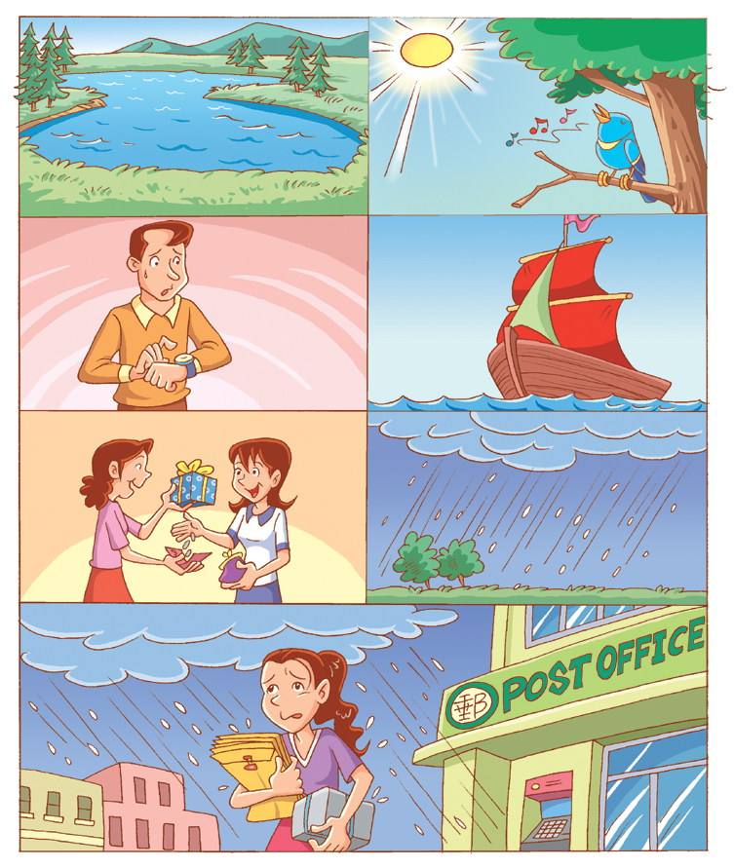

2、選出正確的答句：
- ( ) What can you do?
a. I draw.
b. I can draw.
- ( ) How’s the weather?
a. I can read.
b. It’s sunny.
- ( ) You can talk!
a. Sorry.
b. Sure!
- ( ) I can cook.
a. I can cook, too.
b. I do cook.
- ( ) Let’s play outside.
a. Okay.
b. Hurry up.
- ( ) How’s the weather?
a. It’s an orange.
b. It’s windy.
- ( ) How’s the weather today?
a. It’s hot.
b. It’s 5:00.

3、重組句子：
- read./can’t/We/write/and
→_______________________

- go/outside/./Let’s
→

- easy/Take/./it
→_______________________

三 、Reading 15％

四、Speaking 15％

五、 k k 10％

