沙港國小何嘉仁版 100學年度英語 第一學期 第 3 次試題測驗 四年 號姓名

ㄧ、聽力測驗： (CD曲目49)10%
1. Listen and Circle 仔細聽，將聽到的單字圈起來。
(1) | red | led
(2) | leg | rat
(3) | rock | lock
(4) | lamp | ramp
(5) | rabbit | lemon

2. Listen and Check 仔細聽，勾選出聽到的句子。10%(CD曲目40)

(1) | ( ) Look, they’re cute. | ( ) Look, it’s cute.
(2) | ( ) How much is the  chocolate? | ( ) How much is the  cookie?
(3) | ( ) They are $45. | ( ) They are $54.
(4) | ( ) Merry Halloween! | ( ) Merry Christmas!
(5) | ( ) How much are the  cookies? | ( ) How much are the  candy canes?

3.Listen and Number 仔細聽，將圖片依聽到的順序編號。10%(CD曲目50)

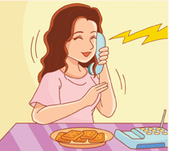
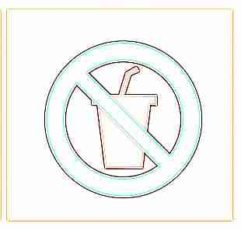




4. Listen and Write “s” or “z” 仔細聽，寫出單字的字首字母 s 或 z。10%(CD曲目42)

(1) | __ ip
(2) | __ oo
(3) | __ ero
(4) | __ un
(5) | __ ack

二、文法選擇： 10%
( ) 1. How much are the ____?
(a) candy cane (b) candy canes

( ) 2. The grape juice ___ sour.
- are (b) is

( ) 3. The banana cake ____ sweet.
(a) are (b) is

( ) 4. How much ____ the hot dog?
(a) are (b) is

( )5. Here ____ some candy canes for you.
(a) are (b) is

( ) 6. The chocolate cookies ___ yummy.
- are (b)

( )7. How much is the ____?
(a) orange (b) oranges

( ) 8. The grapes ____ $90.
- are (b) is

( )9. Here ____ some cookies.
- are (b) is

( )10. Here is an ____.
(a) apple (b) apples

三、配合題：10%

(a) Do you want some?
(b) Here you are.
(c) In a minute, please.
(d) Happy holidays!
(e) No drinking.

(1) ( ) |   (2) ( ) | (3) ( )  e )

(4) ( )   | (5) ( )

四 Reading 20％

五 Speaking 20％

